NAME …………………………………………………………….ADM ………………..
JUJA GIRLS HIGH SCHOOL
MID TERM III EXAMS 2018
FORM 2 CHEMISTRY
INSTRUCTIONS
- Answer all questions in the spaces provided.
- The figure below represents set up that can be used to prepare and collect oxygen gas.
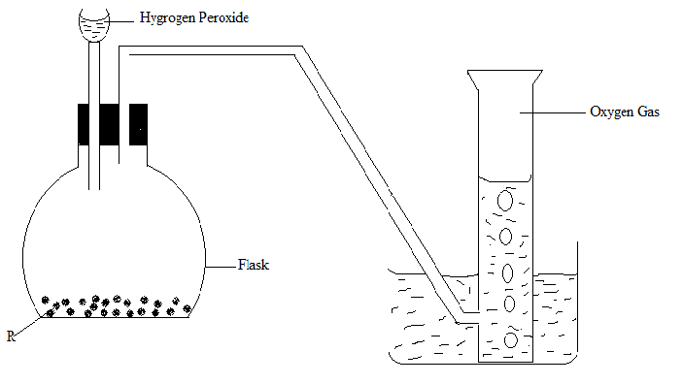

- Name solid R (1mk)
………………………………………………………………………………………………………………………………………………………………………………………………
- What is the role of solid R? (1mk)
……………………………………………………………………………………………………………………………………………………………………………………………..
- Write a word equation for the reaction that takes place. (1mk)
………………………………………………………………………………………………………………………………………………………………………………………………
- Identify the method of gas collection employed. (1mk)
………………………………………………………………………………………………………………………………………………………………………………………………
- Why is the method in (d) above suitable for collecting oxygen?. (1mk)
………………………………………………………………………………………………………………………………………………………………………………………………
- Explain why it is important not to collect any gas for the first few seconds of the experiment. (1mk)
………………………………………………………………………………………………………………………………………………………………………………………………………………………………………………………………………………………………
- State the chemical test for oxygen gas. (1mk)
………………………………………………………………………………………………………………………………………………………………………………………………
- Name a solid which would produce oxygen gas when water is added to it.(1mk)
………………………………………………………………………………………………………………………………………………………………………………………………
- Name any two solids which when heated produces oxygen gas as one of the products. (2mks)
………………………………………………………………………………………………………………………………………………………………………………………………………………………………………………………………………………………………
- When magnesium is burnt in air, it reacts with oxygen and nitrogen giving a white ash. Write two word equations for the two reactions. (2mks)
………………………………………………………………………………………………………………………………………………………………………………………………………………………………………………………………………………………………
- The set up below was used to study some properties of air.
Gas jar
Burning candle

Sodium hydroxide solution
- State two observations made after some time. Give a reason for each observation.(4mks)
………………………………………………………………………………………………………………………………………………………………………………………………………………………………………………………………………………………………………………………………………………………………………………………………………………………………………………………………………………………………
- Explain why sodium hydroxide solution was used in this experiment rather than water. (2mks)
……………………………………………………………………………………………………………………………………………………………………………………………………………………………………………………………………………………………………………………………………………………………………………………………..
- Given that the volume of air in the gas jar at the beginning of experiment was 150cm³. Calculate the percentage of air used up if the final volume of air was 120cm³. (3mks)
………………………………………………………………………………………………………………………………………………………………………………………………………………………………………………………………………………………………………………………………………………………………………………………………………………………………………………………………………………………………………………………………………………………………………………………………………………………………………………………………………………………………
- Name the main component of the remaining 120cm³. (1mk)
……………………………………………………………………………………………………………………………………………………………………………………………..
- Identify two possible sources of error in this experiment. (2mks)
………………………………………………………………………………………………………………………………………………………………………………………………………………………………………………………………………………………………………………………………………………………………………………………………
- a)What is the chemical name for rust? (1mk)
………………………………………………………………………………………………………………………………………………………………………………………………
b) State two conditions necessary for rusting to occur. (2mks)
………………………………………………………………………………………………………………………………………………………………………………………………………………………………………………………………………………………………
c) Write word equations for the formation of rust. (2mks)
………………………………………………………………………………………………………………………………………………………………………………………………………………………………………………………………………………………………
d) Explain why it is possible for an iron article to rust until it is completely eaten away yet rust forms a coat on the article. (2mks)
………………………………………………………………………………………………………………………………………………………………………………………………………………………………………………………………………………………………………………………………………………………………………………………………
e) State two conditions which accelerate rusting. (2mks)
………………………………………………………………………………………………………………………………………………………………………………………………………………………………………………………………………………………………
f) State any two methods that may be used to prevent rusting. (2mks)
………………………………………………………………………………………………………………………………………………………………………………………………………………………………………………………………………………………………
g) State a disadvantage of rusting. (1mk)
………………………………………………………………………………………………………………………………………………………………………………………………
5) You are provided with zinc granules, dilute hydrochloric acid, flat bottomed flask, gas jar, trough of water, delivery tube and bee hive shelf.
a) Make a complete arrangement of the apparatus to prepare and collect hydrogen gas.(3mks)

b) Identify the two methods of gas collection that can be used to collect hydrogen gas. Give a reason why each of the methods is suitable. (4mks)
………………………………………………………………………………………………………………………………………………………………………………………………………………………………………………………………………………………………………………………………………………………………………………………………………………………………………………………………………………………………………………………………………………………………………………………………………………………………………………………………………………………………………………………………………………………
c) Explain why dilute nitric(V) acid cannot be used in place of the hydrochloric acid.(1mk)
………………………………………………………………………………………………………………………………………………………………………………………………………………………………………………………………………………………………………………………
d) Explain why the following metals are not suitable for use in place of zinc. (4mks)
i) Magnesium ………………………………………………………………………………………………………………………………………………………………………………………………………………
ii) Iron ………………………………………………………………………………………………………………………………………………………………………………………………………………
iii)Copper………………………………………………………………………………………………………………………………………………………………………………………………………
iv) Sodium …………………………………………………………………………………………………………………………………………………………………………………………………………….
- State any two drying agents for hydrogen gas. (2mks)
………………………………………………………………………………………………………………………………………………………………………………………………………………………………………………………………………………………………

