JUJA GIRLS HIGH SCHOOL

NAME………………………………………………….ADM…………………………………………..

DATE…………………………………………………..SIGNGATURE………………………………

**233/2**

**CHEMISTRY**

**PAPER 2**

**(THEORY)**

JULY, 2018

**TIME: 2 HOURS**

**END OF TERM II FORM THREE EXAMINATION, 2018**

*233/2*

*CHEMISTRY*

*PAPER 2*

*(THEORY)*

*TIME: 2 HOURS*

***INSTRUCTIONS:***

* *Write your name, school and index number in the spaces provided above.*
* *Sign and write the date of the examination in the spaces provided above.*
* *Answer* ***ALL*** *the questions in the spaces provided.*
* *Mathematical tables and silent electronic calculators may be used.*
* *All working must be clearly shown where necessary.*
* *This paper consists of* ***12*** *printed pages.*
* *Candidates should check to ensure that all pages are printed as indicated and no questions are missing.*

**FOR EXAMINER’S USE ONLY**

|  |  |  |
| --- | --- | --- |
| **Question** | **Maximum score** | **Candidate’s score** |
| **1** | 6 |  |
| **2** | 12 |  |
| **3** | 11 |  |
| **4** | 7 |  |
| **5** | 14 |  |
| **6** | 7 |  |
| **7** | 6 |  |
| **8** | 9 |  |
| **9** | 8 |  |
| **TOTAL SCORE** | **80** |  |

1.The figure below represents a section of the periodic table. Study it and answer questions (a) to (h). Note that the letters do not represent the actual symbols of the elements.



(a) Consider elements D. H and I

i) Give the chemical family of these elements. (1mk)

ii) How do their atomic radius compare. (1mk

iii) Compare and explain the reactivity of the three elements. (2mks)

b.Write the electronic configuration of;

(i)Element H (1mk)

ii) The ion of element G. (1mk)

2. Study the table below and answer the questions the follow. The letters do not represent the actual symbols of elements.

|  |  |
| --- | --- |
| **Formula of ion** | **Electronic configuration** |
| A2+ | 2 |
| B- | 2.8 |
| C2- | 2.8.8 |
| D3+ | 2.8 |
| E2+ | 2.8.2 |

a) Select the elements in

1. The same group (1mks)
2. Period 3 (2mks)

b) With reasons compare

1. Ionic radius of D3+ and E2+  (2mks)
2. Reactivity of A and E (2mks)

c) Write electronic configurations of elements (2mks)

1. C
2. D

d) i) write the formula of the compound formed when B and E react (1mk)

ii) What type of bond is formed when A reacts with oxygen. Give a reason for your answer.

(2mks)

3. Study the flow chart below and answer the questions that follow.

|  |
| --- |
| ethanol |

Conc.H2SO4

|  |
| --- |
| A |

Br2

|  |
| --- |
| C |

H2

|  |
| --- |
| B |

|  |
| --- |
| E |

|  |
| --- |
| GAS F |

|  |
| --- |
| GAS G |

|  |
| --- |
| White precipitate |

O2 (excess)

Na lime water

a) Identify substances (4mks)

A……………………………………………

B…………………………………………….

F…………………………………………….

G…………………………………………..

b) Write down the equation for the formation of;

1. Substance C (1mk)
2. E and F (2mks)
3. Gas G (2mks)

c) State

1. The condition necessary for the formation of product C (1mk)
2. The catalyst required in the conversion of A to B (1mk)

4. The diagram below represents a set up that can be used to react calcium metal with water.

1. Give the formula of Gas Q. (1mk)
2. State and explain the likely pH of the solution in the beaker at the end of reaction (2mks)
3. Write an equation for the reaction that occurs. (2mks)
4. Describe a test that can be used to confirm the identity of gas Q (1mk)
5. Why is it not advisable to use potassium in place of calcium in this experiment? (1mk)

5. The diagram below represents an incomplete set up of the apparatus that can be used to prepare and collect dry carbon (IV) Oxide gas.

1. Complete the diagram to show how dry carbon (IV) oxide may be collected. (2mks)
2. Name liquid B. (1mk)
3. Explain the purpose of water in the above set up. (1mk)
4. Write an equation for the reaction that occurs. (1mk)
5. When calcium carbonate was replaced with lead (II) carbonate, the volume of the gas collected was very small. Explain. (2mks)
6. Calcium hydroxide solution can be used to detect the presence of carbon (IV) oxide gas while potassium hydroxide cannot be used explain. (2mk)

b) State two properties that make carbon (IV) oxide suitable for use in fire extinguishers. (2mk)

c) Burning magnesium was placed in a gas jar containing carbon (IV) oxide.

1. State the observation made (1mk)
2. Write equation for the reaction above (1mk)
3. Why does magnesium burn in carbon (IV) oxide when its known that carbon iv oxide does not support combustion. (1mk)

6. (a) Below is a diagram of the set-up of apparatus used to investigate the products of combustion of candle wax in an experiment.

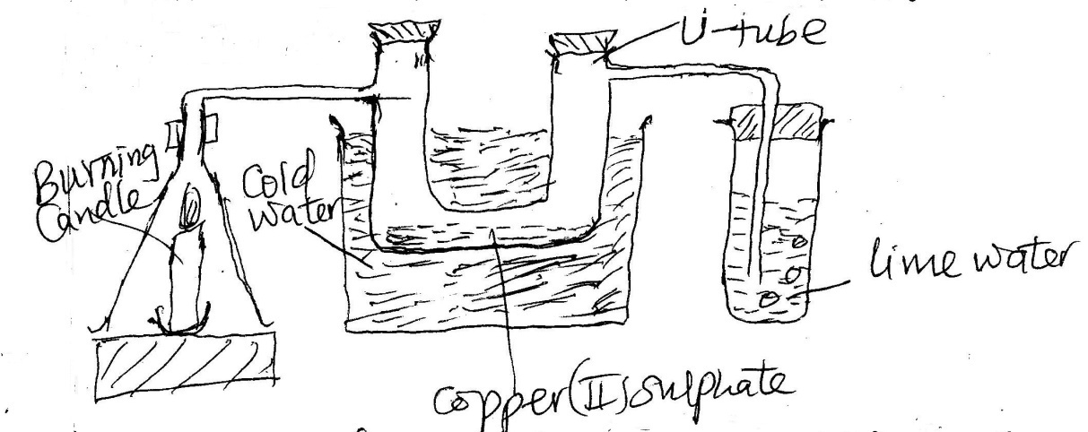

1. State and explain the observations made in the u-tube containing anhydrous copper (II) sulphate. (2mks)
2. Name the liquid formed when the candle burns. (1mk)
3. What would be observed in the test tube containing lime water? Explain. (2mks)
4. What conclusion can be made from this experiment about what composes of a candle wax? (1mk)
5. Write a chemical equation for the combustion of candle wax. (CxHy) (1mk).

7 a) A student set up the apparatus as shown in the diagram below to prepare and collect dry ammonia gas.

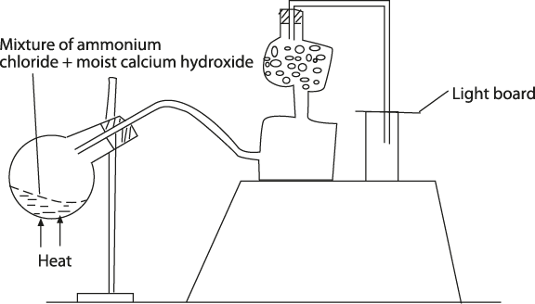

1. Identify three mistakes in the set up and give a reason why each is mistake. (3mks)

ii) Name a suitable drying agent for ammonia. (1mk)

iii) Write an equation for the reaction that occurred when a mixture of ammonium chloride and calcium hydroxide was heated. (1mk)

iv) Describe one chemical test for ammonia gas. (1mk)

8. The following information was obtained by Midway high school students during an experiment to determine the empirical formula of a compound formed when copper combines with oxygen.

|  |  |
| --- | --- |
| Mass of empty porcelain boat (M1) | 14.215g |
| Mass of porcelain boat + copper (II)oxide (M2) | 19.00g |
| Mass of porcelain boat +residue (M3) | 18.071g |

Calculate:

1. mass of copper in copper( II) oxide used (1mk)
2. mass of oxygen in copper(II)oxide used (1mk)
3. mass of copper (II) oxide used (1mk)
4. percentage composition by mass of :
5. copper (1mk)
6. oxygen (1mk)

(v)The empirical formula of the compound. (Cu=63.50, O=16) (4mks)

9. i) distinguish between a covalent bond and a dative bond. (2mks)

ii) explain why:

1. graphite is slippery (1mk)
2. diamond is used in cutting of glass (1mk)

iii)Using dots and crosses draw a diagram to show bonding in ;

1. water(H2O) (2mks)
2. hydroxonium ion( H3O+) (2mks)