

**MAASAI MARA UNIVERSITY**

**REGULAR UNIVERSITY EXAMINATIONS**

**2016/2017 ACADEMIC YEAR**

**THIRD YEAR FIRST SEMESTER**

**SCHOOL OF TOURISM AND NATURAL RESOURCE MANAGEMENT**

**BACHELOR OF SCIENCE IN ENVIRONMENTAL STUDIES**

**COURSE CODE: EPM 304**

**COURSE TITLE: REMOTE SENSING AND**

**IMAGE INTERPRETATION**

**DATE:24TH JANUARY, 2017 TIME: 11.00AM – 1.00PM**

**INSTRUCTIONS TO CANDIDATES**

Answer **ALL** questions in section **A** and any other **THREE** in section **B. Use illustrations where appropriate.**

***This paper consists of 2 printed pages. Please turn over***

**SECTION A (25 MARKS) ANSWER ALL QUESTIONS**

1. Briefly explain your understanding of film speed and why it is important in aerial photography **(2 marks)**
2. Explain photo printing process followed for making aerial photos **(4 marks)**
3. Give the name of the file shown below, define it and explain two reasons why its important to a user of remotely sensed data **(4 marks)**

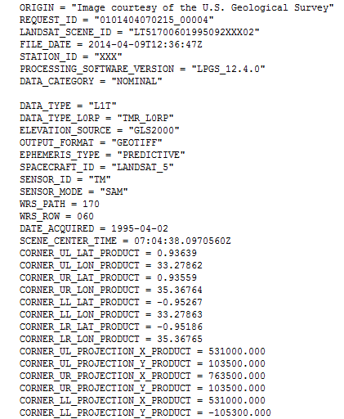

1. Explain your understanding of Urban Heat Island. How can remote sensing help in mapping and monitoring of Urban Heat Island **(4 marks)**
2. Explain two advantages of digitalaerialphotographyovertraditionalfilm-basedaerialphotography **(4 marks)**
3. Name any three types of aerial photographic film and their uses**(3 marks)**
4. Briefly explain how a geologist can use remote sensing as a tool to extract lithological structure information and composition **(4 marks)**

**SECTION B (45 MARKS) ANSWER ANY THREE QUESTIONS**

1. (a) Explain at least four considerations as a remote sensing technician you

will use to define the type of remote sensing data needed to fulfill the

user ʹs stated objectives,and where theexisting remote sensing

data which fulfills his/her objectives may be located. Discuss various

sources **(8 marks)**

(b) Discuss at least four advantages and three disadvantages of airborne

remote sensingplatforms **(7 marks)**

1. Discuss in detail remote sensing application in urban management. Include in your discussion the scope and some of the challenges/limitations of the remote sensing data **(15 marks)**
2. What are the different classifications of folds **(15 marks)**
3. Identify five agents of change in geomorphology and for each agent cite

an example of how it acts to influence the landscape development and

explain how the agent is involved **(15 marks)**

**//END**