NAME……………………………………………………………… ADM NO.…………..
CANDIDATE’S SIGNATURE…………………………………DATE…………………..

AGRICULTURE
PAPER 1
444/1
TIME 2 HOURS
FORM 4

INSTRUCTIONS TO CANDIDATES:
- Write your name and index number in the spaces provided above.
- Sign and write the date of examination in the spaces provided above.
- This paper consists of THREE Sections A, B and C.
- Answer all questions in Section A and B.
- Answer two questions in Section C in the spaces provided.

FOR EXAMINER’S USE ONLY

Section | Question | Maximum  Score | Candidate’s  Score
A | 1 - 20 | 30
B | 21 - 25 | 20
C | 26 - 28 | 20
 |  | 20
Total Score |  | 90

SECTIONA:(30MARKS)

Answer ALL the questions in this section in the spaces provided.

1. State two reasons why nitrogenous fertilizers are suitable for topdressing (1mark)

....................................................................................................................................................

................................... .................................................................................................................

2. Outline four factors that affect the effectiveness of pesticide (2marks)

3. State six factors to be considered when selecting implements for primary cultivation
(3marks)

4. State two reasons that lead to subsistence farming in Kenya (1mark)

5. State four factors that encourage rooting in tea stem cuttings (2marks)

6. List two tertiary operations that may be carried out on a seedbed (2marks)

7. State six advantages of mixed grass legume pasture over Apure grass pasture (3marks)

8. Give four types of records a poultry farmer should keep (2marks)

9. State four advantages of using organic manure over inorganic fertilizers in Kenya (2marks)

10. Name four forms of livestock farming in Kenya (2marks)

11. State four advantages of single stem pruning system in coffee production (2marks)

12. Give four benefits of practicing agro forestry in crop farming (2marks)

13. State four advantages of using polythene sleeves in the establishment of tree seedlings
(2marks)

14. Give four conditions that favour the use of chemicals to control weeds (2marks)

- State four ways in which herbicides can be classified (2marks)

SECTION8:(20marks)

Answer ALL the questions in the spaces provided

- The diagram below shows a method of preparing compost manure

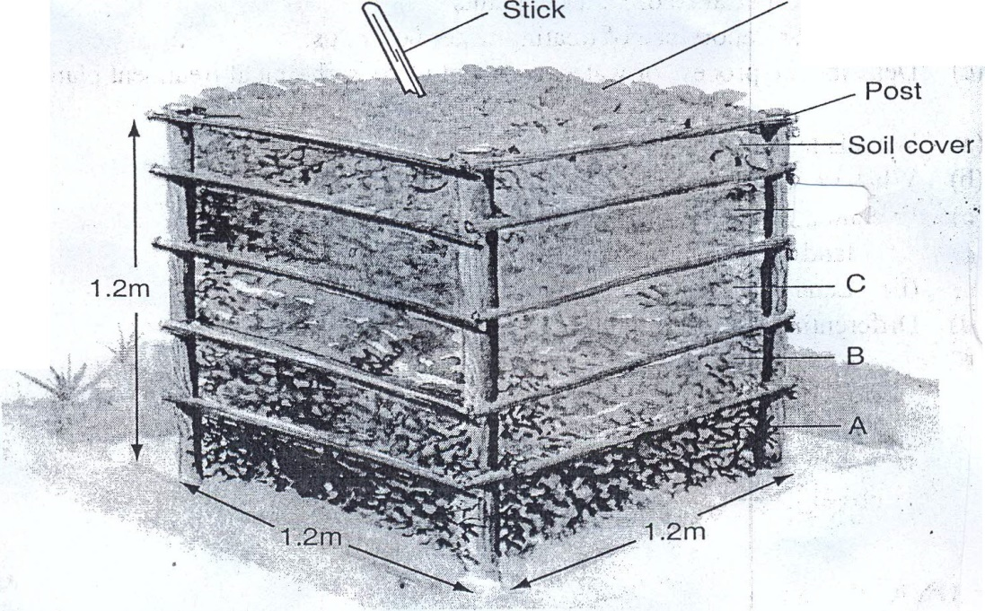
dry leaves

-··

a} Identify the method (1mark)

  - Identify the parts labeled AandB (2marks}
A ....................................................................................................................................... .

B....................................................................................................................................... .

  - Give function for part labelledC (1mark)

  - Give the reason for inserting along sharp pointed stick into the pile (1mark)

- ThediagrambelowlabelledG,H,JandKshowdifferentstagesofcottonfruitdevelopment

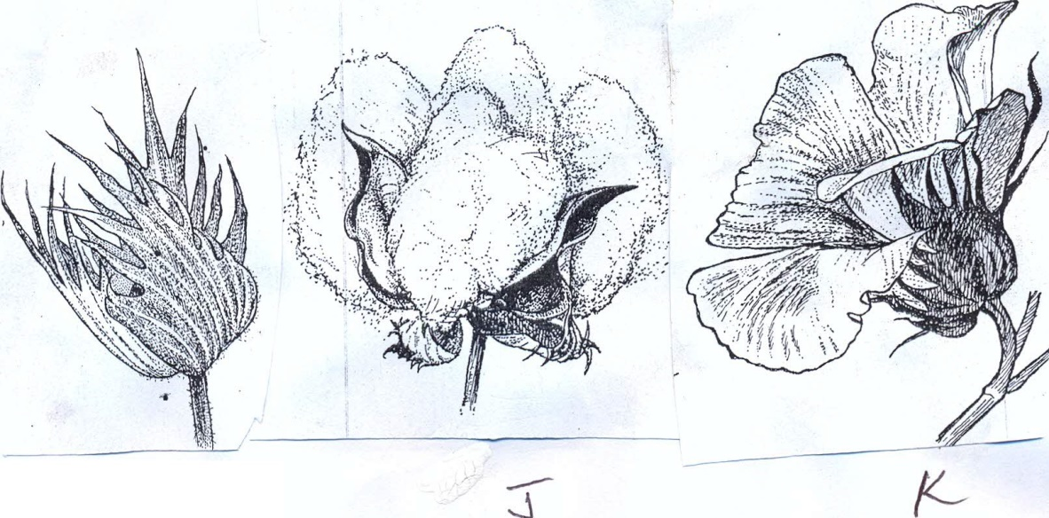
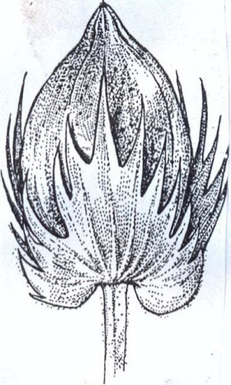
H-

- Re-arrangethelabelsG,H,JandKtoshowthecorrectsequenceinwhichthecottonfruit develops (1mark)

- WhatwouldbetheeffectofattackbycottonbollwormsatthestagelabelledK
(1mark)

- Statetwoprecautionsthatshouldbeobservedwhenharvestingtoensurethatcottonpickedisofhighquality (2marks)

- Name two products which are obtained after processing cotton in a ginnery (1mark)

......................................................................,.................................................................................

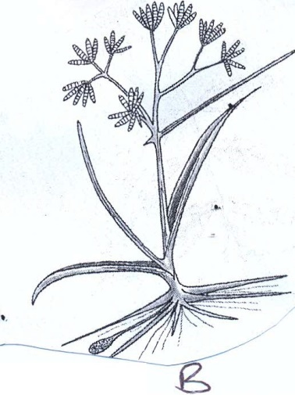
1 a) Identify the weeds below;

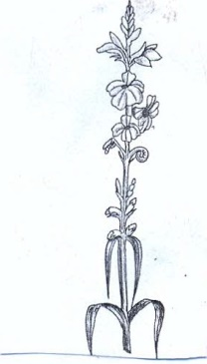

A ............................................................ .............................................................

B .............................................. ........................................................................... .

  - Why is weed B difficult to control?

  - Name two crops associated with weed A

  - Other than use of herbicides, state two control measures for weed A

- The table below shows a format of labour record
No.ofhours  Worked | Livestock  Production | Crop  Production | Machinery  ··Mainteance | Dateof  Working | Remarks
 |  |  | .,.,...
 |  | ,
ICost/hour |  | .. | T |  | .;.
lTotalcost

  - Name the type of farm record illustrated above

  - State four uses of the farm record shown above
(1mark)(1mark)(1mark)

(1mark)

(2marks)

(1mark)

(4marks)

SECTIONC:(40marks)
Answerany TWO questions from this section in the spaces provided.

- a) OutlinefivewaysinwhichlandfragmentationincreasesthecostoffoodproductioninKenya (5marks)
b) Explaineightsoilconservationmeasuresthatcanbeusedtoconservesoilona
 | Sloping farmland | (8marks)
c) | Describe the procedure of silage making | (7marks)

- a) Describe the production of common beans under the following subheadings

  - Planting
  - Pest control
  - Harvesting

(5marks)
(3marks)
(2marks)

b) State and explain five methods of applying fertilizer in crop production (10marks)

22. a)
b)
c)
Outline five benefits of timely planting in cereal production (5marks)Describe five ways in which wind negatively affect agricultural production(5marks)
Describe ten factors that should be consider when deciding on the crop to grow
(10mark

