NAME…………………………………………..INDEX NO………………….. CAND. SIGN…………………………………… DATE………………………..
443/2
AGRICULTURE
PAPER 2
[THEORY]
2 HOURS
FORM 4

INSTRUCTIONS
[a] Write your name and index number in the spaces provided above .
[b]Sign and write the date of examination in the spaces provided above .
[c]This paper consists of three sections : A ,B,C .
[d]Answer all the questions in Section A and B and any two questions in Section C
[e]All answers should be written in the spaces provided on the question paper .
FOR EXAMINERS USE ONLY
SECTION | QUESTIONS | MAX.SCORE | CAND. SCORE
A | 1-19 | 30
B | 20-23 | 20
C | 24 ,25 ,26 | 20
 | 24 ,25 ,26 | 20
TOTAL SCORE |  | 90

SECTION A [30 MARKS]
Answer all the questions in this section in the spaces provided .
1.Name four dairy breeds of goats .[2marks]
………………………………………………………………………………………………………………………………………………………………………………………………………………………………………………………………
2.Give four characteristics of clean and high quality milk .[2marks]
………………………………………………………………………………………………………………………………………………………………………………………………………………………………………………………………………………………………………………………………………………………………………………………………………………………………………………………………………………………………………………………………
3.Name two classes of livestock feedstuff .[1mark]
………………………………………………………………………………………………………………………………
4.Give three systems of out breeding .[1.5marks]
……………………………………………………………………………………………………………………………………………………………………………………………………………………………………………………………….
5.Give the pathogens that cause the following livestock diseases .
[a] Anthrax [0.5marks]…………………………………………………………………………………………..
[b] Gumboro [0.5marks]…………………………………………………………………………………………
6.State two reasons for hoof trimming in livestock .[1mark]
………………………………………………………………………………………………………………………………………………………………………………………………………………………………………………………………
7.Give four symptoms of Newcastle disease .[2marks]
………………………………………………………………………………………………………………………………………………………………………………………………………………………………………………………………
8.State four management activities done to piglets immediately after parturition .[2marks]………………………………………………………………………………………………………………………………………………………………………………………………………………………………………………………………………………………………………………………………………………………………………………………………………………………………………………………………………………………………………………
9. Give four pre disposing factors of mastitis in dairy cows .[2marks]
……………………………………………………………………………………………………………………………………………………………………………………………………………………………………………………………………………………………………………………………………………………………………………………………………………………………………………………………………………………………………………………………….
10.State four routine management practices carried out on a replacement stock that is a heifer.[2marks]
………………………………………………………………………………………………………………………………………………………………………………………………………………………………………………………………………………………………………………………………………………………………………………………………………………………………………………………………………………………………………………………………
11. Outline two control measures of roundworms. [1mark]
………………………………………………………………………………………………………………………………………………………………………………………………………………………………………………………………………………………………………………………………………………………………………………………………
12.Give two maintenance practices carried out on a barbed wire fence . [1mark]
………………………………………………………………………………………………………………………………………………………………………………………………………………………………………………………………
13. [a] Name a pig breed that is purely black with a long back and drooping ears . [0.5mark]……………………………………………………………………………………………………………..

[b] Name four materials collected by bees . [2marks]
………………………………………………………………………………………………………………………………………………………………………………………………………………………………………………………………
14. State four mechanical methods of controlling ticks .[2marks]
………………………………………………………………………………………………………………………………………………………………………………………………………………………………………………………………………………………………………………………………………………………………………………………………………………………………………………………………………………………………………………………………
15. Give two roles of ovaries in a cows reproductive system . [1mark]
………………………………………………………………………………………………………………………………………………………………………………………………………………………………………………………………
16. State four reasons that make keeping of rabbits popular. [2marks]
………………………………………………………………………………………………………………………………………………………………………………………………………………………………………………………………………………………………………………………………………………………………………………………………………………………………………………………………………………………………………………………………
17. Give two roles of a bee drone . [1 mark ]
………………………………………………………………………………………………………………………………………………………………………………………………………………………………………………………………
18.State four management practices carried out in a deep litter system of poultry keeping . [2marks]
……………………………………………………………………………………………………………………………………………………………………………………………………………………………………………………………………………………………………………………………………………………………………………………………………………………………………………………………………………………………………………………………..
19. Name two functions of a clutch in the tractors transmission system .[1mark]
………………………………………………………………………………………………………………………………………………………………………………………………………………………………………………………………
SECTION B [20MARKS]
Answer all the questions in this section in the spaces provided .
20.The diagrams below represent some farm tools and equipment .Study them and answer the questions that follow .
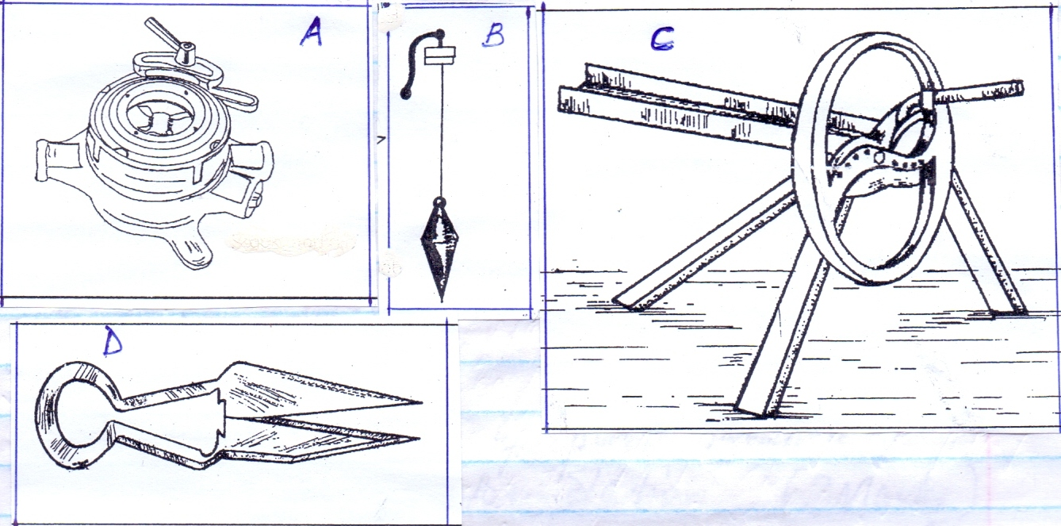
[a]Identify the tools labeled A and B
A……………………………………………………………………………… [1mark]
B………………………………………………………………………………. [1mark]
[b]State one use of each of the tools labeled C and D
C……………………………………………………………………………………………………………. [1mk.]
D……………………………………………………………………………………………………………. [1MK.]
[c] Explain one maintenance practice carried out on tool D . [1mk.]
……………………………………………………………………………………………………………….................

21.The diagram below represents a foundation of a farm structure .Study it and answer questions that follow .
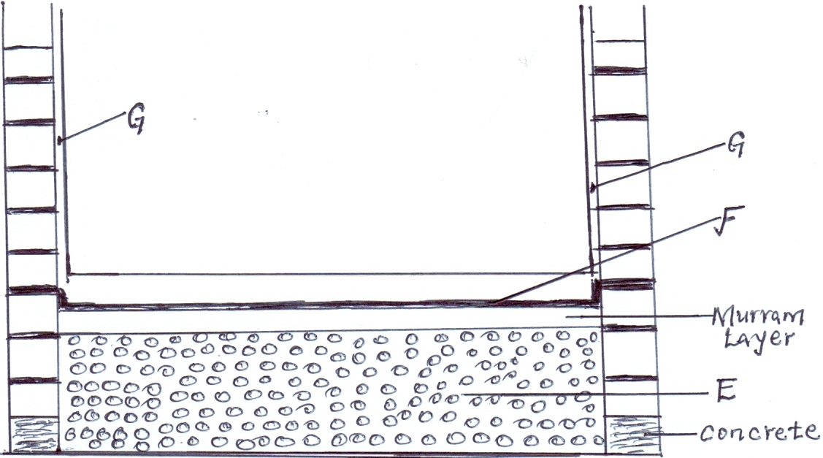
[a] Identify the parts labeled E and F .
E………………………………………………………………………………… [1mk.]
F………………………………………………………………………………… [1mk.]
[b]State two uses of part labeled F in a foundation structure . [2mks.]
………………………………………………………………………………………………………………………………………………………………………………………………………………………………………………………………………………………………………………………………………………………………………………………………
[c]What ingredients are used to complete part G . [1mk.]
………………………………………………………………………………………………………………………………

22.The diagram below illustrates an internal parasite of livestock .
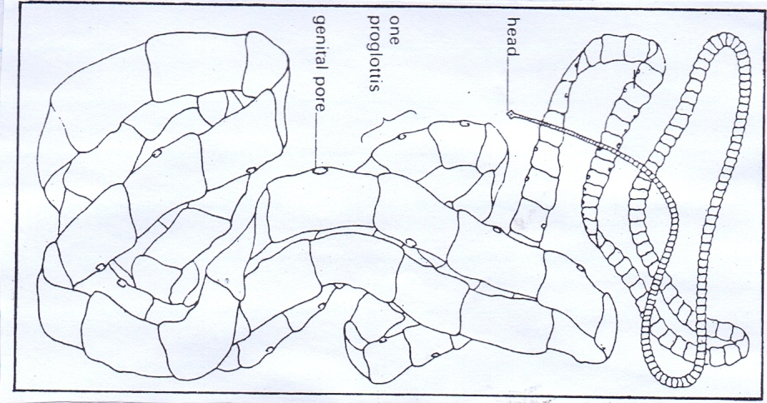
[a] Identify the parasite above . [1mk.]
………………………………………………………………………………………………
[b]Name two common species of the parasite illustrated above . [2mks.]
…………………………………………………………………………………………………………….
…………………………………………………………………………………………………………….
[c] Give two control measures of the above parasite . [2mks.]
………………………………………………………………………………………………………………………………………………………………………………………………………………………………………………………………………………………………………………………………………………………………………………………………
23.Study the diagram below and answer questions that follow .
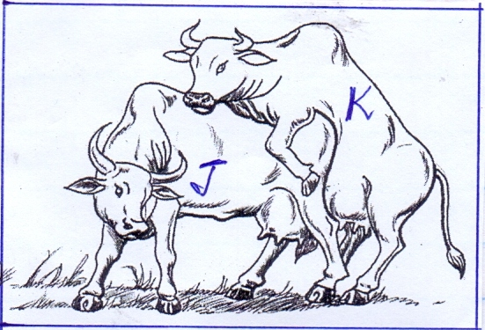
[a] Which of the above cows shows the signs of heat ? [1mk.]
……………………………………………………………………………………………………………………………….
[b]Give one reason to confirm your answer in [a] above .
……………………………………………………………………………………………………………………………….
[c] State two benefits of natural mating system . [2mks.]
……………………………………………………………………………………………………………………………………………………………………………………………………………………………………………………………………………………………………………………………………………………………………………………………….
[d] Name a disease that is easily spread by this method of mating . [1mk.]
………………………………………………………………………………………………………………………………
SECTION C [40MARKS]
Answer any two questions from this section in the spaces provided .
24. [a] Describe six signs of farrowing in a sow . [6mks.]
……………………………………………………………………………………………………………………………………………………………………………………………………………………………………………………………………………………………………………………………………………………………………………………………………………………………………………………………………………………………………………………………………………………………………………………………………………………………………………………………………………………………………………………………………………………………………………………………….
[b]Explain six benefits of the Kenya top bar hive . [6mks.]
………………………………………………………………………………………………………………………………………………………………………………………………………………………………………………………………………………………………………………………………………………………………………………………………………………………………………………………………………………………………………………………………………………………………………………………………………………………………………………………………....................................................................................................................................
[c]Explain eight factors considered when siting farm structures .[8mks.]
………………………………………………………………………………………………………………………………………………………………………………………………………………………………………………………………………………………………………………………………………………………………………………………………………………………………………………………………………………………………………………………………………………………………………………………………………………………………………………………………………………………………………………………………………………………………………………………………………………………………………………………………………………………………………………………………………………………………………………………………………………………………………………………………………………………………………………………………………………………………………………………………………………………………………………………………………………………………………………………………………………………………………………………………………………………………………………………………
25. [a] Describe rinderpest disease under the following sub headings .
Animals affected . [2marks]
………………………………………………………………………………………………………………………………………………………………………………………………………………………………………………………………
Causal organism . [1 mark ] ………………………………………………………………………….
Symptoms of attack . [ 5 marks]
……………………………………………………………………………………………………………………………………………………………………………………………………………………………………………………………………………………………………………………………………………………………………………………………………………………………………………………………………………………………………………………………………………………………………………………………………………………………………………………………………………………………………………………………………………………………………………………………………………………………………………………………………………………………………………………………………………………………………………………………………………………………………………………………….

Control measures . [2 marks ]
………………………………………………………………………………………………………………………………………………………………………………………………………………………………………………………………………………………………………………………………………………………………………………………………
[b] Describe the digestion of food in poultry from the beak to the duodenum .[5marks]
………………………………………………………………………………………………………………………………………………………………………………………………………………………………………………………………………………………………………………………………………………………………………………………………………………………………………………………………………………………………………………………………………………………………………………………………………………………………………………………………………………………………………………………………………………………………………………………………………………………………………………………………………………………………………………………………
[c] Explain five uses of solar energy in a farm . [5marks]
………………………………………………………………………………………………………………………………………………………………………………………………………………………………………………………………………………………………………………………………………………………………………………………………………………………………………………………………………………………………………………………………………………………………………………………………………………………………………………………………………………………………………………………………………………………………………………………………
26. [a]Describe the working of a two stroke cycle engine . [10mks.]
…………………………………………………………………………………………………………………………………………………………………………………………………………………………………………………………………………………………………………………………………………………………………………………………………………………………………………………………………………………………………………………………………………………………………………………………………………………………………………………………………………………………………………………………………………………………………………………………………………………………………………………………………………………………………………………………………………………………………………………………………………………………………………………………………………………………………………………………………………………………………………………………………………………………………………………………………………………………………………………………………………………………………………………………………………………………………………………………………………………………………………………………………………………………………………………………………………………………………………………………………………………………………………………………………………………………………………………………………………………………………………………………….…
[b]Explain five factors considered when siting a fish pond.[5mks.]
………………………………………………………………………………………………………………………………………………………………………………………………………………………………………………………………………………………………………………………………………………………………………………………………………………………………………………………………………………………………………………………………………………………………………………………………………………………………………………………………………………………………………………………………………………………………………………………………………………………………………………………………………………………………………………………………………………………………………………………………………………………………………………………………
[c]Explain five reasons for swarming of bees. [5mks.]
……………………………………………………………………………………………………………………………………………………………………………………………………………………………………………………………………………………………………………………………………………………………………………………………………………………………………………………………………………………………………………………………………………………………………………………………………………………………………………………………………………………………………………………………………………………………………………………………………………………………………………………………………………………………………………………………..

