MAASAI MARA UNIVERSITY

REGULAR UNIVERSITY EXAMINATIONS 2016/2017 ACADEMIC YEAR
FOURTH YEAR FIRST SEMESTER

SCHOOL OF TOURISM AND NATURAL RESOURCE MANAGEMENT
BACHELOR OF SCIENCE IN WILDLIFE MANAGEMENT

COURSE CODE: FOR 435E
COURSE TITLE: FOREST TRANSPORTATION SYSTEMS

DATE: 23RD JANUARY, 2017 TIME: 2.30PM-4.30PM
INSTRUCTIONS TO CANDIDATES
Answer ALL questions in section A and any other THREE in section B.

Section A: Answer ALL QUESTIONS in this section.
1. Explain why rail transportation of logs is not commonly used in Kenya (2 marks)
2. Differentiate between an arterial road and a secondary road (2 marks)
3. State the factors that influence the choice of logging trucks used in forest transportation (2 marks)

4. Define the following terms as used in landing operations (2 marks)
- Hot decks
- Fleeting
- Bucking
- Sorting

5. Sub-grade soil is sometimes weak that it is unable to support a road designed for off-highway trucks. Give reasons why soil modification may be required for such a soil (4 marks)

6. (a) Describe the characteristics of an aggregate material that would make a good layer of a forest road (2 marks)
(b) Calculate the number of truckloads of aggregate material needed for the following road section. It is 19 Km long, 6.5 metres wide and the depth of aggregate to be added is 250mm. the gravel weight is 1750 K/m³. A truck will hold 24 tonnes of gravel. (3 marks)

7. Identify two environmental effects arising from forest road construction and briefly discuss the impacts of these effects on the environment (4 marks)
8. (a) What does ESA stand for? (1 mark)
(b) Calculate the total ESA for the truck with configuration shown below (use the information provided in the chart and table) (2 marks)

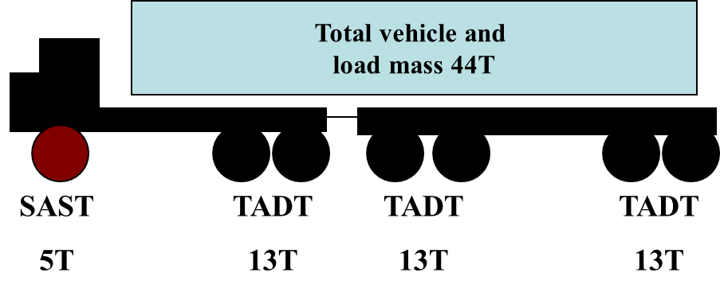
Axle Type | Standard Load kN (T)
SAST | 53 (5.4)
SADT | 80 (8.2)
TAST | 90 (9.2)
TADT | 135 (13.7)
TRDT | 181 (18.5)
QADT | 221 (22.5)

(c) What would be the effect of increasing the payload of the above truck by 50%? (1 mark)

Section B: Answer ANY THREE QUESTIONS from this section. ALL questions carry equal marks.
9. (a) State five site features that may be used to determine a road standard (5 marks)
(b) State the benefits of a properly constructed forest road to a forest harvesting contractor (10 marks)
10. State the typical construction stages and equipment used for forest roads (15 marks)
11. (a) State the factors that determine the size of a landing (8 marks)
(b) Discuss problems associated with poorly designed landing (7 marks)
12. (a) Forest products material handling must be technically feasible, financially viable, acceptably safe, and environmentally sound. Explain. (12 marks)
(b) State thee advantages associated with sound planning of forest transportation systems. (3 marks)
END OF PAPER

