**NAME……………………………………………………ADM NO….............CLASS………….**

**SIGNATURE…………………………………………………DATE………………………….**

**FORM 4 2015 APRIL**

**BIOLOGY**

**PAPER 2**

**(THEORY)**

**TIME: 2 HOURS**

**INSTRUCTIONS TO CANDIDATES:-**

* Write your **name** and **adm** **number** in the spaces provided above.
* This paper consists of **two** sections; **A** and **B**.
* Answer **all** the questions in Section **A** in the spaces provided.
* In section **B**, answer question **6** (**compulsory**) and either question **7** or **8** in the spaces provided after question 8.

**For Examiner’s Use Only:**

|  |  |  |  |
| --- | --- | --- | --- |
| **Section** | **Question** | **Maximum score** | **Candidates score** |
| A | 1  2  3  4  5 | 8  8  8  8  8 |  |
| B | 6  7 or  8 | 20  20  20 |  |
| **TOTAL SCORE** | | **80** |  |

***This paper consists of 10 printed pages. Candidates should check to ascertain that all the pages are printed as* *indicated and that no* *questions are missing.***

**SECTION A (40 Marks)**

***Answer all questions in this section in the spaces provided.***

1. In human beings, a **downward pointed frontal hairline** (“windows peak”) is a heritable trait. A person with windows peak always has at least one parent who has this trait; where as persons with **frontal hairline** may occur in families in which one or even both parents have windows peak. Using **W** and **w** to symbolize genes for this trait

(a) Determine the F1 generation if a homozygous windows peak male parent is married to a homozygous frontal hairlined female parent (4mks

(b) State two causes of variations (1mk)

……………………………………………………………………………………………………………………………………………………………………………………………………………………………………

c) Name two sex linked genetic disorders affecting human females and males (2mks)

……………………………………………………………………………………………………………………………………………………………………………………………………………………………………

(d) What is genome

……………………………………………………………………………………………………….…………………………………………………………………………………………………

2. The diagram below shows an organism obtained from an aquatic ecosystem

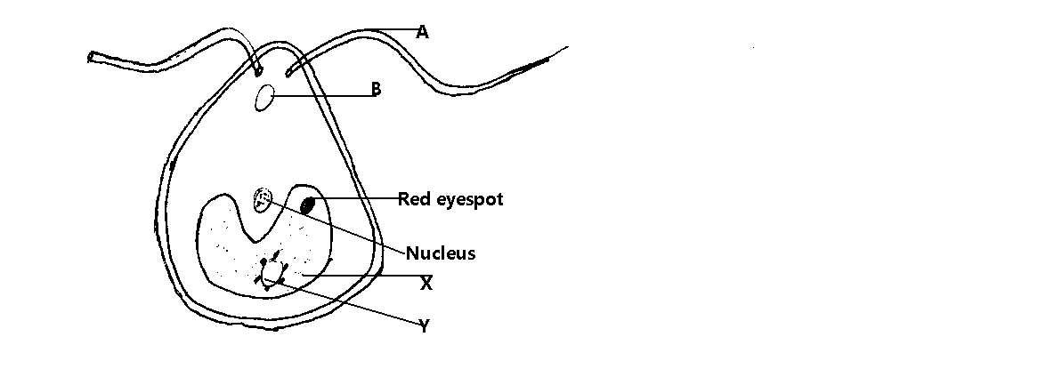

(a) **State** the kingdom in which the organism belongs. (1mk)

………………………………………………………………………………………………

(b) **Name** the parts labeled (1mk)

**B**

………………………………………………………………………………………………

**Y**  (1mk)

………………………………………………………………………………………………

(c) **State** the functions of the following parts

**A**  (1mk)

………………………………………………………………………………………………………………………………………………………………………………………………

**X**  (1mk)

……………………………………………………………………………………………………………………………………………………………………………………………

Z (1mk)

……………………………………………………………………………………………

(d)Explain briefly why the organism is described as eukaryotic (2mk)

………………………………………………………………………………………………………………………………………………………………………………………………………………

3a) The diagram below shows some of the features of a synovial joint. Study the diagram carefully and answer the questions that follow.

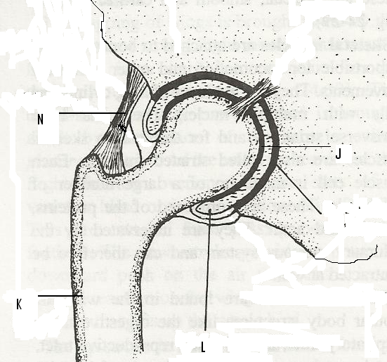

1. Name the type of synovial joint. (1 mark)

………………………………………………………………………………………………

1. Name the parts labeled J, and L (2 marks)

J ………………………………………………………………………………………...

L ………………………………………………………………………………………..

1. State **two** roles of the part labeled L. (2 marks)

………………………………………………………………………………………………………………………………………………………………………………………………………………………………………………………………………………………………

1. Suggest **one** advantage of this type of joint. (1 mark)

……………………………………………………………………………………………………………………………………………………………………………………………………

b) State how the following tissues are adapted to provide mechanical support in plants (2mks)

i) Parenchyma

……………………………………………………………………………………………

ii) Collenchyma

……………………………………………………………………………………………………

4. A student set up an experiment using soaked and dry seeds as shown below

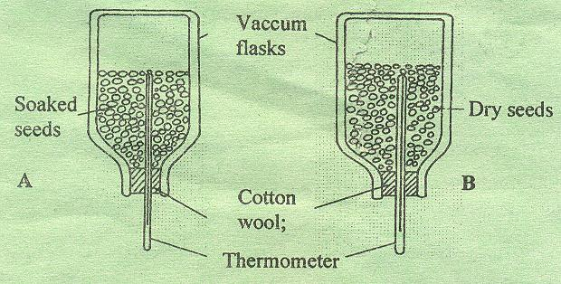

1. State the objective of this experiment (1mk)

........................................................................................................................................................................................................................................................................................................................

1. State the observations made in each of the flask after 24 hours (2mks)

………………………………………………………………………………………………………………………………………………………………………………………………………………………………………………………………………………………………………………………

1. Account for the observation made in (b) above (2mks)

………………………………………………………………………………………………………………………………………………………………………………………………………………………………………………………………………………………………………………………………………………………………………………………………………………………………………………………………………………………………………………………………………

1. Suggest why vacuum flasks were used in this experiment (1mk)

………………………………………………………………………………………………………………………………………………………………………………………………………………

1. What alteration would you make in the set-up to make the results more reliable (1mk)

………………………………………………………………………………………………………………………………………………………………………………………………………………

1. Why should the seeds be washed with antiseptic/10% formalin? (1mk)

……………………………………………………………………………………………………

5 a) Explain how the following meristematic tissues contribute to growth of higher plants

i) Vascular cambium (2mks)

………………………………………………………………………………………………………………………………………………………………………………………………………………………………………………………………………………………………………………………

ii) Cork Cambium (2mks)

………………………………………………………………………………………………………………………………………………………………………………………………………………………………………………………………………………………………………………………

b) The diagram below shows a life cycle of a cockroach

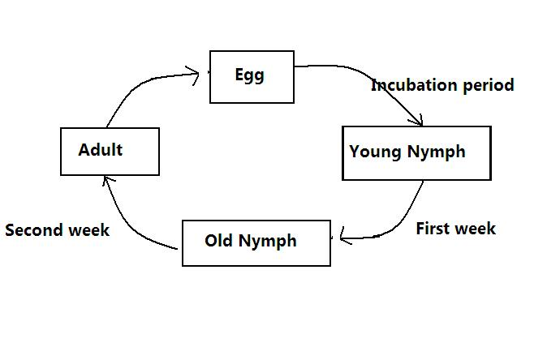

a) Name the hormone that would be at high concentration during.

1. First week (1mk)

………………………………………………………………………………………………

(ii) Second week (1mk)

………………………………………………………………………………………………

b) Name the structure that produces hormone in a (ii) above (1mk)

……………………………………………………………………………………………………

c) Name the series of stages through which the nymph undergoes to reach adult stage (1mks)

……………………………………………………………………………………………………………………………………………………………………………………………………………...

**SECTION B (40 Marks)**

***Answer question 6 (Compulsory) and either question 7 or 8 in the spaces provided.***

6. The menstrual cycle is a sequence of events repeated monthly in the female production system. The table below shows the concentration of oestrogen and progesterone hormones and body temperatures of female against time.

|  |  |  |  |
| --- | --- | --- | --- |
| Time in days | Oestrogen mg/100cm of blood | Progesterone mg/100cm3 of blood | Temperature in 0oc |
| 1 | 20 | 0 | 36.4 |
| 2 | 20.5 | 0 | 36.6 |
| 3 | 25 | 0 | 36.7 |
| 4 | 27.5 | 0 | 36.8 |
| 5 | 30 | 0 | 36.7 |
| 6 | 32.5 | 0 | 36.6 |
| 7 | 35 | 0 | 36.8 |
| 8 | 40 | 0 | 36.7 |
| 9 | 48 | 0 | 36.6 |
| 10 | 56 | 0 | 36.8 |
| 11 | 64 | 0 | 36.7 |
| 12 | 72 | 0 | 36.6 |
| 13 | 80 | 0 | 36.4 |
| 14 | 170 | 20 | 36.3 |
| 15 | 140 | 50 | 36.6 |
| 16 | 80 | 80 | 37.0 |
| 17 | 70 | 130 | 37.2 |
| 18 | 65 | 170 | 37.0 |
| 19 | 60 | 160 | 37.1 |
| 20 | 65 | 150 | 37.15 |
| 21 | 130 | 130 | 37.2 |
| 22 | 140 | 110 | 37.1 |
| 23 | 130 | 90 | 37.0 |
| 24 | 100 | 70 | 37.1 |
| 25 | 80 | 50 | 37.2 |
| 26 | 60 | 20 | 37.0 |
| 27 | 20 | 0 | 36.4 |

a). Using the same axis draw graphs of oestrogen and progesterone against time/days (8mks)



b) State the possible event taking place in the uterus during the first week? (1 mark)

……………………………………………………………………………………………………………………………………………………………………………………………………

c) State the events taking place in the ovary between day 1 and day 13. (2 marks)

………………………………………………………………………………………………………………………………………………………………………………………………………………………………………………………………………………………………………

d) Account for the sudden increase in the progesterone concentration between day 14 and day18.

(2 marks)

……………………………………………………………………………………………………………………………………………………………………………………………………………………………………………………………………………………………………………………

e) Account for the change in temperature between day 14 and 17. (1 mark)

………………………………………………………………………………………………………………………………………………………………………………………………………………

f) Account for the change of the curve of progesterone between day 19 and 27. (2marks)

……………………………………………………………………………………………………………………………………………………………………………………………………………………………………………………………………………………………………………………

1. State the function of the following.
   1. Ovary (1mark)

………………………………………………………………………………………………………………………………………………………………………………………………………………

* 1. Progesterone (1 mark)

………………………………………………………………………………………………………………………………………………………………………………………………………………

* 1. Oestrogen (1 mark)

………………………………………………………………………………………………………………………………………………………………………………………………………………

7 a) Describe how the following evidences support the theory of organic evolution: geographical distribution, fossil records and comparative anatomy (10mks)

b) Explain tropic responses in plants and their survival values (10mks)

8 a) Describe the structural adaptations of mammalian heart to its Functions (10mks)

b) Explain the role of osmosis in organisms (10mks)

………………………………………………………………………………………………………………………………………………………………………………………………………………………………………………………………………………………………………………………………………………………………………………………………………………………………………………………………………………………………………………………………………………………………………………………………………………………………………………………………………………………………………………………………………………………………………………………………………………………………………………………………………………………………………………………………………………………………………………………………………………………………………………………………………………………………………………………………………………………………………………………………………………………………………………………………………………………………………………………………………………………………………………………………………………………………………………………………………………………………………………………………………………………………………………………………………………………………………………………………………………………………………………………………………………………………………………………………………………………………………………………………………………………………………………………………………………………………………………………………………………………………………………………………………………………………………………………………………………………………………………………………………………………………………………………………………