Name: ……………………………………………………… ADM No: ….….……..………..……
Class………….………………
Date: ……………….…………………………..
CHEMISTRY
FORM ONE
CAT I TERM TWO, MAY 2019
Time: 2 Hours

RANJIRA MIXED SECONDARY SCHOOL
CAT I TERM TWO EXAMS FORM ONE 2019
Kenya Certificate of Secondary Education (K.C.S.E)
(60 marks)

INSTRUCTIONS TO CANDIDATES:

- Write your name and Admission number in the spaces provided above.
- Write the class and date of examination in the spaces provided above
- Answer all the questions in the spaces provided.
- Students must answer all the questions in English
- This paper consists of 7 printed pages. Student should check to ascertain that all pages are printed as indicated and that no questions are missing.

For Examiner’s Use only:

QUESTION | MAXIMUM SCORE | CANDIDATE’S SCORE
1 – 23 | 60

- Name any one types of mixtures (1mk)
………………………………………………………………………………………………………………………………………………………………………………………………
- Give the method of separation of the following mixtures: (2mks)

- Water and ethanol
………………………………………………………………………………………

- Sodium Chloride and Ammonium Chloride
……………………………………………………………………...

- Give any one branches and one roles of chemistry in the society. (2mks)
Branches:
………………………………………………………………………………………………

Role:
……………………………………........................................................................................................................................................................................................................................

- Give any one reasons why most laboratory apparatus are made of glass (1mks)

……………………………………………………………………………………………………………………………………........................................................................................ ………………………………………………………………………………………………
- (a) Give two characteristics of temporary chemical change. (2mks)
..................................................................................................................................................................................................................................................................................................................................................................................................................................................................................................................................................................................................................................................
(b) Give any one example of temporary physical changes (1mk)

………………………………………………………………………………………………………………………………………………………………………………………………………………

- Give the functions of the following apparatus: (2mks)

- Reagent bottle.........................................................................................
- Tongs...........................................................................................................

Draw a deflagrating spoon. (1mk)

- Wooden splints F and G were placed in different zones of a Bunsen burner flame.
The diagram below gives the observations that were made
G
F
Burnt parts
Burnt part

- Explain the difference between F and G (1mk)
……………………………………………………………………………………………………………………………………………………………………………………………………………………………………………………………………………………………………………………………………………………………………………………………………………………………………………..
- Name the type of flame that was used in the above experiment (1mk)

………………………………………………………………………………………………………………………………………………
- What do the experiments show about the outer region of the flame? (1mk)
…………………………………………………………………………………………………………………………………………………………………………………....

- (a) When the air-hole is fully opened, the Bunsen burner produces a non-luminous flame.
Explain. (1mk)
……………………………………………………………………………………………………………………………………………………………………………………………………………………………………………………………………………………………………………………………………
(b)Draw a labelled diagram of a non-luminous flame (2mks)

9. (a) State two differences between luminous flame and non-luminous flame (2mk)

Luminous | Non-Luminous

(b) It is advisable to set a Bunsen burner to luminous flame prior to an experiment.
Explain (1mk)
………………………………………………………………………………………………………………………………………………………………………………………………………………

12. A mixture of oil and water was shaken and left to separate as shown in the diagram below:
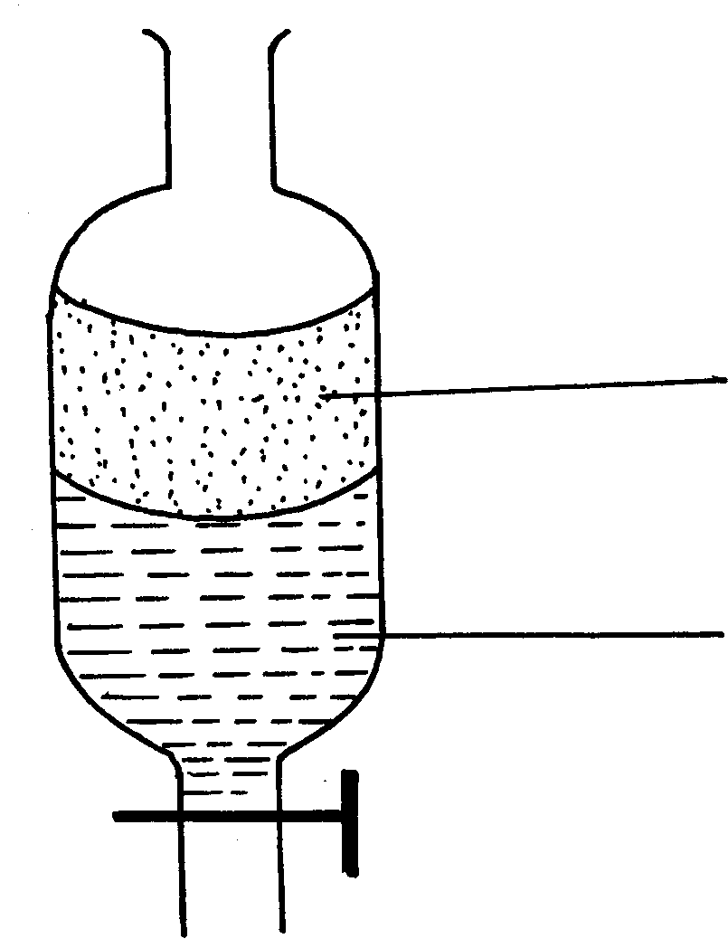
oil
W

Name the method of separation……………………………………………………………………… (1mk)
13. Give a reason why a luminous flame is not used for heating purposes (1mk)
………………………………………………………………………………………………………………………………………………………………………………………………………………

14. Name the process which takes place when Carbon (IV) oxide gas changes directly into solid carbon (iv) Oxide (Dry ice). (1mk)

………………………………………………………………………………………………………………………………………………………………… 15. State the observations made when iodine crystals is heated in a boiling tube? (1mk)

………………………………………………………………………………………………………………………………………………………………………………………………………………
- The diagram below shows the relationship between the physical states of matter.Study it and answer the questions that follows.
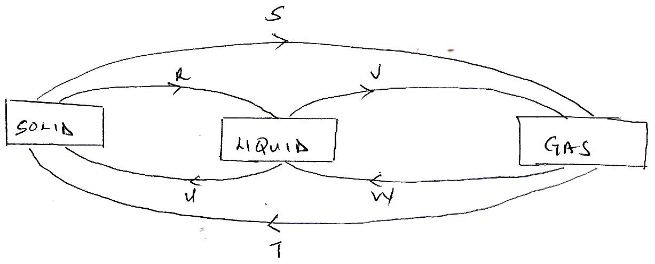

- Identify the process R and W ( 2 mks)

R……………………………………………………………………………………………………………………………………………………
W…………………………………………………………………………………………………………………………………………………
- Name two substances which can undergo the process represented by process S and T. ( 2mks)

……………………………………………………………………………………………………………………………………………………………………………………………………………………………………………………………………………………………………….

16. Name any one apparatus that are used to measure accurate volume of liquids. ( 1mks)

………………………………………………………………………………………………………

17.The diagram below shows the heating curve of a pure substance. Study it and answer the questions that follow:

- What is the physical state of the substance at points Y (1mk)

……………………………………………………………………………………………
(b) What is the Boiling point of the substance? (1mk)

………………………………………………………………………………………………………
(c) State and explain what happens in the following regions: (4mks)

BC………………………………………………………………………………………………………………………………………………………………………………………………………

CD………………………………………………………………………………………………………………………………………………………………………………………………………..

18. a) What is chromatography? (1mk)
………………………………………………………………………………………………………………………………………………………………………………………………………………
b) Give two applications of chromatography (2mks)
…………………………………………………………………………………………………………………………………………………………………………………………………………………………………………………………………………………………………………………….. c) The chromatography below shows the constituents of a flower extract using an organic solvent:-

(i) Name a possible solvent you can use for this experiment. (1mk)

...............................................................................................................................................
(ii) State one property that makes the red pigment to move the furthest distance from M
(1mk)
………………………………………………………………………………………………………
(iii) On the diagram indicate solvent front (1mk)

19. Define the following terms giving an example in each case. ( 2mks)
- Element…………………………………………………………………………………………………………………………………………………………………………………………………………………………………………………………………………………………………………………………………………………………………………………………………………………………………………
- Compound……………………………………………………………………………………………………………………………………………………………………………………………………………………………………………………………………………….........................................................................................................................................................
20. Describe how you would separate a mixture of salt, sand and iodine into different components
( 3mks)
……………………………………………………………………………………………………………………………………………………………………………………………………………………………………………………………………………………………………………………………………………………………………………………………………………………………………………………………………………………………………………………………………………………………………………………………………………………………………………………………………………………………………………………………………………………………………………………………………………………………………………
- State the two causes of accidents in a Chemistry laboratory. ( 1mks)
…………………………………………………………………………………………………………………………………………………………………………………………………………………………………………………………………………………………………………….

- Classify the following processes as either temporary or Permanent process type of change
( 2mks)
- Heating hydrated copper(ii) sulphate crystals…………………………………………………………………………
- Obtaining Kerosene from crude oil…………………………………………………………………………………………
- Souring of milk…………………………………………………………………………………………………………………………
- Melting a candle wax……………………………………………………………………………………………………………….

- a) Fill in the table bellow ( 3mks)
Element | Latin Name | Symbol
Sodium
 | Plumbum
 |  | Hg

- Name the elements presents in the following compounds ( 2mks)
- Calcium Hydrogen sulphate

- Lead Nitrate

- Write a chemical word equation for Lead and bromine as reactants (1mk)

E.N.D
‘’ let’s us walk chemistry, talk chem and practice chem’’ regards….sir\Alex

