Name: ……………………………………………………… ADM No: ….….……..………..
Student’s sign………….………………
Date: ……………….…………………………..
CHEMISTRY
FORM TWO
CAT I TERM TWO, MAY 2019
Time: 2 Hours

RANJIRA MIXED SECONDARY SCHOOL
CAT I TERM TWO EXAMS FORM TWO 2019
Kenya Certificate of Secondary Education (K.C.S.E)
(50 marks)

INSTRUCTIONS TO CANDIDATES:

- Write your name and Admission number in the spaces provided above.
- Write the class and date of examination in the spaces provided above
- Answer all the questions in the spaces provided.
- Students must answer all the questions in English
- This paper consists of 7 printed pages. Student should check to ascertain that all pages are printed as indicated and that no questions are missing.

For Examiner’s Use only:

QUESTION | MAXIMUM SCORE | CANDIDATE’S SCORE
1 – 23 | 50

- The grid below represents part of the periodic table. Study it and answer the questions that follow:

S
C
Q
D
Z
R

E

G
M
U
X

T

V

(a) What name is given to the family of elements to which elements X and T belong?
(1mk)
……………………………………………………………………………………………… (b) Which of the metal among S,C and Q is most reactive? Explain (2mks)

………………………………………………………………………………………………………………………………………………………………………………………………….
(c) Explain why atomic radius of Q is greater than that of S (1mk)

………………………………………………………………………………………………………………………………………………………………………………………………………………
(d) Compare the atomic radii of D and Z. (1mk)

……………………………………………………………………………………………………
(f) Which of the element in the table does not have the ability to form compounds with other elements? Explain (1mk)

…………………………………………………………………………………………….
(g) Give the formula of the compound formed between Z and E (1mk)
……………………………………………………………………………………………………… (h) Write the electron arrangement of element Q (1mk)
………………………………………………………………………………………………………
(i) Element W has atomic number 15. Indicate its position on the grid. (1mk)

(k) Write down equations to show the combustion of C in Oxygen the elements. ( 1mk)

……………………………………………………………………………………………………………………………………………………………………………………………………………… (l) State whether the oxides of G is basic or acidic (1mk)

………………………………………………………………………………………………………

(m) Using crosses (x) to represent electrons, draw the atomic structure of element E
(1mk)

(n) State the period and the group to which element M belong (1mk)

Period…………………………………………………………………
Group…………………………………………………………..

- Write balanced chemical equations for the reactions below: (5mks)
- Zinc and dilute hydrochloric acid
………………………………………………………………………………………......
- Magnesium and nitrogen
…………………………………………………………………………………………
- Sodium hydroxide and dilute sulphuric acid.
………………………………………………………………………………………......
- Dilute hydrochloric acid and calcium carbonate
………………………………………………………………………………………………......
- Carbon and oxygen(limited supply of oxygen)
………………………………………………………………………………………………......

- i. Define the term valency. (1mk)

………………………………………………………………………………………………………………………………………………………………………………………………………………
ii. Using valency swopping, write the formula of; (4mks)

- Silver Sulphate…………………………………………………………………………………

- Magnesium Hydrogen Carbonate……………………………………………………………….

- Aluminium.Nitrate………………………………………………………………………….......

- Copper(I)oxide…………………………………………………………………………

- Balance the following equations: (2mks)
- NaHCO_{3(S)} Na₂CO_{3(S)} + H₂O_{(l)} + CO_{2(g)}

- C₆H_{6(l)} + O_{2(g)} CO_{2(g)} + H₂O_{(l)}

- (a) What are isotopes? (1mk)

……………………………………………………………………………………………………………………………………………………………………………………………………………….

(b) Element X has two isotopes with mass numbers 6 and 7. If the relative atomic mass of X is 6.94, determine the percentage abundance of each isotope. (2mks)
……………………………………………………………………………………………………………………………………………………………………………………………………………………………………………………………………………………………………………………………………………………………………………………………………………………………………………………………………………………………………………………………………………………………………………………………………………………………………………………………………………………………………………………………………………………………………………………………………………………………………………………………….
(c ) An element Z has two isotopes with relative abundance of 65% and 35%. If the mass number of the two isotopes is A and 31 respectively, find the mass number represented by A, given the relative atomic mass of the element is 30. (2mks)
……………………………………………………………………………………………………………………………………………………………………………………………………………………………………………………………………………………………………………………………………………………………………………………………………………………………………………………………………………………………………………………………………………………………………………………………………………………………………………………………………………………………………………………………………………………………………………………………………………………………………………………………….
(d) The table below shows the relative atomic masses and the percentage abundance of isotope M₁ and M₂ of element M.

 | Relative atomic mass | % abundance
M₁ | 62.93 | 69.09
M₂ | 64.93 | 30.91

Calculate the relative atomic mass of element M (2mks)
………………………………………………………………………………………………………………………………………………………………………………………………………………………………………………………………………………………………

- A student set up the experiment below to collect gas K. The glass wool was heated before heating the Zinc powder.
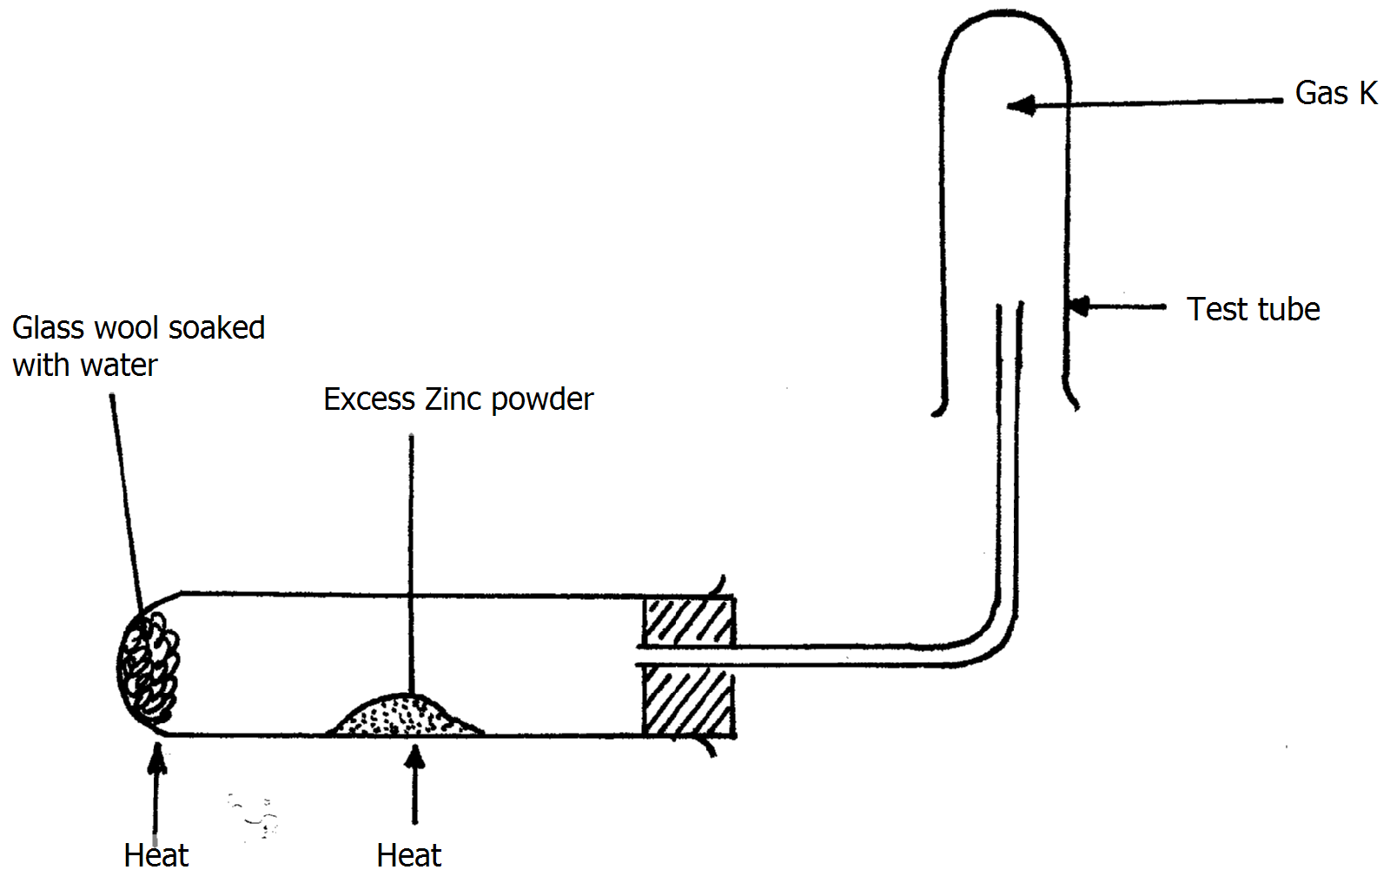
- Why was it necessary to heat the moist glass wool before heating Zinc powder?(1mk)
……………………………………………………………………………………………………………………………………………………………………………………
- What would happen if the Zinc powder was heated before heating the glass wool?
(1mk)
……………………………………………………………………………………………………………………………………………………………………………………
- What property of gas K makes it possible for it to be collected as shown in the diagram (1mk)
…………………………………………………………………………………………………………………………………………………………………………………………………………….

7. An oxide of element G has the formula as G₂O₃
(a) State the valency of element G (1mk)

………………………………………………………………………………………………….......
(b) In which group of the periodic table is element G? (1mk)

………………………………………………………………………………………………………

8. The table below gives information about the ions T⁺ and Z²⁻
Ion | T⁺ | Z²⁻
Electron arrangement | 2.8 | 2.8.8
Number of neutrons | 12 | 16
(a) How many protons are there in the nucleus of : (2mks)
(i) Element T? ……………………………………………………………………………
(ii) Element Z?....................................................................................................................
(b) Determine the relative formula mass of the compound formed between T and Z (1mk)

……………………………………………………………………………………………………

9. Use the information in the table below to answer the questions that follow.
(The letters do not represent the actual symbols of the elements).
Element | Q | P | R | S | T
Atomic number | 18 | 5 | 3 | 5 | 20
Mass number | 40 | 10 | 7 | 11 | 40
(a) Which two letters represent the same element? Give a reason (2mks)
……………………………………………………………………………………………………………………………………………………………………………………………………
(b) Give the number of neutrons in an atom of element R (1mk)

…………………………………………………………………………………………....
10. The table below gives information on four elements by letters K, L, M and N. Study it and answer the questions that follow. The letters do not represent the actual symbol of the elements.
Element | Electron arrangement | Atomic radius (nm) | Ionic radius (nm)
K  L  M  N | 2.8.2  2.8.7  2.8.8.1  2.8.8.2 | 0.136  0.099  0.203  0.174 | 0.065  0.181  0.133  0.099
(a) Which two elements have similar properties? Explain (2mks)

……………………………………………………………………………………………………………………………………………………………………………………………………………..
(b) What is the most likely formula of the oxide of N? (1mk)
………………………………………………………………………………………………

(c) Which element is non-metal? Explain (2mks)

………………………………………………………………………………………………………………………………………………………………………………………………

11. (a) Define ionization Energy (1mk)

………………………………………………………………………………………………………………………………………………………………………………………………………………………………………………………………………………………………………………………………………………………………………………………………

(b) Ionisation decrease down group one elements. Explain (1mk)

………………………………………………………………………………………………………………………………………………………………………………………………………………………………………………………………………………………………

E.N.D

’ let’s us walk chemistry, talk chem and practice chem’’ regards….sir\Alex

