Name: ……………………………………………………… ADM No: ….….……..………..……
Student’s Signature………….………………
Date: ……………….…………………………..
CHEMISTRY
FORM THREE
CAT I TERM TWO, MAY 2019
Time: 2 Hours

RANJIRA MIXED SECONDARY SCHOOL
CAT I TERM TWO EXAMS FORM THREE 2019
Kenya Certificate of Secondary Education (K.C.S.E)
(60 marks)

INSTRUCTIONS TO CANDIDATES:

- Write your name and Admission number in the spaces provided above.
- Sign and write the date of examination in the spaces provided above
- Answer all the questions in the spaces provided.
- KNEC Mathematical tables and silent electronic calculators may be used for calculations.
- All workings must be clearly shown where necessary
- Candidates must answer all the questions in English
- This paper consists of 8 printed pages. Student should check to ascertain that all pages are printed as indicated and that no questions are missing.

For Examiner’s Use only:

QUESTION | MAXIMUM SCORE | CANDIDATE’S SCORE
1 – 29 | 60

1. The grid below represents part of the periodic table. Study it and answer the questions that follow:

S
C
Q
D
Z
R

E

G
M
U
X

T

V

(a) Identify the element that gains electrons most readily (1mk)

……………………………………………………………………………………………
(b) Which of the metal is most reactive? (1mks)
…………………………………………………………………………………………………
(c) What name is given to the family of elements to which elements X and T belong?
……………………………………………………………………………………………(1mk)
(d) Explain why atomic radius of Q is greater than that of S (1mk)

…………………………………………………………………………………………………....................................................................................................................................................................
(e) Compare the atomic radii of C and G. Explain (2mk)

………………………………………………………………………………………………………………………………………………………………………………………………………………………………………………………………………………………………………………………
(f) Which of the element in the table does not have the ability to form an ionic or covalent bond? Explain (1mk)

………………………………………………………………………………………………………………………………………………………………………………………………………

(g) Give the formula of the compound formed between R and Z (1mk)
………………………………………………………………………………………………………
(h) Which element has the same electron arrangement as the stable ion of Q (1mk)

………………………………………………………………………………………………………
(i) Element W has atomic number 15. Indicate its position on the grid. (1mk)

(j) Write the type of bond present in a compound formed between D and X. Explain.
(2mks)
………………………………………………………………………………………………………
(k) Write down equations to show the combustion of C in Oxygen the elements. (1mk)
…………………………………………………………………………………………………………………………………………………………………………………………………………….. (l) State whether the oxides of G is basic or acidic (1mk)
………………………………………………………………………………………………............

(m) Using crosses (x) to represent electrons, draw the atomic structure of element E (1mk)

(n) State the period and the group to which element M belong (1mk)

Period…………………………………………………………………
Group…………………………………………………………..

(o) Using dots (•) and cross (x) to represent electrons, draw a diagram to illustrate bonding in the sulphide of D (2mks)

(p) State one use of element U (1mk)

……………………………………………………………………………………………………………………………………………………………………………………………………………
2. 60cm³ of oxygen gas diffused through a porous hole in 50 seconds. How long will it take 80cm³ of sulphur(iv) oxide to diffuse through the same hole under the same conditions. (3mks)
(S= 32.0. O=16.0)
………………………………………………………………………………………………………………………………………………………………………………………………………………………………………………………………………………………………………………………………………………………………………………………………………………………………………………………………………………………………………………………………............

4. 2.12 grams of anhydrous sodium carbonate are dissolved in 200.0cm³ water.
Calculate the concentration of sodium carbonate in mole/litre. (Na=23, C=12, O=16)
(2mks)
………………………………………………………………………………………………………………………………………………………………………………………………………………………………………………………………………………………………………………………………………………………………………………………………………………………………………………………………………………………………………………………………………
5. A hydrated salt has the following composition by mass. Iron 20.2 %, oxygen 23.0%,
sulphur 11.5%, water 45.3% .Determine the formula of the hydrated salt (Fe=56, S=32, O=16, H=1) (3mks)
………………………………………………………………………………………………………………………………………………………………………………………………………………………………………………………………………………………………………………………………………………………………………………………………………………………………………………………………………………………………………………………………………………………………………………………………………………………………………………………………………………………………………………………………………………………………………………………………………………………………………………………………………………………………………………………………………………………………………………………………………………………………………………………………………………………………………………………………………………………………………………………………………………………………………………………………………………………………
6. A student set up the experiment below to collect gas K. The glass wool was heated before heating the Zinc powder.
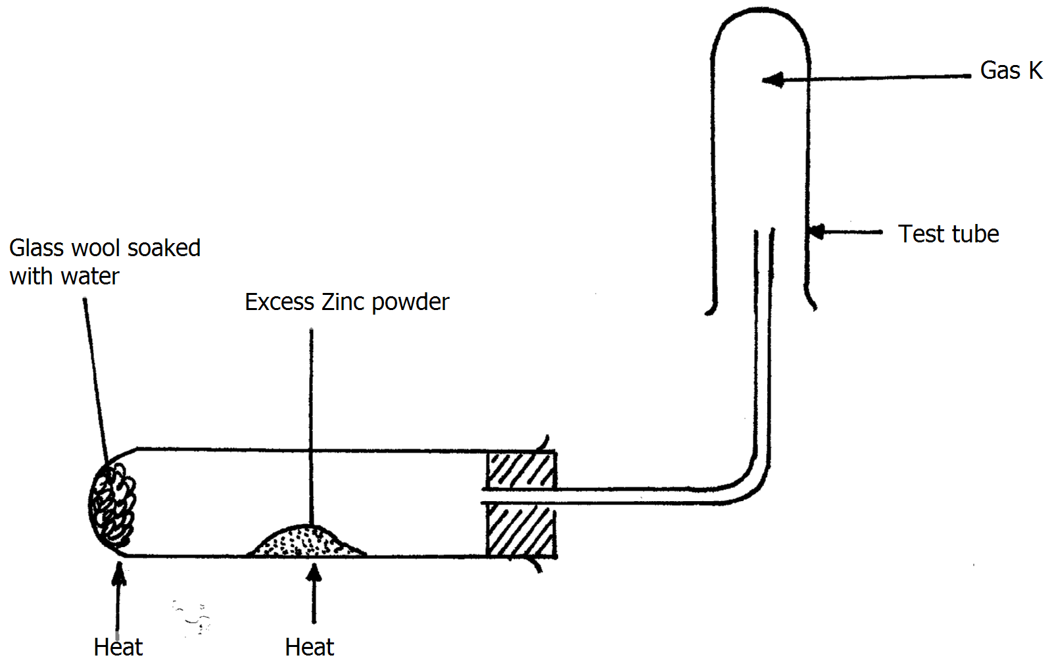
- Why was it necessary to heat the moist glass wool before heating Zinc powder?(1mk)
……………………………………………………………………………………………………………………………………………………………………………………
- What would happen if the Zinc powder was heated before heating the glass wool?
(1mk)
……………………………………………………………………………………………………………………………………………………………………………………
- What property of gas K makes it possible for it to be collected as shown in the diagram (1mk)
……………………………………………………………………………………………………………………………………………………………………………………..
7. Find the percentage composition by mass of Carbon in Sodium carbonate (Na=23,O=16,C=12) (2mks)
……………………………………………………………………………………………………………………………………………………………………………………………………………………………………………………………………………………………………………………………………………………………………………………………………………………………..

8 . Use the scheme to answer the questions that follow:
Solid N changes from yellow to white
on cooling

H₂SO_{4(aq)}
Solution Q
HCl _{(aq)}
Solution L

(a) Identify solid N …………………………………………………………………(1mk).
(b) Write a balanced equation for the formation of Q (1mk)
………………………………………………………………………………………………………………………………………………………………………………………………………
(c) Write the formula of the cat ion and anion present in solution L (1mrks)
Cation............................................................
Anion...........................................................

10. Study the diagram below and use it to answer the questions that follow:-
Lead (II) bromide
A
B
Heat

- Identify electrodes B (1mk)

..............................................................................................................................................
(b) Name the product formed at the anode (1mrk)

………………………………………………………………………………………………………………………………………………………………………………………………………………
(c) Write the electrode half equation of reaction at electrode A (1mrk)

........................................................................................................................................................................................................................................................................................................................
- Write ionic equations for the reactions between aqueous solutions of Barium chloride and magnesium sulphate (1mk)

…………………………………………………………………………………………………………………………………………………………………………………………….
- A compound of carbon, hydrogen and oxygen contains 57.15% carbon, 4.76% hydrogen and the rest oxygen. If its relative molecular mass is 126, find its molecular formula(3mk)
………………………………………………………………………………………………………………………………………………………………………………………………………………………………………………………………………………………………………………………………………………………………………………………………………………………………………………………………………………………………………………………………………………………………………………………………………………………………………………………………………………………………………………………………………………………………………………………………………………………………………………………………………………………………

- Calculate the number of atoms in 13.8g of sodium (Na=23) (2mks)
………………………………………………………………………………………………………………………………………………………………………………………………………………………………………………………………………………………………

- Calculate the mass of 1.2 moles of H₂SO₄ (H=1,S=32,O=16) (2mks)
................................................................................................................................................................................................................................................................................................................................................................................................................................................................................................................................................................................................
- Determine the formula mass of each of (NH₄)₂SO₄ (1mk)
………………………………………………………………………………………………………………………………………………………………………………………………………………………………………………………………………………………………
17. In an experiment to standardize sodium hydroxide solution, 0.5M hydrochloric acid was titrated with 25cm³ of the sodium hydroxide solution using phenolphthalein indicator and results recorded. The table below gives some of the results obtained.

Experiment | I | II | III
Final Burette reading (cm³) | 26.5 | 26.4
Initial Burette reading(cm³) | 0.0 |  | 0.0
Volume of acid used (cm³) |  | 26.4 | 26.3

- Complete the table by filling the blank spaces (1mks)
- What is the colour of the indicator in the sodium hydroxide solution? (1mk)
………………………………………………………………………………………………
- Calculate the average volume of the acid used (2mks)
………………………………………………………………………………………………………………………………………………………………………………………………………………………………………………………………………………………………
- Write the equation for the reaction that took place (1mk)
………………………………………………………………………………………………………………………………………………………………………………………………………………………………………………………………………………………………
- Determine the number of moles of hydrochloric acid used (2mks)
…………………………………………………………………………………………………………………………………………………………………………………………………………………………………………………………………………………………….
- Calculate the molarity of sodium hydroxide used in this experiment (2mks)
………………………………………………………………………………………………………………………………………………………………………………………………

27. Study the information in the table below and answer the questions that follow:

Ion | No. of protons | No. of electrons
P³⁻  R²⁺ | 7  12 | 10  10

a) Write the electron arrangement of element P. (1mk)
……………………………………………………………………………………………………………………………………………………………………………………………………………
b) Give the group and period of which elements R. (1mk)
Group ……………………………………………………
Period ……………………………………………………

29. The table below gives information on four elements by letters K, L, M and N. Study it
and answer the questions that follow. The letters do not represent the actual symbol of
the elements.

Element | Electron arrangement | Atomic radius (nm) | Ionic radius (nm)
K  L  M  N | 2.8.2  2.8.7  2.8.8.1  2.8.8.2 | 0.136  0.099  0.203  0.174 | 0.065  0.181  0.133  0.099
(a) Which two elements have similar properties? Explain (2mks)
……………………………………………………………………………………………………………………………………………………………………………………………………………………………………………………………………………………………………………………

(b) Which element is non-metal? Explain (2mks)
………………………………………………………………………………………………………………………………………………………………………………………………………………………………………………………………………………………………

E.N.D
‘’ when you rest, you rust and practice makes it perfect, let you be determined,’’ Regards….sir\Alex

