NAME…………………………………………………………….ADM…………………CLASS……………

FORM 2 GEOGRAPHY
TIME: 2 ½ HRS

INSTRUCTION
- This paper consists of two sections A and B.
- Answer all questions in section A. In section B answer any three questions.

SECTION A
1. (a) Distinguish between the Earth’s rotation and Revolution. (2mks)
(b) List two effects of the forms of movement mentioned in 1 (a) above.
(i) Rotation (2mks)
(ii) Revolution (2mks)
2. (a) Give the weather instruments used to measure the following (3mks)
Wind direction
Atmospheric pressure
Rainfall amount
(b) State five significance of weather forecasting. (5mks)
3. Convert the scale 1:50000 into a statement scale (show your workings) (2mks)
4. Outline the relationship between Geography and
(a) Biology (2mks)
(b) Agriculture (2mks)
5. (a) Define the term rock (2mks)
(b) Give the three main types of rocks according to their mode of formation. (8mks)

SECTION B
Answer any three questions in this section.
6. (a) Draw a diagram of a simple fold on it mark and name (3mks)
- Anticline
- Syncline
- Limb
(b) Name one Fold Mountain in each of the following continents: (4mks)
- North America
- South America
- Asia
- Africa
(c) With the help of well labeled diagrams describe how fold mountains are formed (8mks)
(d) Explain five ways through which folding influence human activities. (10mks)
7. (a) Give four methods which are used in recording data during field study. (4mks)
(b) State three problems researchers are likely to encounter when undertaking a field study in an open air market. (3mks)

(c) Use the following data to answer the questions below:
Rainfall and Temperature records of a station P
 | J | F | M | A | M | J | J | A | S | O | N | D
Rainfall(mm) | 110 | 122 | 130 | 76 | 52 | 36 | 26 | 38 | 71 | 108 | 121 | 120
Temperature(⁰C) | 24 | 24 | 23 | 22 | 19 | 17 | 17 | 18 | 17 | 20 | 22 | 23

(i) Work out the mean monthly rainfall for the station (3mks)
(ii) Give the modal temperature of the station. (2mks)
(iii) Use a scale of 1 cm rep 10mm for rainfall and 1 cm rep 2⁰C to draw a combined bar and liner graph to represent the data. (9mks)
(iv) Use the graph to:
- Identify the wettest and driest month in the station. (2mks)
- Relate temperature to rainfall. (2mks)

8. (a) On the map of East Africa identify the mineral mined in the areas marked J,K,L and M.
(4mks)

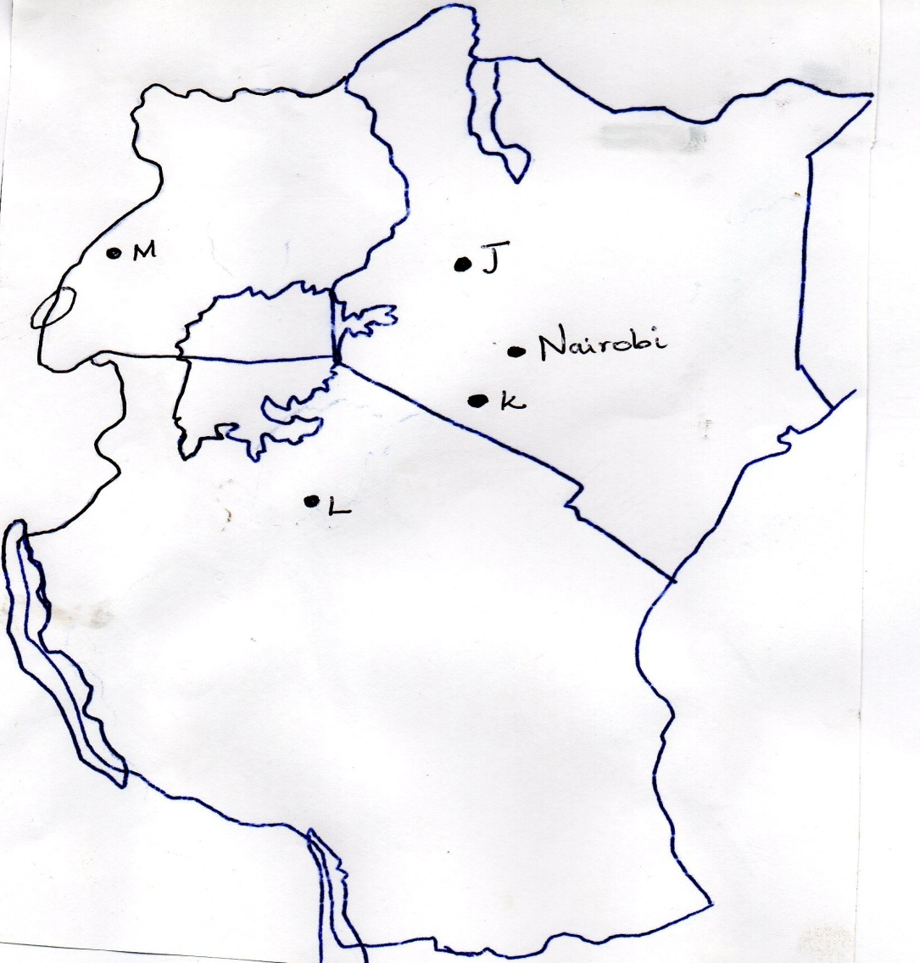

(b) Name the area where the following minerals are mined in Kenya. (2mks)
- Diatomite
- Salt
(c) State five benefits of mining in Kenya. (5mks)
(d) (i) Name two other methods of mining apart from deep shaft mining. (2mks)
(ii) Briefly describe the procedures of mining using the deep shaft methods. (6mks)
(iii) Explain three problems associated with mining. (6mks)

9. (a) Define faulting (2mks)
(b) Give three types of faults (3mks)
(c) With the help of well labeled diagrams describe how a rift valley is formed through tensional forces. (10mks)
(d) Describe how faulting influence physical and human environment. (10mks)

