NAME:……………………………..……………………..ADM. NO……………..………
SCHOOL:………………………………………STUDENT’S SIGN ……………………
DATE……………………………….
443/1 FORM ONE
JULY, 2019
Time: 2 Hours

Kenya Certificate of Secondary Education (K.C.S.E)
AGRICULTURE

INSTRUCTIONS TO CANDIDATES

a) Write your name and Admission number in the spaces provided above.
b) Sign and write the date of examination in the spaces provided above.
c) This paper consists of three sections A, B and C.
d) Answer ALL the questions in section A and B and any two questions in section C.
e) ALL answers must be written in the spaces provided in this booklet.

FOR EXAMINER’S USE ONLY

SECTION | QUESTIONS | MAX. SCORE | CANDIDATE’S SCORE
A | 1 – 17 | 30
B | 18– 20 | 20
C | 21-22 | 20
 |  | 20
TOTAL SCORE |  | 70

This paper consists of 10 printed pages. Candidates should check the question paper to ensure that all pages are printed as indicated and no questions are missing.

SECTION A 20MRKS
Answer all questions in the spaces provided
- State two effects of temperature on agricultural production. (1mk)
…………………………………………………………………………………………..
…………………………………………………………………………………………..
- List three physical weathering agents in the soil formation process (1¹/₂mrks)
…………………………………………………………………………………………..
…………………………………………………………………………………………..
…………………………………………………………………………………………..
…………………………………………………………………………………………..
- State two mechanical methods of separating soil particles according to size
during soil analysis (1mks)
…………………………………………………………………………………………..
…………………………………………………………………………………………..
- State four roles of organic matter in sandy soils. (2 mks)
…………………………………………………………………………………………..
…………………………………………………………………………………………..
…………………………………………………………………………………………..
…………………………………………………………………………………………..
- Give four reasons for minimum tillage. (2 mks)
…………………………………………………………………………………………..
…………………………………………………………………………………………..
…………………………………………………………………………………………..
…………………………………………………………………………………………..

- Name three sources of underground water. (1 ½ mks)
…………………………………………………………………………………………..
…………………………………………………………………………………………..
…………………………………………………………………………………………..
- Give four advantages of intensive farming. (2 mks)
…………………………………………………………………………………………..
…………………………………………………………………………………………..
…………………………………………………………………………………………..
…………………………………………………………………………………………..
- Give four reasons why land should be prepared early in readiness for planting. (2 mks)
…………………………………………………………………………………………..
…………………………………………………………………………………………..
…………………………………………………………………………………………..
…………………………………………………………………………………………..
- State four biotic factors that influence crop production. (2mks)
…………………………………………………………………………………………..
…………………………………………………………………………………………..
…………………………………………………………………………………………..
…………………………………………………………………………………………..
- State three advantages of shifting cultivation. (1 ½ mks)
…………………………………………………………………………………………..
…………………………………………………………………………………………..
…………………………………………………………………………………………..

- Give four factors that influence the number of secondary cultivations in
seedbed preparation. (2 mks)
…………………………………………………………………………………………..
…………………………………………………………………………………………..
…………………………………………………………………………………………..
- Give two disadvantages of intensive system of fanning. (1 mk)
…………………………………………………………………………………………..
…………………………………………………………………………………………..
- List four methods of farming. (2 mks)
…………………………………………………………………………………………..
…………………………………………………………………………………………..
…………………………………………………………………………………………..
…………………………………………………………………………………………..
- State four features that should be considered when choosing water pipes
for use on the farm. (2 mks)
…………………………………………………………………………………………..
…………………………………………………………………………………………..
…………………………………………………………………………………………..
…………………………………………………………………………………………..
- Give four reasons for treating water for use on the farm. (2 mks)
…………………………………………………………………………………………..
…………………………………………………………………………………………..
…………………………………………………………………………………………..
…………………………………………………………………………………………..
- Give two reasons for carrying out each of the following operations in land preparation:
(a) rolling; (1 mk)
…………………………………………………………………………………………..
…………………………………………………………………………………………..
(b) levelling. (1 mk)
…………………………………………………………………………………………..
…………………………………………………………………………………………..
- Name three recommended practices that should be carried out when clearing
the bush during land preparation. (1 ½ mks)
…………………………………………………………………………………………..
…………………………………………………………………………………………..
…………………………………………………………………………………………..

SECTION B (20 MRKS)
Answer ALL the questions in this section in the spaces provided
- The diagram below illustrates a feature observed after digging the soil several
metres deep. Study the diagram carefully and answer the questions that follow.
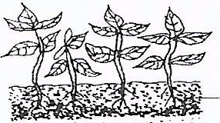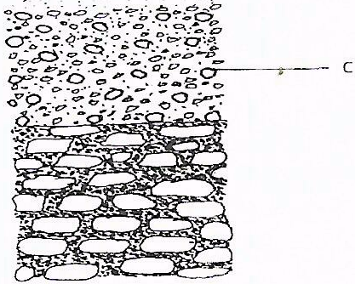
C
B
A
D
a) Identify the feature that the diagram above represents in the study of soil (1mk)
……………………………………………………………………………………………
(b) Name the parts of the diagram labelled A, B, C and D. (2 mks)
A ………………………………………….
B …………………………………………..
C …………………………………………..
D …………………………………………..

(c) State two ways in which the knowledge of the above feature would be of benefit
to a farmer. (2 mks)
…………………………………………………………………………………………..
…………………………………………………………………………………………..
- The diagram below illustrates an experiment on soil. Study it carefully and
answer the questions that follow.
C
B
A
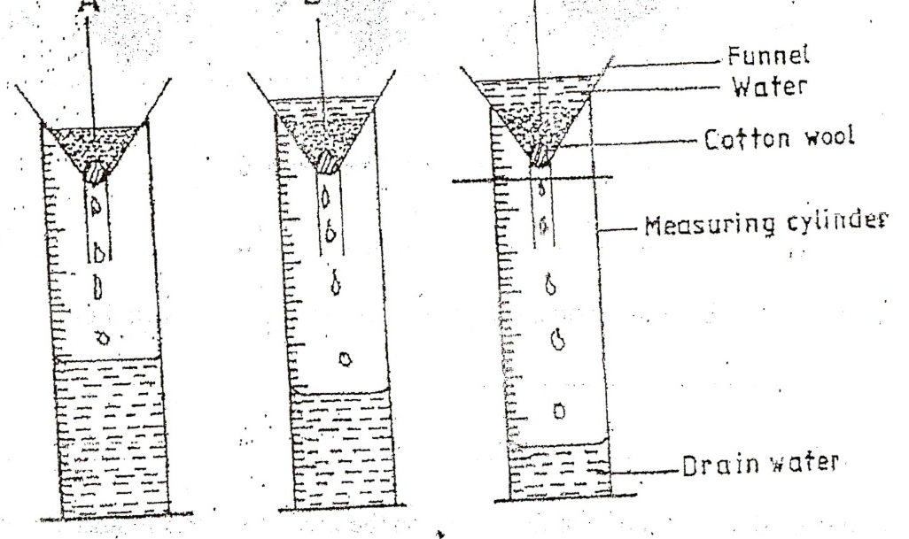
Cotton wool
Drain water
Measuring cylinder
Water
Funnel
- State the aim of the experiment (1mk)
……………………………………………………………………………………………….
- If the volume of water illustrated in the measuring cylinder was observed
after one hour identify the soil sample labeled A, B and C. (3mrks)
A……………………………………………………………………………………
B……………………………………………………………………………………
C ……………………………………………………………………………………
- State Two ways in which the soil structure of the sample labeled C
above can be improved (2 mks)
…………………………………………………………………………………………..
…………………………………………………………………………………………..

21 The diagrams below show a set up of an experiment to study an aspect of soil. The
set up was left undisturbed for rive hours. Study it and answer the questions that follow.

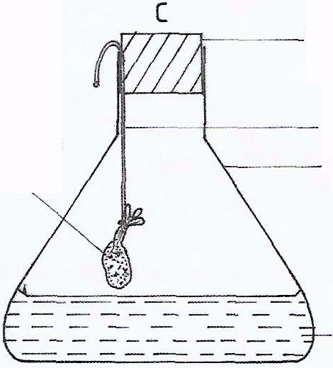
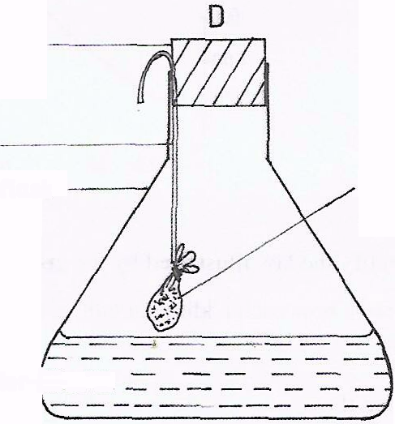
Rubber corks
String
Fresh garden soil in muslin bag

Strongly heated garden soil in muslin bag
Conical flask
Lime water

(a) What was the aim of the experiment? (1 mk)
…………………………………………………………………………………………..
(b) State one observation that was made in each of the flasks labelled C and D (2mrks)
C…………………………………………………………………………
D………………………………………………………………………...
c) Give a reason for each of your answers in (b) above
C……………………………………………………………………….. (1mk)
D………………………………………………………………………… (1mk)

- The diagram below illustrates an investigation on a property of soil using soil
samples labelled J, K and L.
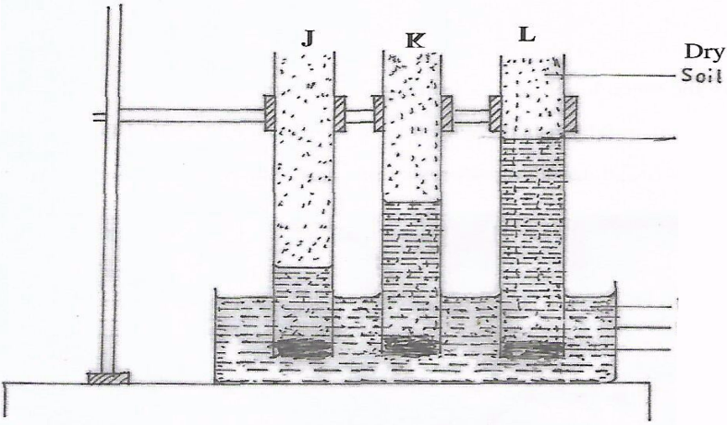
Water trough
Cotton wool
Glass tube
Water level
Dry soil
a) If the levels of water shown in the diagram were observed after three hours, name
the property of soil being investigated. (1mk)
………………………………………………………………………………………………….
b) What is the relationship between the soil property named in (a) above and
the size of soil particles? (2mk)
…………………………………………………………………………………………….
…………………………………………………………………………………………….
c) Which soil sample would be suitable for growing paddy rice? (1mk)
……………………………………………………………………………………………
SECTION C (40 MKS)
Answer any two questions from this section in the spaces provided after question
- (a) Discuss the importance of irrigation if farming ( 12 mks)
(b) Explain the factor that influence the type of irrigation to be used in a farm ( 8 mks)
- (a) State and explain five roles of agriculture in economic development of Kenya (10 mks)
(b) Explain four ways in which:
(i) HIV/AIDS limits agricultural production (4 mks)
(ii) Government policy improves agricultural production (2 mks)
(iii) Low level of education and technology influences agriculture. (4 mks)
- (a) State and explain various stages involved in chemical water treatment process (12mrks)
(b) State and explain four factors that determine the number of times of secondary
cultivation (8mrks)

…………………………………………………………………………………………………….
…………………………………………………………………………………………………….
…………………………………………………………………………………………………….
…………………………………………………………………………………………………….
…………………………………………………………………………………………………….
…………………………………………………………………………………………………….
…………………………………………………………………………………………………….
…………………………………………………………………………………………………….
…………………………………………………………………………………………………….
…………………………………………………………………………………………………….
…………………………………………………………………………………………………….
…………………………………………………………………………………………………….
…………………………………………………………………………………………………….
…………………………………………………………………………………………………….
…………………………………………………………………………………………………….
…………………………………………………………………………………………………….
…………………………………………………………………………………………………….
…………………………………………………………………………………………………….
…………………………………………………………………………………………………….
…………………………………………………………………………………………………….
…………………………………………………………………………………………………….
…………………………………………………………………………………………………….
…………………………………………………………………………………………………….
…………………………………………………………………………………………………….
…………………………………………………………………………………………………….
…………………………………………………………………………………………………….
…………………………………………………………………………………………………….
…………………………………………………………………………………………………….
…………………………………………………………………………………………………….
…………………………………………………………………………………………………….
…………………………………………………………………………………………………….
…………………………………………………………………………………………………….
…………………………………………………………………………………………………….
…………………………………………………………………………………………………….
…………………………………………………………………………………………………….
…………………………………………………………………………………………………….
…………………………………………………………………………………………………….
…………………………………………………………………………………………………….
…………………………………………………………………………………………………….

