NAME:……………………………..……………………..ADM. NO……………..………
SCHOOL:………………………………………STUDENT’S SIGN ……………………
DATE……………………………….
443/1 FORM TWO
JULY, 2019
Time: 2 Hours

Kenya Certificate of Secondary Education (K.C.S.E)
AGRICULTURE

INSTRUCTIONS TO CANDIDATES

a) Write your name and Admission number in the spaces provided above.
b) Sign and write the date of examination in the spaces provided above.
c) This paper consists of three sections A, B and C.
d) Answer ALL the questions in section A and B and any two questions in section C.
e) ALL answers must be written in the spaces provided in this booklet.

FOR EXAMINER’S USE ONLY

SECTION | QUESTIONS | MAX. SCORE | CANDIDATE’S SCORE
A | 1 – 15 | 30
B | 16– 20 | 20
C | 21-22 | 20
 |  | 20
TOTAL SCORE |  | 90

This paper consists of 10 printed pages. Candidates should check the question paper to ensure that all pages are printed as indicated and no questions are missing.
SECTION A 20MRKS
Answer all questions in the spaces provided
- Give two disadvantages of intensive system of farming. (1 mk)
…………………………………………………………………………………………………
…………………………………………………………………………………………………
- List four methods of farming. (2 mks)
…………………………………………………………………………………………………
…………………………………………………………………………………………………
…………………………………………………………………………………………………
………………………………………………………………………………………………...
- Give four reasons-for keeping livestock health records on the farm. (2 mks)
…………………………………………………………………………………………………
…………………………………………………………………………………………………
…………………………………………………………………………………………………
…………………………………………………………………………………………………
- State four features that should be considered when choosing water pipes
for use on the farm. (2 mks)

…………………………………………………………………………………………………
…………………………………………………………………………………………………
…………………………………………………………………………………………………
…………………………………………………………………………………………………
- Name three recommended practices that should be carried out when clearing
the bush during land preparation. (1 ½ mks)

…………………………………………………………………………………………………
…………………………………………………………………………………………………
…………………………………………………………………………………………………

- Give four factors that would determine the stage at which a crop is harvested. (2 mks)
…………………………………………………………………………………………………
…………………………………………………………………………………………………
…………………………………………………………………………………………………
…………………………………………………………………………………………………
- State four disadvantages of mono cropping in crop production. (2 mks)
…………………………………………………………………………………………………
…………………………………………………………………………………………………
…………………………………………………………………………………………………
…………………………………………………………………………………………………
- List four post-harvest practices that are carried out in maize production. (2 mks)
…………………………………………………………………………………………………
…………………………………………………………………………………………………
…………………………………………………………………………………………………
…………………………………………………………………………………………………
- State four disadvantages of organic mulches. (2mks)
…………………………………………………………………………………………………
…………………………………………………………………………………………………
…………………………………………………………………………………………………
…………………………………………………………………………………………………
- Give four factors that influence the number of secondary cultivations in
seedbed preparation. (2 mks)

…………………………………………………………………………………………………
…………………………………………………………………………………………………
…………………………………………………………………………………………………
…………………………………………………………………………………………………
- State four factors that determine the stage at which a crop is harvested. (2mks)
…………………………………………………………………………………………………
…………………………………………………………………………………………………
…………………………………………………………………………………………………
…………………………………………………………………………………………………
- Give four reasons why land should be prepared early in readiness for planting. (2 mks)
…………………………………………………………………………………………………
…………………………………………………………………………………………………
…………………………………………………………………………………………………
…………………………………………………………………………………………………
- What is meant by each of the following terms: (3 mks)
    - mixed cropping
…………………………………………………………………………………………………
    - Monocropping
…………………………………………………………………………………………………
    - Intercropping
…………………………………………………………………………………………………
- State four advantages of timely planting. (2 mks)
…………………………………………………………………………………………………
…………………………………………………………………………………………………
…………………………………………………………………………………………………
…………………………………………………………………………………………………
- Name the plant part used for vegetative propagation of each of the following plants:
(a) cassava (1mk)
…………………………………………………………………………………………………

(b) sisal (1mk)
…………………………………………………………………………………………………
(c) pyrethrum (1mk)
…………………………………………………………………………………………………
(d) sweet potatoes. (1mk)
…………………………………………………………………………………………………
SECTION B (20 MRKS)
Answer ALL the questions in this section in the spaces provided

- The diagrams labeled A_{1,} A₂, A_{3,} and B below illustrate materials and methods
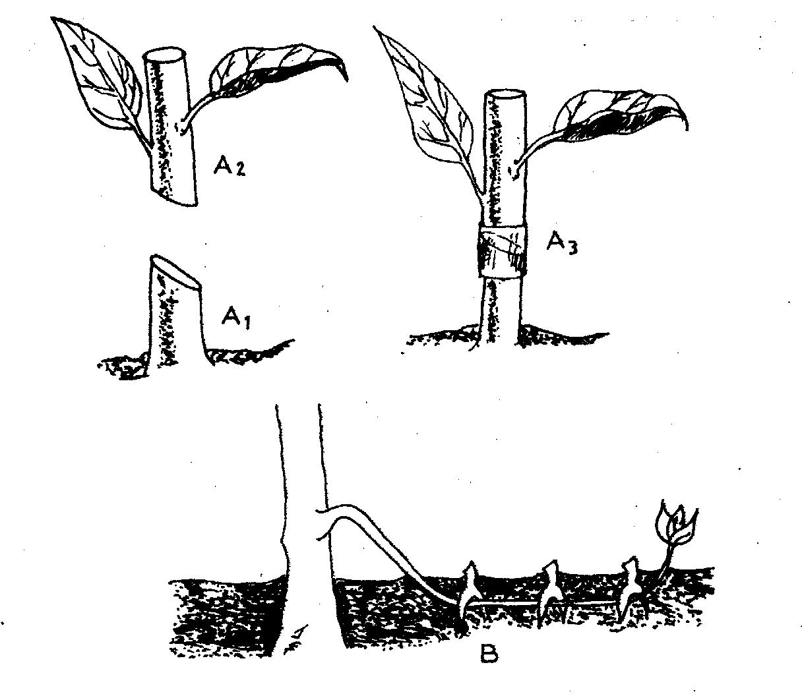
of vegetative propagation. Study them and answer the questions that follow.

(a) Name the parts labeled A₁, and A₂ ( 2 mks)
A₁………………………………………………………………………………
A₂……………………………………………………………………………….
(b) Name the methods of propagation illustrated in diagrams A₃ and B ( 2 mks)
A₃……………………………………………………………………
B…………………………………………………………………….
- The diagrams labeled D and E below are illustrations of coffee established
using two different formative pruning systems. Study them and answer the
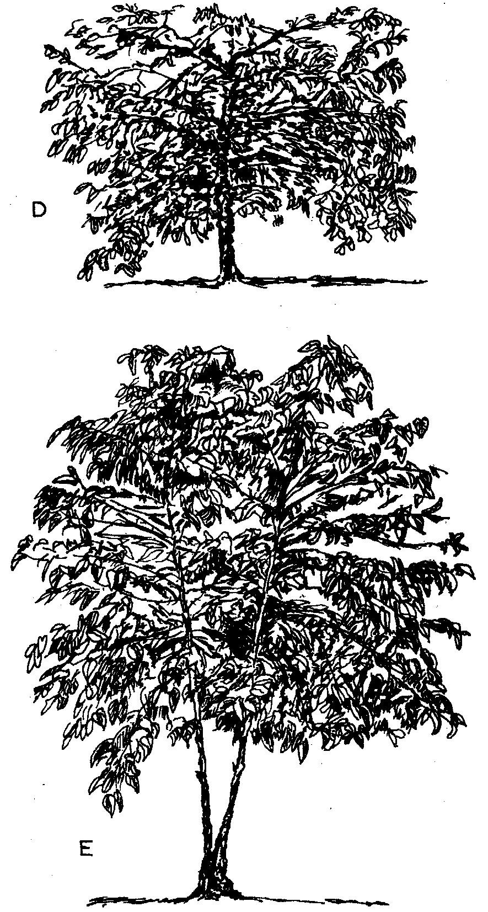
questions that follow.

(a) Name the system of pruning illustrated in diagram D above ( 1mk)
…………………………………………………………………………………………………
(b) Outline how the pruning system illustrated in diagram E is carried out (2 mks)
…………………………………………………………………………………………………
…………………………………………………………………………………………………

- A member of young farmers club was advised to apply a complete fertilizer
30: 20:10 in a tomato plot measuring 10m long by 5m wide at the rate of 300kg
per hectare
(a) State the percentage of P₂0₅ in the complete fertilizer ( 1 mk)
…………………………………………………………………………………………………
(b) Calculate the amount of fertilizer the member would require for the plot (2 mks) (Show your working)
…………………………………………………………………………………………………
…………………………………………………………………………………………………
…………………………………………………………………………………………………
…………………………………………………………………………………………………
- The diagram below illustrates a final seedbed after a tertiary operation done
during land preparation. Study it carefully and answer the questions that follow.
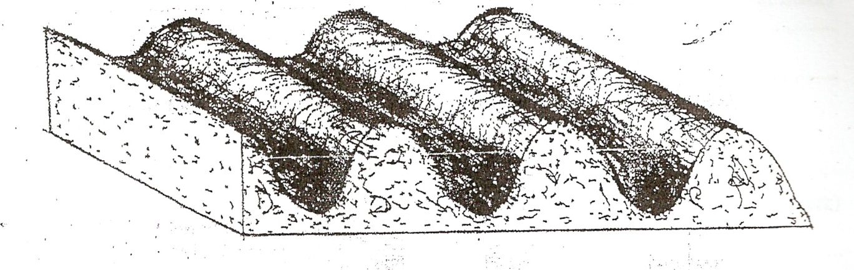
(a) Name the tertiary operation carried out on the seedbed (1mk)
…………………………………………………………………………………………………
(b) Describe how the tertiary operation named in one above is carried out. (1mk)
…………………………………………………………………………………………………
(c) Give two advantages of planting crops on a final seedbed illustrated above (2mrks)
…………………………………………………………………………………………………
…………………………………………………………………………………………………

- The diagrams below show a set up of an experiment to study an aspect of soil. The
set up was left undisturbed for rive hours. Study it and answer the questions that follow.

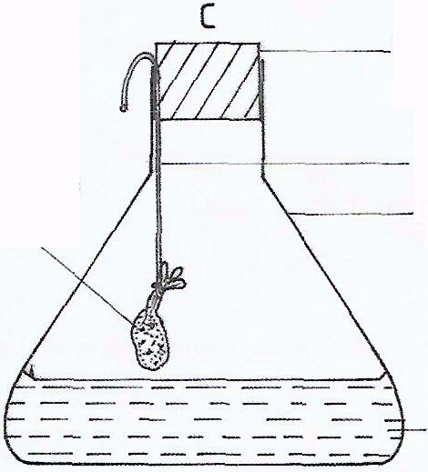
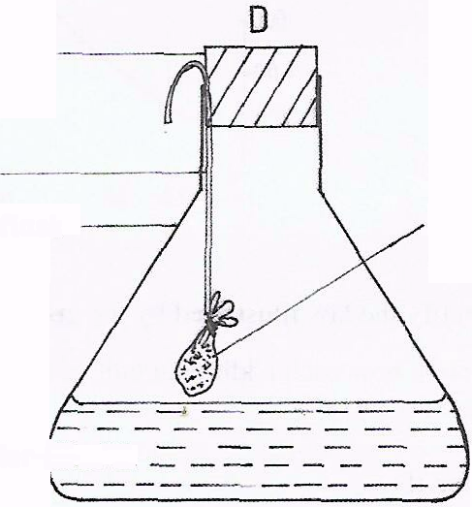
Rubber corks
String
Fresh garden soil in muslin bag
Strongly heated garden soil in muslin bag
Conical flask
Lime water

(a) What was the aim of the experiment? (1 mk)
…………………………………………………………………………………………………
(b) State one observation that was made in each of the flasks labelled C and D
C………………………………………………………………………………. (1 mk)
D……………………………………………………………………………… (1 Mk)
c) Give a reason for each of your answers in (b) above
C……………………………………………………………………………….. (1mk)
D………………………………………………………………………………. (1mk)
SECTION C (40 MKS)
Answer any two questions from this section in the spaces provided after question
- Describe the establishment of kales under the following sub – headings:
a) Nursery preparation
b) Establishment in the nursery
c) Management of seedlings in the nursery.
d) Transplanting of seedlings.
- (a) Discuss the importance of irrigation if farming ( 12 mks)
(b) Explain the factor that influence the type of irrigation to be used in a farm ( 8 mks)
- State and explain:
(a) Five advantages of crop rotation. (10 mks)
(b) Five factors which may influence the spacing of crops. (10 mks)

…...….…………………………………………………………………………………………………
…...….…………………………………………………………………………………………………
…...….…………………………………………………………………………………………………
…...….…………………………………………………………………………………………………
…...….…………………………………………………………………………………………………
…...….…………………………………………………………………………………………………
…...….…………………………………………………………………………………………………
…...….…………………………………………………………………………………………………
…...….…………………………………………………………………………………………………
…...….…………………………………………………………………………………………………
…...….…………………………………………………………………………………………………
…...….…………………………………………………………………………………………………
…...….…………………………………………………………………………………………………
…...….…………………………………………………………………………………………………
…...….…………………………………………………………………………………………………
…...….…………………………………………………………………………………………………
…...….…………………………………………………………………………………………………
…...….…………………………………………………………………………………………………
…...….…………………………………………………………………………………………………
…...….…………………………………………………………………………………………………
…...….…………………………………………………………………………………………………
…...….…………………………………………………………………………………………………
…...….…………………………………………………………………………………………………
…...….…………………………………………………………………………………………………
…...….…………………………………………………………………………………………………
…...….…………………………………………………………………………………………………
…...….…………………………………………………………………………………………………
…...….…………………………………………………………………………………………………
…...….…………………………………………………………………………………………………
…...….…………………………………………………………………………………………………
…...….…………………………………………………………………………………………………
…...….…………………………………………………………………………………………………
…...….…………………………………………………………………………………………………
…...….…………………………………………………………………………………………………
…...….…………………………………………………………………………………………………
…...….…………………………………………………………………………………………………
…...….…………………………………………………………………………………………………
…...….…………………………………………………………………………………………………
…...….…………………………………………………………………………………………………
…...….…………………………………………………………………………………………………
…...….…………………………………………………………………………………………………
…...….…………………………………………………………………………………………………
…...….…………………………………………………………………………………………………
…...….…………………………………………………………………………………………………
…...….…………………………………………………………………………………………………
…...….…………………………………………………………………………………………………
…...….…………………………………………………………………………………………………
…...….…………………………………………………………………………………………………
…...….…………………………………………………………………………………………………
…...….…………………………………………………………………………………………………
…...….…………………………………………………………………………………………….

