NAME:………………………………………….. ADM NO…………………………………
CANDIDATE’S SIGN …………………………..DATE ………………………………………
443/2 FORM 3
AGRICULTURE
Paper 2
JULY - 2019
Time: 2 Hours

Kenya Certificate of Secondary Education (K.C.S.E)

443/2
AGRICULTURE
Paper 2
JULY - 2019
Time: 2 Hours
INSTRUCTIONS TO CANDIDATES
1. Write your name and index number in the spaces provided above
2. Sign and write the date of examination in the spaces provided above.
3. This paper consists of three sections: A, B and C
4. Answer all the questions in section A and B and any two questions from section C
5. Do not remove any pages from this booklet

For Examiner’s Use Only

Section | Question | Maximum Score | Candidate’s Score
A | 1 – 16 | 30
B | 17 – 20 | 20
C | 21-23 | 20
 |  | 20
 | Total Score | 90

This paper consists of 9 printed pages.
Candidates should check the question paper to ensure that all pages are printed as indicated
and no questions are missing.
SECTION A 30MRKS ANSWER ALL QUESTIONS
- State four factors that determine the amount of water required by livestock. (2 mks)
…………………………………………………………………………………………………….
…………………………………………………………………………………………………….
…………………………………………………………………………………………………….
…………………………………………………………………………………………………….
- What is heterosis in livestock breeding? (1 mk)
…………………………………………………………………………………………………….
- State four factors that would contribute to the depreciation of farm equipment. (2 mks)
…………………………………………………………………………………………………….
…………………………………………………………………………………………………….
…………………………………………………………………………………………………….
…………………………………………………………………………………………………….
- State four practices that should be carried out on wooden fencing posts to make them last long. (2 mks)
…………………………………………………………………………………………………….
…………………………………………………………………………………………………….
…………………………………………………………………………………………………….
…………………………………………………………………………………………………….
- Name four structures which would assist in the control of livestock parasites on a farm. (2 mks)
…………………………………………………………………………………………………….
…………………………………………………………………………………………………….
…………………………………………………………………………………………………….
…………………………………………………………………………………………………….
- Differentiate between mothering ability and prolificacy in livestock breeding. (1 mk)
…………………………………………………………………………………………………….
……………………………………………………………………………………………………..
- State how the following practices can be used to control livestock diseases:
(a) Quarantine; (1 mk)
…………………………………………………………………………………………………….
(b) Prophylactic measures. (1 mk)
…………………………………………………………………………………………………….
- Name the breeds of livestock described below:
(a) A pig breed which is white in colour, with straight snout and long ears
Drooping over the face; (1 mk)
…………………………………………………………………………………………………….
(b) A beef cattle breed, deep red in colour; the face and part of the legs
below the knees and hocks are always white. (1 mk)
…………………………………………………………………………………………………….
- Name one intermediate host for each of the following livestock parasites:
(a) Liver fluke (fascicle spp) (1mk)
…………………………………………………………………………………………………….
(b) Tape worms (taenia spp) (1mk)
…………………………………………………………………………………………………….
- State four ways of restraining cattle during routine management (2mks)
…………………………………………………………………………………………………….
…………………………………………………………………………………………………….
…………………………………………………………………………………………………….
…………………………………………………………………………………………………….
- What is meant by the following terms as used in livestock health?
(a) Incubation period (1mks)
…………………………………………………………………………………………………….

(b) Mortality rate (1mks)
…………………………………………………………………………………………………….
- Give four reasons for rearing indigenous cattle in marginal areas of Kenya. (2mks)
…………………………………………………………………………………………………….
…………………………………………………………………………………………………….
…………………………………………………………………………………………………….
…………………………………………………………………………………………………….
- List four materials that can be used in constructing a Kenya Top Bar Hive. (2 mks)
…………………………………………………………………………………………………….
…………………………………………………………………………………………………….
…………………………………………………………………………………………………….
…………………………………………………………………………………………………….
- State four characteristics of roughage livestock feeds (2 mks)
…………………………………………………………………………………………………….
…………………………………………………………………………………………………….
…………………………………………………………………………………………………….
…………………………………………………………………………………………………….
- State four roles of worker bees in a colony. (2 mks)
…………………………………………………………………………………………………….
…………………………………………………………………………………………………….
…………………………………………………………………………………………………….
…………………………………………………………………………………………………….
- Name four tools that are used when laying concrete blocks during construction
of a wall. (2 mks)
…………………………………………………………………………………………………….
…………………………………………………………………………………………………….
…………………………………………………………………………………………………….
…………………………………………………………………………………………………….

SECTION B 20MRKS ANSWER ALL QUESTIONS
- The diagrams labeled A and B below show the teeth arrangements in hand workshop tools.
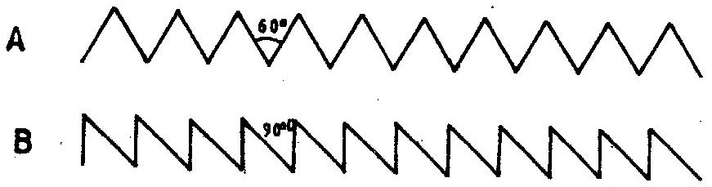

a) Identify the tools represented with by the teeth arrangements
A and B. (1mk)
A ……………………………………………..
B ……………………………………………..
b) State one functional difference between tools represented by the (2mrks)
teeth arrangements A and B.
A ………………………………………………
B ………………………………………………
c) Give two maintenance practices for the tools represented by the
teeth arrangement shown above. (2mks)
…………………………………………………………………………………………………….
…………………………………………………………………………………………………….
- a) The diagram below illustrates a method of identification in livestock
production. Study the diagram and answer the Questions that follow.
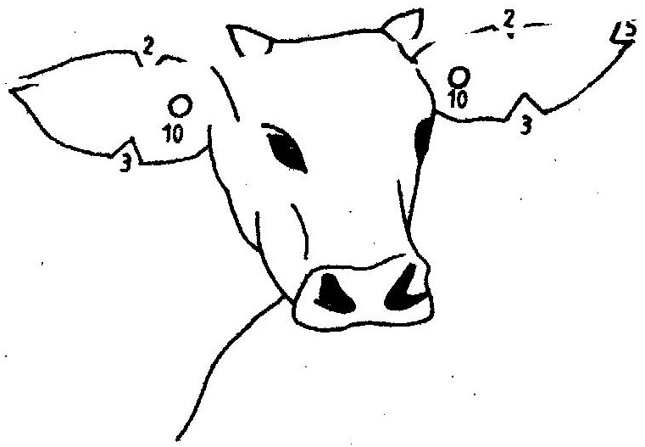

i) Name the type of identification illustrated above. (1mks)
…………………………………………………………………………………………………….

ii) Give the identification number of the animal illustrated in the diagram
above. (1mk)
…………………………………………………………………………………………………….
iii) Using diagrams illustrate how you can identify animals Nos
24 and 36 using the above method. (2mks)
Animal No. 24

Animal No. 36

(b) If a sow was successfully served on 27th September, 2006, state the date
she is likely to have farrowed. (1mks)
…………………………………………………………………………………………………….
- The diagram below shows a type of a farm gate. Study the diagram and
answer the questions that follow.
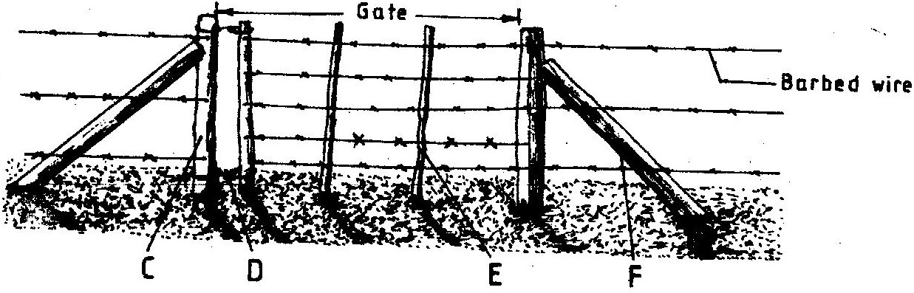

a) Identify the type of gate shown (¹/₂ mk)
b) Name the parts labeled C, D and E. (1 ½ mks)
C …………………………………………..
D ……………………………………………
E …………………………………………..
c) i) State one function of the part labeled F. (1mk)
F ……………………………………………
ii) State two functions of the gate illustrated above. (2mks)
…………………………………………………………………………………………………….
…………………………………………………………………………………………………….
- The diagram below illustrates the stages of life cycle of a tick. Study the diagram
and answer the questions that follow.

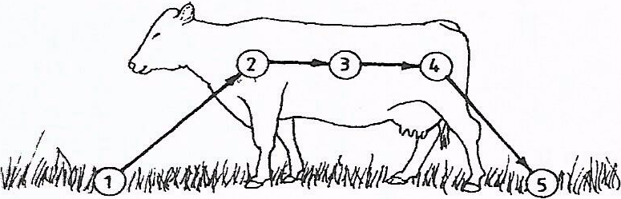

(a) Describe the development of ticks at 1, 2,3 and 4. (4mks)
1…………………………………………………………………………………..
2………………………………………………………………………………….
3…………………………………………………………………………………..
4…………………………………………………………………………………..
(b) Classify the tick on the basis of the life cycle. (1 mk)
…………………………………………………………………………………………….
SECTION B 40MARKS
Answer any two questions in the spaces provided
- (a)Describe ten signs of ill –health in livestock (10mks)
(b) Describe the process of digestion in the following sections in the alimentary
canal of a non-ruminant animal:
- Mouth (1mks)
- Stomach (3mks)
- Small intestine (6mks)
- (a) Describe the use of various hand tools required for the construction of a
Wooden rabbit hutch, (10 mks)
(b) What factors should a farmer consider when selecting materials for
Constructing a dairy cattle shed. (10 mks)
- (a) Describe the uses of fences on the farm. (10 mks)
(b) Give five harmful effects of liver flukes in sheep rearing. (5 mks)
(c) Explain the factors considered when culling livestock. (5 mks)

……………………………………………………………………………………………………....
……………………………………………………………………………………………………....
……………………………………………………………………………………………………....
……………………………………………………………………………………………………....
……………………………………………………………………………………………………....
……………………………………………………………………………………………………....
……………………………………………………………………………………………………....
……………………………………………………………………………………………………....
……………………………………………………………………………………………………....
……………………………………………………………………………………………………....
……………………………………………………………………………………………………....
……………………………………………………………………………………………………....
……………………………………………………………………………………………………....
……………………………………………………………………………………………………....
……………………………………………………………………………………………………....
……………………………………………………………………………………………………....
……………………………………………………………………………………………………....
……………………………………………………………………………………………………....
……………………………………………………………………………………………………....
……………………………………………………………………………………………………....
……………………………………………………………………………………………………....
……………………………………………………………………………………………………....
……………………………………………………………………………………………………....
……………………………………………………………………………………………………....
……………………………………………………………………………………………………....
……………………………………………………………………………………………………....
……………………………………………………………………………………………………....
……………………………………………………………………………………………………....
……………………………………………………………………………………………………....
……………………………………………………………………………………………………....
……………………………………………………………………………………………………....
……………………………………………………………………………………………………....
……………………………………………………………………………………………………....
……………………………………………………………………………………………………....
……………………………………………………………………………………………………....
……………………………………………………………………………………………………....
……………………………………………………………………………………………………....
……………………………………………………………………………………………………....
……………………………………………………………………………………………………....
……………………………………………………………………………………………………....
……………………………………………………………………………………………………....
……………………………………………………………………………………………………....
……………………………………………………………………………………………………....
……………………………………………………………………………………………………....
……………………………………………………………………………………………………....
……………………………………………………………………………………………………....
……………………………………………………………………………………………………....
……………………………………………………………………………………………………....

