MURANG’A HIGH SCHOOL

BIOLOGY FORM 4 C.A.T. 1 – 2016 TIME: 1 HOUR

NAME:………………………………………….ADM.NO…………CLASS………..CL.NO……

1. (a) Identify the types of placentations illustrate below. (3 marks)

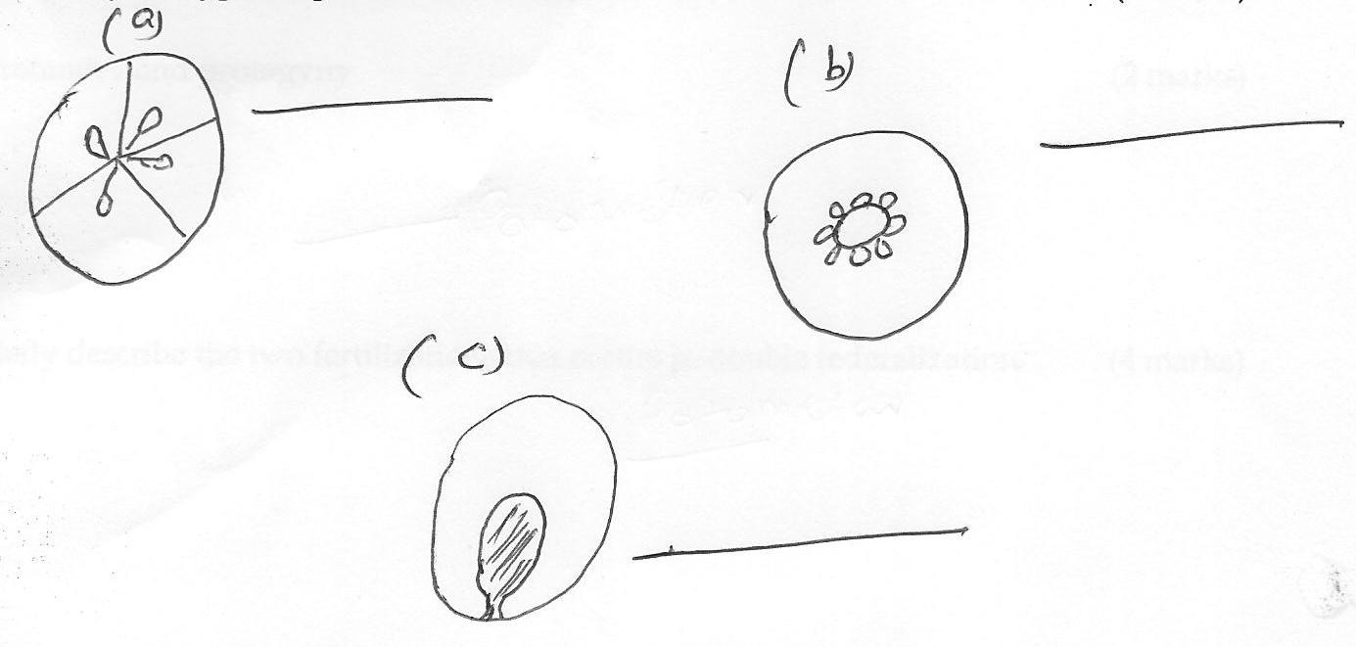

(b) Name two types of the following

(i) Dry dehiscent fruits. (2 marks)

(ii) Dry indehiscent fruits (2 marks)

(c) Briefly explain how the seeds of a succulent fruit get dispersed. (2 marks)

2. Distinguish between the following terms:-

(a) Monoecious and dioecious (2 marks)

(b) Protandry and protogyny (2 marks)

3. Briefly describe the two fertilizations that occurs in double federalization. (4 marks)

4. Draw a well labelled diagram of an embryo sac. (3 marks)

5. Give two ways in which the following type of plants are adapted to their habitats

(i) hydrophytes (2 marks)

(ii) halophytes (2 marks)

6. Explain the meaning of the following terms:-

(i) Green house effect (2 marks)

(ii) Global warming (2 marks)

7. To estimate the population of tilapia fish in a school fish pond, capture recapture method was used where 400 fish were caught, marked and released back to the pond. Four days later, another catch was carried out. 374 fish were caught. 80 were found marked.

(a) Calculate the population size of the fish in the pond. (3 marks)

(b) State the assumptions made during the investigation (2 marks)

(c) Name one other method of population estimation (1 mark)

8. (a) Briefly explain how the following disease causing organisms get transmitted.
(2 marks)

(i) Plasmodium

(ii) Ascaris lumbricoides

(b) Give one method of controlling spread of malaria based on the following. (2 marks)

(i) Killing of the causative parasite

(ii) Mosquitoes habitat

9. Explain how an increase in nitrate concentration in a river can lead to death of fish.
(3 marks)

10. Explain how the following adaption minimizes the rate of transpiration. (3 marks)

(a) Leaf folding

(b) Reversed stomata rhythm

(c) Sunken stomata

11. (a) What is the use of a potometer (1 mark)

(b) Give two precautions taken when using the potometer (2 marks)

12. Give three ways in which the xylem is adapted to its functions. (3 marks)

==END==

