MURANG’A HIGH SCHOOL

GEOGRAPHY PAPER 1 FORM 4 C.A.T. 1 – 2016 TIME: 1 HOUR

NAME:………………………………………….ADM.NO…………CLASS………..CL.NO……

SECTION A: (25 MARKS)

1. (a) Besides troposphere, name two other layers of the atmosphere (2 marks)

(b) State three characteristics of the troposphere (3 marks)

2. (a) Name two instruments kept in the Stevenson’s screen. (2 marks)

(b) State three conditions necessary for siting a weather station. (3 marks)

3. Use the diagram below to answer the questions that follow:-
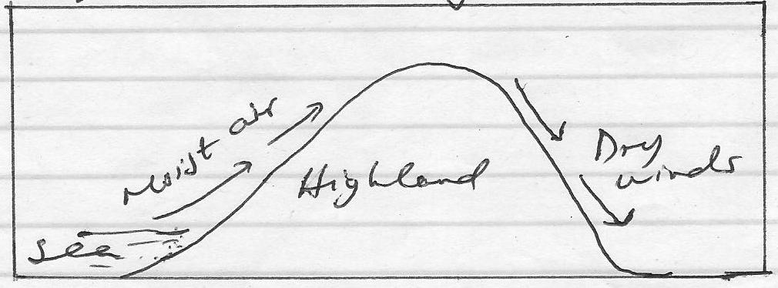

Outline the process through which moist winds shown go through to eventually become dry winds. (5 marks)

4. (a) Give two main processes of glacial erosion. (2 marks)

(b) Describe the formation of a pyramidal peak. (4 marks)

5. State four conditions necessary for the growth of coral polyps (4 marks)

SECTION B: (25 MARKS)

6. Study the map provided Migwani 1:50,000 (sheet 151/1) and answer the following questions:-

(a) (i) Give the six figure grid reference of the trigonometrically station 1515 near Kamutotya
(2 marks)

(ii) Calculate the area of the vegetation to the east of the water pipeline. (2 marks)

(iii) Identify two types of vegetation in the area covered by the map. (2 marks)

(b) (i) Draw a rectangle 15 cm by 10 cm to represent the area enclosed to the east of easting 00 and north of northing 75 (2 marks)

(ii) On the rectangle work and label the following:-
- Rock outcrop (1 mark)
- River Ngoo (1 mark)
- Mboni Dam (1 mark)
- Dry weather road (1 mark)

(c) Citing evidence from the map, give four social services offered at Mutitu (Ndooa)
(8 marks)

(d) Describe the drainage of the area covered by the map. (5 marks)

==END==

