MURANG’A HIGH SCHOOL

MATHS FORM 4 C.A.T. 1 – 2016 TIME: 1 HOUR

NAME:………………………………………….ADM.NO…………CLASS………..CL.NO……

Answer all the questions in the spaces provided:-

1. Make A the subject of the formula (3 marks)

T = $\frac{2m}{n} \sqrt{\frac{L-A}{3k}}$

2. The figure below shows a triangle ABC in which AB = 20 cm angle BAC = 110º and angle ACB = 30º. Calculate to Idp. the length AB and hence the area of the triangle ABC.
(3 marks)
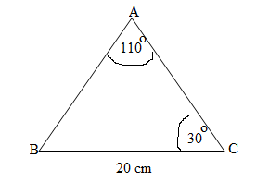

3. Solve the following quadratic equation by completing the square. (3 marks)

2x² – 5x + 3 = 0

4. Given the matrices A = $\left(\begin{matrix}3 & 2 \\ 4 & 1\end{matrix}\right)$ and B $\left(\begin{matrix}1 & -1 \\ 2 & 3\end{matrix}\right)$ and C = AB, find the inverse of C
(3 marks)

5. The equation of a circle is

x² – 8x + y² + 12y + 16 = 0

Determine the coordinates of the centre of the circle and its radius. (3 marks)

6. Solve the equation $\frac{2}{x- 1} - \frac{1}{x+2} = \frac{1}{x}$ (3 marks)

7. Given the column vectors a = $\begin{matrix}1 \\ -2 \\ 1\end{matrix}$ b= $\begin{matrix}6 \\ -3 \\ 9\end{matrix}$ c = $\begin{matrix}-3 \\ 2 \\ 3\end{matrix}$ and that P = 2a - $\frac{1}{3} b+c$

Express P as column vector and hence calculate it’s magnitude to 3 significant figures.
(3 marks)

8. The points A¹(3,-8) and B¹(-5,4) are the images of A and B under a transformation whose matrix is T$\left(\begin{matrix}3 & 1 \\ -1 & 2\end{matrix}\right)$. Find the co-ordinates of A and B (3 marks)

9. A man has 140 m of mesh wire with which he intends to fence a rectangular enclosure for rearing hens. Find the length of the enclosure which will give maximum area and hence calculate it’s area. (4 marks)

10. Jane travels at an average speed of 60 Km/h for 2 hours. She then travels a distance of 84 km at an average speed of 70 km/h. Calculate the average speed of the whole journey.
(2 marks)

11. In the figure below ABCDE is a pentagon inscribed in a circle. CX is a tangent to the circle at C and EDX is a straight line. <ADE = 34º, <CAD = 42º, AB = BC and BC is parallel to AD

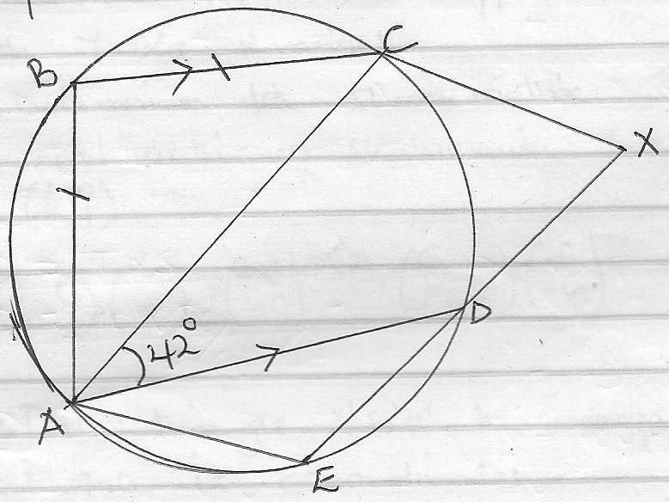

Determine giving reasons in each case

(a) <ABC (2 marks)

(b) <ACD (2 marks)

(c) <EAD (2 marks)

(d) <CXD (2 marks)

(e) Given length ED = 5 cm and DX = 4 cm, calculate length CX (2 marks)

12. On the grid provided draw triangle ABC whose co-ordinates are A(-6,5), B(-4,1) and C(3,2)
(1 mark)

(b) Given that A(-6,5) is mapped onto A¹(-6,-4) by a shear with Y-axis invariant

(i) Determine the shear matrix (2 marks)

(ii) Draw triangle A¹B¹C¹ the image of ABC under the shear and state it’s co-ordinates
(3 marks)

(c) Triangle A¹¹B¹¹C¹¹ is the image of triangle A¹B¹C¹ under the transformation whose matrix
is $\left(\begin{matrix}-1 & 0 \\ 1\frac{1}{2} & -1\end{matrix}\right)$

(i) Draw triangle A¹¹B¹¹C¹¹ and state it’s co-ordinates (2 marks)

(ii) Describe fully a single transformation which maps ABC onto A¹¹B¹¹C¹¹ (2 marks)

