**Name:……………………………………………………………… Index No.: ……………………...............**

**School:…………………………………………………………….. Sign.: ……………………………………….**

**Date:………………………………………...**

*Kenya Certificate of Secondary Education ( K.C.S.E )*

**232/1**

**PHYSICS**

**PAPER 1**

**(THEORY)**

**MARCH/APRIL 2018**

**TIME: 2 HOURS**

**KCSE MOCK EXAM 2018**

FORM 4

PHYSICS

PAPER 1

**INSTRUCTIONS TO CANDIDATES:**

* Write your **name, admission** **number** and the **name of your school** in spaces provided above.
* Sign and write the **date** of examination in the spaces provided above.
* This paper consists of sections: **A and B.**
* Answer **all** the questions in section A and B in the spaces provided below each question.
* **All** working **must** be clearly shown in the spaces provided.
* Mathematics tables and silent electronic calculators may be used.
* Take gravitational acceleration = 10 m/s2.

**FOR EXAMINER’S USE ONLY**

|  |  |  |  |
| --- | --- | --- | --- |
| **SECTION** | **QUESTION** | **MAXIMUM SCORE** | **CANDIDATE’S SCORE** |
| A | 1 – 11 | 25 |  |
| B | 12 | 9 |  |
| 13 | 9 |  |
| 14 | 9 |  |
| 15 | 9 |  |
| 16 | 9 |  |
| 17 | 10 |  |
| **TOTAL SCORE** | | **80** |  |

*This paper consists of 8 printed pages.*

*Candidates should check to ascertain that all pages are printed as indicated*

*and that no questions are missing.*

**SECTION A ( 25 MARKS)**

1. The figure 1 below shows the level of water in a measuring cylinder. 20 lead shots each of volume 0.5cm3 and dropped into the water. Indicate on the diagram the new level of water. (2mks)



2. A common thermometer has a thin-walled bulb and a very fine bore among other main features. State two other main features of a common thermometer. (2mks)

………………………………………………………………………………………………………………………………………………………………………………………………………………………………

3. The figure 2 is diagram of a manometer used to determine the density of a liquid. Given that the density of liquid B is 2000kg/m3, determine the density of the liquid A in SI units. (3mks)

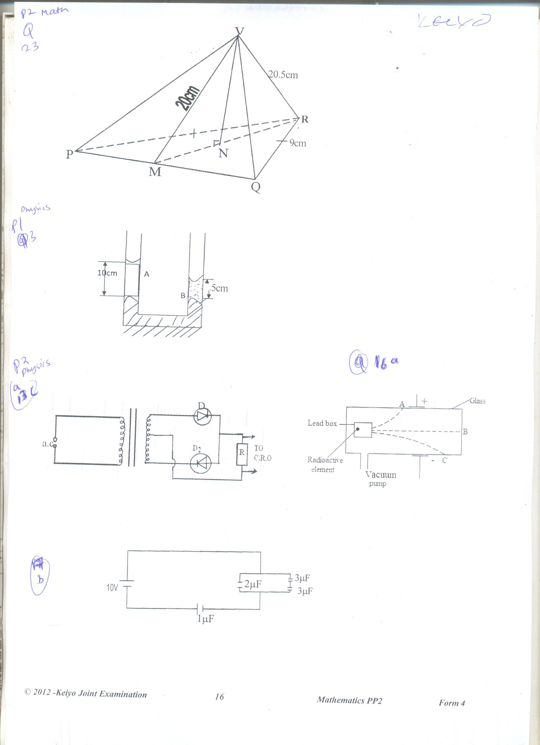

4. A drop of oil of volume 3.0 x 10-6m3 forms a patch of diameter 32cm on the surface of water. Determine the size of a molecule of oil. (3mks)

5. The figure below shows a simple fire alarm. When fire breaks the bell rings to alert people that there is fire. Explain briefly how the fire alarm works. (2mks)

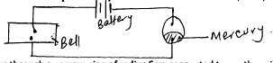

……………………………………………………………………………………………………………………………………………………………………………………………………………………………

………………………………………………………………………………………………………………………………………………………………………………………………………………………………

6. Water flows through a narrow pipe of radius 6cm connected to another pipe of radius 9cm. If the speed of water in the narrow pipe is 3m/s, determine the speed of water in the wider section. (3mks)

7. Pure water normally boils at 1000C. A student heated some water and noticed that it boils at a higher temperature than 1000C. State two possible reasons for this observation (2mks)

………………………………………………………………………………………………………………………………………………………………………………………………………………………………

8.. The rate of diffusion of a gas will depend on many factors. State two of these factors. (2mks)

………………………………………………………………………………………………………………………………………………………………………………………………………………………………

9. Explain why passengers traveling in a double-deaker bus are NOT allowed to stand in the upper decker of the bus. (2mks)

………………………………………………………………………………………………………………………………………………………………………………………………………………………………………………………………………………………………………………………………………………

10. A body starts from rest and attains a velocity of 72m/s in 10 seconds. It travels at this velocity for 5 seconds and then decelerates to rest after another 12 seconds sketch a velocity – time graph for the body’s motion. (3mks)

11. Define angular velocity. (1mk)

12. On the axis provided sketch a graph of pressure against volume for a fixed mass of gas. (1mk)

**SECTION B (55 MARKS)**

13. a) Distinguish between load and effort. (2mks)

………………………………………………………………………………………………………………………………………………………………………………………………………………………………

b) Explain why the efficiency of a machine is never 100% (2mks)

………………………………………………………………………………………………………………………………………………………………………………………………………………………………

c) A mason uses a six wheel pulley system to raise gravel in storey building for construction. He raises a weight of 2500N through a vertical height of 2.5m using the machine. If the mason pulls using an effort of 500N calculate;

i) The velocity ratio of the pulley system (1mk)

ii) The work done by the mason (2mks)

iii) The useful work done by the pulley system (2mks)

iv) The efficiency of the system (3mks)

14. a) State the law of flotation. (1mk)

b) What determines the depth to which a body sinks in a liquid? (1mk)

c) A student constructed a hydrometer for use in milk industry. State the modification he can make to increase the sensitivity of the hydrometer. (1mk)

d) Name this type of hydrometer (1mk)

e) State the Archimedes Principle (1mk)

f) A balloon of volume 9.0m3 is filled with hydrogen of density 0.18kg/m3 and held in position as shown. If it floats in air of density 1.3kg/m3 and the weight of the balloon envelope is 45N calculate the tension T. (3mks)

g) A solid object weighs 90N when suspended in air and 84N when immersed in water. When fully submerged in an acid it weighs 76N. Determine the relative density of the acid. (3mks)

15. a) State Hooke’s law (1mk)

……………………………………………………………………………………………………………… ………………………………………………………………………………………………………………

b) Define the term Spring Constant (1mk)

……………………………………………………………………………………………………………… ………………………………………………………………………………………………………………

i) State two factors that determine **spring constant**  (2mks)

……………………………………………………………………………………………………………… ………………………………………………………………………………………………………………

ii) The graph in the figure below was obtained when suitable weights were suspended from a spiral and extensions measured



Explain the shape of the graph between

AB (1mk)

……………………………………………………………………………………………………

………………………………………………………………………………………………………

CD (1mk)

……………………………………………………………………………………………………

………………………………………………………………………………………………………

c) Two identical spiral springs are then arranged in parallel and the weights suspended. On the same axes

above, sketch the graph that would now be obtained (2mks)

d) The pointer of an unloaded spring reads 32cm. when a mass of 120g is applied to the spring, the pointer reads 38cm. A pan, in which a mass of 210g is placed, is now suspended from the spring and the pointer reads 48cm. Determine the mass of the pan.

(3mks)

16. a) Define specific heat capacity of a substance. (1mk)

……………………………………………………………………………………………………

………………………………………………………………………………………………………

b) A block of metal of mass 150g at 1000C is dropped into a lagged calorimeter of specific heat capacity of 40JKg-1K-1 containing 100g of water of 250C. The temperature of the resulting mixture is 340C (specific heat capacity of water = 4200JKg-1K-1, mass of calorimeter=50g)

Determine:

i) Heat gained by calorimeter (2mks)

ii) Heat gained by water (2mks)

iii) Heat loss by the metal block (2mks)

iv) Specific heat capacity of the metal block (2mks)

17. a) State the law of conservation of momentum (1mk)

……………………………………………………………………………………………………

………………………………………………………………………………………………………

b) Distinguish between elastic and inelastic collisions (2mks)

……………………………………………………………………………………………………

………………………………………………………………………………………………………

c) A bullet of mass 22g traveling horizontally with a velocity of 300ms-1 strikes a block of wood of mass 1,978g which rests on a rough surface. After impact the bullet and the block move together and come to rest when the block has traveled a distance of 5cm.

Calculate

i) The velocity of the bullet and wood after impact. (2mks)

ii) The frictional force between the wood and the surface. (2mks)

d) A car starts from rest and accelerates uniformly at 2ms-1 for 5 seconds. It then travels at a constant velocity for the nest 3 seconds before accelerating again at 2.5ms-1 for 2 more seconds.

i) Sketch a velocity – time graph for this motion. (2mks)



iii) From the graph, calculate the total distance traveled by the car. (3mks)