Name:…………………………………………………………………….. Index. No.: ………
School:…………………………………………………………………… Sign.: ………………
Date:…………………

Kenya Certificate of Secondary Education ( K.C.S.E )

BUSINESS STUDIES
PAPER 2
FORM FOUR
MARCH/APRIL 2018
TIME: 2 1/2 HOURS

KCSE MOCK EXAM 2018
INSTRUCTIONS TO CANDIDATES:

- This paper consists of six questions
- Answer any five questions.
- Write your answers in the answer booklet provided
All questions carry equal

1.a) Explain five benefits that would accrue to a businessman who uses a Liner rather than Tramps Steamers (10mks)
b) Using a diagram, describe the effects of outward shift in supply curve on equilibrium price and quantity. (10mks)
2.a) Explain four measures that may be taken by the government to promote her export. (8mks)
b) The following Trial Balance was extracted from the books of Kisumu Auto spares as at 31stOct
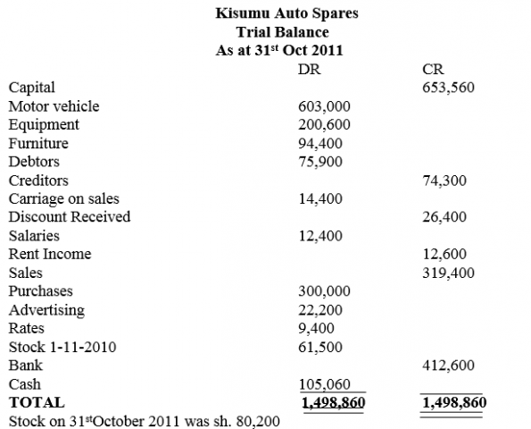
Required,
(i) Prepare Trading ,Profit and Loss account for the year ended 31stOct 2011
(ii) Prepare Balance sheet as at 31stOctober 2011 (12mks)
3.a) Explain Five circumstances under which a manufacturer would find it advisable to distribute his goods through wholesalers. (10mks)
b) Explain five functions of the central bank of Kenya in the Economy. (10mks)
4.a) Distinguish between shares and debenture as a source of finance. (10mks)
b) Outline five circumstances under which a firm will be located near the market for its products. (10mks)

5.
a) The following information relates to Bizna Distributor Company for the year ended 31stDec 2009
Required calculate
i) Margin (2 ½ mks)
ii) Rate of stock turnover (2 ½ mks)
iii) Return on capital employed (2 ½ mks)
iv) Current ratio (2 ½ mks)
b) Explain five ways in which the Entrepreneur contributes to the production of goods. (10mks)
5.a) Describe five ways in which the price of a product can be determined in a market. (10 mks)
b) Explain five benefits of mobile phone money transfer services. (10 mks)

