Name:………………………………………………………………… Index No.: ……………………...

School:……………………………………………………………… Sign.: …………………………...

Date:……………………………

Kenya Certificate of Secondary Education ( K.C.S.E )
121/1
MATHEMATICS
PAPER 1
JULY/AUGUST 2018
TIME: 2 ½ HOURS

KCSE MOCK EXAM 2018

FORM 4
MATHEMATICS
PAPER 1
INSTRUCTIONS TO CANDIDATES:
- Write your name, admission number and the name of your school in spaces provided above.
- Sign and write the date of examination in the spaces provided above.
- This paper consists of two sections: Section I and II.
- Answer all the questions in section I and any five questions from section II.
- All working and answers must be written on the question paper in the spaces provided below each question.
- Show your all steps in your calculations, giving your answers at each stage in the spaces provided below each question.
- Marks may be given for correct working even if the answer is wrong.
- Non-programmable silent electronic calculators and KNEC mathematical tables may be used.
- Candidates will be penalized for Not following the instructions given in this paper.

SECTION I (50 Marks)
1.Evaluate without using calculator or mathematical tables leaving your answer as a simplified fraction.(2mks)
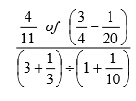
2.What is the exact value of 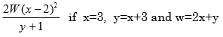(2mks)
3.Oketch sells his car to Jane and makes a profit of 17%. Jane sells the same car to Issa at Sh.300, 000, making a loss of 10%. Determine the price at which Oketch bought the car.(3mks)
4.The figure below shows vectors a and b. Construct on the same grid, c given that 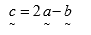
(3mks)
5.
In a book store, books packed in cartons are arranged in rows such that there are 50 cartons in the first row, 48 cartons in the next row, 46 in the next and so on. a) How many cartons will be there in the 8th row?
b) If there are 20 rows in total, find total number of cartons in the book store.(4mks)
6.
At 90km/h, a car takes 2 hours to cover a distance A to B. How long would it take to cover the same distance if the car was travelling at 120km/h?(2mks)
7.Solve for x and y in the equation (3 mks)
8.A sales man earns a basic wage of Ksh 1,500 per week. In addition , he is paid commission per week as follows:
Commission
For sales up to Ksh 50,000 0%
For sales above Ksh 50,000
i) For the first Ksh 25,000 2%
ii) For the next Ksh 25,000 2 ½ %
iii) For any amount above Ksh100, 000 5%
During that week, he sold goods worth Ksh 115,000.What was his total pay for that week?(4mks)
9.The coordinates of the points P and Q are (1, -2) and (4, 10) respectively. A point T divides the line PQ in the ratio 2:1
a) Determine the coordinates of T (2mks)
b) Find the equation of the line perpendicular to PQ and passing through T. (2mks)
10.A salesman gets a commission of 2.4% on sales up to sh.100, 000.He gets additional commission of 1.5% on sales above this. Calculate the commission he gets for sales worth sh.280, 000.(3mks)
11. The figure below shows an arc ACE of a circle with centre O and radius 6cm. If BC=CD=4cm, calculate the area of the shaded region if DE=AB =1.53cm(4 mks)
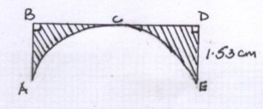
12. The diagram below shows part of the quadrilateral PQRS.

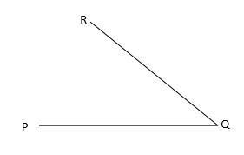

Given that 2RS=RQ and that PQRS is a cyclic quadrilateral, complete the diagram.(3 mks)
13. A poultry farmer has twenty times as many hens as turkeys and three quarters as many ducks as turkeys.
a) If there are t, turkeys, write down a simplified expression in terms of t for the total number of birds on the farm. (1mk)
b) Given that he has 72 ducks, calculate as a percentage the sum of turkeys and ducks to the number of hens on the farm. (4mks)
14. The sum of angles of a triangle is given by the expression (2a+b) 0 while that of a quadrilateral is given by (13a-b) ⁰ Calculate the values of a and b(3 mks)
15.
The table below represents the marks scored by form 4 students in an end of term examination
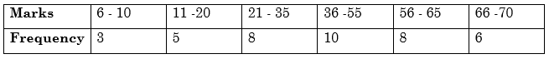
Calculate the upper quartile.(2 mks)
16.
. Determine the inequalities that represent and satisfy the unshaded region below.(3 mks)

SECTION II (50 Marks)
Attempt only FIVE questions from this section
17.
The figure below shows a portable Kennel.
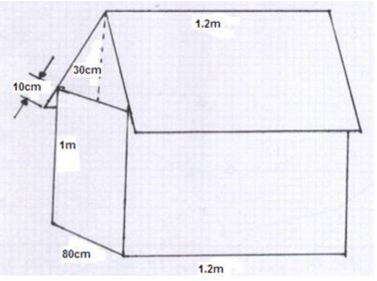
a) Calculate i) The total surface area of the walls and the floor. (2mks)
ii) The total area of the roof. (2mks)
b) The cost of roofing is Ksh 500 per square meter and that of making walls and floor is Ksh 600 per m2.Find the cost of making the Kennel. (2mks)
c) Find the cost of roofing another Kennel whose dimensions are 50% more than those of the given Kennel. (2mks)
d) Calculate the volume of air inside the Kennel in cm3. (2mks)
s
18.
Given the coordinates of the points A, B and C as (3,-2); (6, 4) and (9, 3) respectively. a) Express the following vectors in terms of
i) AB (1mk)
ii) CB (1mk)
b) Calculate the magnitude from A to C through B. (3mks)
c) Determine the coordinates of the mid point of AC. (2mks)
d) If R divides AC externally in the ratio 3:1, determine the coordinates of R. (3mks)
19.
Triangle ABC has vertices A(-5,-3),B(-3,-5) and C(-3,-1).
a) Plot triangle ABC and its image A1B1C1 under reflection in the line y=-x. (3mks)
b) A^{II}B^{II}C^{II} is the image of AIBICI under rotation centre (0,0) through a positive quarter turn. Plot A¹¹B¹¹C¹¹ and state its co-ordinates.
c) A³B³C³ with coordinates A³( 7.5,-4.5),B3(4.5,-7.5) and C³(4.5,-1.5) is the image of A¹¹B¹¹C¹¹ under a certain transformation. Plot A³B³C³ and describe this transformation. (2mks)
d) A⁴(5,-1.5) is the image of A³ under translation. State the co-ordinates of B⁴
and C^{4.}
20.
Four towns P, Q, R and S are such that town Q is 120km due east of town P. Town R is 160km due north of town Q, town S is on a bearing of 3300 from P and on a bearing of 3000 from R
a) Using ruler and compasses only, show the relative positions of towns P,Q,R and S. Take a scale of 1cm rep 50km. (5mks)
b) Determine i) The distance SP in km (2mks)
ii) The bearing of S from Q (1mk)
iii) How far north, S is, from line QP produced. (2mks)
21.
and at their centres respectively and intersect at P and Q as shownθθThe figure below shows two intersecting circles of centres C and D radii 16cm and 20cm respectively. The two circles subtend angles 2 1
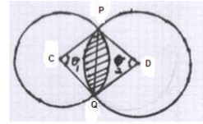
a) Given that the area of triangle PCQ is 80.14cm2,calculate the size of
i) The angle marked (2mks)
ii) The angle marked
(3mks)
b) Calculate the area of the shaded region. (5mks)
22.
A private farmer in Mwea produced 14,400bags of rice in 2008. This was a decrease of 20% over the production in 2007. In 2009 he increased production by 30%. In 2010, he managed to produce 12,000 bags of rice.
a) Find the number of bags of rice he produced in;
i) 2007 (2mks)
ii) 2009 (2mks)
b) What was the percentage decrease in production in 2010 over that of previous year? (2mks)
c) Calculate the percentage decrease in production in 2010 over that in 2007 (2mks)
d) The price per bag of rice was Ksh 3500 in 2010, how much did he get if he sold 65% of the produce in that year. (2mks)
23.
The diagram below (not drawn to scale) shows the position of a harbor H and three islands A,B and C. C is due North of H. The bearing of A from H is 062⁰ and angle HAB=1280 HA=54km and AB=31km
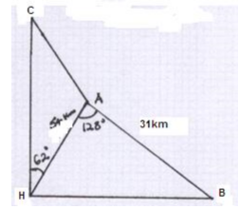
a) Calculate the distance HB (3mks)
b) Find the bearing of B from A (1mk)
c) Given that the bearing of A from C is 1330, calculate AC (3mks)
d) A light ship L is positioned due North of H and equidistant from A and H. Calculate HL. (3mks)
24.
. The table below gives some of the values of x and y for the function in the interval
a) Complete the values in the table above. (1mk)
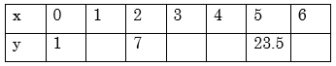
b) Use the values in the table to draw the graph of the function on the grid provided below. (2mks)
c) Using the graph and the mid- ordinate rule with 6 strips, estimate the area bounded by the curve, the x –axis, the y-axis and the line x=6 (3mks)
d) Using integration, calculate the exact area and hence find the percentage error made when mid-ordinate rule is used . Give your answer correct to 2d.p. (4mks)

