Name: .............................................................................................. INDEX No. ........................
School: ............................................................................................ Signature: .............................
Date: .....................................

The Kenya Certificate of Secondary Education (K.C.S.E)
AGRICULTURE
PAPER 1
FORM FOUR
MARCH/APRIL 2018
TIME: 2 HOURS

KCSE MOCK EXAM 2018

INSTRUCTIONS TO CANDIDATES:
- Write your name and index number in the spaces provided
- This paper consists of three sections A, B and C
- Answer all questions in section A and B and any TWO questions from section C.

SECTION A (30 Marks)
- Give two advantages of growing one type of annual crop on the same piece of land continually

List four sources of organic matter in soil(2mks)
3.
State three objectives of land settlement which have been under taken in Kenya(1.5 mks)
ks
4.
State three effects of excessive application of nitrogenous fertilizer on crop growth(1.5 mks)
5. State four advantages of using organic matter for mulching.

(2 mks)
6.
Outline two routine maintenance practices carried out on water storage tanks(1mks)
s
7.
State four characteristics of a fertile soil(2 mks)
8.
Give two ways by which losses are incurred in silage9(1mk)
9.
Define the following terms a) “Economic injury Level” of a crop pest (1 mk) ____________________________________________________________________________ ____________________________________________________________________________ ____________________________________________________________________________ ____________________________________________________________________________
b) Opportunity cost (1 mk)
____________________________________________________________________________ ____________________________________________________________________________
c) Marginal product (1 mk)
____________________________________________________________________________ ____________________________________________________________________________
10.
Give a reason for each of the following practices
a) Top dressing established crops (1 mk)
____________________________________________________________________________ ____________________________________________________________________________
b) Topping in pasture management (1 mk)
____________________________________________________________________________
____________________________________________________________________________
c) Stooking in maize production (1 mk)
____________________________________________________________________________ ____________________________________________________________________________
11.
Give three reasons why seedlings may fail to establish in the field
12.
List three types of surface irrigation in crop production
13.
State two roles of house hold – firm relationship
14.
Define the following terms a) Per capital income (1 mk) ____________________________________________________________________________ ____________________________________________________________________________ ____________________________________________________________________________ ____________________________________________________________________________
b) Land reform (1 mk)
____________________________________________________________________________
15.
List two types of terraces(1mk)
16.
List two methods used to drain farm land(1mk)
17.
Give two varieties of carrots(1mk)
Carrot................................................................
18.
Differentiate the following terms a) Hybrid and composite in maize (1 mk) ____________________________________________________________________________ ____________________________________________________________________________
b) Undersowing and oversowing (1 mk)
____________________________________________________________________________ ____________________________________________________________________________
19. State two characteristics of a good rootstock for grafting

SECTION B (20 Marks)
20.
Study the diagram below and answer the question that follows.

i) Identify the pest that has attacked the crop as illustrated above (1 mk) ______________________________________________________________________ ______________________________________________________________________ ______________________________________________________________________
ii) Give two control measures against the pest (2 mks) ______________________________________________________________________
21.
Study the diagrams below showing soil sampling method

a) Identify the method illustrated (1 mk)
A._______________________________________________________________________
B _______________________________________________________________________
b) Describe in brief the procedure of sampling (3 mks)
______________________________________________________________________ ______________________________________________________________________
c) Give three information that should be indicated on the sample bag (1 ½ mks)
______________________________________________________________________
22.
The diagram below shows a weed plant labeled C.

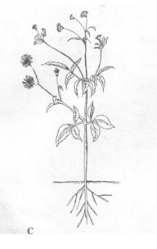

i) Identify the weed plant (½mk)
______________________________________________________________________________
ii) State two reasons for controlling the weed labeled C in a crop field (1mk) ______________________________________________________________________________ ______________________________________________________________________________ ______________________________________________________________________________ ______________________________________________________________________________
iii) State one herbicide that can be used to control the weed in a field of growing maize (1mk) ______________________________________________________________________________ ______________________________________________________________________________
iv) At what stage of growth of maize should a post emergence herbicide be applied? (½mk) ______________________________________________________________________________ ____________________________________________________________________________
22.
Observe the diagram below carefully and answer question below
a) What does diagram Y illustrate (1 ½ mk)
______________________________________________________________________ ______________________________________________________________________ ______________________________________________________________________
b) Name the part labeled (2 mks)
Q_____________________________________________________________________ R.____________________________________________________________________ S.____________________________________________________________________ T_____________________________________________________________________
c) Give three importances of illustration Y to a farmer (1½ mks) ____________________________________________________________________________ ____________________________________________________________________________ ____________________________________________________________________________
5 marks
24.
a) What is production function? (1 mk)
____________________________________________________________________________ ____________________________________________________________________________ ____________________________________________________________________________
b) Name and describe three production zones in agriculture (3 mks) ____________________________________________________________________________

SECTION C (40 Marks)
25.
Describe field production of napier grass under the following sub headings
a) Seedbed preparation (5mks)
b) Planting (5 mks)
c) Fertilizer application (2 mks)
d) Weed control (5 mks)
e) Utilization (3 mks)
26.
a) Mention and explain five sites for agro-forestry trees in the farm (10 mks)
b) Explain the factors to consider in choosing the type of irrigation in the farm (10 mks)

27.
The following is a supply and demand schedule of eggs by teachers in chuth ber High school.

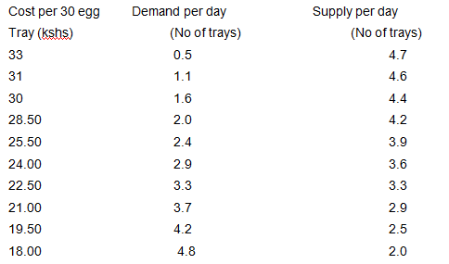

i) Using the same axis with price on the vertical axis, draw the two graphs to indicate the
relationship between price demand and supply (6 mks)
ii) Name the point of intersection of the two graphs (1 mk)
iii) What is the price of eggs per tray at the point of intersection? (1 mk)
iv) What is the supply and demand of eggs at the point of intersection ( 1 mk)
v) What is the price at supply of three trays (1 mk)
b) Describe factors which determine demand of a commodity ( 5 mks)
c) Outline the agricultural services available to farmers (5 mks)

