Name:…………………………………………………… Adm. No.: ……………………...

School:………………………………………………….. Sign.: ………………………………

Date:………………………………..

Kenya Certificate of Secondary Education ( K.C.S.E )
121/2

MATHEMATICS ALT. A

PAPER 2

JULY/AUGUST 2018

TIME: 2 ½ HOURS

KCSE MOCK EXAM 2018

INSTRUCTIONS TO CANDIDATES:
- Write your name, admission number and the name of your school in spaces provided above.
- Sign and write the date of examination in the spaces provided above.
- This paper consists of two sections: Section I and II.
- Answer all the questions in section I and any five questions from section II.
- All working and answers must be written on the question paper in the spaces provided below each question.
- Show your all steps in your calculations, giving your answers at each stage in the spaces provided below each question.
- Marks may be given for correct working even if the answer is wrong.
- Non-programmable silent electronic calculators and KNEC mathematical tables may be used except where stated otherwise..
- Candidates will be penalized for Not following the instructions given in this paper.

SECTION A (50 Marks)
Answer all the questions in this section in the spaces provided.
1. Simplify completely 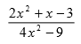)(3mks)

2.
Pipes S and T can fill a tank in 2 hours and 3 hours respectively. Pipe U can empty the full tank in 4 hours.
How long will it take to fill the tank with all the pipes running? )(3mks)

3.
Make d the subject in the given formula. 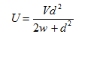

3 marks
4.
In the figure below, the tangents DC and BC meet at point C, angle BCD=50⁰ while angle ABE=70⁰
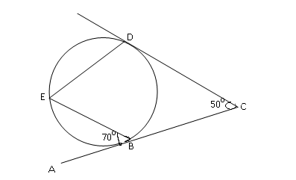
Calculate the sizes of angles)(3mks)

i) <CBD
ii) <CDE
5.
Solve for x in the equation below. )(3mks)

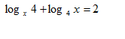
6.
Solve the equation 3 Sin 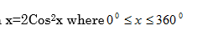(4 mks)
7.
In the diagram below, CD is a tangent to the circle at point D. If BC=7cm and CD=9cm, calculate the length of the chord AB. )(3mks)

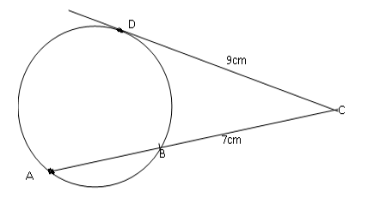
8.
Calculate the relative error 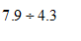)(3mks)

9.
Determine the semi-interquartile range for the given set of data. 40,20,30,42,10,18,26,32
(3mks)

10.
a) )(3mks)
Expand 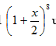up to a term in x³
b) Use the expansion in(a)above to find the value of (0.9)⁸
11.
Mrs. Ondiek invested Ksh63560 in a bank where the interest was compounded quarterly at the rate of 12% per month. Determine the amount of money she had after 2 ½ years. )(3mks)

12.
. Simplify without using mathematical tables or calculator. 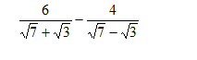

3 marks
13.
The figure below is a square –based pyramid with vertex V. Point O is the intersection of diagonals AC and BC. VA=VB=VC=VD=12cm and AB=BC=4cm.
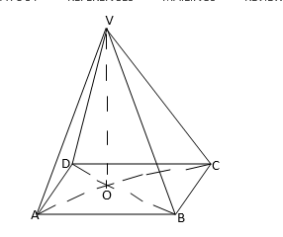
a) Name the projection of line VA on plane ABCD.
b) Find the angle between line VB and the plane ABCD. (3mks)

14.
An equation of a curve is given as
Find the equation of the tangent to the curve at x=1(3mks)

15.
Find the equation of a circle whose diameter has the end points (-2,6) and 6,2)(3mks)
16.
The distance between two places 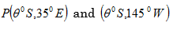
on the earth via
South Pole is 3240nm. Find
a) the value of θ^{0.}
b) the distance between P and Q along the parallel of latitude in nautical miles(4 mks)

SECTION B (50 Marks)
Answer only five questions in this section.
17.
. The table below shows income Tax rates
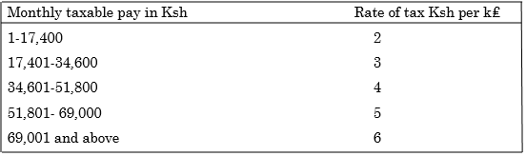
Faith earns a monthly basic salary of Ksh 45,000 and she is also given taxable allowances amounting to Ksh 20480 per month.
a) Calculate Faiths’ gross income tax per month. (4mks)
b) Faith is entitled to a personal tax relief of Ksh 1162. Determine her net income per month. (2mks)
c) Faith received 50% increase in her total income; calculate the corresponding percentage increase on the net income tax. (4mks)
18.
In the figure below, E is the midpoint of BC,AD:DC=3:2 and AE intersect with BD at
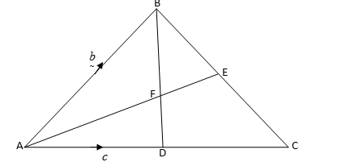

c) What is the ratio in which F divides . AE(10 mks)
19.
Using a ruler and a pair of compasses only. a) Construct
a ∆ABC in which AB =7.4cm, AC=8.2cm and <BAC=45^{0.}
b) On the same diagram, construct ∆ACD such that D, and B are on the opposite sides of line AC, D is equidistant from A and C and BD=8.5cm. Measure AD.
c) Draw locus of Q which passes through C and is parallel to BD.
d) The normal from C meets BD at N. Mark the points M1 and M2 on the locus of Q such that M₁N=M₂N=4.1cm.
Measure the lengths M₁M₂ and CN. (10 mks)
20.
. a) i) On the grid (graph paper) plot and draw triangle ABC where A(4,3),B(4,6) and C(7,6) .
GRID
ii) Triangle ABC is given a rotation of +900 about (0,0) to map onto A^{I}B^{I}C^{1.}Plot A^{I}B^{I}C^{I} and state its co-ordinates.
iii) Triangle A^{I}B^{I}C^{I}is transformed by the matrix
to map onto A¹¹B¹¹C¹¹
Plot A¹¹B¹¹C¹¹ and state its co-ordinates.
b) AIIBIICII is further transformed by a reflection on the line x=0 to map onto A^{III}B^{III}C^{III.} Plot A^{III}B^{III}C^{III}
What single transformation will map A¹¹¹B¹¹¹C¹¹¹ onto triangle ABC? (10 mks)
21.
. A particle P moves in a straight line so that its velocity Vm/s at time t seconds where 0

Find
a) The time when P is instantaneously at rest.
b) The speed of P at the instant when the acceleration of P is zero.
c) Given that P passes through point O of the line when t=0
i) Find the distance of P from O when P is instantaneously at rest.
ii) Find the distance covered by the particle during the 3rd second. (10 mks)
22.
. The table below shows the masses in kg of some form three students in a school.
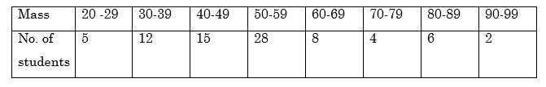
a) i) State the median class.
ii) Using an assumed mean of 54.5, calculate the mean mass
b) Calculate the standard deviation of the data, give your answer correct to 2 decimal places(10 mks)
23.
The probability that it will rain on a certain morning is1/3 . If it rains, the probability
that Sagero misses the bus is 3/4 . If it does not rain, the probability that he catches
the bus is
5/6 .
a) Represent the above information in a tree diagram.
b) Calculate the probability that on a given morning
i) it rains and he catches the bus.
ii) it rains and he misses the bus.
iii) he misses the bus.
iv) it does not rain and he misses the bus. (10 mks)

24. A small scale farmer wishes to buy some sheep and goats for rearing. A sheep costs sh.400 and a goat costs sh.300. The farmer has enough space for only 20 animals and may spend at most sh.6800. The number of goats should not exceed twice the number of sheep.
a) By letting x and y to represent the number of sheep and goats he can buy respectively, write down all inequalities from the above information.
b) Represent the inequalities on the grid(10 mks)

