NAME: ……………………………………………… ADM NO:………………………………………….

312/1
GEOGRAPHY
PAPER 1
TIME: 2 ¾ HOURS

NYAKWADHA MIXED SECONDARY SCHOOL
END OF TERM I EXAMINATION - 2019
Kenya Certificate of Secondary Education
Geography Paper 1

INSTRUCTIONS:

- The paper comprises of two sections A and B.
- Attempt all question in section A.
- In section B, answer question 6 and choose any other two.
- Use separate answer sheets for each question in section B.
- The candidate should check to ascertain that all the questions have been printed

SCORE SHEET

SECTION A
QUESTIONS 6
QUESTION 7
QUESTION 8
QUESTION 9
QUESTION 10
TOTAL | %

- What is the relationship between Geography and mathematics? (2mks)
- Give three reasons why it is important to study geography. (3mks)
- The diagram below represent the structure of the earth. Use it to answer question a)
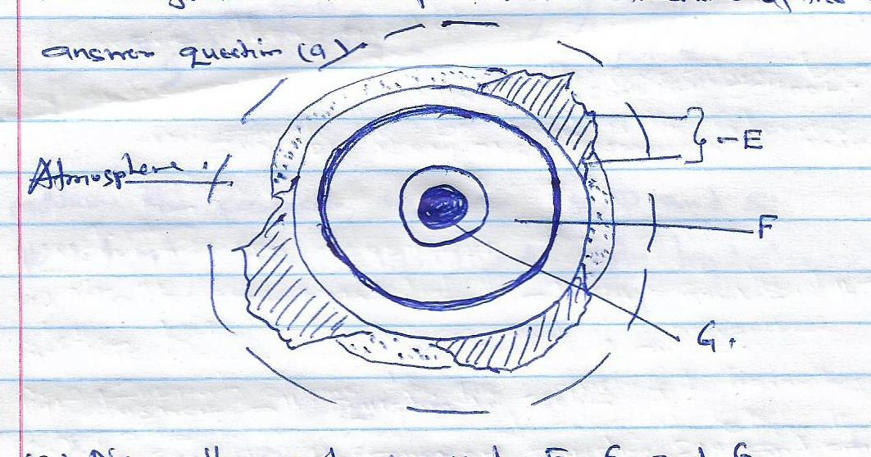
- Name the parts marked E, F and G. (3mks)
- Give two effects of the rotation of the earth on its axis. (2mks)

- Define the term weather. (2mks)
- The diagram below represents a measuring instrument.
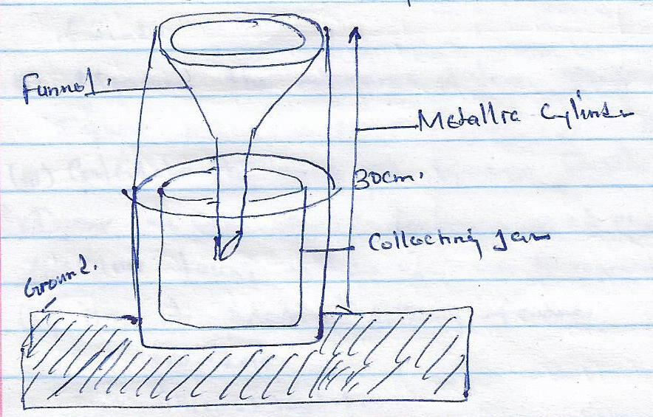
- Which element of weather is measured using the instrument. (1mk)
- Describe how the above instrument is used. (2mks)

- What is a rock? (2mks)
- Give the characteristics of sedimentary rocks. (3mks)

- The diagram below shows the hydrological cycle. Use it to answer the question that follow:
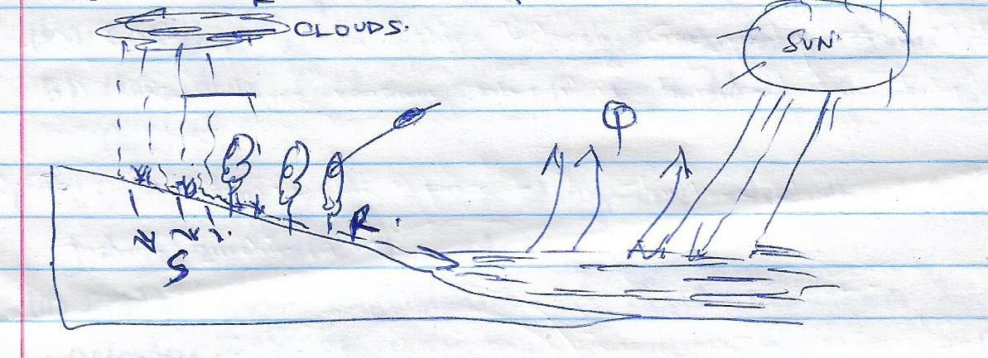
- Name the parts marked R, Q and S. (3mks)
- List two significance of hydrological cycle. (2mks)
SECTION B
ANSWER QUESTION SIX AND ANY OTHER TWO QUESTIONS
- Use the map of Taita Hills 1: 50,000 to answer the questions that follow.

- List the two types of scale used with Taita Hills map. (2mks)
- What is the magnetic declination as at January 1991. (1mk)

- Name the provinces and the district where Taita Hill Map is found. (2mks)
- Measure the distance of lose surface road from Maktau grid square 2213 to Mission grid square 2418 in kilometers. (2mks)
- Calculate the area of Ronge forest in kilometers .(2mks)

- Draw a cross section between grid reference 390177 and 445200 taking a scale of 1cm represent 20m.
- On it mark the following feature
- Bridge (1mk)
- Thicket vegetation.
- Loose surface road.

- Describe the drainage of the Taita Hills. (4mks)
- With evidence state any two economical activities in Taita Hills. (2mks)
- Taita Hill map is which type of a map. (1mk)

- Name two types of boundaries according to the plate tectonic theory .(2mks)

- Give three effects of the movements of the tectonic plates. (3mks)
- Name the fold mountain in East Africa where glacier is found. (3mks)

- With the aid of a diagram describe how fold mountains are formed. (10mks)
- Explain four significance of fold mountains to human activities. (8mks)

- What is mass wasting? (2mks)
- Give two processes of slow mass movement. (2mks)
- State two physical condition that may influence landslide. (2mks)

- Describe the following process of mass wasting. (4mks)
- Rock fall
- Mud flow
- Identify methods of data collection in an area where mass wasting has occurred. (3mks)

- Explain four effects of mass wasting on the environment. (8mks)
- Give four processes of hydrological cycle. (4mks)

- What is an earth quake? (2mks)
- List three causes of earthquake. (3mks)
- Explain any four negative effects of earthquake. (8mks)
- Describe the following processes of weathering.
- Alternate wetting and drying. (3mks)
- Carbonation. (3mks)

- Differentiate between weathering and mass wasting. (2mks)
- Give four significance of weathering. (4mks)
- The map of Kenya drawn below show some climatic regions. Use it to answer a)
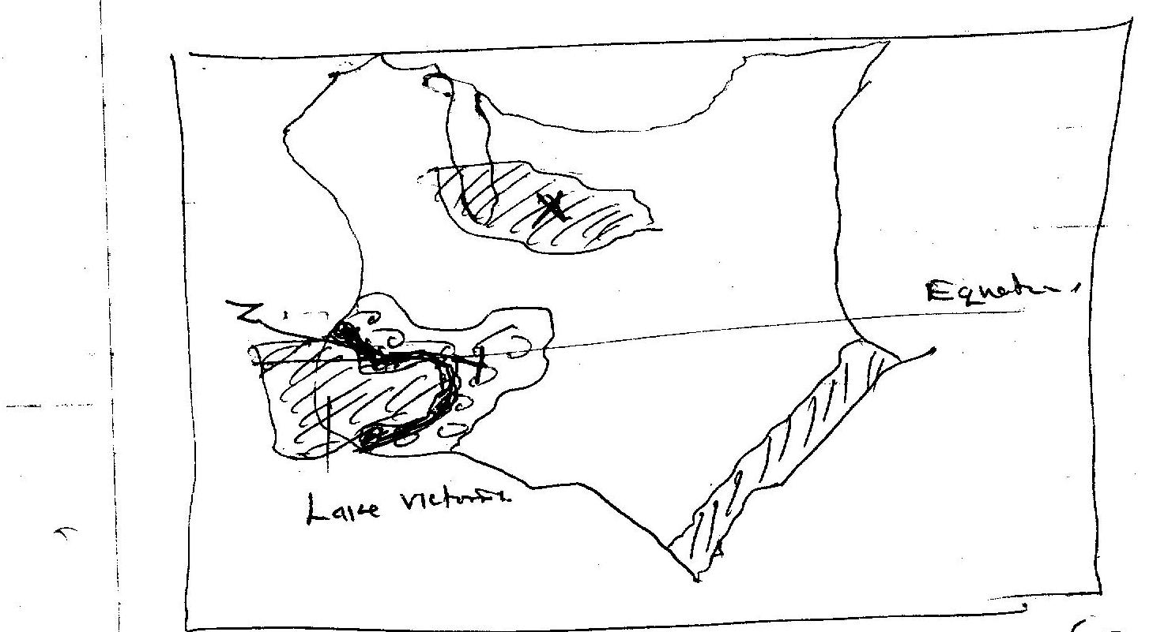

- Name the climatic region marked X and Y. (2mks)
- State four characteristics of the climate marked Z. (4mks)
- Explain how each of the following factors influence climate:
- Attitude. (4mks)
- Ocean currents (4mks)

- Use the table below to draw the bar graph to represent the rainfall figures. Use vertical scale of 1cm represents 10mm. (8mks)

Month | J | F | M | A | M | J | J | A | S | O | N | D
Temp ºc | 24 | 22 | 23 | 22 | 19 | 17 | 17 | 18 | 19 | 20 | 22 | 23
Rainfall mm | 109 | 122 | 130 | 76 | 52 | 34 | 28 | 38 | 70 | 108 | 121 | 120

- Describe the rainfall at the station. (3mks)

