Name………………………………………………………. IndexNo…………………/…….
Adm number……………… Stream……………. Candidate’s Signature…………… ………….Date………………………………..

121/1
MATHEMATICS
PAPER 1
SEPT/OCT 2018
TIME: 2 ½ HRS

ORIWO BOYS HIGH SCHOOL
POST MOCK EXAMINATION
Kenya Certificate of Secondary Education (K.C.S.E)

INSTRUCTIONS TO CANDIDATES.
- Write your name, index number,

- adm. number and stream in the spaces provided above
- The paper contains two sections: section I and section II
- Answer ALL questions in section I and ANY FIVE questions in section II
- All answers and working must be written in the blank spaces provided below each question
- Marks may be given for correct working even if the answer is wrong
- Non – programmable and silent Electronic calculators and mathematical tables may be used unless stated otherwise.
FOR EXAMINER’S USE ONLY
SECTION I
1 | 2 | 3 | 4 | 5 | 6 | 7 | 8 | 9 | 10 | 11 | 12 | 13 | 14 | 15 | 16

SECTION II
17 | 18 | 19 | 20 | 21 | 22 | 23 | 24

Grand Total

This paper consists of 14 printed pages .Candidates should check the question paper to
Ensure that all the pages are printed as indicated and no questions are missing.
Answer all the questions in this section

- Evaluate without using mathematical tables $\left(1000\sqrt{\frac{0.0128}{200}}\right)$ (3mks)

- Factorize a² – b² (1mk)

Hence find the exact value of 2557² - 2547² (2mks)

- The mass of 6 similar books and 4 similar biology books is 7.2 kg. The mass of 2 such art books and 3 such biology books is 3.4 kg. Find the mass of one art book and mass of one biology book. (3mks)

- A salesman gets a commission of 2.4% on sales up to Kshs 100.00. He gets an additional commission of 1.5% on sales above this. Calculate the commission he gets on sales worth Kshs 280.000

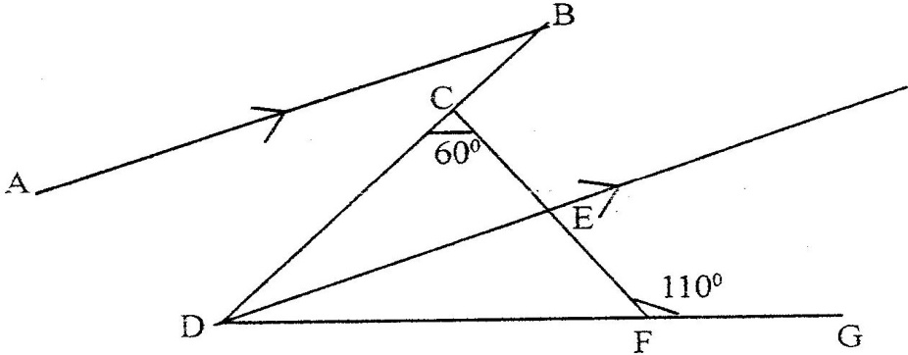
- In the figure below, AB is parallel to DE, DE bisects angle BDG, angle DCF = 60⁰ and angle CFG = 110⁰

Find, giving reasons for your answers,

  - $<$ CDF (2mks)

(b) $<$ ABD (2mks)

- A point A is directly below a window. Another point B is 15 m from A and at the same horizontal level. From B angle of elevation of the the bottom of the window is 30$°$and the angle of elevation of the top of the window is 35$°$. Calculate the vertical distance.
  - From A to the bottom of the window (1mk)

  - From the bottom to top of the window (2mks)

- The third and fifth term of an arithmetic progression are 10 and -10 respectively
    - Determine the first and the common difference

    - The sum of the first 15 terms
- A matrix A is given by A = $\left(\begin{matrix}x & o \\ 5 & y\end{matrix}\right)$

(a)Determine A² (1mk)

(b)Given that A²=$\left(\begin{matrix}1 & 0 \\ 0 & 1\end{matrix}\right)$,Find the values of x and y (2mks)

- Given that log y = log (10^{n} ) make n the subject. (3mks)

- A quantity T is partly constant and partly varies as the square root of S.Using constants a and b, write down an equation connecting T and S.If S = 16, when T = 24 and S = 36 when T = 32, find the values of the constants a and b (3mks)

- A cylindrical container of radius 15cm has some water in it. When a solid is submerged into the water, the water level rises by 1.2 cm.If the solid is a circular cone of height 9 cm, calculate the radius of the cone to 2 decimal places. (3mks)

- Six weeks after planting the height of bean plants were measured correct to the nearest centimeter. The frequency distribution is given in the table below.
Height (x) | 0 ≤ x ≤ 4 | 4 ≤ x ≤ 8 | 8≤ x ≤ 12 | 12 ≤ x ≤ 16 | 16 ≤ x ≤ 20
Frequency | 3 | 8 | 19 | 14 | 6
Cumulative Frequency

- Enter the cumulative frequency values in the above table (1mk)

- Estimate the median height of the plants (2mks)

- A financial institution charges compound interest on money borrowed. A business woman borrowed Kshs. 16, 000 from the financial institution. She paid back Kshs 25,000 after 2 years. Find the interest rate per annum. (3mks)

- Solve the equation cos (3θ + 120⁰) = √³/₂ for 0 ≤ θ ≤ 180⁰ (3mks)

- The radius of circle is given as 2.8 cm to 2 significant figures.If C is the circumference of the circle, determine the limits between which ^{C}/∏ lies (3mks)

- A and B are towns 360 km apart. An express bus departs form A at 8 am and maintains an average speed of 90 km/h between A and B. Another bus starts from B also at 8 am and moves towards A making four stops at four equally spaced points between B and A. Each stop is of duration 5 minutes and the average speed between any two spots is 60 km/h. Calculate distance between the two buses at 10 am. (3mk)

SECTION II:ATTEMPT ANY 5 QUESTIONS IN THIS SECTION.
17. Line QR = 6.5cm is given below:-(Do not use a protractor for this question)
(a) Draw triangle PQR such that P lies above line QR, ∠ PQR = 30º and PQ = 7cm (2mks)

Q
R

(b) By accurate construction on the diagram above, show the locus of a point which lies within the triangle such that:-
  - T is more than 2.5cm from line PQ and (2mks)

(ii) T is not more than 4.5cm from Q (2mks)
Shade the region in which T lies

(c) Lines QP and QR are produced to K and M respectively
(i) Show by construction on the diagram above, the locus of a point C which is
equidistant from each of the lines PK, PR and RM (2mks)

(ii) With centre C and an appropriate radius, draw a circle to touch each of the lines PK, PR and RM only once .Measure the radius (2mks)

END

18. The diagram below shows the speed-time graph for a bus traveling between two towns. The bus starts from rest and accelerates uniformly for 50seconds. It then travels at a constant speed for 150seconds and finally decelerates uniformly for 100seconds.

Speed m/s
30 Time in seconds 80

30

0 130

Given that the distance between the two towns is 2700m, calculate the ;
- maximum speed in km/h, the bus attained (3mks)

- acceleration (3mks)

- distance the bus traveled during the last 50seconds (2mks)

- time the bus takes to travel the first half of the journey (2mk)

19.On the Cartesian plane below, triangle PQR has vertices P(2, 3), Q ( 1,2) and R ( 4,1) while triangles P” Q “ R” has vertices P” (-2, 3), Q” ( -1,2) and R” ( -4, 1)
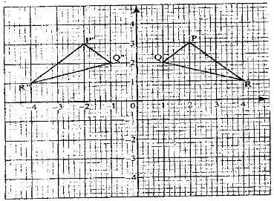

- Describe fully a single transformation which maps triangle PQR onto triangle P”Q”R”
(2mks)

(b) On the same plane, draw triangle P’Q’R’, the image of triangle PQR, under reflection in line
y = -x (2mks)

- Describe fully a single transformation which maps triangle P’Q’R’ onto triangle P”Q”R
(2mks)

- Draw triangle P”Q”R” such that it can be mapped onto triangle PQR by a positive quarter turn about (0, 0) (2mks)

(e) State all pairs of triangle that are oppositely congruent (2mks)
20.The figure below represents a model of a solid structure in the shape of frustrum of a cone with ahemisphere top. The diameter of the hemispherical part is 70cm and is equal to the diameter of thetop of the frustrum. The frustrum has a base diameter of 28cm and slant height of 60cm.

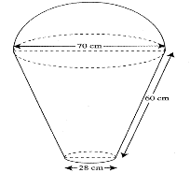

Calculate:
- The area of the hemispherical surface (2mks)

- The surface area of frustrum (2mks)

- The area of the base (2mks)

(e) The total surface area of the model (2mks)

21.Four towns P,Q,R, and S are such that town Q is 120km due east of town P. Town R
is 160km due north of town Q. Town S is on a bearing of 330⁰ from P and on a bearing of 300⁰ from R. Use a ruler and compasses ONLY for all constructions in this question. Taking a scale of 1cm = 50km, construct a scale drawing to show the positions of towns P,Q,R, and S. (5mks)

Use your scale drawing to determine
(i) the distance SP (1mk)

(ii) the bearing and distance of P from R (2mks)

(iii) the bearing and distance of town S from town Q. (2mks)

22. Last year Homabay Teachers Sacco received a gross income of sh. 12.5 Million from 50,000 shares. After paying salaries and other expenses, the Sacco had a balance of sh. 6.5 Million. Each year. 60% of a balance is paid to members as dividends which is calculated per share. This year the sacco’s gross income increased by 15%, the salaries and other expenses increased by 35% while members’ share went up by 15000 shares calculate:
- The amount of dividends paid per share last year (2marks)

- The amount of dividends paid per share this year. (5 marks)

- If Mr. Wamono had saved by 31st December last year Shs 40,000 and a share is sh 225, how much dividend did he receive this year? (2 marks)

23. The diagram below shows a histogram representing the marks obtained in a certain test:-
0
Marks
Frequency Density
1
2
3
4
5
6
7
4.5
9.5
19.5
39.5
49.5

(a) If the frequency of the first class is 20, prepare a frequency distribution table for the data ) (4mks)

(b) State the modal class (1mk)

(c) Estimate: (i) The mean mark (2mks)

(ii) The median mark (3mks)

24. a) Solve the inequality and write your answer as a single statement and represent on a number line (4mks)
2x – 4 < 4 > - 3x – 5 (4mks)

b) Write the inequalities satisfying the region below. (3mks) (5mks)
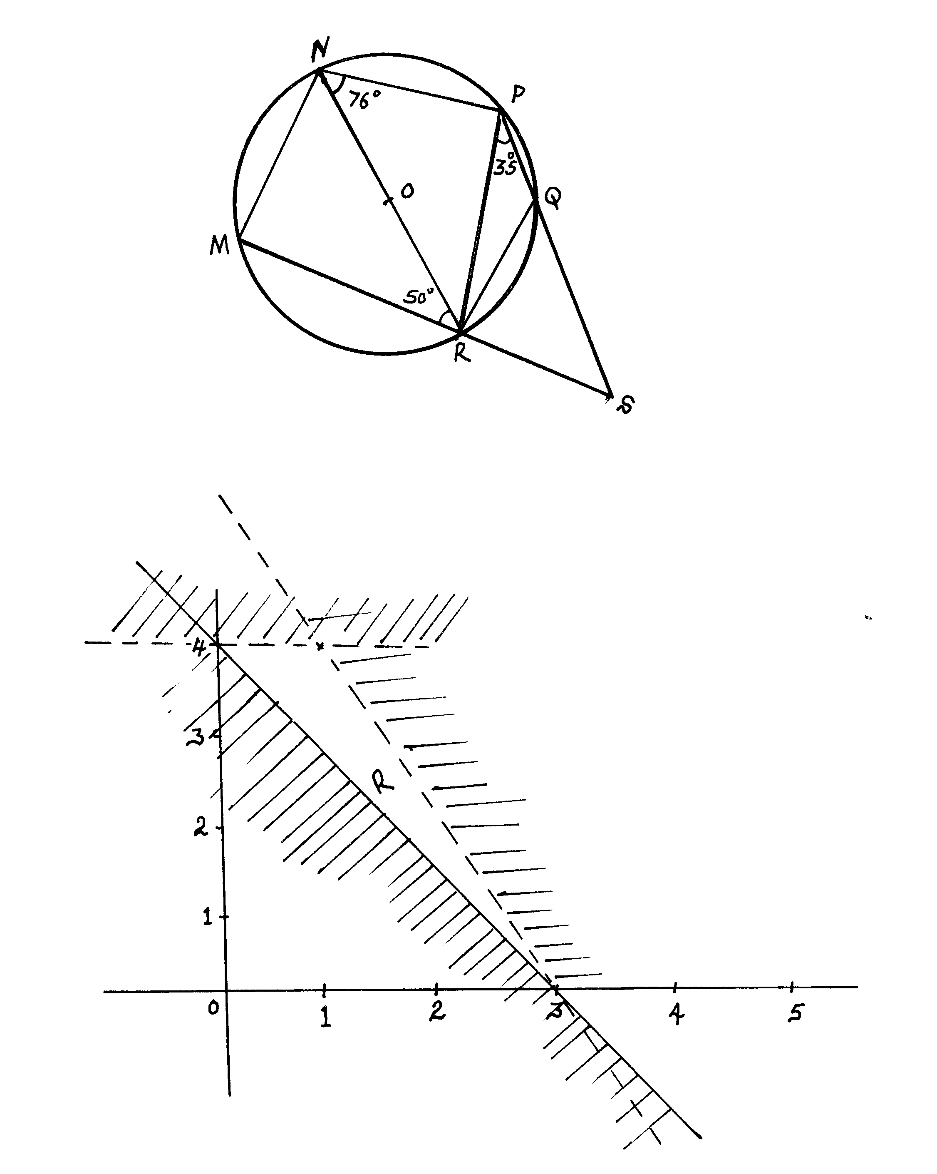
c) Find the area of the required region. (3mks) (2mks)

This is the last page printe
21.The table below shows some values of the function; y = x² + 2x – 3 for -6≤ x ≤ -3

X | -6 | -5.75 | -5.5 | -5.25 | -5 | -4.75 | -4.5 | -4.25 | -4.0 | -3.75 | -3.5 | -3.25 | -3
Y | 21 | 18.56 |  | 14.06 |  | 10.06 | 8.25 |  | 5 |  | 2.25 | 1.06 | 0
- complete the table (2mks)

(b) using the completed table and the mid-ordinate rule with six ordinates, estimate the area of the region bounded by the curve; y = x² + 2x – 3 and the lines y = 0 , x = -6 and x = -3 (2mks)

GRAPH

- (i) by integration find the actual are of the region in (b) above (3mks)

(ii) Calculate the percentage error arising from the estimate in (b) (3mks)

