**ASUMBI GIRLS HIGH SCHOOL**



**THE NATIONAL LONGHORN CHEMISTRY CONTEST**

**7TH EDITION**

**Senior Category**

**NAME…………………………………………SCHOOL……………………CODE………….**

**School Category: Girls [ ] Boys [ ] Mixed [ ]**

**Kenya Certificate of Secondary Education 2019**

**SUNDAY 2nd June, 2019**

**2 Hours**

**CHEMISTRY**

**SUNDAY 2nd June 2019**

**2 Hours.**

**Instructions to candidates’**

* Write your name, school and school code in the spaces provided above
* This paper consists of ***three*** sections, answer **ALL** the questions in each section in the spaces provided
* Mathematical tables and electronic calculators may be used
* All workings **MUST** be clearly shown where necessary
* This paper consists of ***15 printed pages***, candidates should check to ascertain that all pages are printed as indicated and that no questions are missing

**For examiner’s use only**

|  |  |  |
| --- | --- | --- |
| **Questions** | **Maximum score** | **Candidate’s score** |
| **1-22** | **80** |  |

**©2019 ASUMBI GIRLS LONGHORN NATIONAL CHEMISTRY CONTEST.**

**CHEMISTRY CONTEST 2019**

**70041232019**

**SECTION A (40 MARKS)**

**1.** A form one student prepared the set up below during a chemistry lesson, study it and answer the questions that follow

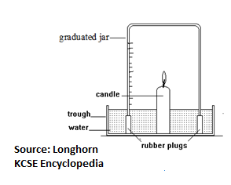

a) State the main objective of the study for which the set up was made. (1mk)

………………………………………………………………………………………………………………

b) In a similar experiment, dilute sodium hydroxide solution was used instead of water, explain the difference in the observation made.(2mks)

……………………………………………………………………………………………………………………………………………………………………………………………………………………………………………………………………………………………………………………………………………..

**2** Describe how pure zinc oxide can be obtained from a mixture of zinc oxide, aluminium chloride and magnesium sulphate powders. (2mks)

……………………………………………………………………………………………………………………………………………………………………………………………………………………………………………………………………………………………………………………………………………………………………………………………………………………………………………………………………………………………………………………………………………………………………………….

3. The diagram below shows a picture of a match stick.



With a reason explain whether the reaction that occurs when you strike a match is an exothermic or endothermic. (1mk)

………………………………………………………………………………………………………………………………………………………………………………………………………………………………

**4.** The diagram below shows a set up used to prepare dry carbon (II) oxide gas and to investigate some of its properties in the laboratory. Study it and answer the questions that follow.

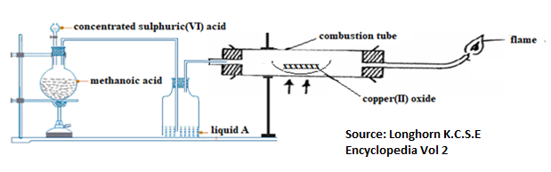

1. Name liquid A and state its function in this set up (1mk)

…………………………………………………………………………………………………………………………………………………………………………………………………………………………

1. Write the equation for the reaction that produced carbon (II) oxide. (1mk)

………………………………………………………………………………………………………………………………………………………………………………………………………………………………

1. State the observation made in the combustion tube (1mk)

………………………………………………………………………………………………………………………………………………………………………………………………………………………………………………………………………………………………………………………………………

5. Explain why potassium metal bursts into a flame on contact with water . (1mk)

………………………………………………………………………………………………………………………………………………………………………………………………………………………………………………………………………………………………………………………………………………………………………………………………………………………………………………………………

6. a) Starting with magnesium carbonate describe how pure and magnesium hydroxide can be prepared in the laboratory (2mks)

………………………………………………………………………………………………………………………………………………………………………………………………………………………………………………………………………………………………………………………………………………………………………………………………………………………………………………………………………………………………………………………………………………………………………………

b) State one use for magnesium hydroxide. (1mk)

……………………………………………………………………………………………………………………………………………………………………………………………………………………………….

7. An acid-base indicator, HIn, dissociates and forms an equilibrium according to the following equation.

HIn(aq)  H+(aq) + In–(aq)

colour A colour B

Explain which colour of the indicator would be observed in a strongly acidic solution. (2mks)

………………………………………………………………………………………………………………………………………………………………………………………………………………………………………………………………………………………………………………………………………………………………………………………………………………………………………………………………

8. The table below gives information on the standard enthalpy of formation of some compounds. Study it and use it to answer the question that follows

|  |  |  |  |
| --- | --- | --- | --- |
| **Substance** | Hex-1-ene | Carbon (IV) oxide | Water |
| **Standard enthalpy of formation, *H*fӨ / kJ1 mol** | –43 | –394 | –242 |

Calculate the standard enthalpy of combustion of hex-1-ene, hence write the thermochemical equation for combustion of hex-1-ene. (3mks)

……………………………………………………………………………………………………………………………………………………………………………………………………………………………………………………………………………………………………………………………………………………………………………………………………………………………………………………………………………………………………………………………………………………………………………….

9. The diagram below is illustrates the major steps in industrial preparation of hydrochloric acid. Study it and answer the questions that follow.

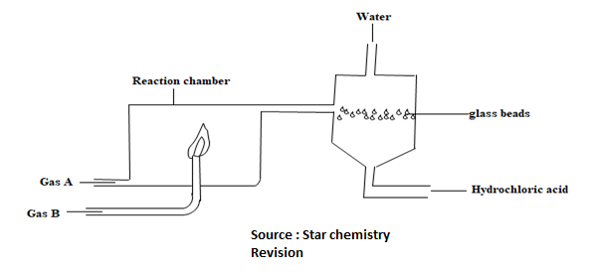

1. Explain what is done to prevent possible explosion in the reaction chamber. (1mk)

…………………………………………………………………………………………………………………………………………………………………………………………………………………………………………………………………………………………………………………….

1. Explain the role of glass beads in the set up. (1mk)

……………………………………………………………………………………………………………………………………………………………………………………………………………………………………………………………………………………………………………………………………..

10. **20.0** **cm³** of a solution containing **4.5g/dm3** of sodium hydroxide reacted exactly with **24.0cm³** of dilute oxalic acid solution (H2C2O4). Calculate the concentration of the acid solution in **g/dm3** (H=1, C=12, O=16, Na=23) (3mks)

………………………………………………………………………………………………………………………………………………………………………………………………………………………………………………………………………………………………………………………………………………………………………………………………………………………………………………………………………………………………………………………………………………………………………………………………………………………………………………………………………………………………………………………………………………………………………………………………………………

11.The diagram below shows a fountain formed when ammonia gas is dissolved in water.

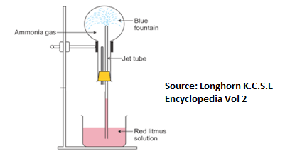

a)What property of ammonia does the fountain experiment demonstrate? (1mk)

………………………………………………………………………………………………………………………………………………………………………………………………………………………………

b)Explain how the fountain is formed. (2mks)

………………………………………………………………………………………………………………………………………………………………………………………………………………………………………………………………………………………………………………………………………………………………………………………………………………………………………………………………………………………………………………………………………………………………………………

12 a) Define the term allotropy (1mk)

……………………………………………………………………………………………………………………………………………………………………………………………………………………………………………………………………………………………………………………………………………..

1. Using structure and bonding, explain the role of graphite in “lead” pencils. (2mks)

………………………………………………………………………………………………………………………………………………………………………………………………………………………………………………………………………………………………………………………………………………………………………………………………………………………………………………………………………………………………………………………………………………………………………………

13 a) State Charles’s law (1mk)

………………………………………………………………………………………………………………………………………………………………………………………………………………………………………………………………………………………………………………………………………………

b) The fuel and air gases in the cylinders of a 1200 cm3 car engine go from 25°C before combustion and rise to a peak temperature of 210°C after combustion. If normal atmospheric pressure is 101kPa, calculate the peak pressure reached after combustion if the volume of the piston remains the same. (1mk)

………………………………………………………………………………………………………………………………………………………………………………………………………………………………………………………………………………………………………………………………………………………………………………………………………………………………………………………………………………………………………………………………………………………………………………

14 a) Distinguish between nuclear fusion and nuclear fission. (1mk)

……………………………………………………………………………………………………………………………………………………………………………………………………………………………………………………………………………………………………………………………………………………………………………………………………………………………………………………………….

b) The count rate of a radioactive nuclide reduced from 240 counts per second in a GM tube to 20 counts per second after 6 hours. Calculate the half-life of the nuclide. (2mks)

………………………………………………………………………………………………………………………………………………………………………………………………………………………………………………………………………………………………………………………………………………

15. The chart below shows some reactions of hydrogen sulphide gas. Study it and answer the questions that follow.

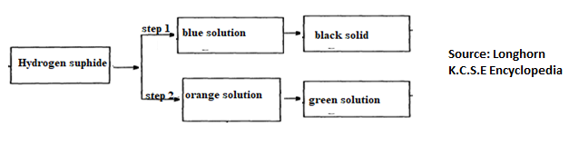

1. Write the ionic equations for the reactions in steps 1 and 2 (2mks)

Step 1…………………………………………………………………………………………

Step 2………………………………………………………………………………………..

1. With a reason identify the property of hydrogen sulphide gas shown in step 2 (1mk)

……………………………………………………………………………………………………………………………………………………………………………………………………………………………..

16. Describe how you can use hydrated cobalt (II) chloride to demonstrate characteristics of temporary chemical change in the laboratory (2mks)

……………………………………………………………………………………………………………………………………………………………………………………………………………………………………………………………………………………………………………………………………………………………………………………………………………………………………………………………………………………………………………………………………………………………………………..

17. a) By writing their general formula, distinguish between a **soapy** detergent and a **soapless** detergent.

**Soapy detergent (**1mrk)

………………………………………………………………………………………………………………………………………………………………………………………………………………………………………………………………………………………………………………………………………………

**Soapless detergent.**

………………………………………………………………………………………………………………………………………………………………………………………………………………………………………………………………………………………………………………………………………………

**SECTION B (30 MARKS)**

18. a) (i) Define the term ionization energy of an element. (1mk)

…………………………………………………………………………………………………………………………………………………………………………………………………………………………………………………………………………………………………………………………………………………………………………………………………………………………………………

(ii) The table below shows ionization energies of a given element. Study it and answer the question that follows

|  |  |  |  |  |
| --- | --- | --- | --- | --- |
|  | **1st IE** | **2nd IE** | **3rd IE** | **4th IE** |
| kJ/mole | -737 | -1450 | -7732 | -10,540 |

With a reason identify the group to which the element belongs. (2mks)

……………………………………………………………………………………………………………………………………………………………………………………………………………………………………………………………………………………………………………………………………………………………………………………………………………………………………………………………….

b) The grid below shows part of the periodic table. Study it and answer the questions that follow. The letters are not the actual symbols of the elements.

|  |  |  |  |  |  |  |  |  |
| --- | --- | --- | --- | --- | --- | --- | --- | --- |
|  |  | | | | | | |  |
|  |  |  | A |  |  | B | C | D |
| E | F |  |  |  |  |  |  |
|  |  |  |  |  |  | G |  |
| H |  |  |  |  |  |  |  |

1. With a reason compare the melting and boiling points of elements **C** and **G** (1mk)

…………………………………………………………………………………………………………………………………………………………………………………………………………

1. With a reason compare the sizes of **E+** and **F2+** (1mk)

…………………………………………………………………………………………………………………………………………………………………………………………………………

1. State one use of element **D** in entertainment industry (1mk)

……………………………………………………………………………………………………………………………………………………………………………………………………………………….

1. Using dots and crosses show the bonding in the compound formed when elements **A** and **B** combine (1mk)

………………………………………………………………………………………………………………………………………………………………………………………………………………………………………………………………………………………………………………………………………………………………………………………………………………………………………………………………

19. The diagram below shows a number of reactions starting with ethyl propanoate. Study it and use it to answer the questions that follow

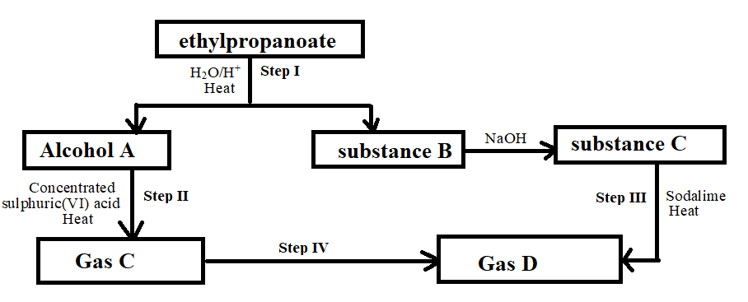

i) Name the reactions taking place in Step **I**  (1mk)

…………………………………………………………………………………………………….

ii) Identify; (2mks)

Substance **A**…………………………………………………………………………………………………

Gas **C**…………………………………………………………………………………………………………

iii) Write the equations for the reactions in Steps **III** and **IV**  (2mks)

Step **III**

............................................................................................................................................................................

Step **IV**

............................................................................................................................................................................

iv) State the industrial application of the process represented in Step **II** (1mk)

…………………………………………………………………………………………………………………

20. a) The diagram below shows a cross-section of a dry cell. Study it and answer the questions that follow

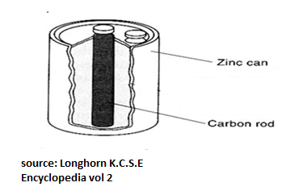

(i) Name the electrolyte in the battery. (1mk)

……………………………………………………………………………………………………………

(ii) Write the equation for the reaction that occurs in the anode. (1mk)

……………………………………………………………………………………………………………

(iii) Explain how ammonia gas formed in the cell is removed to improve the efficiency of the cell. (1mk)

…………………………………………………………………………………………………………………………………………………………………………………………………………………………………………………………………………………………………………………………………………………………………….

b) The standard electrode potentials for two half-cells involving iron are given below.

Fe2+(aq) + 2e– → Fe(s) *E*~~ο~~ = –0.44 V  
Fe3+(aq) + e–→ Fe2+(aq) *E*~~ο~~ = +0.77 V

Explain whether it is advisable or not to keep a solution of Fe3+ in a container made of Fe (2mks)

…………………………………………………………………………………………………………………………………………………………………………………………………………………………………………………………………………………………………………………………………………………………………………………………………………………………………………………………….

21. Copper is one of the widely used metals in the world. The most common ore from which copper is extracted is CuFeS2. The flow chart below shows the major steps in the extraction of copper after the ore is finely ground. Study it and answer the questions that follow

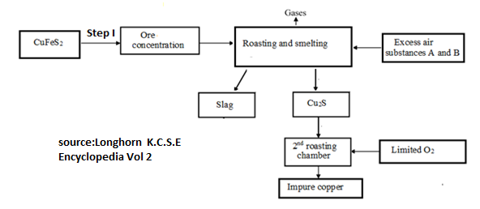

a) Name the Process used in Step I. (1mk)

……………………………………………………………………………………………………….……………………………………………………………………………………………………………………

b) Name substances A and B added together with excess air in the roasting and smelting chamber. (1mk)

……………………………………………………………………………………………………….………………………………………………………………………………………………………………………

c) Name any two impurities present in the copper obtained from the above process. (1mk)

……………………………………………………………………………………………………….………………………………………………………………………………………………………………………..

c) During Electrolysis of Copper (II) Sulphate Solution using copper electrodes, a current of 0.4A was passed for 50minutes. (Cu=64 , 1F =96500)

i) Write ionic equation for the reaction at the Anode. (1mrk)

……………………………………………………………………………………………………………………………………………………………………………………………………………………………….

b) Calculate the mass of copper deposited at the cathode. (2mrks)

………………………………………………………………………………………………………………………………………………………………………………………………………………………………………………………………………………………………………………………………………………………………………………………………………………………………………………………………..

21. Sodium thiosulphate (Na2S2O3) solution reacts with dilute hydrochloric acid at room temperature. Such a reaction was used to investigate the effect of change in concentration on the rate of reaction by students from Hekima Mixed secondary school. Different concentrations of sodium thiosulphate solutions were reacted with dilute hydrochloric acid and the time taken for the reaction to come to completion recorded as shown in the table below. Study the table and use it to answer the questions that follow.

|  |  |  |  |  |  |
| --- | --- | --- | --- | --- | --- |
| **Experiment** | 1 | 2 | 3 | 4 | 5 |
| **Concentration of Na2S2O3(aq)**  **in moles dm-3** | 0.15 | 0.12 | 0.09 | 0.06 | 0.03 |
| **Time in seconds** | 23 | 27 | 36 | 60 | 111 |
| **X 10-3 S-1** |  |  |  |  |  |

1. Complete the table by filling the row for X 10-3 (1mk)
2. Draw the graph of X 10-3against concentration of sodium thiosulphate solution in the grid below (3mks)

c) From the graph determine the time the reaction would take if the concentration of sodium thiosulphate solution was 0.04 mol dm-3 (1mk)

……………………………………………………………………………………………………………………………………………………………………………………………………………………………………………………………………………………………………………………………………………..

d) Using kinetic theory, explain the effect of change in concentration on the rate of reaction (1mk)

……………………………………………………………………………………………………………………………………………………………………………………………………………………………………………………………………………………………………………………………………………….

**SECTION C (10 MARKS)**

**22**. i) A student was provided with **solid A** to carry out some qualitative tests. The table below show the procedures, observations and inferences made. Study the tables and complete them by filling in missing observations and inferences

|  |  |  |
| --- | --- | --- |
| **Procedure** | **Observations** | **Inference** |
| **a)** Place half of the solid in a boiling tube, heat it strongly. Test for the gases produced using a moist blue litmus paper. Observe the residue | (2mks) | NO3- |
| (1mk) | PbO formed |
| **b)** Place the remaining solid in a test tube, add 5cm3 of distilled water, shake thoroughly and keep the resulting mixture for use in the next step | Solid dissolves to form a colourless solution | (1mk) |
| **c)** To a portion of the mixture from (b) above, add drops of ammonia solution till excess | (1mk) | Pb2+ |

**(ii)** A student was provided with **solid B** to carry out some qualitative tests. The table below show the procedure, observations and some inferences made by the student. Study the table and complete it by inserting the missing procedure, observations and inferences.

|  |  |  |
| --- | --- | --- |
| **Procedure** | **Observations** | **Inference** |
| **a)** Place a portion of solid B on a metallic spatula and ignite | Solid melts and burns with a smoky flame | (1mk) |
| **b)** Dissolve the remaining portion in water in a test tube and divide the solution into two three parts. To the first part add a spatula end full of Na2CO3 | (1mk) | H+ |
| **c)** To the second portion, add drops of universal indicator and match the colour of the resulting solution to the full range pH chart | (1mk) | Solution is weakly acidic |
| **d)** To the third portion, add drops of ethanol, warm the mixture then pour into a beaker containing water. Smell the products formed | (1mk) | (1mk) |

**RECOMMENDED CHEMISTRY BOOKS BY LONGHORN PUBLISHERS.**

* **Star secondary Revision chemistry**
* **A+ Plus Revision K.C.S.E chemistry**
* **Mastering chemistry practical.**
* **Solving Chemistry paper 1 and 2**
* **Quick Reading chemistry Form 1 –Form 4**
* **Longhorn secondary chemistry F1-F4**
* **Longhorn kcse Encyclopedia volume two Mathematics and Sciences**



**THIS IS THE LAST PRINTED PAGE!!!!!!**