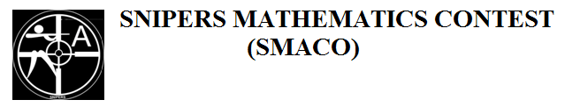
Name……………………………………… Adm. No:……...
School: …………………………………… Date……………...
121/1
MATHEMATICS
PAPER 1
2 ½ HOURS

FORM THREE MATHEMATICS CONTEST—2019
Kenya Certificate of Secondary Education (K. C. S. E)

Instructions to candidates
- Write your name, admission number anddate of examinationin the spaces provided above.
- The paper contains two sections Aand B.
- Answer all questions in section Aand only five questions in section B.
- All workings and answers must be written on the question paper in the spaces provided below each question.
- Marks may be awarded for correct working even if the answer is wrong.
- Negligence and slovenly work will be penalized.
- Non programmable silent electronic calculators and mathematical tables are allowed for use.
- This paper consists of 15 printed pages. Candidates should check to ensure that all pages are printed as indicated and no questions are missing.
FOR EXAMINER’S USE ONLY
SECTION A

1 | 2 | 3 | 4 | 5 | 6 | 7 | 8 | 9 | 10 | 11 | 12 | 13 | 14 | 15 | 16 | TOTAL

SECTION B

GRAND TOTAL
17 | 18 | 19 | 20 | 21 | 22 | 23 | 24 | TOTAL

SECTION A (50MARKS)
Answer ALL questions in this section
- Evaluate without using mathematical table or calculator (3mks)
$$\frac{0.036×0.0049}{0.07×0.048}$$

- Use tables of reciprocals and cube roots to evaluate (4mks)
$$\frac{4}{25.34}+\sqrt[3]{0.03154}$$

- Determine the value of $θ$in the equation below (3mks)
$${Sin(2θ}^{0}-{30}^{0})-{Cos⁡(3θ}^{0}+{20}^{0})=0$$

- Given that $t=2i-j$and $r=i+3j$, find; (3mks)
$$\left|2t-\frac{1}{2}r\right|$$

- Solve the inequality below and state all the integral values of x that satisfy the inequality (3mks)
$$2x+4<4x-2≤18-x$$

- The LCM of two numbers is 240 while their GCD is 12. If one of the numbers is 144, determine the other possible number. (3mks)

- By giving a reason, find the value of x in the figure below (2mks)
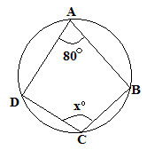

- Use completing the square method to solve the following quadratic equation ${2x}^{2}+8x-4=0$ (3mks)

- Wanjiru, Atieno and Jeptoo shared the profit of their business in the ratio 3:5:9respectively. If Atieno received sh.6000, how much did the business yield? (3mks)

- A line passing through point A(-1,3k) and B(k,3) is parallel to a line whose equation is
$2y+3x=9$. Determine the coordinates of point A and B. (4mks)

- The sum of interior angles of a regular polygon is 1080⁰
- Find the size of each exterior angle (3mks)

- Give the name of the polygon (1mk)

- Without using mathematical tables or calculator, solve for x; (3mks)
$$\log_{10}\left(3x+4\right)+\log_{10}\left(3-x\right)-\log_{10}10=0$$

- A solid metal cuboid measuring 7.2cm long, 4.8cm wide and 2.4cm high is melted and recast into a spherical ball. Calculate to the nearest one decimal place the radius of the ball. (3mks)

- The diagonals of a rhombus are 14cm and 9cm. Calculate the area of the rhombus (2mks)

- Solve for x in the equation. (3mks)
$${27}^{x}+3^{3x}-5=49$$

- Factorize completely (4mks)
$$\frac{{15x}^{2}-xy-{6y}^{2}}{{9x}^{2}-{4y}^{2}}$$

SECTION B (50 MARKS)
Attempt ANY FIVE questions in this section

- Construct a parallelogram ABCD such that AB=6cm, BC=8cm and angle $∠ABC={67.5}^{0}$ (3mks)

- Measure length of diagonal CA and $∠CAB$ (2mks)
CA=................................ $∠CAB$..............................

- Drop a perpendicular from point m(point of intersection of the diagonals of the parallelogram) to meet AB atp. Measure length MP (2mks)
MP =______________ cm

- Find the area of triangle ACD in $m^{2}$ (3mks)

- Given that $y={-x}^{2}+3x+7$, complete the table below. (2mks)
X | -3 | -2 | -1 | 0 | 1 | 2 | 3 | 4 | 5 | 6
$$y={-x}^{2}+3x+7$$ | -11 |  |  | 7 |  |  | 7 |  |  | -11

- On the grid provided, draw the graph of$y={-x}^{2}+3x+7$ (3mks)
- Sate the roots of the curve given that ${-x}^{2}+3x+7=0$ (1mk)

- Use your graph to solve the following equations
- $x^{2}-4x-3=0$ (2mks)

- $y=4+x$ (2mks)

- Below is a bucket in frustum shape with top r=28cm and bottom r=21cm. The perpendicular height of the pale is 90cm.
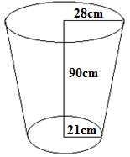
- Determine the total surface area of the bucket (5mks)

- Determine the capacity of water that can fill the bucket (5mks)

- Four towns P, Q, R and S are such that town Q is 120km due east of town P while town S is on a bearing of 330⁰ and 150km from P. Town R on the other hand is on a bearing of 70⁰from S and due north of Q.
- Use a ruler and a pair of compasses only to accurately show the positions of these four towns by scale drawing (take 1cm rep 50km) (5mks)

- Determine;
- The distance SR (2mks)

- The distance SQ (2mks)

- The bearing of town S from Q (1mk)

- The campus bearing of P from R (1mk)

- The figure below shows intersecting circles centre O₁ and O₂ with radius $8cm$ and $6cm$ respectively and length $AB=10cm$
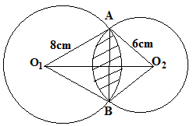
- Determine
- The size of $∠AO_{1}B$ (2mks)

- The size of $∠AO_{2}B$ (2mks)

- Calculate the area of the shaded part (6mks)

- A kite ABCD has vertices at A(3,0), B(4,2), C(3,3) and D(2,2). Draw the kite on the grid provided. (1mk)
- On the same axes, draw the image A¹B¹C¹D¹ of ABCD under rotation of +90⁰ about the origin and state its coordinates. (3mks)

- Draw the image A¹¹B¹¹C¹¹D¹¹ of A¹B¹C¹D¹ under reflection in the line $y=x$ and state its coordinates (3mks)

- Draw the image A¹¹¹B¹¹¹C¹¹¹D¹¹¹ of A¹¹B¹¹C¹¹D¹¹ under enlargement scale factor -2 centre (1,-2) state its coordinates (3mks)

- The distance between town A and B is 720km. A bus left town A at 7.30am and traveled at a speed of 90km/h towards B. 30mins later, a car left town B towards A at a speed of 120km/h.
- Find the time of the day when the bus arrived in town B. (2mks)

- Calculate the relative distance of the two vehicles. (2mks)

- Determine the time of the day when the car met with the bus. (3mks)

- Find the distance of the bus from town B when the car arrived in town A. (3mks)

- The histogram below represents marks obtained in a certain test.
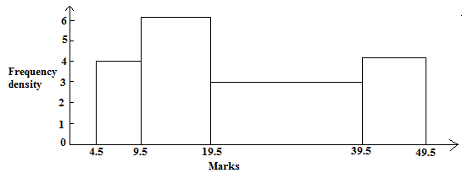
- Develop a frequency distribution table for the data. (4mks)

- Calculate the mean (3mks)

- Find the median mark (3mks)

