Name: …………………………………………………………… Index No: …………………………Class: …………Adm.No……….
Signature: ………………………………….

312/2
GEOGRAPHY
Paper 2
MOKASA II
JULY/AUGUST 2019
Time: 2³/₄ Hours.

MOKASA II JOINT EXAMINATION.
Kenya Certificate of Secondary Education
Geography
Paper 2
MOKASA II
Time: 2³/₄ Hours.

Instructions to candidates
- This paper consist of one section: A
- Answer ALL questions.
- All answers to be written on the answer booklet provided.
- Candidates should check the question papers to ascertain that all the pages are printed as indicated and that no questions are missing.

For Examiners use only:

Section | Candidate Score
A
6
7
8
9
10
Total

SECTION A:
Answer ALL questions in this section
- a). Define mining. (2marks)
b). State three factors influencing the occurrence of minerals. (3marks)
- a). State three advantages of Hydro-electric power in Kenya. (3marks)
b). Give two measures of conservation energy. (2marks)
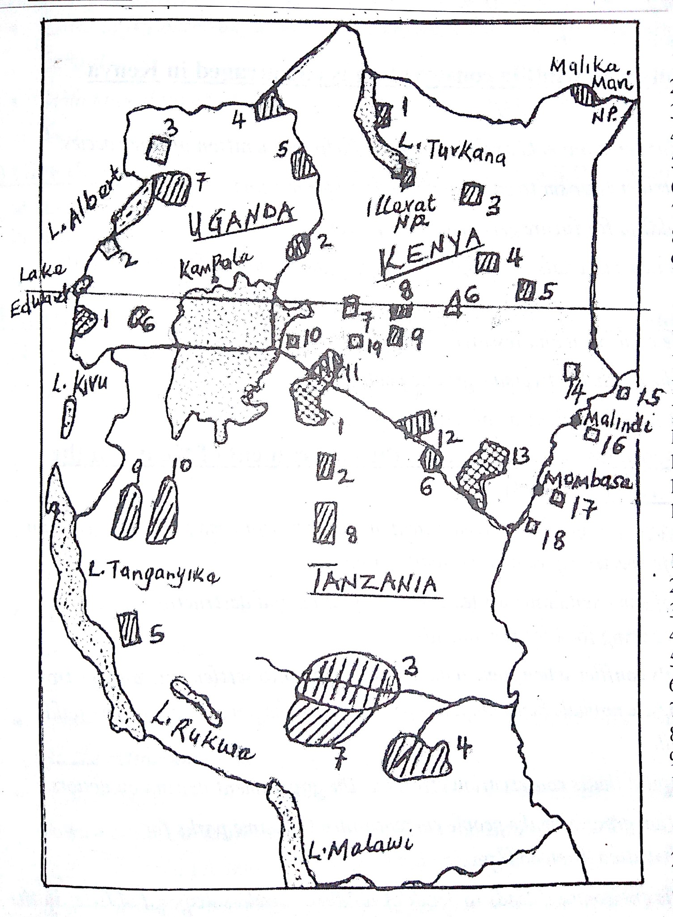
- (a) Study the map blow of East Africa and use it to answer questions.
Name
(i). The National Park marked 2. (1mk)
(ii). The Game Reserve marked 4. (1mk)
(iii). The game sanctuary marked 7. (1mk)
(b) State three reasons why Switzerland receives more tourists than Kenya. (3marks)

- Identify four factors which have contributed to the growth of Mombasa as an international port. (4marks)
- Outline the stages of reclamation of land from the sea in the Netherlands through the Zuider Zee project. (5marks)
SECTION B
Answer question 6 and any other two questions from this section.
- (a). The table below shows maize production in Kenya per county; between 2017 – 2018
in `000 kgs.
Year  County | 2017 | 2018
Trans – Nzoia | 33,055 | 34,065
Uasin – Gishu | 27,060 | 30,040
Nakuru | 12,022 | 14,145
Bomet | 11,336 | 10,272
Narok | 10,678 | 12,128
TOTAL | 83,352 | 100,650

(i). Using a scale of 1cm to represent 10 million kgs, draw a divided rectangle to
represent the data for maize production in 2018. (6marks)
(ii). Describe the production of maize in the 5 counties in Kenya. (4marks)
(iii). State three disadvantage of using a divided rectangle to represent
the above data. (3marks)
(b). State three physical conditions that favour maize growing in Kenya. (3marks)
(c). Give three problems facing maize farmers in Kenya. (3marks)
(d). Explain three ways in which the government of Kenya can assist maize
farmers in Kenya. (6marks)

- (a) State four physical factors that favored the establishment of Ruhr Industrial region
in Germany. (4marks)
(b). Explain four problems arising from industrialization in Kenya. (8marks)
(c). State five characteristics of cottage industry in India. (5marks)
(d). Form four students in your school carried a field study on Thika town.
(i). Give four factors that led to growth of Thika as an industrial centre. (4marks)
(ii). Give four advantages of studying industry through field work. (4marks)
- Study the map of the world below and use it to answer question (a) (i)

(a). (i). Name the fishing grounds marked. (3marks)
X -
Y -
Z -

(ii). Explain three physical factors influencing fishing in the region marked X on the map.
(6marks)
(b) Describe how the basket method is used in catching the fish. (5marks)
(c) (i) State five ways in which marine fisheries in Kenya can be conserved. (5marks)
(ii) Name three methods used to preserve fish in lake Turkana. (3marks)
(d). State three characteristics of demersal fish. (3marks)
- (a). Study the map outline below shows the Great lakes and St. Lawrence sea way and use
it to answer questions below.
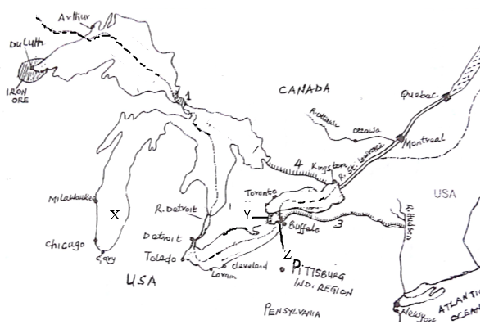
(i). Use the map to name the following: (4marks)
- The lake marked X
- The canal marked Y
- The waterfall marked Z

(ii). State five problems and the solutions faced during the construction of the Great lakes and
St. Lawrence sea way. (5marks)
(iii). Explain three ways through which the water way has promoted industrialization in the
economies of the Canada and U.S.A. (6marks)
(b). State four ways in which the Kenyan government has promoted air transport. (4marks)
(c). What is containerization? (2marks)
(d). Give four advantages of the Great North road. (4marks)

- (a) Differentiate between management and conservation of environment. (2marks)
(b) (i) State four reasons for the management and conservation of environment. (4marks)
(ii) Give three man-made hazards in your country. (3marks)
(c) State five effects of drought in Kenya. (5marks)
(d) You are planning to carry out a field study on causes of pollution along Nairobi river.
(i) Identify three ways you will need to prepare for the study. (3marks)
(ii) Identify five causes of pollution you are likely to see along Nairobi river. (5marks)
(ii) What are possible follow-up activities that students will be involved in after the
study? (3marks)

