NAME……………………………………………………INDEX NO. ………………CLASS………
ADM NO…………………….DATE: ……………………………..SIGN: …………………….………

443/1 AGRICULTURE
PAPER 1
(THEORY)
September 2019 - 2hrs

PANGANI GIRLS’ HIGH SCHOOL
POST MOCK 2019
Kenya Certificate of Secondary education (K.C.S.E)

Instructions to candidates
a) Write your name and index in the spaces provided above
b) Sign and write the date of examination in the spaces provided above
c) This paper consists of three sections A, B and C.
d) Answer all the questions in sections A and B.
e) Answer any two questions in section C
f) All answers should be written in the spaces provided in the question paper.
g) This paper consist of 8 printed pages
h) Candidates should check the question paper to ascertain that all the pages are printed as
indicated and that no questions are missing
i) Candidates should answer all the questions in English.

For Examiner’s Use Only

Section | Question | Maximum  Score | Candidates Score
A | 1 – 17 | 30
B | 18 - 20 | 20
C | 21 - 23 | 20
 |  | 20
Total Score |  | 90

SECTION A (30 Marks)
Answer ALL questions from this section in the spaces provided.(30mks)
1. State four limitations of pastoral nomadism (1mk)
………………………………………………………………………………………………
……………………………………………………………………………………………..
2. Listfour environmental conditions that may lead to low crop yields. (2mk)
………………………………………………………………………………………………
……………………………………………………………………………………………....

………………………………………………………………………………………………
……………………………………………………………………………………………....

3. Givefour factors which determine the depth of ploughing (2mks)

………………………………………………………………………………………………
……………………………………………………………………………………………....

………………………………………………………………………………………………
……………………………………………………………………………………………....

4. Listfour features of plastic pipes a farmer should consider before buying the pipes (2mks)

……………………………………………………………………………………………
……………………………………………………………………………………………....

………………………………………………………………………………………………
……………………………………………………………………………………………....

5. Statefour advantages of using farmyard manure over straight fertilizers (2mks)

………………………………………………………………………………………………
……………………………………………………………………………………………....

………………………………………………………………………………………………
……………………………………………………………………………………………....

6. State four qualities of certified maize seeds (2mks)

………………………………………………………………………………………………
……………………………………………………………………………………………....

………………………………………………………………………………………………
……………………………………………………………………………………………....

7. Statethree disadvantages of tenancy system of farming (1¹/₂mks)

………………………………………………………………………………………………
……………………………………………………………………………………………....

………………………………………………………………………………………………
8. Givefour natural factors that encourage soil erosion (2mks)

………………………………………………………………………………………………
……………………………………………………………………………………………....

………………………………………………………………………………………………
……………………………………………………………………………………………....

9. Statefour field conditions that may favour the choice of chemical weed control (2mk)

………………………………………………………………………………………………
……………………………………………………………………………………………....

………………………………………………………………………………………………
……………………………………………………………………………………………....

10. Givethree damages caused by squirrels(1¹/₂mks)

………………………………………………………………………………………………
……………………………………………………………………………………………....

………………………………………………………………………………………………
……………………………………………………………………………………………....

11. Name the type of farm record from which each of the following information could be
obtained: (1¹/₂mks)

(a) Common Livestock disease occurring in a given farm.
………………………………………………………………………………
(b) The number of jembes a farm owns.
………………………………………………………………………………
(c) The sire used to obtain the calves on the farm.
……………………………………………………………………………

12. State three changes that would indicate improvement in labour efficiency in a farm (1¹/₂mks)

………………………………………………………………………………………………
……………………………………………………………………………………………....

………………………………………………………………………………………………
13. State the use of each of the following financial documents (1mk)

(a) Invoice…………………………………………………………………………………
………………………………………………………………………………….
(b) Cash receipt……………………………………………………………………………
…………………………………………………………………………….
14. Statefour functions of calcium in plant growth and development (2mks)

………………………………………………………………………………………………
……………………………………………………………………………………………....

………………………………………………………………………………………………
……………………………………………………………………………………………....

15. Givefour reasons for sowing annual crops early in the planting season (2mks)

………………………………………………………………………………………………
……………………………………………………………………………………………....

………………………………………………………………………………………………
……………………………………………………………………………………………....

16.a) Per capital income is one of the measures of a country’s development, what does it mean? (1mk)
………………………………………………………………………………………………
……………………………………………………………………………………………....
b) Mention any twoground sources of water. (1mk)
………………………………………………………………………………………………
……………………………………………………………………………………………....

17. (a) Distinguish between monopoly and monopsony (1mk)

………………………………………………………………………………………………
……………………………………………………………………………………………....

………………………………………………………………………………………………
……………………………………………………………………………………………....

(b) State the law of demand (1mk)
………………………………………………………………………………………………
……………………………………………………………………………………………....

SECTION B (20MARKS)

Answer ALL the questions in this section in the spaces provided.
18. The diagram below illustrates two types of soil structures. Study them carefully and answer
the questions that follow
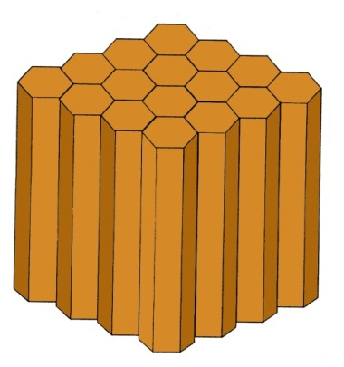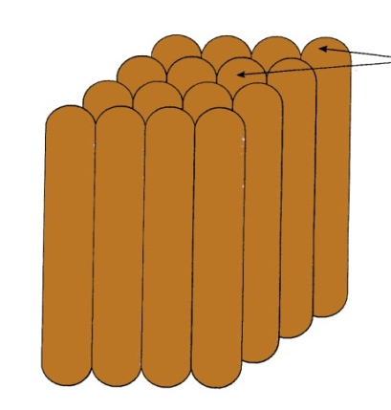
A B
(a) Identify the type of structure illustrated in A and B (2mks)
A…………………………………………………………………………….
B…………………………………………………………………………….
(b) Identify the areas where the two structures are commonly found (1mk)

………………………………………………………………………………………………
……………………………………………………………………………………………....

(c)Statethree ways in which soil structure influence crop production (3mks)

………………………………………………………………………………………………
……………………………………………………………………………………………....

19. (a) Outline the procedure for planting maize manually once you get to the farm with all the
materials.(4mks)

…………………………………………………………………………………………………………………………………………………………………………………………….………………………………………………………………………………………………
……………………………………………………………………………………………....

………………………………………………………………………………………………
(c) List two uses of micro catchments(2mks)
………………………………………………………………………………………………
……………………………………………………………………………………………....

20. (a) What do we mean by production function? (2mks)
………………………………………………………………………………………………
……………………………………………………………………………………………....

(b) Below are graphical representations showing different types of production functions.
Studythem and answer the questions that follow

A B C

(i) Identify the types of production function represented by diagrams A,B and C (3mks)
A…………………………………………………………………………….
B……………………………………………………………………………..
C……………………………………………………………………………..
(c) Listthree circumstances in which illustration (B) above occurs (3mks)
………………………………………………………………………………………………
……………………………………………………………………………………………....

………………………………………………………………………………………………

SECTION C
Answer any TWO questions in this section
21.(a) Describe cabbage production under the following subheadings
i) Major varieties(2mks)
ii) Field management practices (4mks)
iii) Harvesting of cabbages (4mks)
(b) The following information was extracted from Mr. Njuguna’s farm
Cash at hand ksh 5,000
Bank overdraft ksh40,000
Land value ksh 500,000
Lorry worth ksh 3000,000
Grains in store ksh 80,000
Dairy cattle ksh 150,000
Cash at bank ksh 50,000
Debts receivable from dairy co-operative ksh 12,500
Layers ksh 30,000
Debts payable ksh 26,100

(i) Using the above information, prepare a Balance sheet for Njuguna’s farm as at 31stDec
2017 (9mks)
(ii) What is the net worth of the farm? (1mk)
22. (a) Describe 6 methods of draining water logged land (12mks)
(b) Explain four methods of preventing water pollution (4mks)
(c) Explain four factors that influences seed rate (4mks)
23. (a) Outline five qualities of good silage (5mks)
(b) Explain five roles of farm manager in production (5mks)
(c) State and explain five factors affecting selectivity of herbicides (10mks)

