NAME……………………………………………………INDEX NO. ………………CLASS………
ADM NO…………………….DATE: ……………………………..SIGN: …………………….………

443/2
AGRICULTURE
PAPER 11
SEPTEMBER 2019
2 HRS

PANGANI GIRLS’ HIGH SCHOOL
POST MOCK 2019
Kenya Certificate of Secondary education (K.C.S.E)
- Write your name and number in the spaces provided at the top of this page.
- Sign and write the date of the examination in the space provided above.
- This paper consists of three sections A, B and C.
- Answer ALL questions in section A and B.
- Answer any TWO questions in section C.
- Candidate should answer the questions in English.
- All answers should be written in the spaces provided.
- Candidates should check the question paper to ascertain that all pages are printed as indicated and that no questions are missing.
FOR EXAMINERS USE ONLY
SECTION | QUESTION | MAXIMUM SCORE | CANDIDATE SCORE
A |  | 30
B |  | 20
C |  | 20
 |  | 20
TOTAL SCORE |  | 90

SECTION A (30 MARKS)
Answer all the questions in this section in the spaces provide
- Give the terms used to refer to the following farm animals
- Mature female goat ½ mk ………………………………………………………………………………………………………
- Mature castrated male cattle ½ mk …………………………………………………………………………………………………………………………………………………………………………….
- A young female pig from weaning up to the first parturition. ½ mk ………................................................................................................................................................
- Young female bird from eight weeks to point of laying. ½ mk …………………………………………………………………………………………………………………………………………………………………………….
- State four characteristics of Romney Marsh sheep breed. 2mks ………………………………………………………………………………………………………………………………………………………………………………………………………………………………………………………………………………………………………………………………………………………………………………………………………………………………………………………………………………………………………………………………………
- State three uses of camels in the arid and semi-arid regions. 1 ½ mks ……………………………………………………………………………………………………………………………………………………………………………………………………………………………………………………………………............................................................................
- State three qualities of a creep feed that makes it suitable for piglets. 1 ½ mks ………………………………………………………………………………………………………………………………………………………………………………………………………………………………………………………………………………………………………………………
- State three reasons for spreading a polythene paper (PVC) on the slab of a permanent farm building. 1 ½ mks ………………………………………………………………………………………………………………………………………………………………………………………………………………………………………………………………………………………………………………………………………………………………………………………………………………………………
- Classify livestock diseases by cause 2mks ………………………………………………………………………………………………………………………………………………………………………………………………………………………………………………………………………………………………………………………………………………………………………………………………………………………………
- How does proper nutrition help in control of livestock diseases? 2mks ………………………………………………………………………………………………………………………………………………………………………………………………………………………………………………………………………………………………………………………
- State four reasons why it is important to know the life cycle of a parasite in livestock production. 2mks ………………………………………………………………………………………………………………………………………………………………………………………………………………………………………………………………………………………………………………………………………………………………………………………………………………………………
- Define the following terms as used in livestock nutrition.
- Starch equivalent ½ mk ………………………………………………………………………………………………………………………………………………………………………………………………………………
- Dry matter ½ mk ………………………………………………………………………………………………………………………………………………………………………………………………………………
- Digestible crude protein ½ mk ………………………………………………………………………………………………………………………………………………………………………………………………………………
- Crude protein ½ mk ………………………………………………………………………………………………………………………………………………………………………………………………………………
- Kadogo secondary school has a deep litter poultry house measuring 10 m x 4m. if the space allocated per bird is 0.28m², how many birds can the school keep. 2mks ………………………………………………………………………………………………………………………………………………………………………………………………………………………………………………………………………………………………………………………………………………………………………………………………………………………………………………………………………………………………………………………………………
- What are the advantages of a spray race over a plunge dip 2mks ………………………………………………………………………………………………………………………………………………………………………………………………………………………………………………………………………………………………………………………………………………………………………………………………………………………………………………………………………………………………………………………………………
- Give the most appropriate tools used in the following operations.
- Removing metal clippings in files ½ mk ………………………………………………………………………………………………………
- Cutting wood along grains ½ mk ………………………………………………………………………………………………………
- Cutting threads on pipes ½ mk ………………………………………………………………………………………………………
- Give four methods of treating timber 2mks ………………………………………………………………………………………………………………………………………………………………………………………………………………………………………………………………………………………………………………………
- State the importance of fish farming in Kenya 2mks ………………………………………………………………………………….. ………………………………………………………………………………………………………………………………………………………………………………………………………………
- Give reasons why bees swarm. 2mks ………………………………………………………………………………………………………………………………………………………………………………………………………………………………………………………………………………………………………………………………………………………………………………………………………………………………………………………………………………………………………………………………………
- Give the importance of carrying out identification practice in animals. 2mks ………………………………………………………………………………………………………………………………………………………………………………………………………………………………………………………………………………………………………………………
SECTION B ( 20MKS )
Answer all the questions in this section in the spaces provided.
- The diagram below shows the internal structure of an egg. Use it to answer the questions that follows:
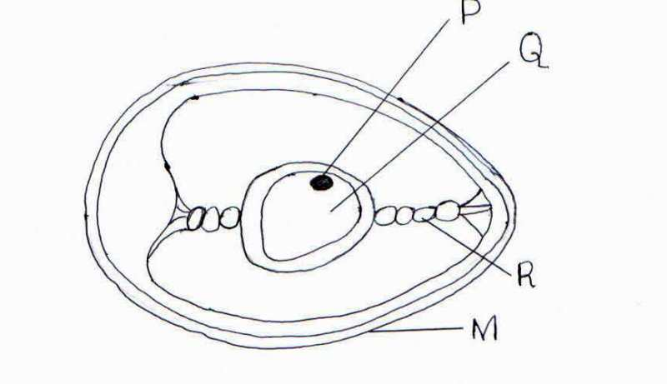
- Name the parts marked P,Q and R 3mks
P ……………………………………………………………………………..
Q …………………………………………………………………………….
R ………………………………………………………………….........................
- Give two defects that may be found on the part marked M that can make the egg unsuitable for incubation. 2mks ………………………………………………………………………………………………………………………………………………………………………………………………………………………………………………………………………………………………………………………
- Study the diagram of a biogas digester plant Shown below and answer the questions that follow.
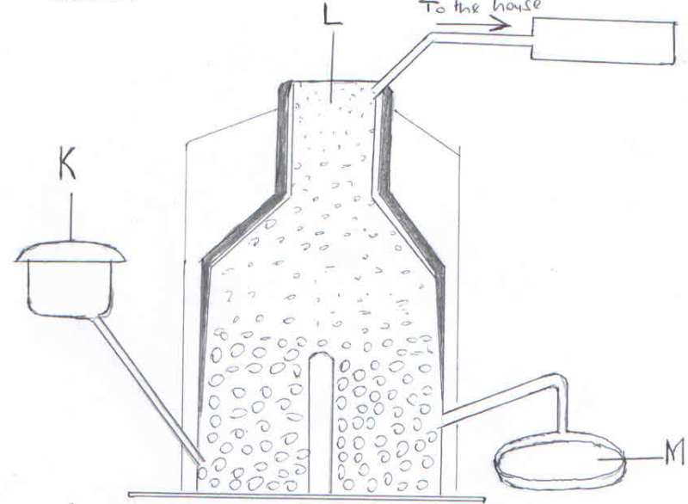
- Name the major component of biogas that is trapped in part L 1mk …………………………………………………………………………………………………….
- Give the name and use of the material deposited in the part labeled M 2mks ………………………………………………………………………………………………………
- What is the component of K in the biogas digester? 1mk ………………………………………………………………………………………………………………………………………………………………………………………………………………
- Outline two disadvantages of biogas as a source of farm power 1mk ………………………………………………………………………………………………………………………………………………………………………………………………………………………………………………………………………………………………………………………
- Study the diagram below and then answer the questions that follows
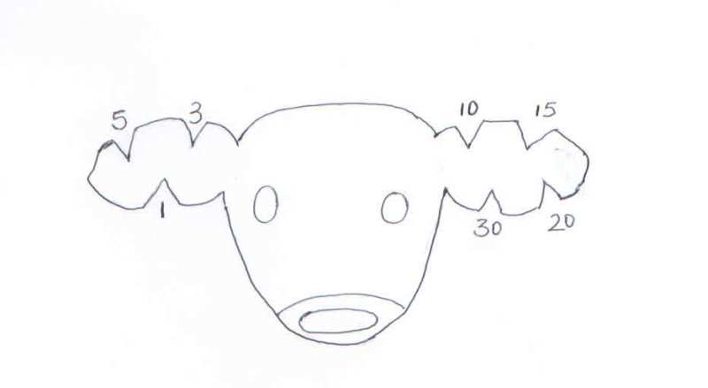
- Identify the method of identification shown above 1mk …………………………………………………………………………………………....................
- Give the identification number of the animal shown above. 1mk ………………………………………………………………………………………………………
- Name three other methods used in identifying animals 3mks ………………………………………………………………………………………………………………………………………………………………………………………………………………………………………………………………………………………………………………………

- The diagram below shows a farm implement. Study it carefully and then answer the questions that follows:
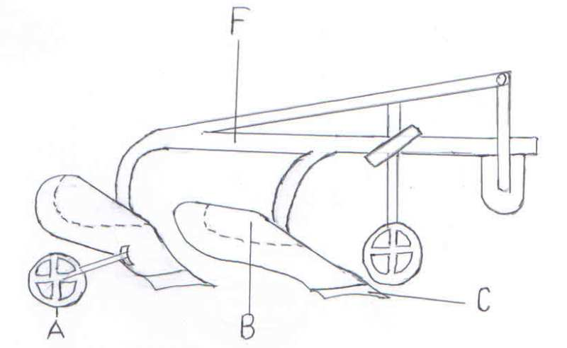
- Identify the implement 1mk ………………………………………………………………………………………………………
- Name the pars labeled A and C 2mks
A ……………………………………………………………………….
C ………………………………………………………………………………
- State the functions of the part labeled B and F 2mks
B ………………………………………………………………………………………………………………………………………………………………………………………………………………
F ………………………………………………………………………………………………………………………………………………………………………………………………………………

SECTION C (40 MARKS)
Answer any two questions from this section in the spaces provided.

- Describe the life cycle of round worms. ( AscarisSPP) 10mks ………………………………………………………………………………………………………………………………………………………………………………………………………………………………………………………………………………………………………………………………………………………………………………………………………………………………………………………………………………………………………………………………………………………………………………………………………………………………………………………………………………………………………………………………………………………………………………………………………………………………………………………………………………………………………………………………………………………………………………………………………………………………………………………………………………………………………………………………………………………………………………………………………………………………………………………………………………………………………………………………………………………………………………………………………………………………………………………………………………………………………………
- State and explain five factors that influence the power output of draught animals. 10mks ………………………………………………………………………………………………………………………………………………………………………………………………………………………………………………………………………………………………………………………………………………………………………………………………………………………………………………………………………………………………………………………………………………………………………………………………………………………………………………………………………………………………………………………………………………………………………………………………………………………………………………………………………………………………………………………………………………………………………………………………………………………………………………………………………………………………………………………………………………………………………………………………………………………………………………………………………………………………………………………………………………………………………………………………………………………………………………………………………………………………………………………………………………………………………………………………………………………

- Describe the construction of a rabbit hutch under the following subheadings:
- Siting the hutch 3mks ……………………………………………………………………………………………………………………………………………………………………………………………………………………………………………………………………………………………………………………………………………………………………………………………………………………………………………………………………………………………………………
- Selection of construction materials. 4mks …………………………………………………………………………………………………………………………………………………………………………………………………………………………………………………………………………………………………………………………………………………………………………………………………………………………………………………………………………………………………………………………………………………………………………………………………………………………………………………………………………………………………………………
- Requirements of a rabbit hutch 3mks ………………………………………………………………………………………………………………………………………………………………………………………………………………………………………………………………………………………………………
- Describe the maintenance practices carried out on a tractor before it is put to daily use. 10mks ………………………………………………………………………………………………………………………………………………………………………………………………………………………………………………………………………………………………………………………………………………………………………………………………………………………………………………………………………………………………………………………………………………………………………………………………………………………………………………………………………………………………………………………………………………………………………………………………………………………………………………………………………………………………………………………………………………………………………………………………………………………………………………………………………………………………………………………………………………………………………………………………………………………………………………………………………………………………

- State the advantages of four stroke cycle engines. 5mks ………………………………………………………………………………………………………………………………………………………………………………………………………………………………………………………………………………………………………………………………………………………………………………………………………………………………………………………………………………………………………………………………………………………………………………………………………………………………………………………………………………………………………………………………………………………
- State the causes of stress in poultry. 8mks ………………………………………………………………………………………………………………………………………………………………………………………………………………………………………………………………………………………………………………………………………………………………………………………………………………………………………………………………………………………………………………………………………………………………………………………………………………………………………………………………………………………………………………………………………………………………………………………………………………………………………………………………………………………………………………………………………………………………………
- Explain the control measures of cannibalism in poultry. 7mks ………………………………………………………………………………………………………………………………………………………………………………………………………………………………………………………………………………………………………………………………………………………………………………………………………………………………………………………………………………………………………………………………………………………………………………………………………………………………………………………………………………………………………………………………………………………………………………………………………………………………………………………………………………………………………………………………………………………………………………………………………………………………………………………………………………………………………………………………………………………………………………………………………………………………………………………………………………………………………………………………………………………………………………………………………………………………………………………………………………………………………………

