NAME…………………………………………………….INDEX NO…………………CLASS……………

ADM NO ……..….................DATE…………......…………SIGN………….….….….…..

231/1
BIOLOGY
PAPER 1
(THEORY)
TIME: 2 HOURS

PANGANI GIRLS’ HIGH SCHOOL
POST MOCK 2019
Kenya Certificate of Secondary Education (KCSE)
September 2019
BIOLOGY
PAPER 1
(THEORY)
TIME: 2 HOURS

INSTRUCTIONS TO CANDIDATES:

1. Write your Name, Index Number, Admission Number and School in the spaces provided above.
2. Sign and write the date of examination in the spaces provided above.
3. Answer all the questions in the spaces provided.
4. Answers must be written in the spaces provided in the question paper.
5. Additional pages must not be inserted.

FOR EXAMINER’S USE ONLY:
Question | Maximum  Score | Candidate’s  Score
1 – 30 | 80

- State the functions of each of the following organelles: (2mks)
- Plasma membrane..............................................................................................................................
......................................................................................................................................................................

- Ribosome.................................................................................................................................................

- (a) State two ways by which leaves of plants are adapted to gaseous exchange. (2mks)

.................................................................................................................................................................................................................................................................................................................................................................................................................................................................................................................................................

b) Name the structure from which the above process occurs. (1mk)
........................................................................................................................................................................

- How do identical and fraternal twins arise?
i) Identical (2mks)
..................................................................................................................................................................................................................................................................................................................................................................................................................................................................................................................................................

ii) Fraternal (1mk)
..................................................................................................................................................................................................................................................................................................................................................................

- State three reasons why it is important for plants to lose water to the atmosphere. (3mks)
..................................................................................................................................................................................................................................................................................................................................................................................................................................................................................................................................................................................................................................................................................................................................
- What is meant by destarching a leaf? (1mk)
.........................................................................................................................................................................................................................................................................................................................................................................................................................................................................................................................................
- State two ways in which sunlight increases the rate of transpiration. (2mks)
..........................................................................................................................................................................................................................................................................................................................................................................................................................................................................................................................................
- List two features of flowers that attract insect pollinators. (2mks)

..........................................................................................................................................................................................................................................................................................................................................................................................................................................................................................................................................
8. State three activities in human digestive system that depend on respiration. (3 mks)

........................................................................................................................................................................................................................................................................................................................................................................................................................................................................................................................................................................................................................................................................................................................
9. In the table below, indicate the deficiency diseases caused by lack ofgiven nutrients in man.(2mks)
Nutrient | Deficiency disease
Iron
Vitamin A

10(a) Give two ways in which red blood cells are adapted to carry out their functions. (2mks)
................................................................................................................................................................................................................................................................................................................................................................................................................................................................................................
(b) Name chemical forms in which carbon IV oxide is transported in the human body. (2mks)
..................................................................................................................................................................................................................................................................................................................................................................................................................................................................................................................................................
11. Name any two divisions of the kingdom plantae. (2mks)
...................................................................................................................................................................................................................................................................................................................................................................................................................................................................................................................................................
12. (a) Name the hormone produced in human body when one takes in a large amount of water. (1mk)
...................................................................................................................................................................................

(b) What disease results from the inadequate production of the hormone in 12(a) above? (1mk)
..............................................................................................................................................................................

13. A cow in a paddock was found to be infected with ticks. State the trophic level occupied by the (2mks)
- i) Cow.......................................................................................................................................

ii) Tick.......................................................................................................................................

- Give one disadvantage of using pesticide to eliminate the ticks. (1mk)
...................................................................................................................................................................................................................................................................................................................................................................
- Write a food chain arising from the above feeding relationship (1 mk)

14. State two roles of water in germinating seeds? (2mks)
.......................................................................................................................................................................................................................................................................................................................................................................................................................................................................................................................................................................................................................................................................................................................
15(a) State two limitations of fossil records as an evidence for organic evolution theory. (2mks)

...........................................................................................................................................................................................................................................................................................................................................................
(b) State an idea that led to the formulation of Lamarck’s theory of evolution. (1mk)

...........................................................................................................................................................................................................................................................................................................................................................
16. Explain what happens to red blood cells placed in distilled water for 20 minutes. (3 mks)

..........................................................................................................................................................................................................................................................................................................................................................
...........................................................................................................................................................................
17(a) Write the base sequence of MRNA that would be coded from the DNA strand shown below. (2mks)
DNA strand
C
A
T
G
A
G
T
RNA strand

(b) How many nitrogenous bases code for a single amino acid? (1mk)

..................................................................................................................................................

18. Why are animal cells put in isotonic solution when performing an experiment? (2mks)
.........................................................................................................................................................................................................................................................................................................................................................................................................................................................................................................................................

19. Study the diagram below
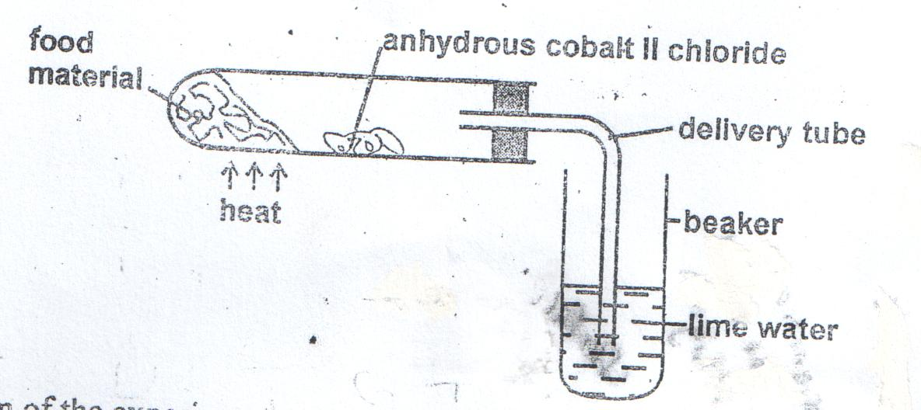
- Suggest the aim of the experiment. (1mk)

..........................................................................................................................................................................................................................................................................................................................................................

- Account for the results observed at the end of the experiment. (2mks)

20.Explain why a camel has a longer nephron than a whale. (3 mks)

21.State role of the following bacteria in the nitrogen cycle. (3mks)
- Nitrosomonas...............................................................................................................................

- Nitrobacter...................................................................................................................................

- Azotobacter.................................................................................................................................

22. Explain the importance of each of the following during digestion in man.
- Teeth................................................................................................................................. (1mk)

- Saliva ................................................................................................................................(1mk)

23(a) Distinguish between prokaryotic and eukaryotic cells. (2mks)
...............................................................................................................................................................................................................................................................................................................................................................................................................................................................................................................................................................................................................................................................................................

b) Name one kingdom with:
- Prokaryotic cells ........................................................................................................(1mk)

- Eukaryotic cells..........................................................................................................(1mk)

24.What would blood gain on passing through each of the following organs:
- The lungs....................................................................................................................(1mk)

- Active muscles...........................................................................................................(1mk)

25.How do sunken stomata lower the rate of transpiration? (2 mks)

........................................................................................................................................................................................................................................................................................................................................................................................................................................................................................................................

26.State two adaptations of fruits dispersed by wind. (2mks)
............................................................................................................................................................................................................................................................................................................................................................
..............................................................................................................................................................................
27(a) Describe two ways how white blood cells fight against infection. (2mks)
.............................................................................................................................................................................................................................................................................................................................................................................................................................................................................................................................................................................................................................................................................................
(b) State the function of blood platelets (1mk)

...................................................................................................................................................................................

28. Calculate the diameter of the cells in micro-metre( µm) given that the diameter of the field of view is 3mm and that they are 10 cells across the field of view, the total magnification was x100. (3mks)

29. (a) Apart from AIDs, name one diseases of the reproductive system in man that is caused by viruses. (1mk)
................................................................................................................................................................................................................................................................................................................................................

(b) State one way by which HIV/AIDs is transmitted from mother to child. (1mk)

......................................................................................................................................................................................................................................................................................................................
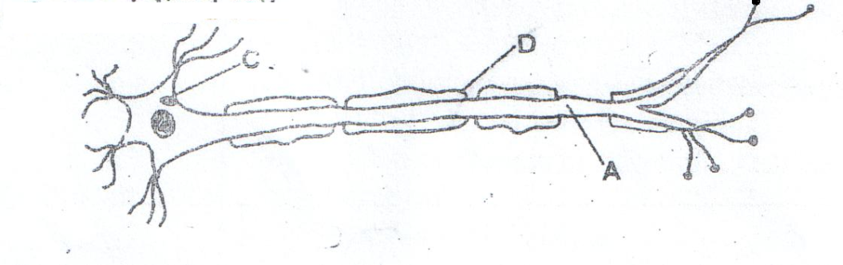
30 (a). Below is a diagram of a specialized cell:

- Name parts (2mks)
A ......................................................................................................................................

D......................................................................................................................................

- What is the role of part D? (1mk)
..................................................................................................................................................................................................................................................................................................................................................................
b. State two roles of progesterone. (3mks)
............................................................................................................................................................................................................................................................................................................................................................ ...........................................................................................................................................................................................................................................................................................................................................................
End

