NAME ………………………………………………………… INDEX NO.……………………
SIGNATURE ……………………………………… DATE…………………………………………
231/2
BIOLOGY
(THEORY)

PAPER 2

TIME: 2 HOURS

PANGANI GIRLS’ HIGH SCHOOL
POST MOCK 2019
Kenya Certificate of Secondary Education (KCSE)
September 2019

INSTRUCTIONS TO CANDIDATES
- Write your name, school and index number in the spaces provided above.
- Write the date of examination and sign in the spaces provided above.
- Answer ALL the questions in section A by filling in the spaces provided.
- In section B, answer question 6 (compulsory question) and any other one question from the remaining two questions. (i.e. 7 or 8)
- Candidates may be penalized for false information and even wrong spellings of technical terms.
- This paper consists of 10 printed pages.
- Candidates should check to ensure that all pages are printed as indicated and no questions are missing.

FOR OFFICIAL USE ONLY
 | Questions | Maximum score | Candidate’s score
Section A | 1 | 8
Section A | 2 | 8
Section A | 3 | 8
Section A | 4 | 8
Section A | 5 | 8
Section B | 6 | 20
Section B | 7 | 20
Section B | 8 | 20
 | Total Score | 80

1.A specimen of Drosophila has red eye and when crossed with a purple mutant all the F1 had red eyes.The offspring’s were mated among themselves and the following proportions of flies were produced; 201 gad red eyes and 67 had purple eyes.Using R to represent the dominant gene and r to represents the recessive gene,answer the following questions.
i)By the help of diagrams shows how the ratio of 201:67 was arrived at ,in the F2generation. (5mks)

ii)Draw diagrams to show the genetic details of a cross between the heterozygous red eyed and a purple eyed individual form F2. (3mks)

2.The diagram below shows the relationship between blood supplies of the embryo, placenta and the uterus.Use it to answer the question that follow.
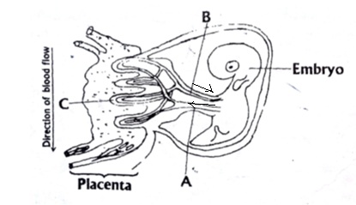

- Name the part labeled A and C. (2mks)

- State any two functions of placenta in mammals. (2mks)

- .(i)What kind of flow does maternal and foetal capillaries exhibit at the placenta. (1mk)

(ii)Why is this kind of flow(c) (i) have an advantage. (1mk)

- If the maternal and foetal blood circulatory system were to be directly connected at the placenta suggest what may happen. (1mk)

- In lactating mammals if the pituitarygland isremoved, explain what happens. (1mk)

3.A student was given four test tubes A, B, C and D, each containing a different mixture among the following:
- Starch +amylase + maltase+water
- Starch +Pepsin +Water
- Starch +Glucose +Water
- Cellulose +amylase+trypsin+Water
She placed the test tubes in an incubator at 30⁰C until all possible reactions had taken place.She then took samples from each test tube and tested them separately for starch,reducing sugar and protein.The results obtained are given in the following table.

Tube | Starch | Reducing | Protein
A | Present | Present | Absent
B | Absent | Absent | Present
C | Present | Absent | Present
D | Absent | Present | Present

a) Name a reagent used to test for reducing sugar and state the appearance of a positive result. (2mks)

b) Identify the contents of each of the test tube A,B,C and D according to the results obtained. (4mks)

c) State the role of enzyme in respiration. (2mks)

4. The graph below shows the effect of injecting one unit of insulin into aperson .The concentration of glucose in the blood is measured at regular intervals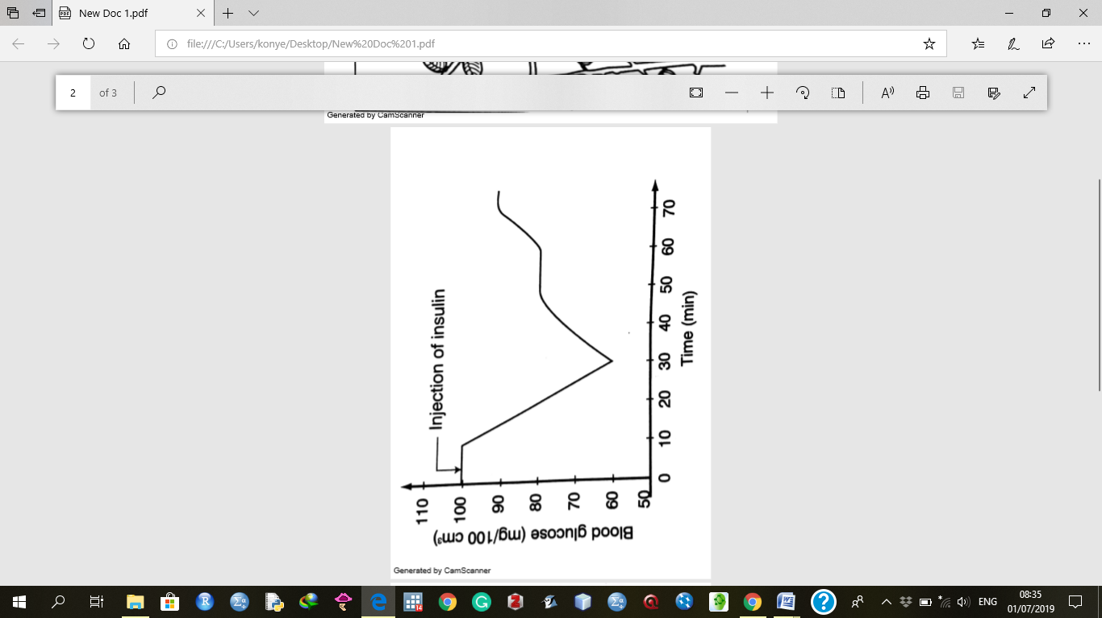
a) Why is insulin injected into blood stream directly instead of being taken orally. (2mks)

b) Explain the fall in blood glucose level. (2mks)

c) Name the mechanism that led to the increase in blood glucose level when it had been falling. (1mk)
d) Name the hormone responsible for the conversion of glycogen to glucose. (1mk)

e) State the effects of each of the following in human beings.
i)Too much glucose in the blood. (1mk)

ii) Very little glucose in the blood. (1mk)

5. The diagram below shows a stem of a passion fruit twining around a post.
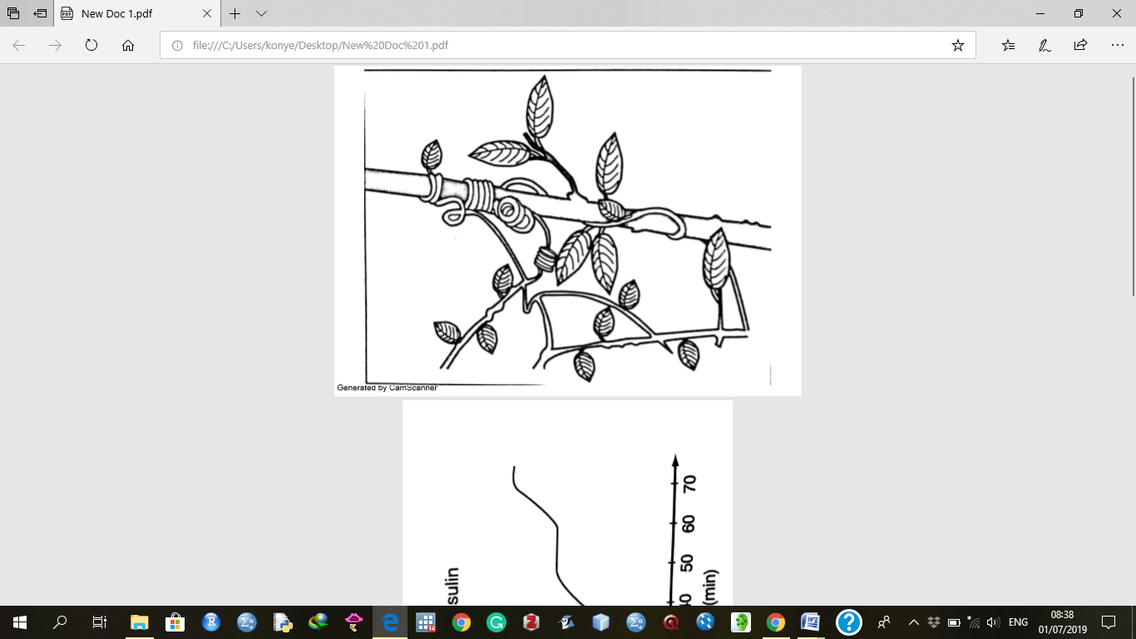
a)What is the name given to the type of growth movement shown above? (1mk)

b) What is the biological importance of this growth? (1mk)

c.i)Account for the twining growth pattern. (3mks)

ii) Name three other types of growth responses exhibited by plants. (3mks)

SECTION B(40 MARKS)
Answer question 6 and either question 7 or 8
6.The formation of acid rain is a serious environmental concern.Sulphuric acid is present in acid rain and has adverse effects on both plants and animals.
a)Name two other acids (other than sulphuric acid)that can be found in acid rain. (2mks)

b)An experiment was carried out to investigate the effects of dilute sulphuric acid on the growth of plant seedlings.Batches of seedlings were grown in glass dishes on filter paper to which dilute sulphuric acid was added.The dishes were then incubated.The root and shoot lengths were measured after 65 hours.The results obtained are as shown in the table below.

Sulphuric acid  Concentration (mol/dm⁻³) | Mean root  Length(mm) | Mean shoot  Length(mm)
0 | 55.5 | 25.2
1x10⁻³ | 63.4 | 18.4
3x10⁻³ | 6.5 | 9.5
4x10⁻³ | 2.0 | 4.6
6x10⁻³ | 1.8 | 0.8
7x10⁻³ | 1.5 | 0.5
8x10⁻³ | 1.3 | 0.3
9x10⁻³ | 1.3 | 0.0
10x10⁻³ | 1.0 | 0.0

Plot a graph of the mean root length and the mean shoot length against the sulphuric acid concentration on the same grid. (7mks)
c) Describe the relationship between the concentration of sulphuric acid and the:
i)Growth of the shoots. (2mks)

ii)Growth of the roots. (2mks)

d) Estimate the mean root and mean shoot lengths when the concentration of sulphuric acid is 5x10⁻³. (2mks)

e)State two other effects of acid rain. (2mks)

f) State three ways of preventing acid rain. (3mks)

SECTION C(Answer one question only)
7.(a) Describe the following terms:
(i) Secretion
(ii) Excretion
(iii) Egestion (3 mks)
b)Explain how the mammalian kidney is adapted to its functions. ( 17 mks)
8.Explain the role of hormones in the growth and development of plants. (20mks)

