NAME……………………………………………………INDEX NO. ………………CLASS………
ADM NO…………………….DATE: ……………………………..SIGN: …………………….………

233/1
CHEMISTRY (THEORY)
PAPER 1
TIME: 2HOURS

PANGANI GIRLS’ HIGH SCHOOL
POST MOCK 2019
Kenya Certificate of Secondary Education (KCSE)
September 2019
CHEMISTRY (THEORY)
PAPER 1

TIME: 2HOURS

Instructions to candidates
- Write your name and index number in the spaces provided above
- Sign and write the date of the examination in the spaces provided above.
- Answer all the questions in the spaces provided after each question
- Mathematical tables and electronic calculators may be used.
- All working must be clearly shown where necessary.
- This paper contains 10 printed pages.

FOR EXAMINER’S USE ONLY

Questions | Maximum score | Candidate’s score
1-29 | 80

Q1. Distinguish between a thistle funnel and a dropping funnel (1mark)

Q2. a) Define an acid. (1 mark)

b) An ammeter was used to test electrical conductivity of sodium hydroxide and ammonia solution.State and explain the observation made. (2 marks)

Q3. a)What name is given to the process by which alcohol is formed from a carbohydrate?(1 mark)

b) Explain why the solubility of ethane in water is lower than that of ethanol. (1 mark)

Q4. An isotope of Uranium 234-U, decays by emission of an alpha particle to thorium Th-92
a) Write the equation for the nuclear reaction undergone bythe isotope. (1 mark)

b) Explain why it is not safe to store radioactive substances in containers made from aluminum sheets.
(1 mark)

Q5. a) Methane reacts with oxygen as shown by the equations I and II below:
I CH₄(g) + 2O₂(g) CO₂(g) + 2H₂O(l)
II 2CH₄(g) + 30₂(g) 2CO(g) + 4H₂O(l)
Which one of the two reactions represents the complete combustion of methane? Explain. (2marks)

b) 80cm³ of ethane reacted with 150cm³ of oxygen forming carbon (IV) oxide and water. Calculate:
(i) The volume of carbon (IV) oxide formed (1 mark)

(ii) The residual air. (1 mark)

Q6.The table below gives the atomic numbers of elements W, X, Y, and Z. The letters do not represent the actual symbols of the elements.

Element | W | X | Y | Z
Atomic Number | 9 | 10 | 11 | 12

a) Which one of the elements is least reactive? Explain. (1mark)

b)i) Which two elements would react most vigorously with each other? (1mark)

ii) Give the formula of the compound formed when the elements in b(i) react. (1mark)

Q7. In an experiment to separate a mixture of two organic liquids, liquid M (b.p 56ºC)
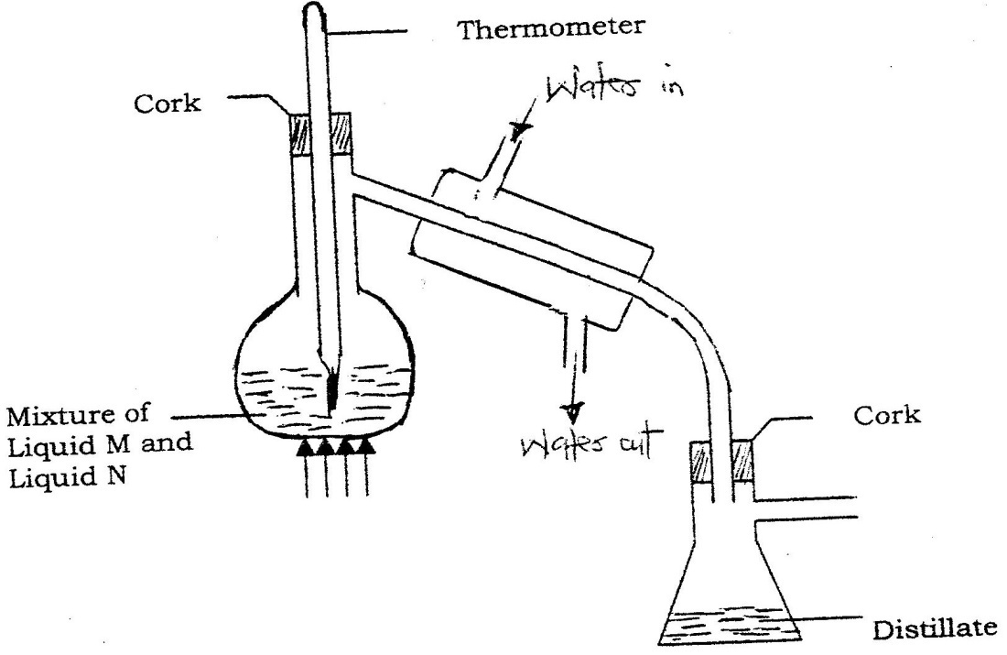
And liquid N (b.p. 118ºC), a student set up the apparatus shown below.

a) Identify two mistakes in the set – up. (2marks)

b) What method would the student use to test the purity of the distillates obtained? (1mark)

Q8. When lead (II) nitrate is heated, one of the products is a brown gas.
a) Write the equation of the reaction that occurs. (1 mark)

b) If 0.290dm³ of the brown gas was produced, calculate the mass of the lead(II)nitrate that was heated.
(R .F.M of lead (II) nitrate = 331; Molar gas volume = 24dm³).(2marks)

Q9.
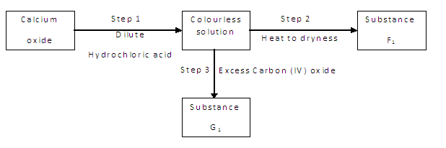
a) Give the name of the process that takes place in step 1. (1mark)

b)Give;
i) The name of substance G₁(1mark)

ii) One use of substance F₁(1 mark)

Q10. When extinguishing a fire caused by burning kerosene, carbon (IV) oxide is used in preference to water .Explain. (2 marks)

Q11. Sulphur burns in air to form sulphur (IV) oxide.A simple energy level diagram for the reaction is given below. Study the diagram and answer the questions that follow.
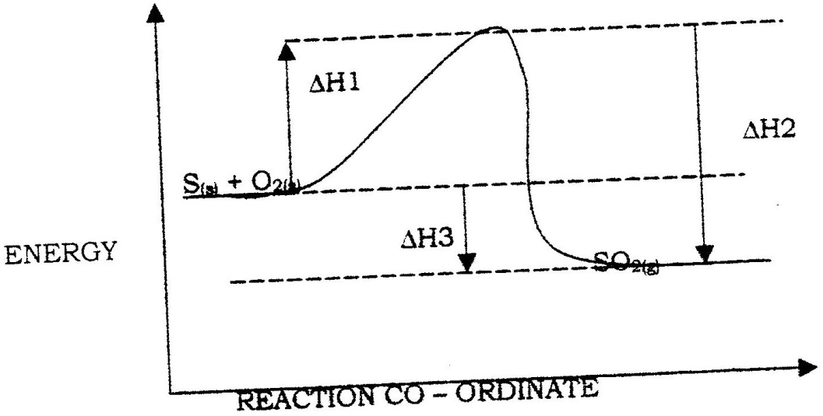

a)What doH₃andH₁ represent? (1 mark)

b)Write an expression, for H₃ in terms of H₁ and H_{2.} (1mark)

Q12. Describe how a solid sample of zinc carbonate can be prepared starting with zinc oxide.
(3 marks)

Q13. An element X has a relative atomic mass of 88. When a current of 0.5ampere was passed through a fused chloride ofX for 32 minutes 10 seconds, 0.44g of X was deposited.
(i) Determine the charge of element X (1 Faraday = 96500C) (2 marks)

(ii) Write the formula of the hydroxide of X. (1 mark)

Q14. A hydrocarbon slowly decolorizes bromine gas in the presence of sunlight but does not decolorize acidified potassium permanganate(VII).
Name and draw the structural formula of the fourth member of the series to which the hydrocarbon belongs. (2marks)

Q15. Potassium sulphite solution was prepared and divided into two portions. The first portion gave a white precipitate when reacted with barium nitrate. On addition of dilute hydrochloric acid the white precipitate disappeared.
a) Write the formula of the compound which formed as the white precipitate. (1mark)

b)Write the equation for the reaction between dilute hydrochloric acid and the compound whose formula is written in (a) above. (1mark)

c) What observation would be made if one drop of potassium dichromate
solution was added to the second portion followed by dilute sulphuric(VI) acid? (1mark)
.

Q16. A compound of carbon, hydrogen and oxygen contains 57.15% carbon, 4.76% hydrogen and the rest oxygen. If its relative molecular mass is 126, find its molecular formula. (C = 12, H = 1, O = 16) (3 mks)

Q17.The simplified flow chart shows some of the steps in the manufacture of sodium carbonate by the Solvay process
Brine
Ammonium Chloride and sodium hydrogen carbonate
Ammonium chloride
Sodium hydrogen carbonate
Sodium carbonate
L
Carbon dioxide
Step 1
Step II
Step III

a) Identify substance L (1mark)

b) Name the process taking place in step II(1mark)

c) Write an equation for the reaction which takes place in step III.(1mark)

Q18.The set – up below was used to study some properties of air.
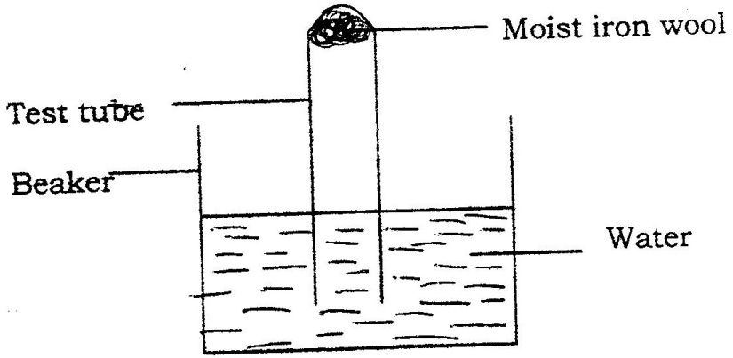

State and explain two observations that would be made at the end of the experiment. (2 Marks)

Q19.(a) A sample of water in a beaker was found to boil at 102⁰C at 1 atmospheric pressure. Assume that the thermometer was not faulty explain this observation (1mk)

(b) Study the information in the table below and answer the questions that follow.

Salt | Solubility g/100g of water
 | at 40°C | of 60°C
CuSO₄ | 28 | 38
Pb(NO₃)₂ | 79 | 98

A mixture containing 35g of CuSO₄ and 78g of Pb(NO₃)₂ in 100g of water at 60°C was cooled to 40°C.
i) Which salt crystallised out? Give a reason. (2 marks)

ii) Calculate the mass of the salt that crystallized out. (1 mark)

Q20.Consider the following reaction at equilibrium.
PCl_{5 (g)}⇌PCl₃ (g) + Cl_{2 (g)}
Complete the table below to show the effect of different factors on the position of equilibrium. (3mks)
Factor | Effect on the equilibrium position
(i) Decrease pressure

(ii) Removing chlorine

(iii) Adding Helium gas to mixture

Q21. The set – up below was used to prepare hydrogen gas
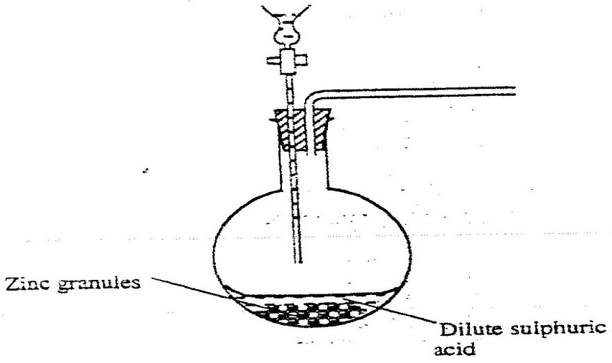

a) Complete the diagram to show how a dry sample of hydrogen gas can be collected(3mks)
b) Write an equation for the reaction, which takes place when hydrogen gas burns in air.(1mk)

22. In a certain reaction, 18.7cm³ of a dibasic acid required 25cm³ of 0.1M NaOH for complete neutralization.
(a) How many moles of Sodium hydroxide are contained in 25cm³? (1mk)

(b) Calculate the molarity of the dibasic acid. (2mks)

Q23 In an experiment to prepare nitrogen (I) oxide, ammonium nitrate was gently heated in a flask.
a) Write the equation for the reaction that took place in the flask. (1 mark)

b) State and explain how the gas was collected.(1 mark)

c) A sample of the gas was tested with damp blue and red litmus papers. What observations were made? (1mark)

Q24.Under certain conditions, chlorine gas reacts with sodium hydroxide to form sodium
hypochlorite.
(a) Name the condition under which sodium hydroxide reacts with chlorine to form
Sodium hypochlorite. (1 mark)

(b) State two uses of sodium hypochlorite. (1 mark)

Q25. (a) Calculate the oxidation state of chromium in the ion Cr₂ O²⁻. (1 mark)

(b) Using oxidation numbers, determine from the equation below the species which undergoes oxidation and reduction.

2FeCl₂(aq) + Cl₂(g)--> 2Fe Cl₃(aq)

Oxidation - (1 mark)

Reduction - (1 mark)

Q26. The table below gives some properties of three elements in group (VII) of the periodic table.
Study it and andanswer the questions that follow:

Element | Atomic  No. | Melting Point  (⁰C) | Boiling Point  (⁰C)
Chlorine | 17 | 101 | -34.7
Bromine | 35 | -7 | 58.8
Iodine | 53 | 114 | 184
a) Which element is in liquid form at room temperature? Give a reason.(2 marks)

b) Explain why the boiling point of iodine is much higher than that of chlorine. (2 marks)

Q27. Study the standard reduction potential given and answer the questions that follow.
(The letters are not the actual symbols of the elements).

E^{ø} (volts)
M²⁺_{(aq)}+ 2e → M_{(s)} -0.76
N²⁺(_{aq)} + 2e → N_{(s)} -2.37
P+_{(aq)} + e → P_{(s)} +0.80
Q²⁺_{(aq)} +2e → Q_{(s):} -0.14

a) The standard reduction potential for Fe ²⁺(aq) is -0.44 volts. Select the element which would best protect iron from rusting.(1 mark)

b) Calculate the E ^{ø} value for the cell represented as M_{(s)} / M²⁺_{(aq)} // P⁺_{(aq)} /P(s). (1mark)

Q28.The formula given below represents a portion of a polymer
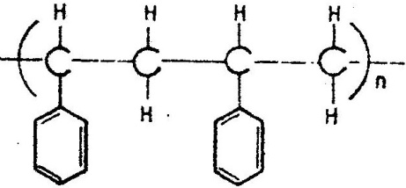

Give:
a) The name of the polymer. (1mark)

b) Draw the monomer. (1mark)

c) One disadvantage of continued use of this polymer. (1mark)

Q29. A sealed glass tube containing air at s.t.p was immersed in water at 100⁰c. Assuming that there was no increase in the volume of the glass tube due to the expansion of the glass, calculate the pressure of the inside tube. (standard pressure = 760mmHg,) ( 2marks).

