NAME………………………………………….……………… INDEX NO…………CLASS……….
ADM……………………….DATE…………................................................SIGN………….……….
312/1
GEOGRAPHY
PAPER 1
2 ¾ HOURS
PANGANI GIRLS’ HIGH SCHOOL
POST MOCK 2019
Kenya Certificate of Secondary Education (KCSE)
September 2019
312/1
GEOGRAPHY
PAPER 1
2 ¾ HOURS
INSTRUCTIONS TO CANDIDATES:
- The paper has two sections:A and B.
- Answer all questions in section A.
- In section B answer 6 and any other two questions.
- All answers must be written in the foolscaps provided.
- Candidates should check the question paper to ensure that all the pages are printed as indicated and that no question(s) are missing.

FOR EXAMINER’S USE ONLY
SECTION | QUESTIONS | MAXIMUM | CANDIDATE’S  SCORE
A | 1-5 | 25
B | 6 | 25
 |  | 25
 |  | 25

SECTION A
Answer all questions in this section
1. a) What is geography? (2marks)
(b) Name the two types of environment. (2marks)
2 .Give three proofs that the earth is almost spherical in shape. (3marks)
3. Use the diagram below to answer questions (a) below.
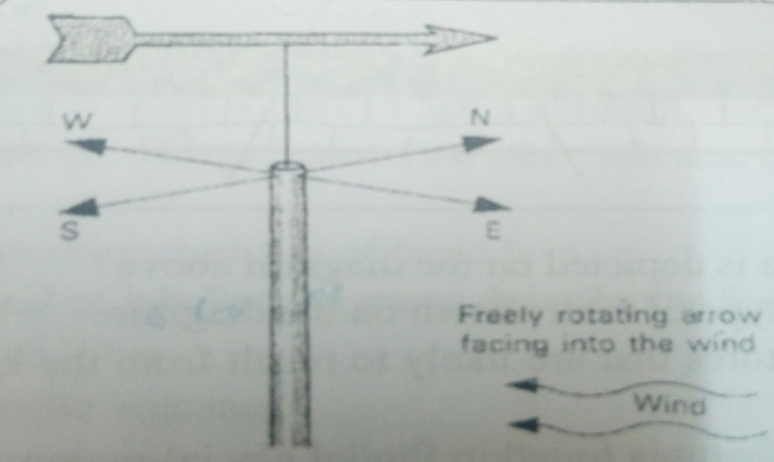

a.(i) Name the weather measuring instrument shown in the diagram. (2marks)
(ii) State the element of weather measured by the instrument named in a.(i) above. (2marks)
(iii)From the diagram, which direction is the wind blowing. (2marks)
b.Differentiatebetween absolute humidity and relative humidity. (2marks)
4. The diagram below shows a coastal landform.
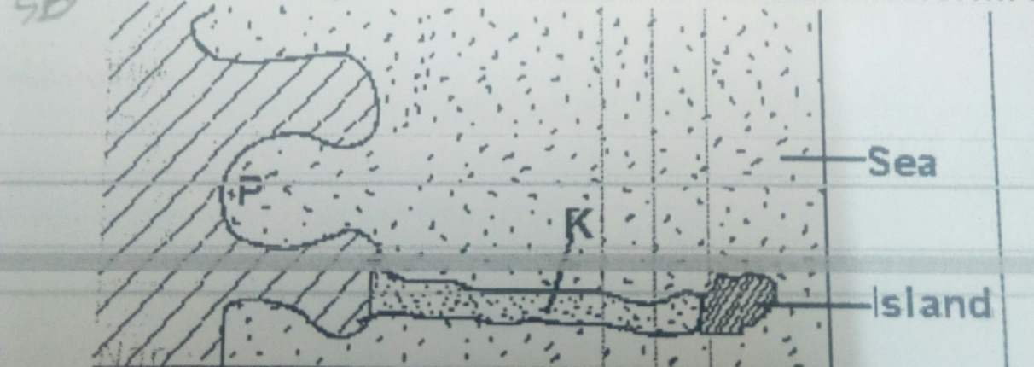
(a) Name the features marked Pand K. (2marks)
(b) List down three types of ocean tides. (3marks)
5 (a) Name the types of earth movements that occur within the earth’s crust. (2marks)
(b) Describe the origin of continents according to the theory of continental drift. (3marks)
SECTION B
Answer question 6 and any other two from this section.
6. Study the map of Taita Hills (1:50,000 (189/4) provided and answer the questions that follows
a (i) Identify the Province and the District shown on the map. (2marks)
(ii) Which two methods of showing relief have been used in the map? (3 marks)
b. (i) Calculate the area covered by Ronge forest. (2marks)
(ii)Give two natural features found in the grid square3419. (2marks)
(iii) Calculate the bearing of the church in grid square 3218 from the school in grid
square 3522. (2marks)
c. (i) Using a vertical scale of 1cm to represent 100Metres, draw a cross section between Grid reference300190 and grid reference 360190. (4marks)
(ii) On the cross section, mark and label the following features; (4 marks)
- A hill
- A river
- Thicket
- Main track (motorable)
(iii) Calculate the vertical exaggeration of the cross section. (2marks)
(d) Citing evidence from the map, explain two factors influencing the distribution of settlement in the area covered by the map. (4 marks)
7. a. (i) Name three types of faults. (3marks)
(ii) Apart from compressional forces, describe two other processes that may cause faulting.
(4 marks)
b. With the aid of diagrams, describe how compressional forces may have led to the formation of the Great Rift Valley. (8marks)
c.Explain five effects of faulting on human activities. (10 marks)
8.a. (i) Define the term Aridity. (2marks)
(ii) State three factors that makes wind an effective agent of erosion and deposition in the
hot deserts. (3 marks)
(b) Describe how a rock pedestal is formed. (5 marks)
(c) Explain four significance of desert features to human activities. (8 marks)
(d) A group of form four students went out for a field study on action of water in an arid area.
(i) Give three methods of data collection they may have used. (3 marks)
(ii) State four problems they have encountered during the field study. (4marks)
9 (a) Describe plucking as a process in glacial erosion. (4 marks)

(b) Explain three conditions that lead to glacial deposition. (6 marks)
(c) The diagram below shows features resulting from glacial deposition in a lowland area.
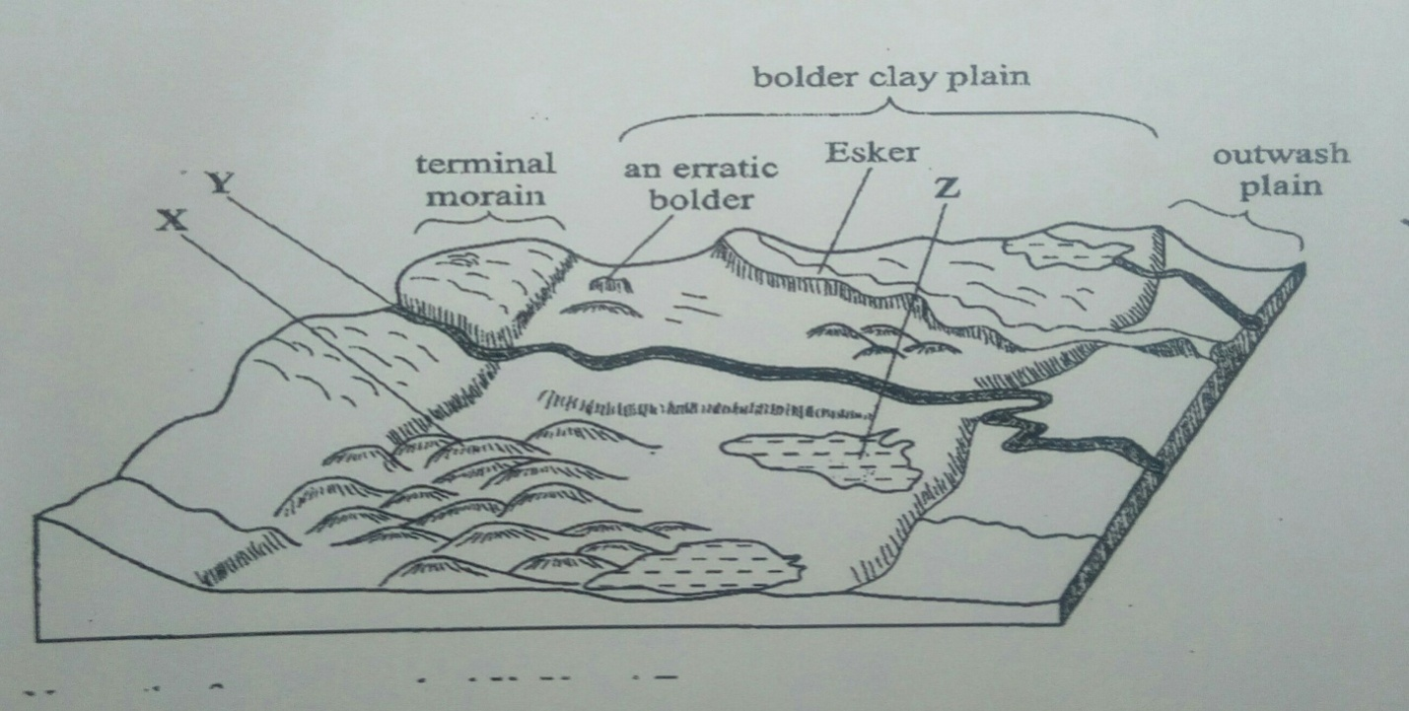

(i)Name the features marked X, Y, and Z. (3 marks)
(ii) Describe how terminal moraine is formed. (4 Marks)
(d) Explain four positive effects of glaciation in low land area. (8 marks)
10. a) What is soil catena? (2 marks)
ii) Draw a well labeled diagram showing the structure of a well-developed soil profile.
(5 marks)
b) Differentiate between mineralization and humification in soil formation. (2 marks)
c) State three factors that determine the color of soil. (3 marks)
d) (i) State four factors that influence soil formation. (4 marks)
(ii) Explain how the following farming practices can cause soil degradation:
- Burning. (2 marks)
- Continuous application of fertilizer on farm land. (2 marks)

- Monoculture. (2 marks)
iii) State threeuses of soil. (3 marks)

