**POST MOCK 1 2019 -September**

PHYSICS -Paper 1

(THEORY)

**2019 – 2 hours**

**232/1 -**

**Name………………………………………………..…………Stream…….Adm ………..**

**Candidate’s signature……………………Date…………………..**

**Instructions to candidates**

(a) Write your name, index number in the spaces provided above.

(b) Sign and write the date of the examination in the spaces provided

(c) This paper consists of **TWO** Sections: **A** and **B**.

(d) Answer **ALL** the questions in section **A** and **B** in the spaces provided.

**(e)** All working **MUST** be clearly shown.

(f) KNEC mathematical tables and silent non-programmable electronic calculators may be used.

**(g) This paper consists of 14 printed pages**

**(h) Candidates should check the question paper to ascertain that all the pages are printed as indicated and that no questions are missing**

**(i) Candidates should answer the questions in English**

**For examiners use only**

|  |  |  |  |
| --- | --- | --- | --- |
| **Section** | **Question** | **Maximum score** | **Candidates score** |
| **A** | 1-13 | 25 |  |
| **B** | 14 | 11 |  |
| 15 | 09 |  |
| 16 | 08 |  |
| 17 | 09 |  |
| 18 | 10 |  |
| 19 | 08 |  |
| TOTAL SCORE | 80 |  |

***SECTION A: 25marks***

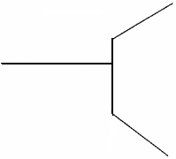1.The figure below shows part of micrometer screw gauge with 50 divisions on the thimble scale. Complete the diagram to show a reading of 5.73mm. (2 marks)

2. A bottle containing a smelling gas is opened at the front bench of a classroom. State the reason why the gas is detected throughout the room. (1 mark)

..................................................................................................................................................................................................................................................................................................3.The figure below shows beaker containing a block of ice.

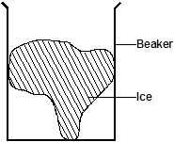

 State and explain the change in stability when the ice melts. (2marks)

...................................................................................................................................................................................................................................................................................................................................................................................................................................................

4. An aero plane is moving horizontally through still air at a uniform speed. It is observed that when the speed of the plane is increased, its height above the ground increases. State the reason for this observation. (2 marks)

…………………………………………….……………………………………………………………………………………………….………………………………………………………………………………………………………………….………………………………

5. A steel ball of mass 0.05kg was placed on top of a spring on a level ground. The spring was then compressed through a distance of 0.2m.

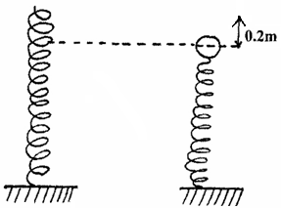

If the spring constant is 15N/m. Calculate the maximum height reached when the spring is released. (3marks)

………………………………………………………………………………………………………………………………………………………………………………………………

6. The figure below shows a uniform metre rule of weight 3N supporting two weights. The metre rule is pivoted somewhere such that it is horizontally balanced. (Pivot not shown)

 The 6N weight is at 15cm mark while the 4N weight is at 70cm mark. Determine the position of the pivot from zero cm mark. (3 marks)

.................................................................................................................................................................................................................................................................................................. 7. State one environmental hazard that may occur when oil spills over a large surface area of the sea. (1 mark)

………………………………………..………………………………………………………………………………………………………………………………..…………………

8. The figure shows a flat bottomed flask containing some water. It is heated directly with a very hot flame. Explain why the flask is likely to crack. (2marks)

...................................................................................................................................................................................................................................................................................................................................................................................................................................................

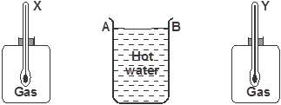9. The figure below shows a cylindrical container having hot water at 95oC. End A is shiny while end B is dull black. At equal distances from the container is placed two identical gas jars fitted with thermometers X and Y.

Compare the readings of the two thermometers after two minutes (1 mark)

..................................................................................................................................................................................................................................................................................................

10. Give a reason for your answer in **question 9** above (1 mark)

 .................................................................................................................................................................................................................................................................................................

11. The figure below shows the change in volume of water in a measuring cylinder when an irregular solid is immersed in it.



Given that the mass of the solid is 268g, determine the density of the solid in SI units.

(3 marks)

...................................................................................................................................................................................................................................................................................................................................................................................................................................................

12. The following figure shows a rod made of wood on one end and metal on the other end suspended freely with a piece of thread so that it is in equilibrium.



The side made of metal is now heated with a Bunsen flame. State with a reason, the side to which the rod is likely to tilt (2 marks)

……………………………………………………………………………………………………………………………………………………………………………………………………………………………………………………………………………………………….

13. The spiral springs shown in the figure below are identical. Each spring has a spring constant, *k = 300N/m*

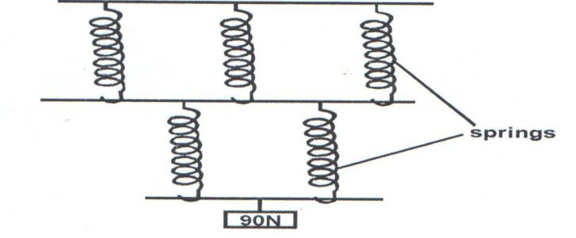

Determine the total extension of the system. (Take the weight of the cross bars to be negligible) (2 marks)

……………………………………………………………………………………………………………………………………………………………………………………………………………………………………………………………………………………………………………………………………………………………………………………………….

***SECTION B: 55marks***

14. (a) State the Archimedes principle. (1 mark)

...................................................................................................................................................................................................................................................................................................................................................................................................................................................

b) A rubber envelope of a hydrogen filled balloon having volume of 2m³ is held in position by a vertical string as shown below.



The mass of the balloon is 1.3kg. Given that density of hydrogen is 0.1kg/m³ density of air is 1.3kg/m³. Calculate

(i) the total weight of the balloon including the hydrogen gas. (2 marks)

...................................................................................................................................................................................................................................................................................................................................................................................................................................................

 (ii) the up thrust. (2 marks) ...................................................................................................................................................................................................................................................................................................................................................................................................................................................

(iii) the tension in the string. (2 marks)

................................................................................................................................................................................................................................................................................................................................................................................................................................................... (c) A solid weighs 50N in air and 44N when complete immersed in water. Calculate

i) Relative density of the solid. (2 marks)

.................................................................................................................................................................................................................................................................................................. (ii) Density of the solid. (2 marks)

..................................................................................................................................................................................................................................................................................................

15.a) The figure below shows a displacement-time graph of the motion of a particle.

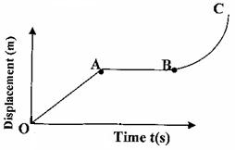

Describe the motion of the particle in the region. (3marks)

OA…………………………..…………………………………………………………….…

AB………………………….………………………………………………………………..

BC…………………………..………………………………………………………………..

(b) State the Newton’s first law of motion. (1 mark)

………………………………………………………………………………………………………………………………………………………………………………………………………………………………………………………………………………………………

c) The figure below shows a trolley moving towards a barrier at a constant velocity of 20m/s. Use this information to answer the questions that follows.

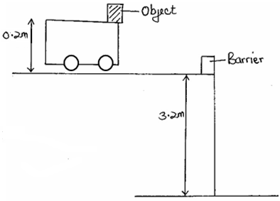

i) Sketch the path followed by the object after the impact (1mark)

ii) Give a reason why the object on the trolley flies off on impact. (1 mark)

……………………………………………………………………………………………………………………………………………………………………………………………….

iii) Determine the time taken by the object to reach the ground. (2 marks)

………………………………………………………………………………………………………………………………………………………………………………………………

iv) Determine the horizontal distance covered by the object from the point of impact to the point where it reached the ground. (2 marks)

………………………………………………………………………………………………………………………………………………………………………………………………………………………………………………………………………………………………

16. a) What is meant by absolute zero temperature? (1 mark)

...................................................................................................................................................................................................................................................................................................................................................................................................................................................

b) The set up below was used by a group of form three students to verify pressure law.



Describe briefly how the set-up can be used to verify pressure law. (4 marks)

......................................................................................................................................................................................................................................................................................................................................................................................................................................................................................................................................................................................................................................................................................................................................................................................................................................................................................................

c) A 4.5cm³ bubble released at the bottom of a dam measured 18cm³ at the surface of the dam. Work out the depth of the dam taking atmospheric pressure to be 105 Pa and the density of water as 1g/cm³. (3marks)

...................................................................................................................................................................................................................................................................................................................................................................................................................................................

17(a) One of the factors that affect the centripetal force is the mass of the body. State another factor. (1mark)

………………………………………………………………………………………………………………………………………………………………………………………………

(b) A mass of 400g is rotated by a string at a constant speed V in a vertical circle of radius 100cm. The tension in the string is 9.2N which is experienced at point T.

•

**T**

i) Determine the velocity V of the mass at point T. (3marks)

……….……………………………………………………………………………………………………….……………………………………………………………………………………………………………………………………………………………………………….

ii) Determine the tension in the string at the bottom of the circle. (2marks)

……………………………………………………………………………………………………………………………………………………………………………………………………………………………………………….……………………………………………

c) State two applications of circular motion (2marks) ……………………………………………………………………………………………………………………………………………………………………………………………………………………………………………………………………………………………….

18. The figure below shows an inclined plane, a trolley of mass 30kg is pulled up a slope by a force of 100N parallel to the slope. The trolley moves so that the centre of mass C travels from points A to B.

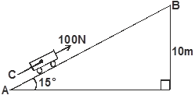

a) What is the work done on the trolley against the gravitational force in moving from A to B? (2marks) ……………………………………………………………………………………………………………………………………………………………………………………………………………………………………………………………………………………………….

b) Determine the work done by the force in moving the trolley from A to B (2 marks) ……………………………………………………………………………………………………………………………………………………………………………………………………………………………………………………………………………………………….

c) Determine the efficiency of the system. (3 marks) ……………………………………………………………………………………………………………………………………………………………………………………………………………………………………………………………………………………………….

d) Determine the mechanical advantage of the system. (3 marks)

……………………………………………………………………………………………………………………………………………………………………………………………………………………………………………………………………………………………….

19. a) Explain why it is advisable to use a pressure cooker for cooking at high altitudes.

(1 mark)

……………………………………………………………………………………………………………………………………………………………………………………………………………………………………………………………………………………………….

b) A block of metal of mass 150g at 100°C is dropped into a lagged calorimeter of heat capacity 40J/K containing 100g of water at 25°C. The temperature of the mixture is 34°C. (specific heat capacity of water = 4200J/kg/K).

Determine:

(i) Heat gained by the calorimeter. (2marks)

…………………………………………………………………………………….………………………………………………………………………………………………….……………………………………………………………………………………………………….

(ii) Heat gained by water. (2marks) ………………………………………………………………………………………………………………………………………………………………………….……………………………………………………………………………………..…………………...…………

(iii) Specific heat capacity of the metal block. (3marks) …………………………………………………………………………….……………………………………………………………………………………………….…………………………………………………………………………………………….……………………

**THIS IS THE LAST PRINTED PAGE**