NAME: ……………………………………………………………….ADM NO: ………………

SCHOOL: ………………………………………………….STREAM: …………………………

INDEX NO: ………………………………………………………………………………………

231/1
BIOLOGY
Paper 1
June 2018
2 HOURS

BUNYORE – MARANDA JOINT PRE-MOCK EXAMINATIONS 2018
BIOLOGY
231/1
PAPER 1
FORM FOUR
2 HOURS

Instructions to candidates
- Write your name, school and index number in the spaces provided
- Answer all questions in the spaces provided

For Examiner’s use only

Question | Maximum Score | Candidate’s Score
1 - 29 | 80

1. Define the following branches of Biology. (2 marks)
i) Genetics
………………………………………………………………………………………………………………………………………………………………………………………………

ii) Entomology
………………………………………………………………………………………………………………………………………………………………………………………………
2. State three reasons that necessitate classification of living organisms by taxonomists. (3 marks)
………………………………………………………………………………………………………………………………………………………………………………………………
………………………………………………………………………………………………………………………………………………………………………………………………
………………………………………………………………………………………………………………………………………………………………………………………………
3. Define resolving power of a microscope. (1 mark)
………………………………………………………………………………………………………………………………………………………………………………………………
4. State two functions played by the cell wall in plant cells and give the adaptation of the cell wall to performing each of the stated functions. (4 marks)

Function | Adaptation
i)

ii)

5. The cells of a certain herbaceous plant were found to have a diameter of 25µm. The cells were placed in varying concentrations of sugar solution. The average diameter of the cells in each solution was determined and the results obtained were as shown in the table below.

Concentration of sugar  solution (%) | Diameter of cells (µm)
1 | 50
5 | 40
10 | 30
15 | 20

- From the results determine the concentration of the cell sap. (1 mark)
………………………………………………………………………………………………………………………………………………………………………………………………
- Give an explanation for the average diameter of the cells placed in 15% sugar solution (3 marks)
………………………………………………………………………………………………………………………………………………………………………………………………
………………………………………………………………………………………………………………………………………………………………………………………………
- Name the process that occurred in the cells which were place din 1% sugar solution. (1 mark)
………………………………………………………………………………………………………………………………………………………………………………………………

6. (a) Name two defects of the circulatory system in humans. (2 marks)
………………………………………………………………………………………………………………………………………………………………………………………………
………………………………………………………………………………………………………………………………………………………………………………………………

(b) State three functions of blood other than transport. (3 marks)
………………………………………………………………………………………………………………………………………………………………………………………………
………………………………………………………………………………………………………………………………………………………………………………………………

7. The following specimens were extracted from a newly discovered organism.
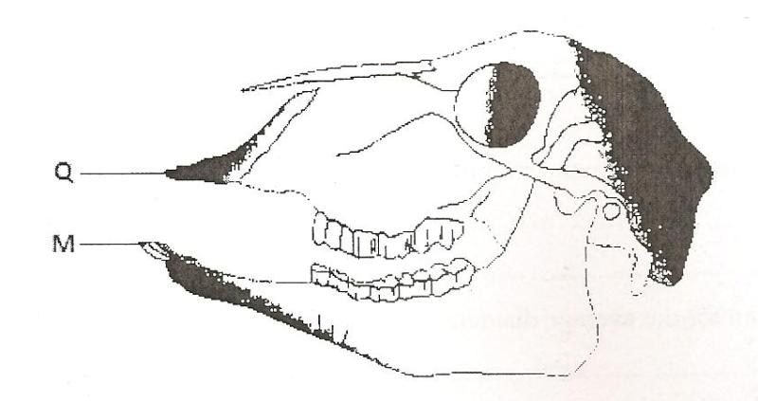

- Name the tooth labeled M. (1 mark)
……………………………………………………………………………………………………………………………………………………………………………………

- Name the part labeled Q and state its role. (2 marks)
Name: …………………………………………………………………………………
Role: ………………………………………………………………………………….
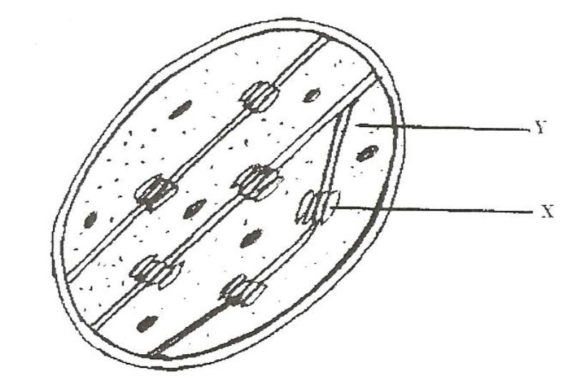
8. The diagram below represents a cell organelle

- Name the part labeled Y (1 mark)

………………………………………………………………………………………………
- State the function of the part labeled X (1 mark)
………………………………………………………………………………………………………………………………………………………………………………………………

9. (a) In what form is energy stored in muscles? (1 mark)
………………………………………………………………………………………………………………………………………………………………………………………………

(b) State the economic importance of anaerobic respiration in plants. (2 marks)
………………………………………………………………………………………………………………………………………………………………………………………………
………………………………………………………………………………………………………………………………………………………………………………………………

10. (a) Name two gaseous exchange surfaces in plants. (2 marks)
………………………………………………………………………………………………………………………………………………………………………………………………

(b) How are gaseous exchange surfaces in animals adapted to performing their function? (2 marks)
………………………………………………………………………………………………………………………………………………………………………………………………
………………………………………………………………………………………………………………………………………………………………………………………………
11. What is the importance of counter flow system in fish? (2 marks)
………………………………………………………………………………………………………………………………………………………………………………………………
………………………………………………………………………………………………………………………………………………………………………………………………
12. State two structural modifications of the kidneys of desert animals like the kangaroo rat. (2 marks)
………………………………………………………………………………………………………………………………………………………………………………………………
………………………………………………………………………………………………………………………………………………………………………………………………
13. (a) Name the fluid that is produced by sebaceous glands. (1 mark)
………………………………………………………………………………………………………………………………………………………………………………………………

(b) What is the role of sweat on the human skin? (2 marks)
………………………………………………………………………………………………………………………………………………………………………………………………
………………………………………………………………………………………………………………………………………………………………………………………………
14. The diagram below represents a certain plant species.
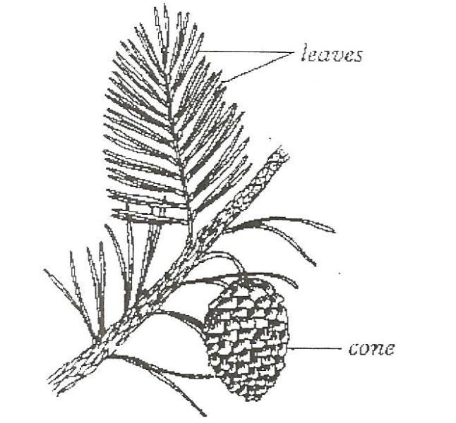

- State the class to which the plant belongs. (1 mark)

………………………………………………………………………………………………………………………………………………………………………………………………

- State the difference between members of Gymnospermaphyta and Atngiospermaphyta (2 marks)

15. Give two reasons why a spider is classified under Phylum Arthropoda. (2 marks)

………………………………………………………………………………………………………………………………………………………………………………………………
………………………………………………………………………………………………………………………………………………………………………………………………
16. (a) Define the following terms as used in ecology. (2 marks)
i) Population

………………………………………………………………………………………………………………………………………………………………………………………………

ii) Autecology
………………………………………………………………………………………………………………………………………………………………………………………………

(b) From three students wanted to estimate the population of grasshoppers in 5km² grass field near a school compound. They captured 36 grasshoppers and marked them before returning them back to the field. After two days they made another catch of grasshoppers. They collected 45 grasshoppers of which only 4 had marks.
i) State why the second capture was done after two days. (1 mark)
………………………………………………………………………………………………………………………………………………………………………………………………

ii) From the data calculate the population size of grasshoppers in the grass field. (2 marks)
………………………………………………………………………………………………………………………………………………………………………………………………

17. In mitosis in animals chromatids failed to separate and move to opposite poles
a) Name the organelle that the cell was lacking (1 mark)
………………………………………………………………………………………………………………………………………………………………………………………………

b) Name two regions in plants where cells actively undergo mitosis (2 marks)
………………………………………………………………………………………………………………………………………………………………………………………………

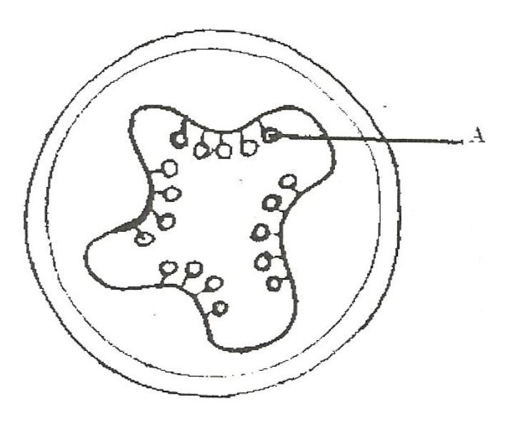
18. The diagram below represents a transverse section of an ovary from a certain flower.

- Name the structure labeled A. (1 mark)

………………………………………………………………………………………………………………………………………………………………………………………………
- Name the type of placentation illustrated in this diagram. (1 mark)
………………………………………………………………………………………………………………………………………………………………………………………………

19. (a) State the functions of the following parts (2 marks)
i) Endometrium
………………………………………………………………………………………………………………………………………………………………………………………………
ii) Epididymis
………………………………………………………………………………………………………………………………………………………………………………………………

b) What mechanism facilitates the movement of the ovum towards the uterus? (1 mark)..............................................................................
20. Use the diagram below to answer questions that follow.
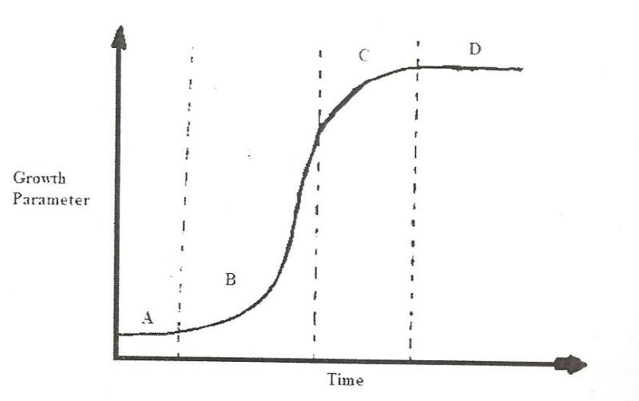

- Identify the type of growth curve shown. (1 mark)

………………………………………………………………………………………………………………………………………………………………………………………………
- State one factor that leads to phase labeled B (1 mark)
………………………………………………………………………………………………………………………………………………………………………………………………

21. Give two differences between epigeal and hypogeal germination (2 marks)
………………………………………………………………………………………………………………………………………………………………………………………………
………………………………………………………………………………………………………………………………………………………………………………………………

22. State the function of juvenile hormone in growth and development of insects. (1 mark)
………………………………………………………………………………………………………………………………………………………………………………………………

23. (a) What is sex linkage? (1 mark)
………………………………………………………………………………………………………………………………………………………………………………………………
………………………………………………………………………………………………………………………………………………………………………………………………
(b) Give two sex linked genes found on the Y chromosome. (2 marks)
………………………………………………………………………………………………………………………………………………………………………………………………
………………………………………………………………………………………………………………………………………………………………………………………………

24. Below is a nucleotide strand
A A G T C

- Identify the type of nucleic acid (1 mark)
………………………………………………………………………………………………………………………………………………………………………………………………

- Give a reason for your answer in (a) above (1 mark)
………………………………………………………………………………………………………………………………………………………………………………………………

25. (a) What are analogous structures? (1 mark)
………………………………………………………………………………………………………………………………………………………………………………………………
………………………………………………………………………………………………………………………………………………………………………………………………
(b) Give one example of analogous structures. (1 mark)
………………………………………………………………………………………………………………………………………………………………………………………………
(c) State comparative embryology as an evidence of organic evolution (2 marks)
………………………………………………………………………………………………………………………………………………………………………………………………
………………………………………………………………………………………………………………………………………………………………………………………………
26. State two structural differences between apes and human beings. (2 marks)
………………………………………………………………………………………………………………………………………………………………………………………………
………………………………………………………………………………………………………………………………………………………………………………………………
27. The diagram below represents parts of a synapse.
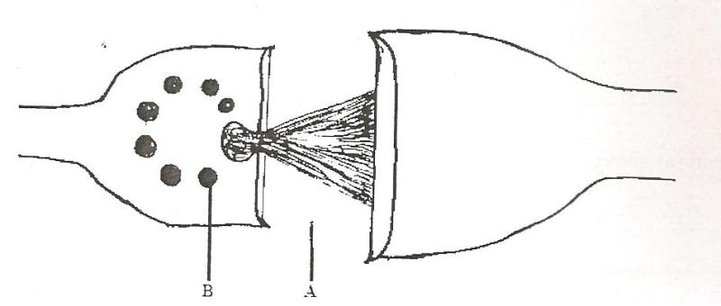

- Name part labeled A. (1 mark)
………………………………………………………………………………………………………………………………………………………………………………………………
- What is the function of part labeled B. (1 mark)
………………………………………………………………………………………………………………………………………………………………………………………………
- On the diagram show the direction of flow of impulse (1 mark)
………………………………………………………………………………………………………………………………………………………………………………………………

28. (a) State the function of cerebrospinal fluid (1 mark)
………………………………………………………………………………………………………………………………………………………………………………………………
(b) How is the choroid of the eye adapted to its function? (1 mark)
………………………………………………………………………………………………………………………………………………………………………………………………
………………………………………………………………………………………………………………………………………………………………………………………………

29. (a) Name a support tissue in plants that is not thickened. (1 mark)
………………………………………………………………………………………………………………………………………………………………………………………………

(b) State the type of skeleton found in all vertebrates. (1 mark)
……………………………………………………………………………………………………………………………………………

