NAME: ……………………………………………………………….ADM NO: ………………

SCHOOL: ………………………………………………….STREAM: …………………………

INDEX NO: ………………………………………………………………………………………

231/2
BIOLOGY
Paper 2
June 2018
2 HOURS

BUNYORE – MARANDA JOINT PRE-MOCK EXAMINATIONS 2018
BIOLOGY
231/2
PAPER 2
FORM FOUR
2 HOURS
INSTRUCTION TO CANDIDATES
Answer ALL questions in section A. In section B answer question 6 (compulsory) and either question 7 or 8 in the spaces provided after question 8.
SECTION | QUESTION | MAX. SCORE | CANDIDATE’S SCORE
A | 1 | 8
 | 2 | 8
 | 3 | 8
 | 4 | 8
 | 5 | 8
B | 6 | 20
 | 7 | 20
 | 8 | 20
TOTAL |  | 80

SECTION A (40 Marks)
1. A climbing plant twines around the stem of a tall tree.
(a) (i) Name the type of response exhibited by the climbing stem. (1 mark)
………………………………………………………………………………………………
………………………………………………………………………………………………
(ii) Explain how the response named in (a) (i) above takes place. (3 marks)
………………………………………………………………………………………………
………………………………………………………………………………………………
………………………………………………………………………………………………
(b) An experiment was carried out to investigate the response of white termites to a certain stimulus. Ten termite were placed at the centre of glass tubing. Calcium chloride was placed one end of the tubing and moist cotton wool at the other end as illustrated below.
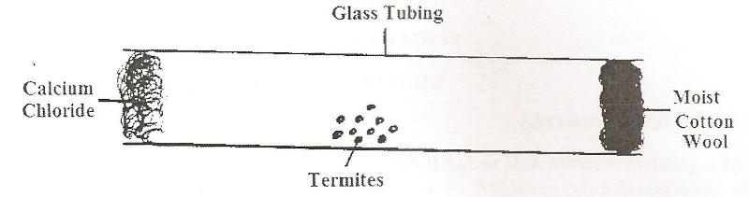

- What observations are made after 20 minutes? (1 mark)
………………………………………………………………………………………………………………………………………………………………………………
- What type of response is exhibited by the termites? (1 mark)
………………………………………………………………………………………………………………………………………………………………………………
- What is the survival value of the above response? (1 mark)
………………………………………………………………………………………………………………………………………………………………………………
- What is Photonasty? (1 mark)
………………………………………………………………………………………………………………………………………………………………………………
2. (a) What is multiple allelism? (1 mark)
………………………………………………………………………………………………………………………………………………………………………………
(b) A pure breeding black male mouse was mated with a pure breeding brown female mouse. All the offspring had black coat colour.
(i) Explain the appearance of black coat colour in the offspring. (1 mark)
………………………………………………………………………………………………………………………………………………………………………………
………………………………………………………………………………………
(ii) If the black parental mouse was mated with a mouse that is heterozygous for coat colour, work out the genotypic ratio of offspring. Show your working. (4 marks)
………………………………………………………………………………………………………………………………………………………………………………
………………………………………………………………………………………………………………………………………………………………………………
(iii) State two disorders in human beings that are as a result of chromosomal mutation. (2 marks)
………………………………………………………………………………………………………………………………………………………………………………
………………………………………………………………………………………………………………………………………………………………………………
3. (a) i) What is meant by the term biological control? (1 mark)
………………………………………………………………………………………………………………………………………………………………………………
………………………………………………………………………………………
(ii) Give an example of biological (1 mark)
………………………………………………………………………………………………………………………………………………………………………………
………………………………………………………………………………………………………………………………………………………………………………
(b) (i) What is eutrophication? (3 marks)
………………………………………………………………………………………………………………………………………………………………………………
………………………………………………………………………………………
(ii) What are the effects of eutrophication? (3 marks)
………………………………………………………………………………………………………………………………………………………………………………………………………………………………………………………………………
4. The diagram below represents a transverse section of a plant organ.
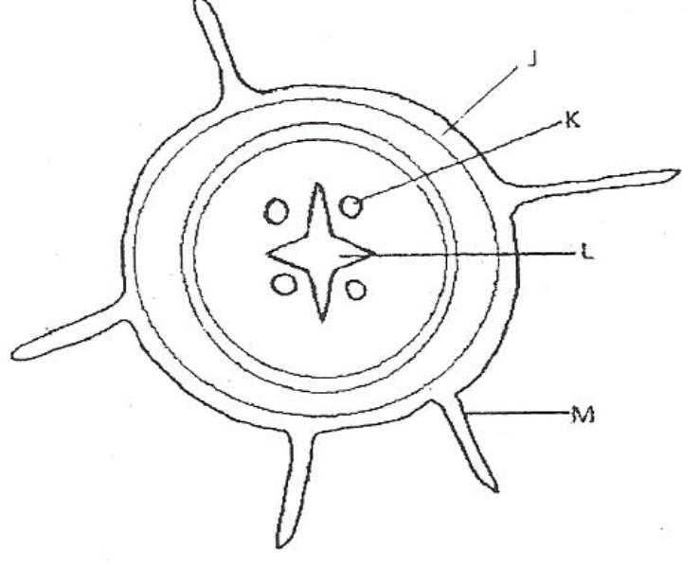

- From which plant organ was the section obtained. (1 mark)
………………………………………………………………………………………………………………………………………………………………………………
- Give two reasons for your answer in (a) above. (2 marks)
………………………………………………………………………………………………………………………………………………………………………………
………………………………………………………………………………………………………………………………………………………………………………
- Name the parts labeled J, K and L (3 marks)
J: ……………………………………………………………………………….
K: ………………………………………………………………………………
L: ………………………………………………………………………………
5. The diagrams below illustrate two types of neurons and associated structures. Study the diagrams carefully and answer the questions that follow.
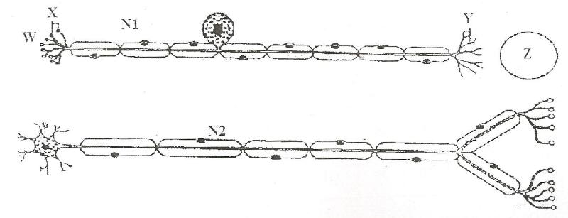

- (i) Identify the type of neurons illustrated in diagrams N1 and N2. (2 marks)

N1: ………………………………………………………………………………….
N2: ………………………………………………………………………………….
(ii) Provide two reasons for your identity of the neuron in diagram N1. (2 marks)
………………………………………………………………………………………………………………………………………………………………………………
………………………………………………………………………………………………………………………………………………………………………………
- Name each of the structure labeled X and Y in diagram N1. (2 marks)

X: ……………………………………………………………………………………

Y: ……………………………………………………………………………………
- Give the general name of the type of cell at position Z in diagram N1. (1 mark)

……………………………………………………………………………………………………………………………………………………………………………………………..

- Give the general name of the substance in position W in diagram N1 (1 mark)

……………………………………………………………………………………………………………………………………………………………………………………………..
SECTION B (40 MARKS)
Answer question 6 (compulsory) in the spaces provided. Answer either question 7 or 8 in the spaces provided after question 8.
6. An investigation was conducted to compare water rate of water loss from twigs of two different species of plants Q and L. the twigs had equal leaf surfaces. The results of the investigation were recorded in the below.
Time of the day | 6 a.m | 8 a.m | 10 a.m | 1 p.m | 12 p.m | 1 p.m | 2 p.m | 3 p.m | 6 p.m | 8 p.m | 12 a.m
Water loss gh^{-h} | 0 | 4 | 20 | 40 | 55 | 36 | 26 | 20 | 2 | 0 | 0
Water loss gh ^{–h} Species L | 8 | 20 | 39 | 131 | 198 | 182 | 130 | 81 | 45 | 12 | 12

- On the graph paper provided on page 7, plot a graph of Water loss gh^{-h} against time for the two plants. (7 marks)
- Name the apparatus which might have been used to investigate the rate of water loss. (1 mark)
………………………………………………………………………………………………………………………………………………………………………………………………
- State two precautions that were taken in setting up the experiment. (2 marks)
……………………………………………………………………………………………………………………………………………………………………………………………..
………………………………………………………………………………………………Which of the plant species is likely to be adapted to arid conditions? Give a reason. (2 marks)
……………………………………………………………………………………………………………………………………………………………………………………………..
………………………………………………………………………………………………Use the graph to answer the following questions:
- At what time of the day was 60gh⁻¹ of water lost by plant species L?
……………………………………………………………………………………………………………………………………………………………………………………………..

- What was the rate of water loss from plant species Q at 11.00 am? (1 mark)
……………………………………………………………………………………………………………………………………………………………………………………………..
(f) Account for the rate of water loss between 6.00 a.m. to 1.00 p.m. by plant species L. (4 marks)
……………………………………………………………………………………………………………………………………………………………………………………………..
……………………………………………………………………………………………………………………………………………………………………………………………..
……………………………………………………………………………………………………………………………………………………………………………………………..
(g) Suggest how the stomata of species Q are structurally adapted to water loss. (2 marks)
……………………………………………………………………………………………………………………………………………………………………………………………..
……………………………………………………………………………………………………………………………………………………………………………………………..
7. Describe how the mammalian male reproductive system is adapted to perform its functions. (20 marks)
8. Describe the structure and functions of various organelles in a mature animal cell. (20 marks)
…………………………………………………………………………………………………………………………………………………………………………………………….........................................................................................
…………………………………………………………………………………………………………………………………………………………………………………………….........................................................................................
……………………………………………………………………………………………………………………………………………………………………………………………..........................................................................................
…………………………………………………………………………………………………………………………………………………………………………………………….........................................................................................
……………………………………………………………………………………………………………………………………………………………………………………………...........................................................................................
…………………………………………………………………………………………………………………………………………………………………………………………….........................................................................................
……………………………………………………………………………………………………………………………………………………………………………………………..........................................................................................
……………………………………………………………………………………………………………………………………………………………………………………………..........................................................................................
…………………………………………………………………………………………………………………………………………………………………………………………….........................................................................................
……………………………………………………………………………………………………………………………………………………………………………………………..........................................................................................
……………………………………………………………………………………………………………………………………………………………………………………………............................................................................................
…………………………………………………………………………………………………………………………………………………………………………………………….........................................................................................
……………………………………………………………………………………………………………………………………………………………………………………………...........................................................................................
……………………………………………………………………………………………………………………………………………………………………………………………..........................................................................................
……………………………………………………………………………………………………………………………………………………………………………………………..........................................................................................
……………………………………………………………………………………………………………………………………………………………………………………………..........................................................................................
……………………………………………………………………………………………………………………………………………………………………………………………..........................................................................................
…………………………………………………………………………………………………………………………………………………………………………………………….........................................................................................
……………………………………………………………………………………………………………………………………………………………………………………………..........................................................................................

