Name: ………………………………………………Index No……………………………….

Candidate’s Signature…………………………….

Date: …………………………………..

231/3
BIOLOGY
Paper 3
(PRACTICAL)
June 2018

MARANDA BUNYORE
Premock-Examination

BIOLOGY
Paper 3
(PRACTICAL)
1 ¾ Hours

Instructions to candidates

- Write your name and index number in the spaces provided above.
- Sign and write the date of the examination in the spaces provided above
- Answer ALL the three questions in the spaces provided
- Spend the first 15 min of the 1hr 45 min to read through the paper carefully before commencing your work.
- Additional pages must NOT be inserted
- This paper consists of 5 printed pages
- Candidates should check the question paper to ensure that all the pages are printed as indicated and no question is missing.

FOR EXAMINER’S USE ONLY

1. You are provided with a specimen labeled R which is a plant organ.
(a) Carefully break it open along its length to expose inner parts hence draw a well labeled diagram of specimen R showing at least four parts. (3 marks)

(b) Crush the already broken specimen R into fine powder, put into a test tube and add 6ml of water to make solution R. Using the provided reagents carry out tests to identify the food substances present in solution R. (9 marks)

TEST FOR | PROCEDURE | OBSERVATION | CONCLUSION

2. The photograph P1 below illustrates some components of a light microscope while P2 show some instruments used for dissection in a biology laboratory. Study them carefully and answer the questions that follow.
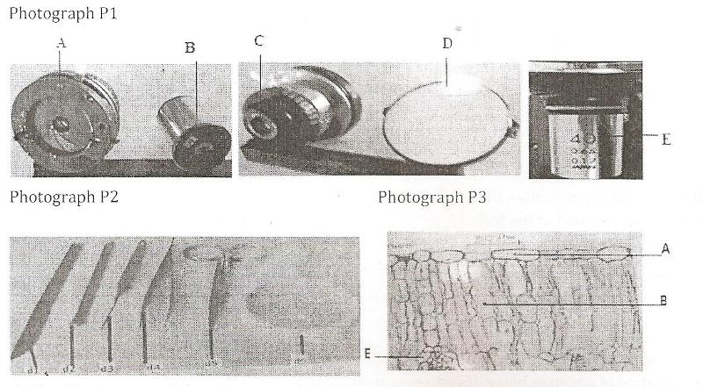

- Identify the parts of the microscope labeled A, B, C, D and E and in each case state its function. (5 marks)
Part | Identity | Function
A
B
C
D
E

- I) Name the instruments labeled d1, d2, and d3 (3 marks)
d1………………………………………………………………………………………….
d2…………………………………………………………………………………………..
d3………………………………………………………………………………………….
ii) State the role of d4, d5 and d6 during dissection (3 marks)
d4…………………………………………………………………………………………..
d5…………………………………………………………………………………………..
d6………………………………………………………………………………….
- Photograph P3 shows the internal structures of a dicotyledonous leaf.
- Name the parts labeled A and E. (2 marks)
A…………………………………………………………………………………

E………………………………………………………………………………….
- State two adaptations of cells B to their function. (2 marks)
………………………………………………………………………………………………………………………………………………………………………………………………………………………………………………………………………
- If the total magnification of the micrograph is X25’000, calculate the actual length of the vertical cross-section of the leaf. (3 marks)

3. Photographs R1, R2, R3 and R4 show fetuses at different stages of development after implantation in a human being. Use them to answer the questions that follow.
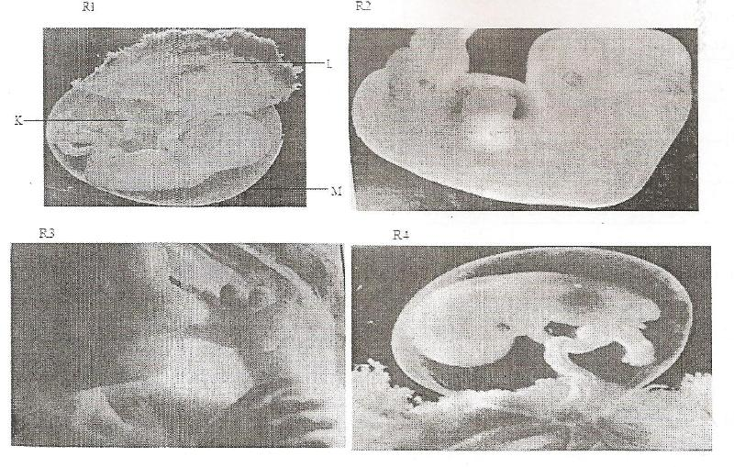

- Arrange the stages of development beginning with the latest. (1 mark)

………………………………………………………………………………………….
- Name the parts labeled K, L and M in photograph R1. (3 marks)

K ………………………………………………………………………………………
L ……………………………………………………………………………………….
M ………………………………………………………………………………………

- Name:
- The blood vessels present in the part labeled K. (2 marks)
…………………………………………………………………………………..

…………………………………………………………………………………..

- The tissue that form the part labeled L. (3 marks)
………………………………………………………………………………………………………………………………………………………………………………………………………………………………………………………

- State one role played by the fluid enclosed by part M. (1 mark)

……………………………………………………………………………………..

………………………………………………………………………………………

