SCIENCE AND TECHNOLOGY
GRADE 4
NAME____________________________ DATE ________________
1) Write down five examples of living things
a) ________________________
b) ________________________
c) ________________________
d) ________________________
e) ________________________
2) A stone and a log of wood are examples of ________________ things
(Living, breathing, non-living)
3) Name two crops grown for food at home
a) __________________
b) _________________
4) Draw and colour a plant in your environment

5) Match the item to the part of the body where it is worn
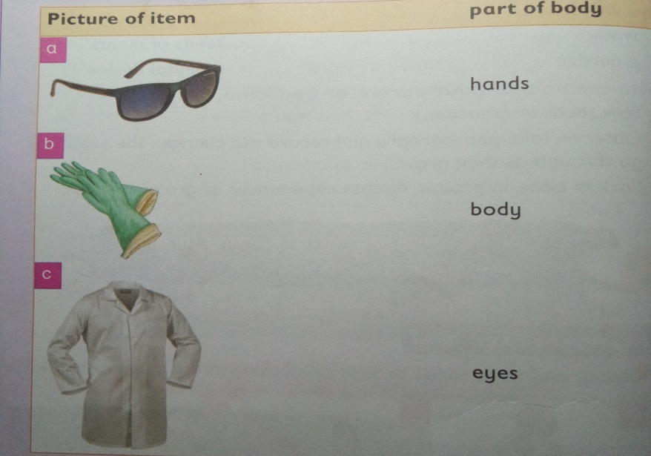
6) Give three examples for each of the following groups of animals
A) Vertebrates B) Invertebrates
____________________ ____________________
_____________________ ____________________
_____________________ ____________________

7) Write true or false.
All animals are living things ______________
All animals eat the same food _____________

8) When animals give birth to young ones we say that they ______________________
(Feed reproduce die)

9) Underline three characteristics of animals as living things
They die
They reproduce
They read
They grow
They cry

