GATUNDU SOUTH SUB-COUNTY EVALUATION
JULY/AUG 2019

Name ………………………..………………………… ………Index No....………………..…….………………………………………..
Candidate’s Signature: …………....………………….. ADM.NO………………………………… Date: ……………………………….
232/1
PHYSICS
Paper 1
2Hours
INSTRUCTION TO CANDIDATES
- Write your name, index number and school in the spaces provided.
- This paper consists of TWO sections: A and B
- Answer ALL questions in section I and II in the spaces provided.
- ALL workings MUST be clearly shown.
- Mathematical tables and electronic calculators may be used.

For examiner’s use only.
Section | Question | Maximum score | Candidate’s score
A | 1 – 10 | 25
B | 11  12  13  14  15 | 11  11  11  10  12
 | Total | 80

SECTION A 25 MARKS
Answer all questions in this section
- The figure I below shows the reading of a vernier calipers used to get the diameter of a cylindrical tin.
9
10
11
0
10

If the vernier caliper had a negative error of 0.02 cm, what is the actual diameter of the tin?
(2 marks)
…………………………………………………………………………………………………………………………………………………………………………………………………………………………………………………………………………………………………………………………………………………………………………………………………………………………………………………………………………

2 .A body is projected vertically upwards from the top of a building. Assuming that it lands at the base of the building. Sketch the velocity time graph of the motion. (2marks

3 The stability of a body can be increased by increasing the base area and lowering its centre of gravity. State how the position centre of gravity can be lowered. (1mark)
…………………………………………………………………………………………………………………………………………………………………………………………………………………………………….

4. When a mercury thermometer is used to measure the temperature of hot water, it is observed that the mercury level first drops before beginning to rise. Explain. (2marks)
……………………………………………………………………………………………………………………………………………………………………………………………………………………………………..

5.The figure below shows a hot water bath with metal rods inserted through one of its sides. Some wax is fixed at the end of each rod.
Hot water
Metal rod
Wax

    - What property of metals could be tested using this set-up? (1 mark)
…………………………………………………………………………………………………………………………………………………………………

    - besides the length of the rods that is kept constant, what else should be kept constant when comparing the property for different metal rods (1 mark)
…………………………………………………………………………………………………………………
6.The figure below shows a uniform meter rule pivoted at 30cm mark. It is balanced by a weight of 2N suspended at the 5cm mark.
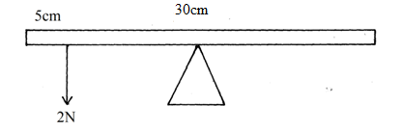
Determine the weight of the meter rule. (2 marks)
……………………………………………………………………………………………………………………………………………………………………………………………………………………………………

7. using the idea of particles, explain why the pressure inside the tyre is increased when it is pumped up … .(2marks)
……………………………………………………………………………………………………………………………………………………………………………………………………………………………………..

8. A trolley of mass 0.5kg moving with a velocity of 1.2ms⁻¹ collides inelastically with a second trolley of mass 1.5kg moving in the same direction with a velocity of 0.2ms⁻¹.
(a) What is an inelastic collision? (1mark)

……………………………………………………………………………………………………………….

(b) Determine the velocity of the trolleys after collision. (3marks)
…………………………………………………………………………………………………………………………………………………………………………………………………………………………………
……………………………………………………………………………………………………………….

9 Ventilations in a house are normally placed high on a wall near the ceiling. Explain. (1mark)

…………………………………………………………………………………………………………….

10. State the reason why mercury is preferred as a barometric liquid and not water. ( 1mark)

…………………………………………………………………………………………………………………
……………………………………………………………………………………………………………….

11.The figure below shows a small toy boat floating in water in a basin. P and Q are two points near the toy.
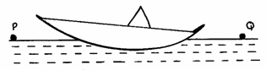

Drops of Soup solution was added at point Q.
- State what was observed (1 mark)
…………………………………………………………………………………………………………………
- Explain the observation (2 marks)
………………………………………………………………………………………………………………………………………………………………….…………………………………………………………………

12.(a) Figure 10 below shows two graphs for two different springs A and B

A F1
Force (N)
B F2

Extension (mm)

F₁ and F₂ are points at which the springs break determine and explain which of the two springs
(i) Obeys Hooke’s law (1 mark)
…………………………………………………………………………………………………………

(ii) Is stronger (1 mark)
…………………………………………………………………………………………………………………

13. When a drop of olive oil of known volume is dropped on the surface of water in a large trough it spread out to form a large circular patch. State one assumption made when the size of the molecule of olive oil is estimated . (1mark)

SECTION B (55 MARKS)

Answer all questions in the spaces provided.
14 (a) Define the term velocity ratio as used in machines (1mark)

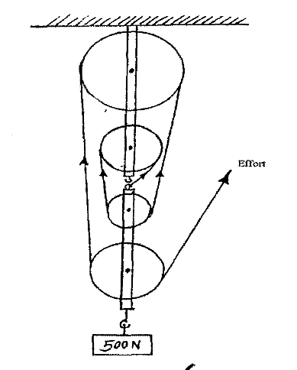
(b) Figure 6 shows a block and tackle pulley system lifting a load of 500N

Fig 6

(i) Determine the velocity ratio of the machine (1mark)
………………………………………………………………………………………………………………………………………………………………………………………………………………………

(ii) If an effort of 120N is required to lift the load using the machines determine the efficiency of the pulley system (3marks)

(iii) In the space provided below, sketch a graph of efficiency against load for the system. (2marks)

15.(a) State the law of flotation. (1 mark)
……………………………………………………………………………………………………………………………………………………………………………………………………………………………………………………………………………………………………………………………………
(b) A body weighs 40N in air, 30N in water and 35N when in liquid X. Find the relative density of liquid X. (3 marks)
………………………………………………………………………………………………………………………………………………………………………………………………………………………………………………………………………………………………………………………………………………………
(c) A simple hydrometer is set up with a test –tube of mass 10g and length 12cm with a flat base and partially filled with lead shots. The test – tube has a uniform cross – sectional area of 2.0cm² and 10cm of its length is under water as shown in the figure below.

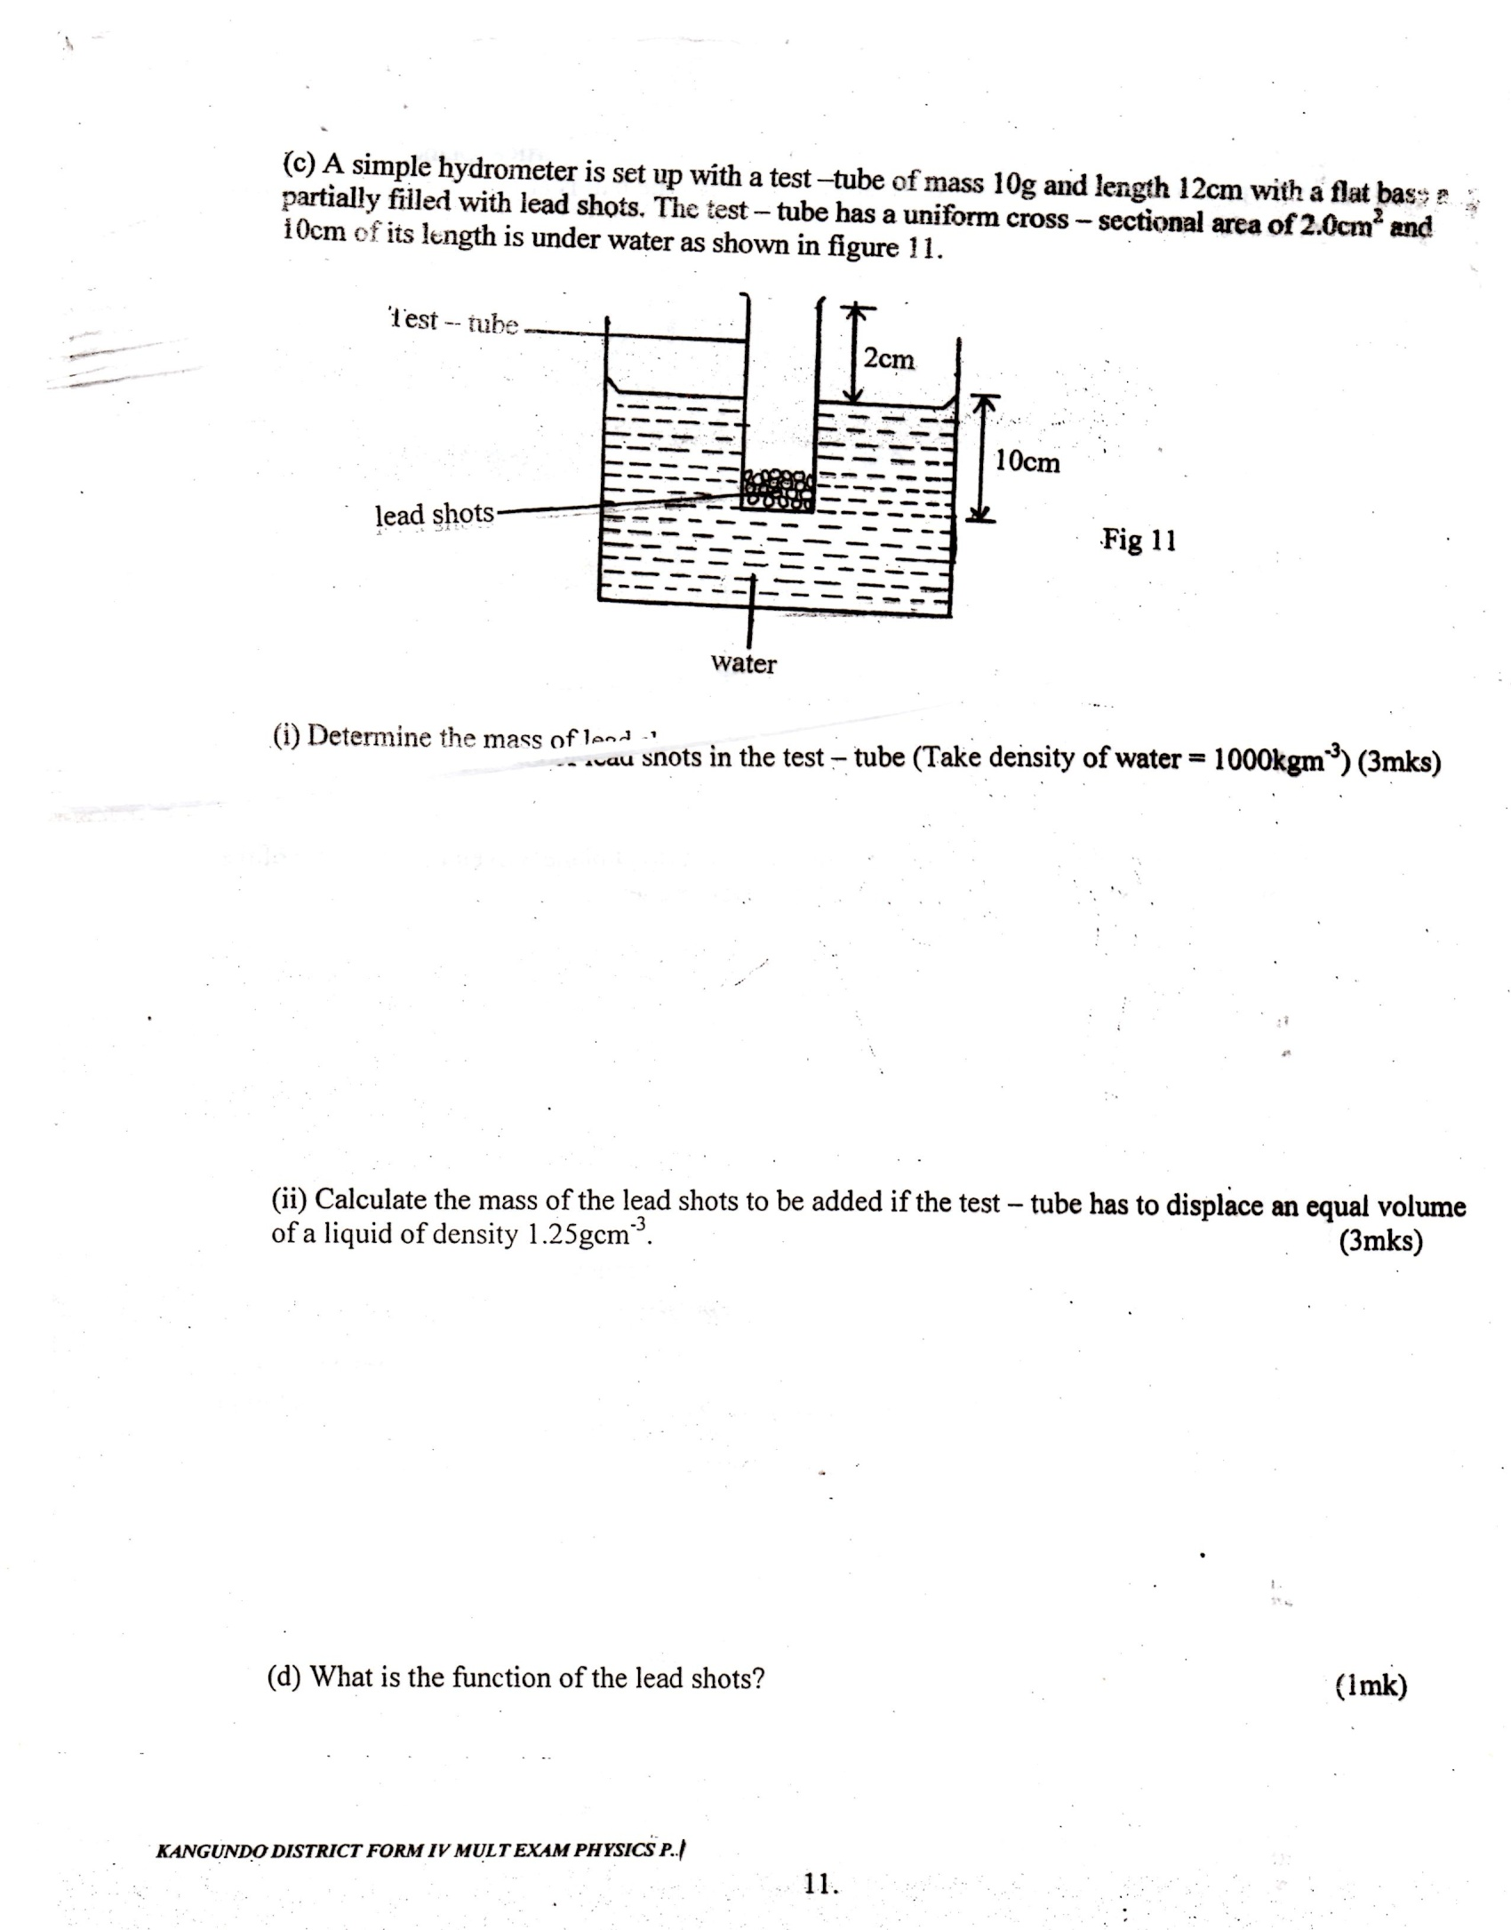
- Determine the mass of lead shots in the test – tube (Take density of water = 1000kgm⁻³)
(3 marks)
……………………………………………………………………………………………………………………………………………………………………………………………………………………………………………………………………………………………………………………………………………………………………………………………………………………………………………………………………………………………………….

(ii) Calculate the mass of the lead shots to be added if the test – tube has to displace an equal volume of a liquid of density 1.25gcm⁻³. (3 marks)
……………………………………………………………………………………………………………………………………………………………………………………………………………………………………………………………………………………………………………………………………………………………………………………………………………………………………………………………………………………………………….

(d) What is the function of the lead shots? (1 mark)
……………………………………………………………………………………………………………………………………………………………………………………………………………………………………………………………………………………………………………………………………

- The figure below shows a set up that can be used to determine the specific heat capacity of a
metal block.
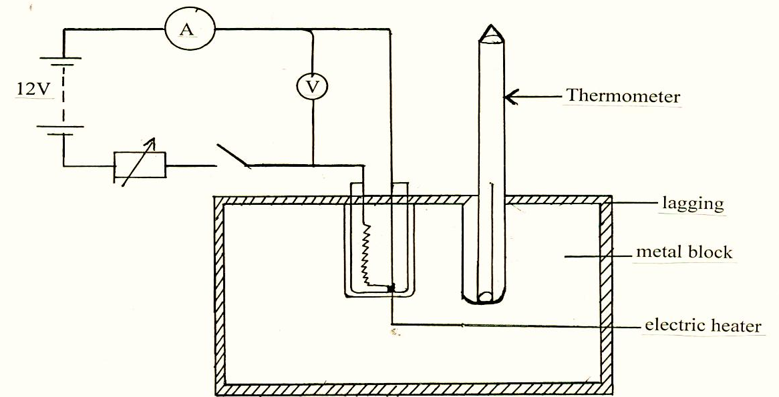
(i) State the measurement that should be taken in the experiment to determine specific heat capacity of the metal block. (3marks)
………………………………………………………………………………………………………………………………………………………………………………………………………………………………………………………………………………………………………………………………………………………..

(ii) Show how the measurement above can be used to determine the specific heat capacity of the metal block. (2marks)
………………………………………………………………………………………………………………………………………………………………………………………………………………………………………………………………………………………………………………………………………………………..

(iii) State the function of the following in the set up
(I) Lagging (1mark)
……………………………………………………………………………………………………………………………………………………………………………………………………………………………………..

(II) Drops of oil in the holes containing thermometer and the electric heater (1mark)

………………………………………………………………………………………………………….
………………………………………………………………………………………………………….

(b) A copper can together with stirrer of total heat capacity 600J/K contains 200g of water at 15⁰C. Dry steam at 100⁰C is passed through the water while stirring until it reaches a final temperature of 55⁰C. Calculate the mass of the steam condensed. Take specific heat of capacity of water as 4200J/Kg/k and specific latent heat of steam as 2,260,000J/kg (5marks)

…………………………………………………………………………………………………………………………………………………………………………………………………………………………………………………………………………………………………………………………………………………………………………………………………………………………………………..

17.(a) A car is negotiating unbanked circular track. What provides the centripetal force of the car. (2marks)
……………………………………………………………………………………………………………………………………………………………………………………………………………………………………………………………………………………………………………………………………

(b) Given that the car above has a mass of 1000kg and the circular path has a radius of 25m. Determine the maximum speed with which the motorist can travel so as not to skid if the frictional force between the tyres and the road is 6500N. (3marks)

………………………………………………………………………………………………………………………………………………………………………………………………………………………………………………………………………………………………………………………………………………………..

(c) A 200g mass tied to a string is being whirled in a vertical circle of radius 32cm with uniform speed,
At the lowest position the tension in the string is 10.5N.: Determine -
(i) The speed of the mass (3marks)

………………………………………………………………………………………………………………………………………………………………………………………………………………………………………………………………………………………………………………………………………………………..

18. The graph below shows the relationship between the pressure and temperature for a fixed mass of an ideal gas at constant
Volume

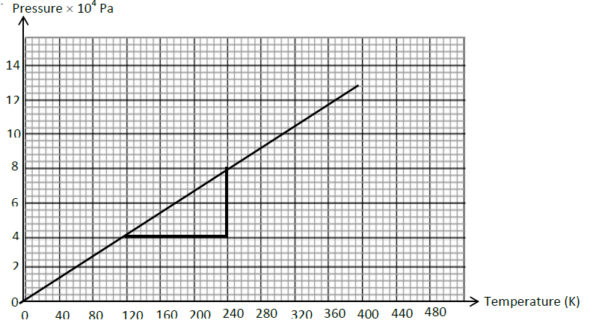

Given that the relationship between the pressure P and temperature T in Kelvin is in the form P = kT + C where k and C are constants.
- Determine from the graph the values of k and C. (2marks)

…………………………………………………………………………………………………………………………………………………………………………………………………………………………………………………………………………………………………………………………………………………

- Why would it be impossible for the pressure of the gas to be reduced to zero in practice? (1mark)

………………………………………………………………………………………………………………………………………………………………………………………………………………………………

(iii) A gas is put into a container of fixed volume at a pressure of 2.1 × 10⁵Pa and temperature of 50°C. The glass is then heated to a temperature of 400°C. Determine the new value of pressure. (3marks)
……………………………………………………………………………………………………………………………………………………………………………………………………………………………………………………………………………………………………………………………………………………..

