EXAMINATION TERM 2 YEAR 2020

NAME………………………………………………ADM NO. ……….

ANSWER ALL THE QUESTIONS IN THE SPACES PROVIDED

- Define the following:
- Element (1mk)

- Ion (1mk)

- i) Identify the following apparatus and give a use for each (3mks)
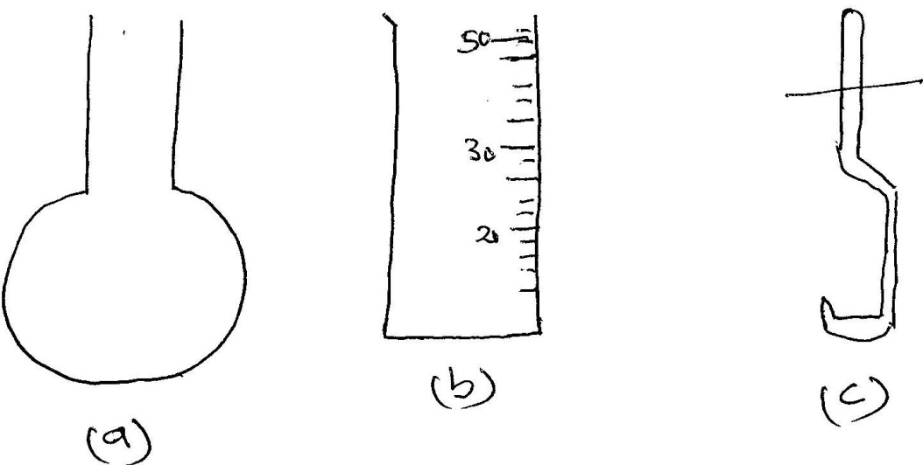

- ………………………………………..Use…………………………………………….
- ………………………………………..Use…………………………………………….
- ………………………………………..Use…………………………………………….

ii) Name another apparatus that can be used in place of (b) (1mk)

- Give four reasons why most apparatus are made of glass (4mks)

- Define the following terms
- Isotope (1mk)

- Ionization energy (1mk)

- Electron affinity (1mk)

- Hydrogen gas was prepared in the lab. Using the following set up
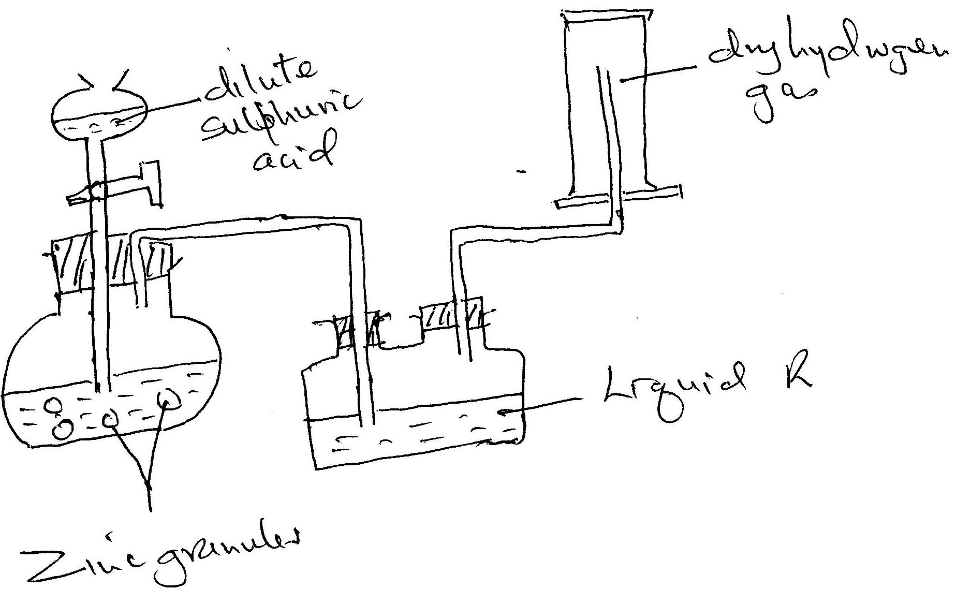
- Write an equation for the reaction taking place and balance it (2mks)

- Name the method used to collect the gas and give a property of hydrogen that enables it to be collected through the method. (2mks)

- Name liquid R and state its function in the set up (2mks)

Liquid R: ……………………………….

Function:………………………………………………………………………………………

…………………………………………………………………………………………………
- Explain why it is not advisable to use sodium metal in place of zinc metal (2mks)

- State two uses of hydrogen gas (2mks)

- What will happen to the pH of the solution in the beaker after one day? Give an explanation.
(2mks)

- Samples of urine from three participants F, G and H at an international sports meeting were spotted onto a chromatography paper alongside two from illegal drugs A1 and A2. A chromatogram was run using methanol. The figure below shows the chromatogram.
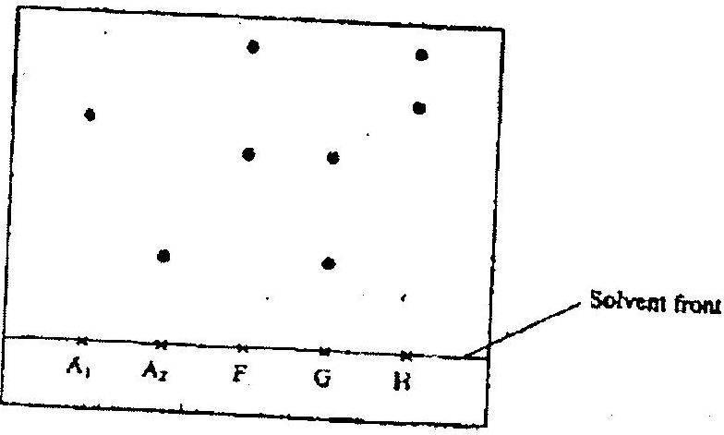
- Identify the athlete who had used an illegal drug (1mk)

- Which drug is more soluble in methanol? (1mk)

- The curve below represents the variation of temperature with time when pure and impure samples of a solid were heated separately.
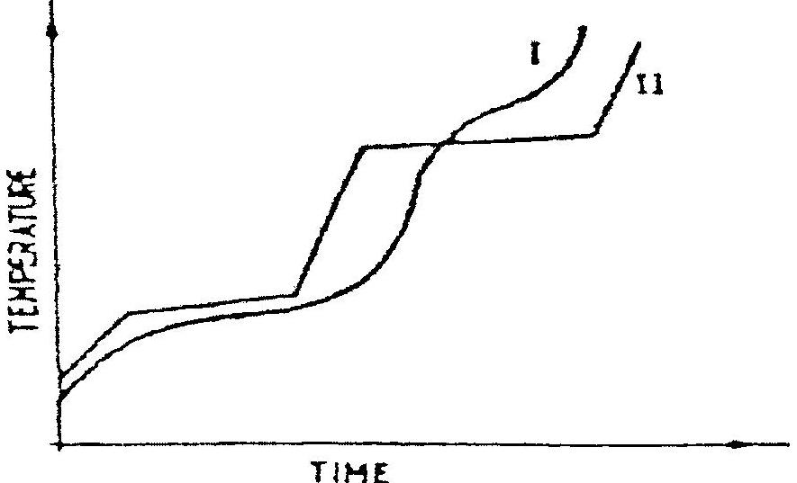
Which curve shows the variation in temperature for the pure solid? Explain. (2mks)

- In an experiment, a test-tube full of chlorine water was inverted in chlorine water as shown in the diagram below and the set up left in sunlight for one day.
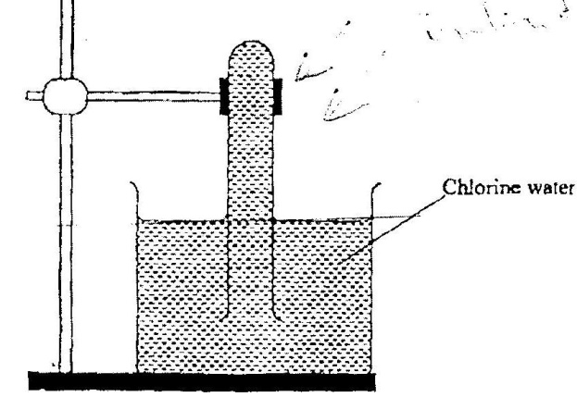
After one day, a gas was found to have collected in the test-tube
- Identify the gas (1mks)

- How can the above gas be tested? (2mks)

- The table below shows some properties and electronic arrangements of common ions of elements represented by letters P to X. Study the information in the table and answer the questions that follow
Element | Ion | Electron arrangement | Atomic radius | Ionic radius
P | P²⁺ | 2,8,8 | 0.197 | 0.099
Q | Q⁻ | 2,8 | 0.072 | 0.136
R | R⁺ | 2,8,8 | 0.231 | 0.133
S | S³⁺ | 2,8 | 0.143 | 0.050
T | T²⁺ | 2,8,8 | 0.133 | 0.074
U | U²⁺ | 2,8 | 0.160 | 0.065
V | V⁺ | 2,8 | 0.186 | 0.095
W | W⁺ | 2 | 0.152 | 0.060
X | X⁻ | 2,8,8 | 0.099 | 0.181

- Give the atomic numbers of the elements P and Q (2mks)

P -

Q –

- Select the most reactive metallic element (1mk)

- Select 3 elements that belong to the same group of periodic table (2mks)

- Select 3 elements that would react with cold water to evolve hydrogen gas (1mk)

- Why is the ionic radius of element X larger than its atomic radius? (1mk)

- Write an equation of the reaction between element S and Oxygen (2mks)

- Moist iron wool was inverted over water. The set up was left to stand for 2 days
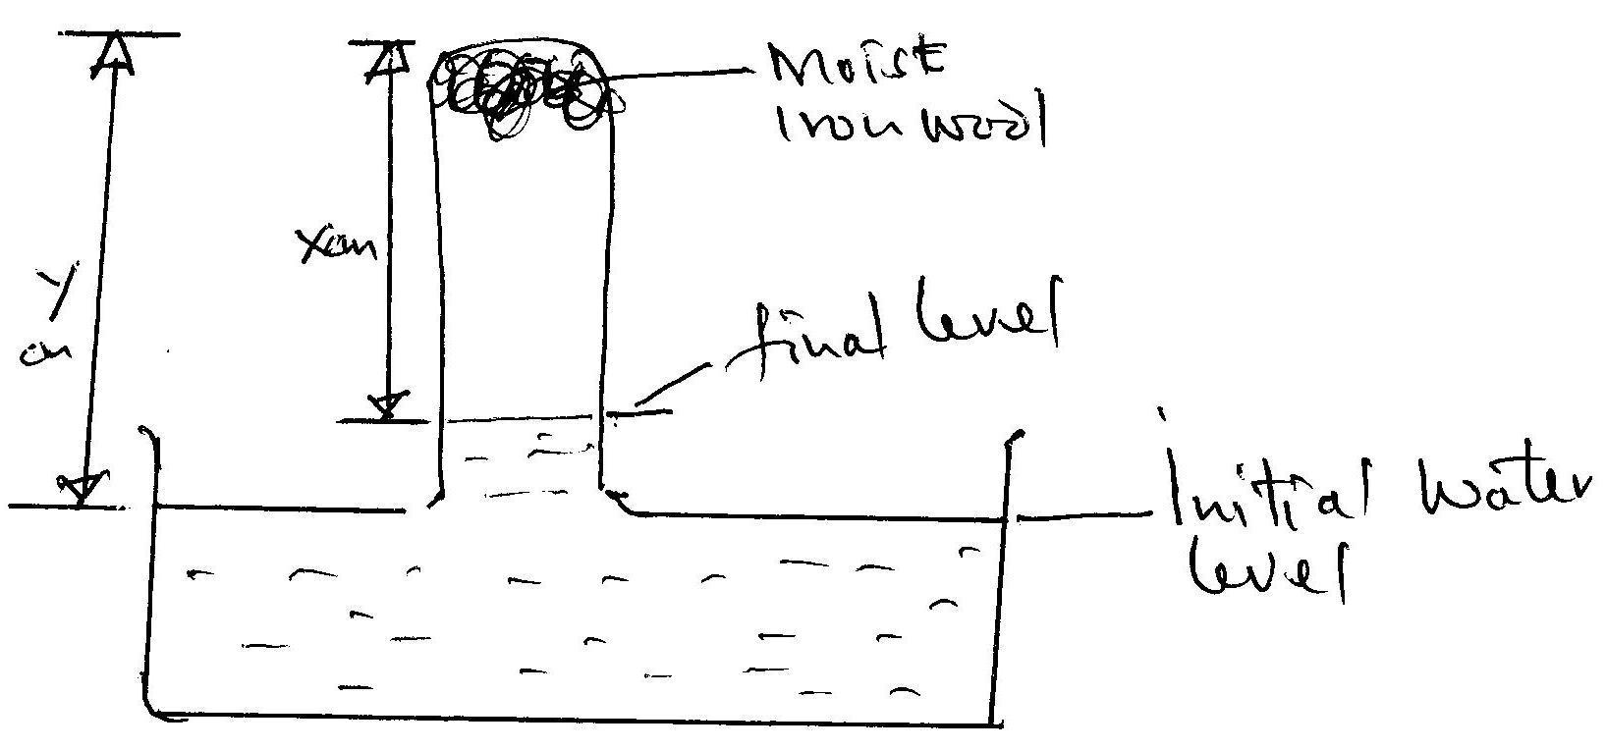
- Explain whether rusting is a physical or chemical reaction (2mks)

- Write an expression using X and Y to show the percentage of Oxygen (2mks)

- What would be the effect of using a larger piece of iron wool? Explain. (2mks)

- State two similarities between rusting and combustion (2mks)

- Observe the equation below
Fe₂O_{3(s)} + CO_{(g)} Fe_{(s)} + CO_{2(g)}
- Balance the equation (1mk)

- Select the following from the above equation
Oxidizing agent (1mk)

Reducing agent (1mk)

- State two situations where redox reactions are applied in industry (2mks)

- Carbon (IV) sublimes at -78ºC. It is called dry ice
- Why is it called dry ice? (1mk)

- It is used for keeping ice cream cold. Why is it preferred to ordinary ice? (2mks)

- Name two other substances that behave as dry ice (2mks)

- Give an industrial application of sublimation (1mk)

- a) Element X has two isotopes. Two thirds of ³³X and one-third ³⁰X. What is the relative mass of element X? ¹⁶ ¹⁶
- An element, A, has 30 protons and 35 neutrons. What is (2mks)
- The mass number of element A?

- The charge on the most stable ion of element A?

- An element B consists of three isotopes of mass, 28, 29 and 30 and percentage abundances of 92.2, 4.7 and 3.1 respectively. Show that the relative atomic mass of element is 28.11 (4mks)

- Elements X and Y have atomic numbers 11 and 17 respectively. Which one of the elements is a metal? Give a reason for your answer. (2mks)

- The table below shows the atomic numbers of four elements W,X,Y and Z
Element | W | X | Y | Z
Atomic number | 20 | 17 | 19 | 9
Which two elements belong to the same group? (2mks)

- Two elements M and N have atomic numbers 17 and 20 respectively. Write the formula of the compound formed when M and N react. (1mk)

- The following diagram represents a non-luminous flame of the Bunsen burner
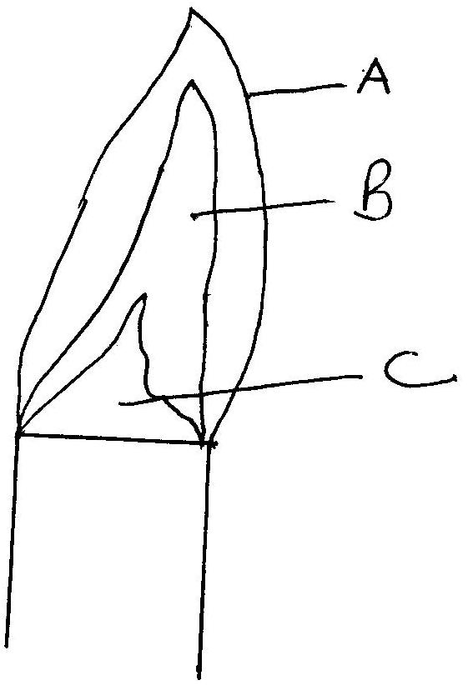
- Name the parts of the flame labeled A, B and C (3mks)

- Which of the parts in (a) above is the hottest? (1mk)

- A non-luminous flame is preferred for heating. Explain (2mks)

- i) Name the other type of flame produced by a Bunsen burner (1mk)

ii) Under what conditions does the Bunsen burner produce the flame in d(i)? (1mk)

- Define the following terms as used in medicine
- Drug (1mk)

- Prescription (1mk)

- Dosage (1mk)

- Drug abuse (1mk)

- Balance the following chemical equations
- Mg + O₂ MgO (1mk)

- Mg + N₂ Mg₃N₂ (1mk)

- Al + HCl AlCl₃ + H₂ (1mk)

- C₃H₈ + O₂ CO₂ + H₂0 (1mk)

- Hydrated Copper (II) Sulphate is heated in a boiling tube as shown.
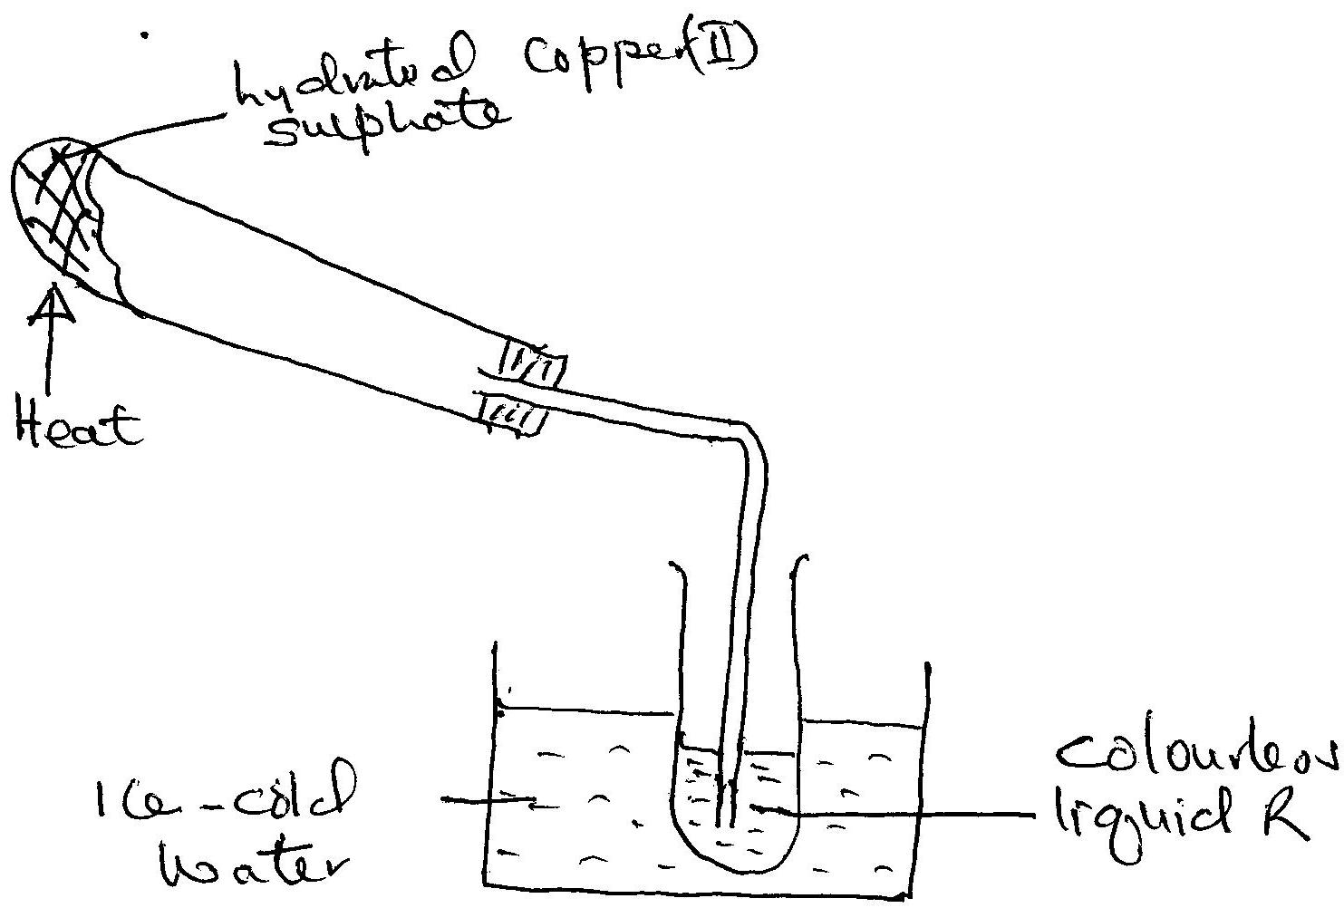
- State the colour of Copper (II) Sulphate before and after heating? (1mk)

- Explain why the boiling tube was slanted (1mk)

- How can the purity of the colourless liquid be confirmed? (1mk)

- Name another substance that can undergo the same change as hydrated Copper (II) Sulphate (1mk)

- A Magnesium ribbon was cleaned with steel wool and used in the following set up. Wet sand was heated before Magnesium ribbon.
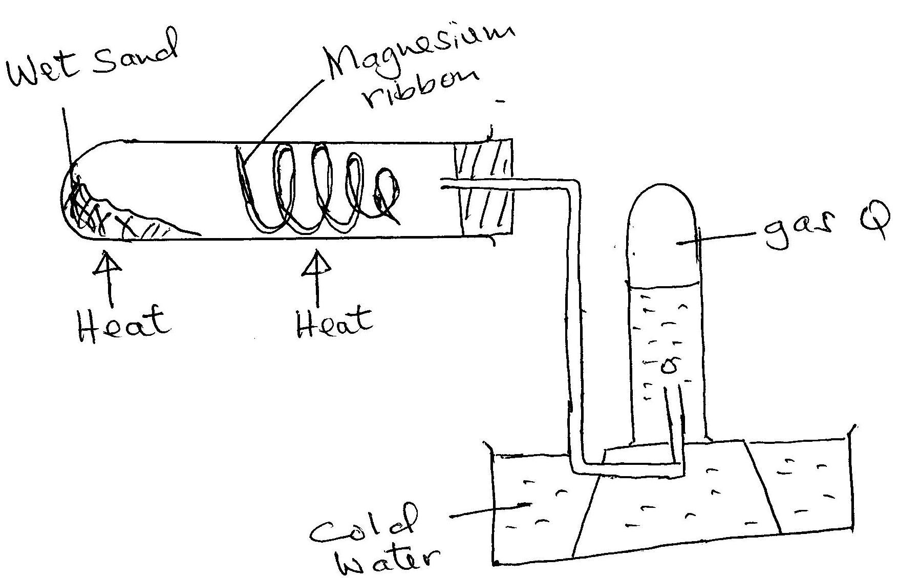
- Explain the following:
- Sand was heated first before heating Magnesium ribbon (1mk)

- Magnesium ribbon was cleaned with steel wool (1mk)

- Name gas R (1mk)

- Write an equation for the reaction taking place in the combustion tube (1mk)

- Name the method used to collect gas R (1mk)

