NAME___________________________________________ ADM NO._______________

BIOLOGY FORM 1
2 Hours

_______________________________ SECONDARY SCHOOL
END OF TERM EXAMINATION
TERM II 2019

Instructions to Candidates
- Write your Name and Admission Number in the Spaces Provided.

- Answer all the questions in the spaces provided.

For Examiner’s Use Only
QUESTIONS | MAXIMUM SCORE | CANDIDATES SCORE
1 – 18 | 100

- State the function of each of the following organelles. (3mks)
- Lysosomes
______________________________________________________________________________
______________________________________________________________________________
- Golgi apparatus
______________________________________________________________________________
______________________________________________________________________________
- Chloroplasts
______________________________________________________________________________
______________________________________________________________________________
- The diagram below represents a cell
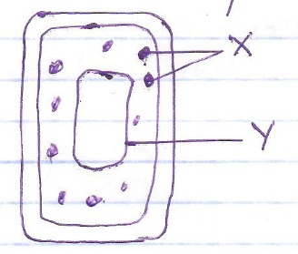
- (i) Is it an animal or a plant cell?_______________________________________ (1mk)

(ii) Give a reason for your anser in (i) above. (1mk)
______________________________________________________________________________
______________________________________________________________________________
- Name the part labeled
X _________________________________ (1mk)

Y _________________________________ (1mk)
- Identify the parts of a light microscope which serve each of the functions described below:
- Making rough focus ____________________________________________ (1mk)

- Reflecting light from the source ___________________________________ (1mk)
- The diagram below represents a set up that was used to investigate a certain process in a plant.
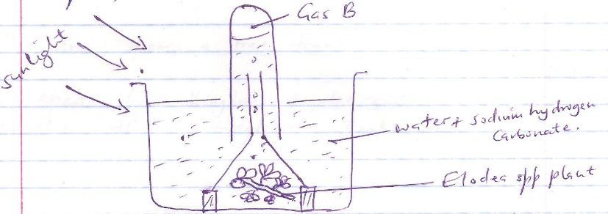
- What aspect of photosynthesis wa being investigated? (1mk)
______________________________________________________________________________
- i) Identify gas B ________________________________ (1mk)

ii) How can gas B be tested? (1mk)
______________________________________________________________________________
______________________________________________________________________________
- State the importance of using sodium hydrogen carbonate in the set up. (1mk)
______________________________________________________________________________
______________________________________________________________________________
- Apart from sunlight state one other factor that is required to get a positive result. (1mk)
______________________________________________________________________________
______________________________________________________________________________
- Give two reasons why Elodea plant has been used instead of using any other terrestrial plant.

______________________________________________________________________________
________________________________________________________________________(2mks)
- a) State the most suitable biological tool for collecting the following organisms:

- A moth from a coffee farm. __________________________________________(1mk)

- Ants from a tree trunk._______________________________________________ (1mk)

b) Apart from kingdoms plantae and Animalia name other three kingdoms. (3mks)
______________________________________________________________________________
______________________________________________________________________________
______________________________________________________________________________
- An experiment was set up as shown below and left for 30 minutes

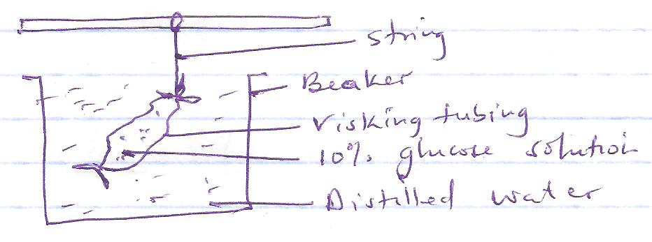
- Name the physiological process that was being investigated (1mk)
______________________________________________________________________________
______________________________________________________________________________
- State the expected results. (1mk)
______________________________________________________________________________
______________________________________________________________________________
- Give a suitable explanation for the results in (b) above. (2mks)
______________________________________________________________________________
______________________________________________________________________________
- Bean plants are known as ‘PHASEOLUS VULGARIS’
- Write the proper scientific name of the bean plant. __________________________(1mk)

- State the name given to this system of naming of living organisms. (1mk)
______________________________________________________________________________
- a) Define the term diffusion (1mk)
______________________________________________________________________________
______________________________________________________________________________

b) How do the following factors affect the rate of diffusion?
i) Diffusion gradient
______________________________________________________________________________
______________________________________________________________________________
ii) Surface area to volume ratio
______________________________________________________________________________
______________________________________________________________________________
iii) Temperature
______________________________________________________________________________
______________________________________________________________________________
c) Outline three roles of active transport in human body. (3mks)

______________________________________________________________________________
______________________________________________________________________________
______________________________________________________________________________
______________________________________________________________________________

- a) Draw a well labeled diagram of a chloroplast. (5mks)

b) State two adaptationsof a chloroplast (2mks)
______________________________________________________________________________
______________________________________________________________________________

- a) Explain what happens during the light stage of photosynthesis.(3mks)
______________________________________________________________________________
______________________________________________________________________________
______________________________________________________________________________
______________________________________________________________________________

- Distinguish between photosynthesis and chemosynthesis. (2mks)
______________________________________________________________________________
______________________________________________________________________________

- Explain why:
- Red blood cells burst when placed in distilled water while plant cells remain intact. (2mks)
______________________________________________________________________________
______________________________________________________________________________
- Fresh water protozoa like amoeba do not burst when placed in distilled water. (2mks)
______________________________________________________________________________
______________________________________________________________________________
- The table below shows the concentration of sodium and iodine ions in pond water and in cell sap of an aquatic plant.

Ion | Concentration in pond water (ppm) | Concentration in cell sap (ppm)
Sodium | 120 | 70
Iodine | 0.2 | 400
- (i) suggest the process by which each of the following ions are taken up by the plant from from the pond water.
Sodium _________________________________________ (1mk)
Iodine __________________________________________ (1mk)
- (i) Which of the two ions would stop to be taken up by the plant if the soil became waterlogged? (1mk)

______________________________________________________________________________
(ii) Explain your answer in question (i) above. (1mk)

- a) Differentiate between an organ and an organ system. (2mks)
______________________________________________________________________________
______________________________________________________________________________
- Identify the following specialized cells and give their functions.
 | Cell | Identity | Function
i
ii
iii

- State three characteristics of a cell membrane. (3mks)
______________________________________________________________________________
______________________________________________________________________________

- With refrence to plant, complete the table below by filling in column II the name fo the cell organelle that corresponds with the statement in column I. (5mks)

Column I | Column II
i) Contains pigment that traps solar energy
ii)Acts as a selective barrier between cell and its sorrounding

iii) is composed of a high molecular polysaccharide called cellulose
iv) Contains enzymes responsiblefor synthesis of most cellular ATP
v) Contains most cellular solutes.

- State the importance of the following characteristics of living things
- Respiration
______________________________________________________________________________
______________________________________________________________________________

- Reproduction
______________________________________________________________________________
______________________________________________________________________________

- Locomotion
______________________________________________________________________________
______________________________________________________________________________

- a) explain why osmosis is referred to as ‘specialized diffusion’ (1mk)
______________________________________________________________________________
______________________________________________________________________________
b) Differentiate between the following
i) Taxon and Taxonomy (2mks)
______________________________________________________________________________
______________________________________________________________________________
______________________________________________________________________________

ii) Heterotrophic nutrition and autotrophic nutrition. (2mks)

______________________________________________________________________________
______________________________________________________________________________
______________________________________________________________________________

iii) Osmotic pressure and osmotic potential (2mks)
______________________________________________________________________________
______________________________________________________________________________
______________________________________________________________________________

iv) Hypotonic solution and hypertonic solution in relation to a cell. (2mks)

______________________________________________________________________________
______________________________________________________________________________
______________________________________________________________________________

- Fill in the blank spaces:
“When a plant cell is placed in a hypotonic solution it _____________________ water by osmosis to become _______________________ while when red blood cells are placed in a hypertonic solution they become ___________________________ by __________________ water (4mks)

