NAME___________________________________________ ADM NO._______________

BIOLOGY FORM 2
2 Hours

_______________________________ SECONDARY SCHOOL
END OF TERM EXAMINATION
TERM II 2019

Instructions to Candidates
- Write your Name and Admission Number in the Spaces Provided.

- Answer all the questions in the spaces provided.

For Examiner’s Use Only
QUESTIONS | MAXIMUM SCORE | CANDIDATES SCORE
1 – 30 | 100

1. State the role of the following:-
i) Pooter (1mk)

ii) Pitfall trap (1mk)

2. State the function of each of the following parts of a microscope.
a) Mirror (1mk)

b) Course adjustment knob (1mk)

c) Stage (1mk)

3. a) Name three monosaccharides. (3mks)

b) List three characteristics of disaccharides. (3mks)

4. An experiment was set up as shown below.
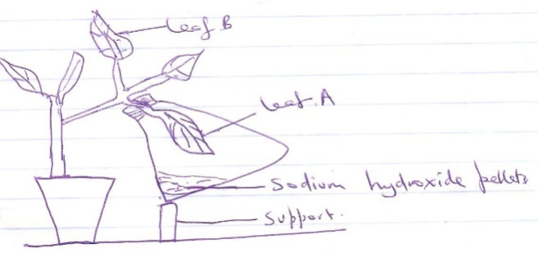

The potted plant was kept in the dark for 48 hours. It was then treated as shown and exposed to light for 4 hours.
a) What was the aim of the experiment? (1mk)

b) Why was the plant kept in the dark for 48 hours? (1mk)

c) Why was it necessary to transfer the plant to light? (1mk)

d) What was the role of sodium hydroxide pellets? (1mk)

e) Leaves A and B were tested for starch. What would be the expected results? (2mks)

5. List 4 differences between haemolysis and plasmolysis. (4mks)

6. An experiment was set up as shown below.
a) Explain what happened to A (3mks)

b) State what happened to B (2mks)

7. List 4 digestive enzymes found in the intestinal juice. (4mks)

8. State three functions of lipids in a human body. (3mks)

9. Name the two reagents used to test for proteins in a substance. (2mks)

10. List four importance of osmosis to plants (3mks)

11. Organisms are grouped into various kingdoms. Name three kingdoms where members (all or some) are unicellular. (3mks)

12. Explain three ways in which the root hair cell is adapted to perform its function. (3mks)

13. Define the following:
i) A tissue (1mk)

ii) An organ system. (1mk)

14. State three factors that determine the rate of diffusion. (3mks)

15. Explain the adaptations of a leaf to photosynthesis. (4mks)

16. a) What is photolysis? (1mk)

b) Where does it take place? (1mk)

17. State the properties of enzymes. (3mks)

18. State and explain five adaptations of ileum to its functions. (5mks)

19. The diagram below represent internal structure of a tooth.
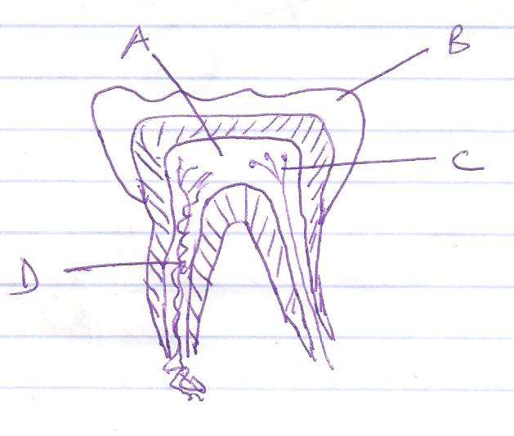
i) Name the type of tooth. (1mk)

ii) Name the parts A, B ,C and D. (4mks)
A ___________________________
B ___________________________
C ___________________________
D ___________________________

20. Name three forces that maintain transpiration stream. (3mks)

21. Explain three adaptations of xylem vessels to their functions. (3mks)

22. Explain two adaptations of gaseous exchange sites (2mks)

23. The diagram below shows cross-section of an artery.
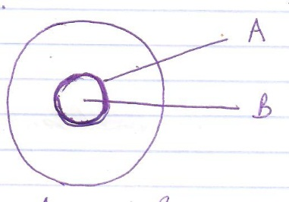
Name parts A and B (2mks)
A _________________________________
B _________________________________
24. Name four adaptations of the heart to its function. (4mks)

25. State three structural differences between arteries and veins. (3mks)

26. What is blood transfusion? (1mk)

27. State two main types of immunity. (2mks)

28. a) What is transpiration? (1mk)

b) State two roles of transpiration. (2mks)

29. State three main differences between aerobic and anaerobic respiration. (3mks)

30. The diagram below represent a kidney nephron.
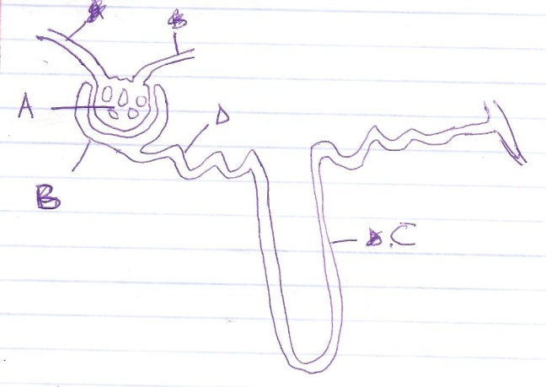
a) Name the parts A, B and C. (3mks)
A ___________________________
B ___________________________
C ___________________________

b) Name the fluid that collects in the structure labeled B. (1mk)

c) Name the main process that takes place at the part labeled D. (1mk)

