NAME___________________________________________ ADM NO._______________

BIOLOGY FORM 3
2 Hours

_______________________________ SECONDARY SCHOOL
END OF TERM EXAMINATION
TERM II 2019

Instructions to Candidates
- Write your Name and Admission Number in the Spaces Provided.

- Answer all the questions in the spaces provided.

For Examiner’s Use Only
QUESTIONS | MAXIMUM SCORE | CANDIDATES SCORE
1 – 23 | 100

- i) What biological knowledge or study is required in dealing with locusts that infest a maize crop? (1mk)

ii) State the functions of the following cell structures.
- Sap vacuole. (1mk)

- Neucleolus. (1mk)

- Name three properties of the cell membrane. (3mks)

- State the importance of the following in living organisms.
- Respiration. (1mk)

- Reproduction. (1mk)

- The diameter of a field of view of a light microscope is 6.5mm. Plant cells lying across the diameter are 12. Determine the size of one cell in micrometers. (3mks)

- Which organelles would be numerous in the following cells.
- Liver cells. (1mk)

- Palisade cell. (1mk)
- The scientific names of three animals, leopard, wolf and lion are Pantherapardus, Canislupas and Pantheraleo respectively.
- Why are scientific names given in latin? (1mk)

- What does canis refer to? (1mk)

- Giving a reason, state the organisms that are most closely related. (2mks)

- The diagram below shows results of what happens to plant cell when placed in a certain solution.
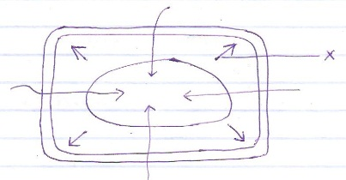
- What was the nature of the solution in which the cell was palced. (1mk)

- Identify the force represented by the arrow X and explain how it develops. (2mks)

- The word equation below shows a biological process.
Water Hydrogen atom + Oxygen
- Name the process. (1mk)

- Where does the process named in (a) above take place? (1mk)

- State two conditions necessary for the process to occur. (2mks

- Study the equation below and answer the questions that follow.
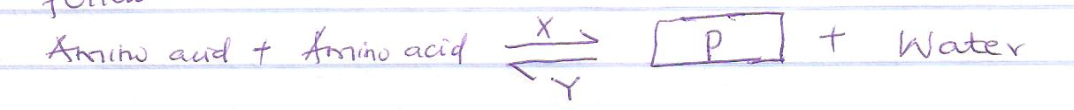
- Name product P. (1mk)

- Name the reaction represented by letters X and Y. (2mks)

- State the functions of the following enzymes
- Pepsin (1mk)

- Salivary amylase. (1mk)

- Enterokinase. (1mk)

- a) Name two enzymes and one metal ion that are needed in blood clotting process
Enzymes; i) __________________________________
ii) __________________________________
Metal ion ____________________________________

- Give two reasons why the pressure of blood is greater in the arteries than in the veins in mammals. (2mks)

c) Name the blood vessels that transport blood from
i) Small intestines to the liver. (1mk)

ii) Lungs to the heart. (1mk)

- the diagram below represents a specialized plant structure
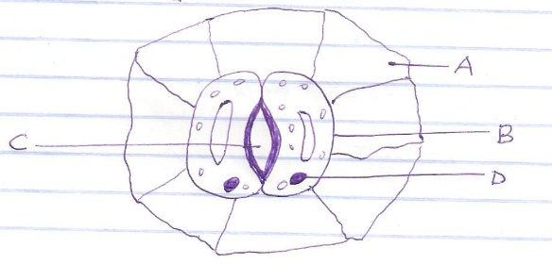
- name the cells labeled A and B. (2mks)

- describe the mechanism of closing of aperture C. (4mks)

- a) Explain the role of antidiuretic hormone when there is excess water in human body. (3mks)

b) State the kidney disorder characterized by production of large volume of dilute urine. (1mk)

- Students set up an experiment as shown below. Use it to answer the questions that follow
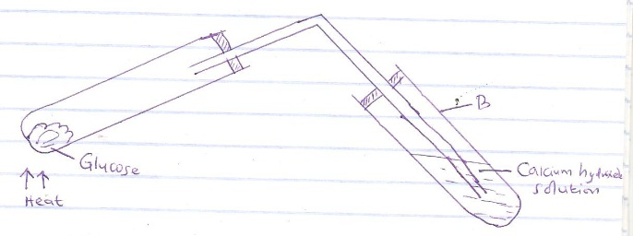
- What was the aim of the experiment? (1mk)
___________________________________________________________________________________

___________________________________________________________________________________

- What observation would be made in test tube B? (1mk)
______________________________________________________________________________ ______________________________________________________________________________
- Explain the results in (b) above(1mk)
_________________________________________________________________________________________________________________________________________________________________________________________________________________________________________________________
- Write a word equation for the process of anaerobic respiration in plants. (1mk)

- The diagram below represents a gill of a bony fish. Study it and answer the questions that follow.
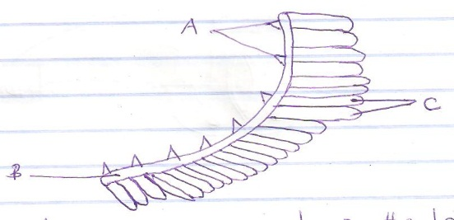
- Give the function of each of the parts labeled A, B and C
- A______________________________________________________________(1mk)
- B______________________________________________________________(1mk)
- C______________________________________________________________(1mk)
- The diagram below show how blood glucose in mammalian body is regulated.
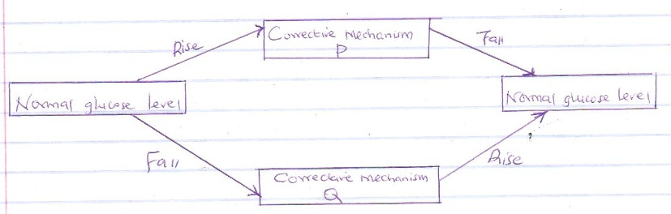
- Explain what happens during corrective mechanism P. (3mks)
_________________________________________________________________________________________________________________________________________________________________________________________________________________________________________________________

- Name the organs involved in corrective mechanism P and Q (2mks)
_________________________________________________________________________________________________________________________________________________________________________________________________________________________________________________________

- What is osmoregulation? (1mk)
_________________________________________________________________________________________________________________________________________________________________________________________________________________________________________________________
- Below is a diagram of nitrogen cycle. Study it and answer the questions that follow.
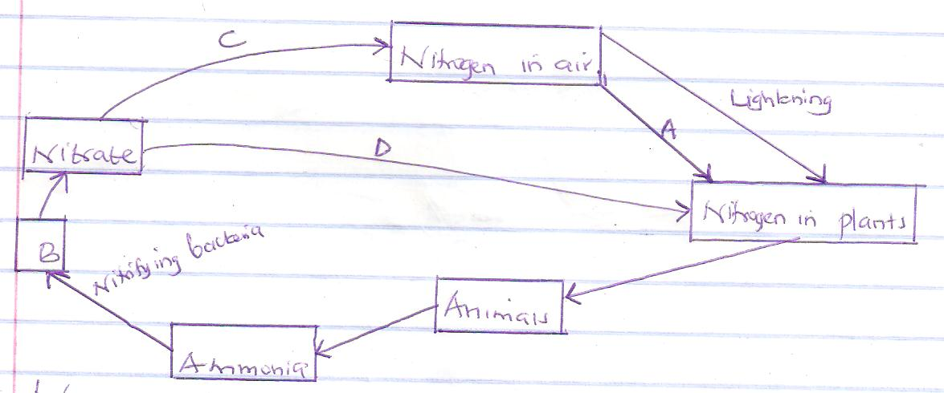
- Name the processes represented by
- A ________________________________________________________ (1mk)
- D__________________________________________________________(1mk)
- Name the compound represented by B (1mk)
___________________________________________________________________________

- Name the group of organisms represented by C. (1mk)
___________________________________________________________________________

- i) identify theclass of plants to which the above cycle takes place. (1mk)
___________________________________________________________________________

ii) Name the part of the plant where process A takes place. (1mk)
__________________________________________________________________________
- how would use of excessive pesticides affect process A. (2mks)
_________________________________________________________________________________________________________________________________________________________________________________________________________________________________________________________
- Name the disease caused by the following parasites.
- Salmonellatyphi____________________________________________________(1mk)

- Entamoebahistolytica________________________________________________(1mk)
- The diagram below represents a food web in a certain ecosystem
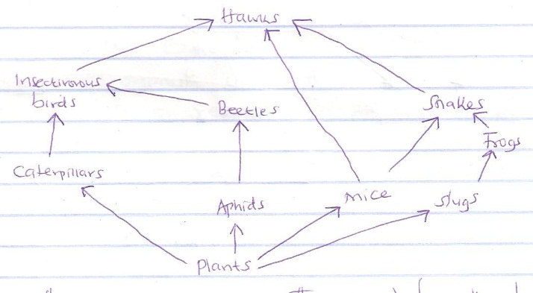
- (i) Name the group of organisms that would have the largest biomass. (1mk)
__________________________________________________________________________

(ii) Give a reason for your answer in (i) above (1mk)
_________________________________________________________________________________________________________________________________________________________________________________________________________________________________________________________
- Construct a food chain ending with:
- Tertiary consumer

- Quaternary consumer

- State the short term effects on the ecosystem if there were prolonged droughts.(2mks)
_______________________________________________________________________________________________________________________________________________________________________________________________________________________________________________________
- In an attempt to estimate the number of weaverbirds in a small woodland 435 were captured, marked and released. Three days later 620 were captured, 75 of which were marked.
- What is the name of the sampling method described above? (1mk)
_________________________________________________________________________
- Calculate the approximate size of the weaverbird population in the woodland. (2mks)

- Give one disadvantage of this method. (1mk)
______________________________________________________________________________ ______________________________________________________________________________ ______________________________________________________________________________
- A student in form 3 caught an organism with the following characteristics.
- Body divided into two parts
- Simple eyes
- Eight legs
Classify the organism up to class level. (3mks)

- Name the type of reproduction in the following organisms
- Yeast ______________________________________________________ (1mk)
- Bacteria ____________________________________________________ (1mk)
- Rhizopus ___________________________________________________ (1mk)
- The diagram below shows a gametophyte of a fern

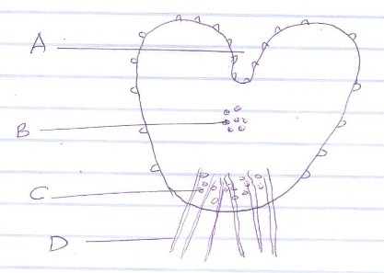

- Name the structure shown above. (1mk)
________________________________________________________________
- Name the parts labeled B and C (2mks)
B _________________________________________
C _________________________________________
- Define the term alternation of generation. (1mk)
______________________________________________________________________________ ______________________________________________________________________________ ______________________________________________________________________________
- Name two plant divisions that exhibit alternation of generation(2mks)
______________________________________________________________________________ ______________________________________________________________________________ ______________________________________________________________________________
- State three features in ferns that make them advanced than moss plant. (3mks)
__________________________________________________________________________________________________________________________________________________________________________________________________________________________________________________________________
- State the importance of a gametophyte to a sporophyte. (1mk)
___________________________________________________________________________________________________________________________________________________________________________________ ______________________________________________________________________________
- Name two benefits that a parasite derives from the host. (2mks)
______________________________________________________________________________________
____________________________________________________________________________________________________________________________________________________________________________
- Other than using the quadrat, give two methods of estimating population of grass. (2mks)
______________________________________________________________________________
______________________________________________________________________________

