**NAME:_______________________________________________________ADM NO:______________**

**FORM 1 PHYSICS**

**2 Hours**

**___________________________________SECONDARY SCHOOL**

**END OF TERM EXAMINATION**

**TERM II 2019**

**Instructions:**

* ***Write your Name and admission Number in the Spaces Provided above.***
* ***This paper consists of TWO Sections: A and B.***
* ***Answer all the questions in Section A and B in the spaces provided in the question paper.***
* ***ALL working MUST be clearly shown.***
* ***Non Programmable silent electronic calculators and KNEC Mathematical tables may be used.***
* ***Candidates should check the question paper to ascertain that all the pages are printed as indicated and that no questions are missing.***

**For Examiner’s Use Only**

|  |  |
| --- | --- |
| **Section** | **Candidates Score** |
| **A** |  |
| **B** |  |
| **Total Score** |  |

SECTION A (55 MARKS)

1. Two form one students ran to the inside of their physics laboratory and founf no teacher inside but there was a substance on the front bench which they tasted to confirm whether it was sugar. They then used a nail to test whether the electricity sockets were live with electricity. State any two laboratory rules that the students may have broken. (2mks)
2. The figure below shows a measuring cylinder which contains water initially at level A. a solidof mass 10g is immersed in the water and the level rises to B.

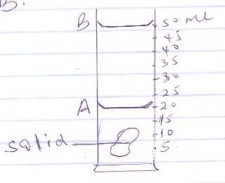

Find the density of the solid. (3mks)

1. A bag of sugar is found to have the same weight on planet earth as an identical bag of dry sawdust on planet Jupiter. Explain why the masses of the two bags must be different. (2mks)
2. The figure below shows a small toy boat floating on water in a basin. X and Y are two points near the toy.

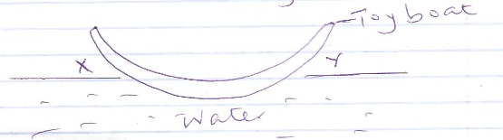

When a hot metal rod is dipped into the water at point X the toy is observed to move towards Y. Explain this observation. (2mks)

1. Name two forces that determine the shape of a liquid drop on a solid surface(2mks)
2. Distinguish between fundamental and derived quantities giving an example of each. (2mks)
3. The figure below shows a glass flask filled with water. The flask is fitted with a cork through which a tube is inserted. When the flask is cooled the water level rises slightly then falls steadily.

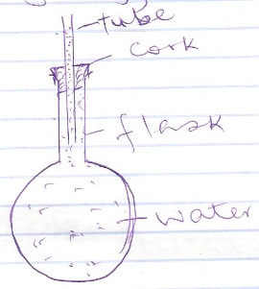

Explain the observation. (3mks)

1. a) What do you understand by anomalous expansion of water? (1mk)

b) The temperature of water in a measuring cylinder is lowered from about 200 to 00. On the axes provided sketch the graph of volume (y-axis) against temperature assuming the water does not freeze.

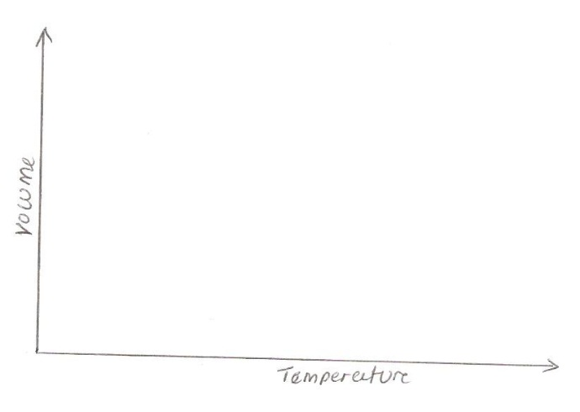

1. Differentiate between heat and temperature. (1mk)
2. Walls of houses in very hot areas are painted white on the outer side. Explain. (2mks)
3. Give one reason why water is not used as a thermometer liquid. (1mk)
4. Give a reason why heat transfer by radiation is faster than heat transfer by conduction. (1mk)
5. A drug manufacturer gives the mass of the active ingredient in a tablet as 5mg. Express this in kilograms. (2mks)
6. A stop watch started 0.5s after the start button was pressed. The time recorded using the stop watch for a ball bearing falling through a liquid was 2.53s. Determine the time of fall in minutes. (3mks)
7. A metal cube of side 7cm was melted and reshaped in cylindrical form of diameter 14cm. find the height of the cylinder in centimeters. Give your answer to 1 decimal place. (3mks)
8. The figure below shows the shape of a leaf of a certain tree.

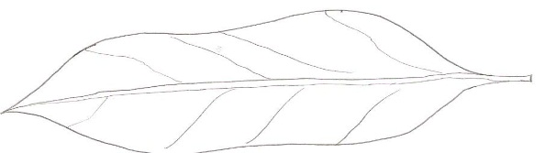

Explain how you can estimate the area of the leaf in square centimeters.(4mks)

1. a) A clinical thermometer has a constriction in the bore just above the bulb. State the use of this constriction. (1mk)

b) Give another special feature of the clinical thermometer other than constriction. (1mk)

1. The figure below shows a piece of wood fitted into copper pipe and a piece of paper wrapped tightly around the junction.



Paper

Copper pipe

Wood

It is observed that when a flame is applied around the paper at the junction, the side of the paper around the wood burns. Explain why. (2mks)

1. State the reason why gases are easily compressible while liquids and solids are not. (1mk)
2. The figure below shows a number of forces acting on a body.

Body

10N

3N

4N

12N

Give the resultant force on the body. (2mks)

1. The table below shows quantities of measurement, SI units and symbols. Fill in the missing gaps. (4mks)

|  |  |  |
| --- | --- | --- |
| Quantity | Symbol | SI unit |
| Temperature | __________________ | _______________ |
| __________________ | M | _________________ |
| __________________ | ______________________ | Ampere |
| Time | _____________________ | _________________ |

1. A school water tank is cylindrical in shape and is of diameter 208m and a height of 3m if it is half-full of water find the volume of the water in

a) Cubic meters

b) litres

1. Give two apparatus used to measure specific volumes of liquids. (2mks)
2. A bottle containing a smelling gas is opened at the front bench of a classroom. State the reason why the gas is detected throughout the room. (1mk)

SECTION B (45MARKS)

1. a) The figure below shows a wooden block just about to be lowered into water in a eureka can.

Water

Eureka can

Wooden block

Measuring cylinder

String

When half the volume of the wooden block is immersed in the water, the volume of water collected in the measuring cylinder is 6cm3and the mass of the wooden block is 30g. Find the:

i) Volume of the wooden block. (2mks)

ii) The density of the wooden block in Kg/M3 (3mks)

b) 100cm3 of sea water is mixed with 400cm3 of clean water. Find the density of the mixture if density of clean water is 1000kg/m3 and that of sea water is 1500Kg/m3. (4mks)

1. The figure below shows a cross-section of a vacuum flask.

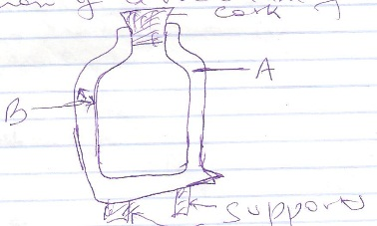

i) Name the parts labeled A and B(2mks)

A _______________________

B _______________________

ii) Explain how the heat losses are minimized when a hot liquid is poured into the flask. (3mks)

iii) boiling water is poured into identical vacuum flasks A and B. Flask A is partially filled while flask B is completely filled. Both are closed tightly. State with a reason the flask in which the water is likely to have higher temperature eight hours later. (2mks)

1. a) The figure below shows how an underground room was ventilated. It had two vents (air outlets) one at A and the other at B. a fire was lit at C.

C

i) Explain what happened to the ventilation when the fire was lit. (3mks)

ii) Other than mode of heat transfer illustrated above state a mode of heat transfer. (1mk)

b) Two identical empty metal containers P and Q are placed over identical Bunsen burners and the burners lit. P is dull black while Q is shiny and bright. After each container attains a temperature of 1000c the burners are turned off. Identical test tubes containing water are suspended in each container without touching the sides as shown below.

Test tube

Bunsen burner

water

water

Q

P

Explain

i) Why the container Q may become hot faster than P. (2mks)

ii) Why the water in test tube P becomes hotter faster than in Q. (1mk)

1. Brownian motion of air particles can be studied using the apparatus shown in the figure below. To observe the motion some smoke is enclosed in the smoke cell and then observed through the microscope

Lamp

Lens

Smoke cell

Microscope

a) Explain the role of the smoke particles, lens and microscope in the experiment. (3mks)

Smoke particles

Lens

Microscope

b)State and explain the nature of the observed motion of the smoke particles. (3mks)

c) state what would be observed about the smoke particles in the temperature sorounding the smoke cell is raised slightly. (2mks)

ANSWER QUESTION 29 OR QUESTION 30

1. a) The figure below shows a lift pump.

Valve B

Valve A

Piston

Explain why when the piston is:

i) Pulled upwards, valve A opens while valve B closes. (2mks)

ii) pushed downwards valve A closes while valve B opens. (2mks)

b) After several strokes water rises above the piston as shown below.

Spout

Water

Water

State how water is removed from the cylinder through the spout. (1mk)

c) A lift pump can lift water to a maximum height of 10m. determine the maximum height that the pump can raise paraffin given that density of paraffin is 800kg/m3 and density of water is 1000kg/m3 (3mks)

d) State one factor that determines the height to which a force pump can lift water. (1mk)

e) A wooden block measures 2cm by 4cm by 5cm and weighs 400g. when placed on a supporting surface. Find:

i) Minimum pressure (3mks)

ii) Maximum pressure. (3mks)

1. a) What do you understand by rectilinear propagation of light? (1mk)

b) (i) What is an eclipse? (1mk)

(ii) During the eclipse of the moon, show the arrangement of the moon, earth and the sun illustrating clearly the regions of total and partial eclipse. (4mks)

c) The figure below shows a ray of light incident on a plane mirror M at point O

500

O

M

i) Complete the diagram to show regular reflection. (1mk)

ii) The mirror is then rotated through 80 in the clockwise direction while maintaining the direction of the incident ray. Find the new angle of reflection. (3mks)

d) A girl 1.2m tall stands in front of a pinhole camera of length 10cm. how far from the pin hole should the girl be for her image on the screen to be 4cm. (3mks)

e) What do you understand by lateral inversion of an image formed by a plane mirror?(2mks)