NAME___________________________________________ ADM NO._______________
SIGNATURE:____________
DATE:___________________

232
PHYSICS
2 1/2 Hours

FORM THREE TERM II END TERM EXAM - 2019

Instructions to Candidates
- Write your Name and admission Number in the Spaces Provided above.
- Answer all the questions in Section A and B in the spaces provided in the question paper.
- ALL working MUST be clearly shown.
- Non Programmable silent electronic calculators and KNEC Mathematical tables may be used.
- Candidates should check the question paper to ascertain that all the pages are printed as indicated and that no questions are missing.

For Examiner’s Use Only
Section | Question | Maximum Score | Candidates Score
A | 1-13 | 25
B | 14 | 10
 | 15 | 09
 | 16 | 13
 | 17 | 14
 | 18 | 09
 | 19 | 10
 | 20 | 10
Total Score |  | 100

SECTION A (25 MARKS)
- Define optics as a branch of physics. (1mk)
___________________________________________________________________________
___________________________________________________________________________
- A liquid of density 1.2g/cm³ and volume of 300cm³ was mixed with 200g of liquid L. Determine volume of liquid L if density of the mixture is 1500Kgm⁻³. (3mks)

- a) State one factor that affects surface tension of liquids. (1mk)
___________________________________________________________________________
b) Define Hookes law (1mk)
___________________________________________________________________________
___________________________________________________________________________

- State what is observed in smoke cell experiment.(1mk)
___________________________________________________________________________
___________________________________________________________________________
- Explain how alarm in figure below operates. (2mks)
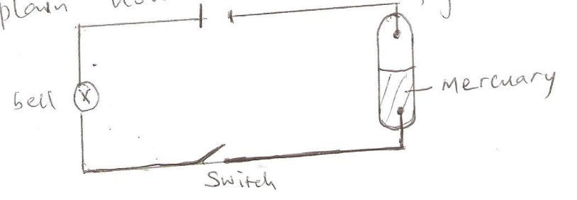
___________________________________________________________________________
___________________________________________________________________________
___________________________________________________________________________
___________________________________________________________________________
- Explain how chimney in kitchen works. (2mks)
___________________________________________________________________________
___________________________________________________________________________
___________________________________________________________________________
- Determine the number of images formed when two mirrors are inclined at 20⁰ (2mk)

- When a body A was brought close to a charged body B it was repelled. Identify the charge on body A. (1mk)
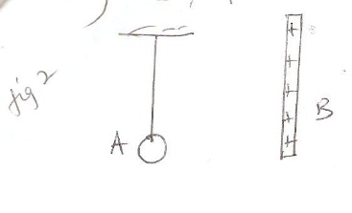
___________________________________________________________________________

- Explain why topping in cells is done using distilled water. (1mk)
___________________________________________________________________________
___________________________________________________________________________

- Determine gas pressure in figure 3 below (g = 10N/Kg, density of water = 1g/cm³, atmospheric pressure =10⁵NM²). (3mks)
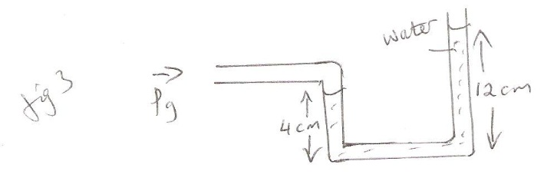
- A bulb rated 75W, 240V was used. Determine its resistance. (2mks)

- A micrometer screw gauge with zero error of -0.035 was used.
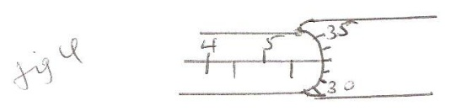
Determine its reading. (2mks)
___________________________________________________________________________

- A uniform body of length 5m and mass 2kg is pivoted and balanced by 10kg at one end and force F
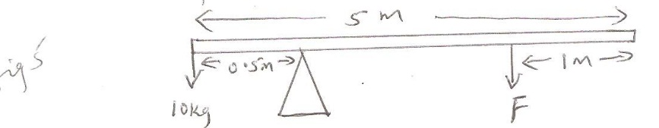

Determine force F(3mks)

SECTION B (55 MARKS)
- a) Determine the focal length in figure 6 below(4mks)
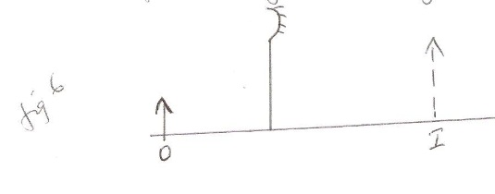
b) A convex mirror of focal length 12cm form an image 9cm from the mirror. Determine the object distance. (3mks)

c) Figure 7 below shows two rays incident normally to face PQ of a glass prism whose critical angle is 42⁰ complete the diagram to show the paths of the two rays as they pass through the prism. (3mks)
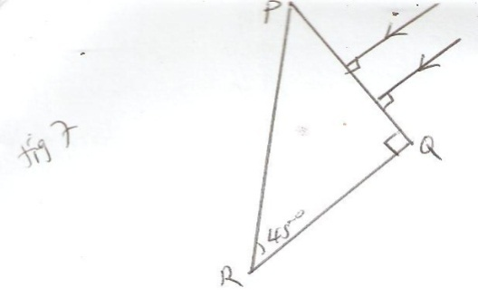

- a) An object dropped from a height h attains a velocity of 6m/s just before hitting the ground. Find the value of h. (3mks)

b) The graph below shows how the velocity varies with time for a body thrown vertically upwards.
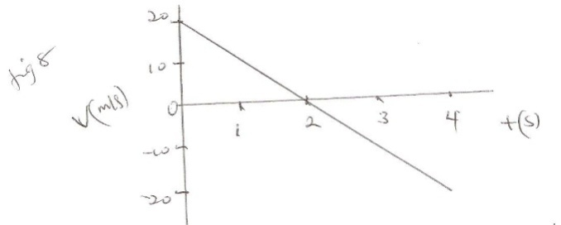
Determine the total distance moved by the body. (3mks)

c) A horizontal force of 12N is applied on a wooden block of mass 2Kg placed on a horizontal surface. It causes the block to accelerate at 5m/s². Determine the frictional force between the block and the surface. (3mks)

- Indicate with an arrow on the diagram the direction in which the conductor will move when it is released. (1mk)
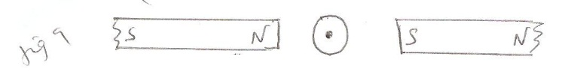
b) The figure 10 below shows a cell in series with a 3Ω resistor and a switch. A high resistance voltmeter is connected across the cell.
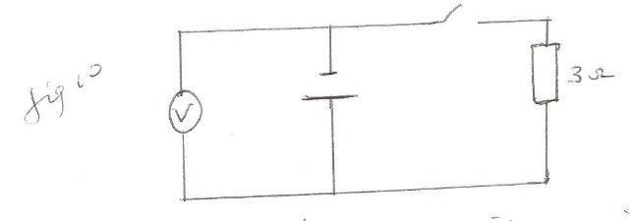

The voltmeter reads 1.5V with switch open and 1.2V with switch closed.
- State the e.m.f. of the cell. (2mks)
___________________________________________________________________________
___________________________________________________________________________
- Determine the current through the 3Ω resistor when the switch is closed. (2mks)

- Determine the internal resistance of the cell(2mks)

- Another resistor R is connected in series with the 3Ω resistor so that a current of 0.15A flows when the switch is closed. Determine the resistance. (3mks)

c) The figure below shows three capacitors connected between two points A and B.
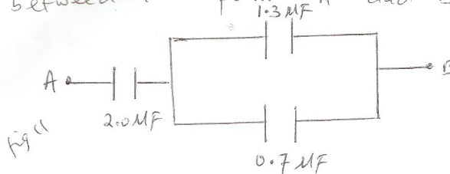
Determine the capacitance across AB (3mks)

d) State the effect of decreasing the distance between the plates of a parallel plate capacitor on the capacitance. (1mk)
___________________________________________________________________________
___________________________________________________________________________

- a) Name the device used to convert light energy directly into electrical energy. (1mk)
___________________________________________________________________________
___________________________________________________________________________

b) The figure below shows a body of mass 5Kg placed on a surface which is inclined at an angle of 30⁰ to the horizontal.

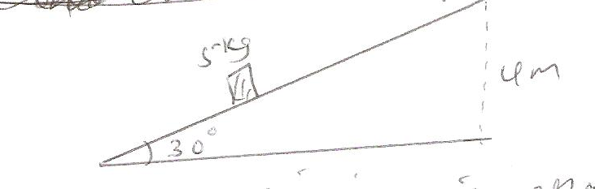
Determine the efficiency if effort used is 30N. (4mks)

c) A crane lifts a load of 2000Kg through a vertical distance of 3.0m in 6seconds. Determine the:
- Work done. (3mks)

- Power developed by the crane. (3mks)

- Efficiency of the crane if mortar is rated 12.5Kw (3mks)

- a) Determine the wavelength of sound wave of frequency 30Hz.
(Speed of sound in air = 330m/s). (3mks)

b) A block of ice of mass 40g at 0⁰c is placed in a calorimeter containing 400g of water at 20⁰c. Ignoring the heat absorbed by calorimeter, determine the final temperature of the mixture after all the ice has melted. (Lf = 334,000j/Kg/K, SHC = 4200j/Kg/K) (6mks)

- a) Explain why it is advisable to use pressure cooker for cooking at high altitude(2mks)
b) Water of mass 5kg at 30⁰is heated in an electric kettlerated 5KW. The water is heated until it boils at 100⁰c (SHC of water = 4200j/Kg/K, C_{kettle}= 450j/K, Lv= 2.26x10⁶j/Kg)
Determine
- Heat absorbed by water. (3mks)

- Heat absorbed by the electric kettle. (3mks)

- Time taken for the water to boil. (3mks)

- a) Define the term velocity ratio. (1mk)

b) Figure 13 shows hydraulic machine
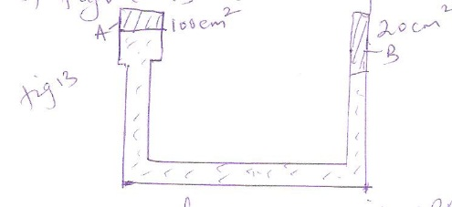

If load of 200Kg is applied at A determine the force lifted at B (4mks)

c) A machine of velocity ratio 45 overcomes load of 4500N due to effort of 135N. Determine
- Mechanical advantage. (2mks)

- Efficiency of the machine. (3mks)

