Name________________________________________________Adm. No______________

233
CHEMISTRY FORM 1
2 HOURS
END OF TERM II 2019

______________________________ SECONDARY SCHOOL

Instructions to Candidates
- Write your name and Admission Number in the spaces provided above.
- Sign and write date of examination in the spaces provided above.
- Answer ALL the questions in the spaces provided.
- Mathematical tables and silent electronic calculators may be used.
- All working MUST be clearly shown where necessary.
- Candidates should check the question paper and ascertain no question is missing.

For Examiner’s use only
Question | Maximum Score | Candidate’s Score
1 – 18 | 100

- Define each of the following terms.
a) Matter
_______________________________________________________________________________________________________________________________________________________ (1mk)
b) Element _______________________________________________________________________________________________________________________________________________________ (1mk)
c) Atom _______________________________________________________________________________________________________________________________________________________ (1mk)
d) Mixture _______________________________________________________________________________________________________________________________________________________ (1mk)
- a) What is drug abuse?_______________________________________________________________________________________________________________________________________________________ (1mk)
b) Name 3 commonly abused drugs in yoursociety. ____________________________________________________________________________________________________________________________________________________________________________________________________________________________________ (3mks)
c) Give two adverse effects of drug abuse to an individual. ______________________________________________________________________________________________________________________________________________________(2mks)
- The diagram below shows the structure of one of the sources of heat in the laboratory. Study it and answer the questions that follow.

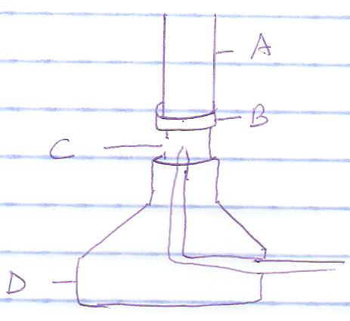

- Name the apparatus drawn above. ___________________________________________________________________(1mk)

- Identify the parts labeled A,B,C, and D and state their functions. (4mks)
Part | Identity | function
A
B
C
D
c) Give four differences between luminous and non-luminous flame
Luminous
Non-luminous

d) Why should a non-luminous flame be turned to luminous after use? ______________________________________________________________________________
________________________________________________________________________(2mks)
e) Name two other sources of heat in the laboratory other than the one drawn above
______________________________________________________________________________
________________________________________________________________________(2mks)
- The diagram below shows the relationship between the physical states of matter. Study it and answer the questions that follow.
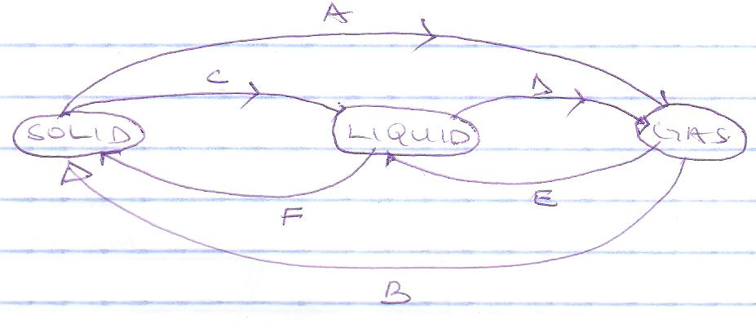
a) identify each of the processes labeled
A _________________________________ (1mk)
B _________________________________ (1mk)
C _________________________________ (1mk)
D _________________________________ (1mk)
b) name two substances that undergo process labeled A (2mks)

- a) give three differences between physical and chemical changes. (3mks)
Physical change
Chemical change

b) (i) What kind of change is burning of charcoal
(ii) Give 2 reasons for your anser in (i) above(2mks)
- Write word equations for the reactions between.
a) sodium and chlorine. ______________________________________________________________________________
_________________________________________________________________________ (1mk)
b) calcium and oxygen. ______________________________________________________________________________
_________________________________________________________________________ (1mk)
c) lithium and fluorine. ______________________________________________________________________________
_________________________________________________________________________ (1mk)
- a) write the symbols for the following elements
    - Hydrogen __________________________________(1mk)

    - Sodium __________________________________(1mk)

    - Nitrogen __________________________________(1mk)

    - Chlorine __________________________________(1mk)

    - Carbon __________________________________(1mk)
b) name the elements in the following compounds
i) Magnesium nitride. ______________________________________________________________________________
_________________________________________________________________________ (1mk)
ii) Calcium sulphide. ______________________________________________________________________________
_________________________________________________________________________ (1mk)
- Below is a diagram of a set up which was used to separate two miscible liquids, A and B whose boiling point are 80⁰c and 100⁰c respectively.
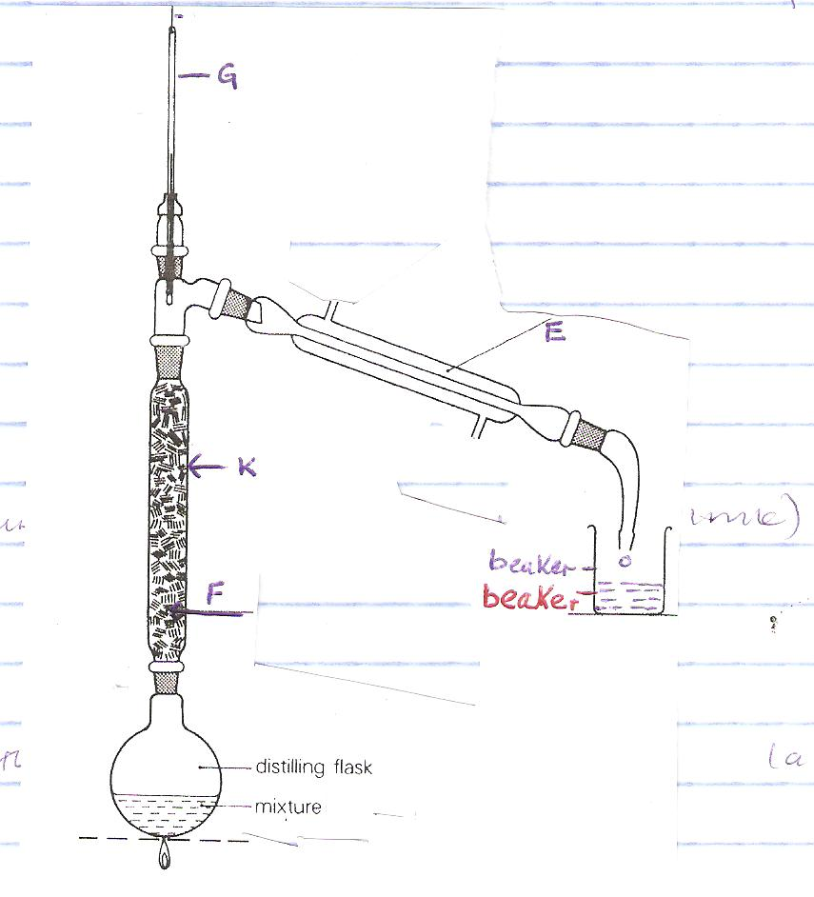
a) What are miscible liquids? ______________________________________________________________________________
______________________________________________________________ ___________(1mk)

b) Name the pieces of apparatus labeled
i) E__________________________ (1mk)
ii) K _________________________ (1mk)

c) State the function of the part labeled
i) G __________________________ (1mk)
ii) F __________________________ (1mk)
d) On the diagram indicate with an arrow ( ) water in and water out. (1mk)
e) Which component of the mixture was collected first? Give a reason for your answer. ______________________________________________________________________________
______________________________________________________________ __________(2mks)
f) What name is given to the pure liquid collected in the beaker? ______________________________________________________________________________
______________________________________________________________ ___________(1mk)
g) Give one industrial application of the method of separation above. ______________________________________________________________________________
______________________________________________________________________________
________________________________________________________ ___________ _____(1mk)
- Identify each of the following laboratory apparatus shown in the diagrams below and state its function (8mks)
Apparatus
Name
Laboratory use

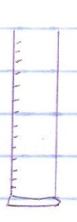
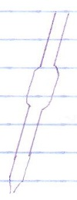
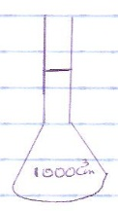
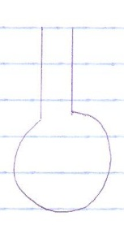
- Describe how you can obtain pure salt from a mixture of salt and sand.(5mks)______________________________________________________________________________

______________________________________________________________________________

______________________________________________________________________________

______________________________________________________________________________

______________________________________________________________________________

______________________________________________________________________________

______________________________________________________________________________

- Give 2 reasons why most laboratory apparatus are made of glass. ______________________________________________________________________________

______________________________________________________________________________

________________________________________________________________________(2mks)
- Spots of pure pigment A and B and a mixture Z were placed on a filter paper and a chromatogram was developed. The results obtained were as shown in the diagram below.
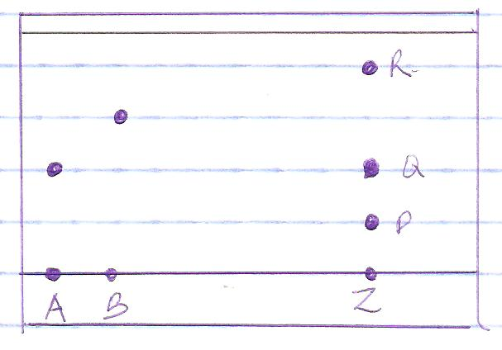
a) on the diagram show
i) solvent front. (1mk)
i) baseline (1mk)
b) which of the pure pigments was a component of Z? _____________________________(1mk)
c) Which of the components of Z was the least dense? Give a reason for your answer. ______________________________________________________________________________
______________________________________________________________ __________(2mks)
d) Name a solvent that could have been used in this chromatography. _________________________________________________________________________(1mk)
- The diagram below is a graphical representation of a heating and a cooling curve of a solid X. study t and answer the questions that follow.
A
B
F
C
E
D
Temperature
Time in minutes
H
G

a) Which letters represent the cooling curve? ______________________________(1mk)

b) Explain what happens to the particles of X between C and D in terms of kinetic theory of matter. ______________________________________________________________________________
______________________________________________________________________________
______________________________________________________________________________
________________________________________________________ _______________ (2mks)
c) Which letter represents:
i) Melting poin. ________________________ (1mk)
ii) Boiling point. _______________________ (1mk)

d) explain why the temperature remains constant between D and E despite the continuous heating. __________________________________________________________________________________________________________________________________________________________________________________________________________________________________________________________________________________________________________________(2mks)
- Brine is made by mixingwater with common salt. Which is the :
- Solute __________________________ (1mk)

- Solvent __________________________ (1mk)

- Solution __________________________ (1mk)

- a) State three laboratory safety rules. ________________________________________________________________________________________________________________________________________________________________________________________________________________________________________________________________________________________________________________________________________________________________________________________________(3mks)
b) give two reasons why it is important to observe laboratory safety rules.___________________________________________________________________________________________________________________________________________________________________________________________________________________________________________________________________________________________________ ______________(2mks)
- Name three careers which require knowledge of chemistry. __________________________________________________________________________________________________________________________________________________________________________________________________________________________________________________________________________________________________ _______________ (3mks)
- Name three branches of chemistry. _________________________________________________________________________________________________________________________________________________________________________________________________________________________________________________________________________________________________ ___________ _____(3mks)
- Give two reasons why air is a mixture and not a compound. ___________________________________________________________________________________________________________________________________________________________________________________________________________________________________________________________________________________________________ ______________ (2mks)

