Name________________________________________________Adm. No______________

233
CHEMISTRY FORM 2
2 HOURS
END OF TERM II 2019

______________________________ SECONDARY SCHOOL

Instructions to Candidates
- Write your name and Admission Number in the spaces provided above.
- Sign and write date of examination in the spaces provided above.
- Answer ALL the questions in the spaces provided.
- Mathematical tables and silent electronic calculators may be used.
- All working MUST be clearly shown where necessary.
- Candidates should check the question paper and ascertain no question is missing.

For Examiner’s use only
Question | Maximum Score | Candidate’s Score
1 – 25 | 100

- During large scale isolation of oxygen, how are the following substances removed?
- Water vapour (1mk)
______________________________________________________________________________________
______________________________________________________________________________________
______________________________________________________________________________________
- Carbon (IV) oxide. (1mk)
______________________________________________________________________________________
______________________________________________________________________________________
______________________________________________________________________________________
- a) Metal Z reacts with dilute sulphuric(VI) acid but not with cold water. Metal Y does not react with dilute sulphuric(VI) acid. X displaces W from the oxide of W and W reacts with cold water. Arramge these metals in order of increasing reactivity. (2mks)
______________________________________________________________________________________
______________________________________________________________________________________
- Helium has replaced hydrogen in weather balloons. Explain this phenomena. (1mk)
______________________________________________________________________________________
______________________________________________________________________________________
______________________________________________________________________________________
- An impure substance A was subjected to chromatographic analysis alongside three other substances. The following chromatogram was formed. Use it to answer questions that follow
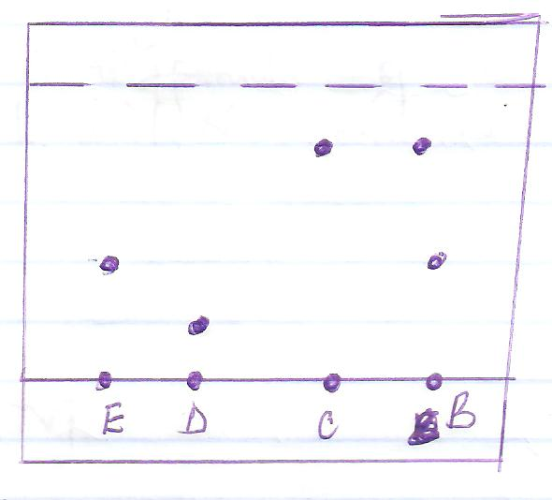
- Which substances make up B (1mk)
______________________________________________________________________________________
______________________________________________________________________________________
- Indicate the solvent front on the chromatogram shown. (1mk)
- Which component of B is more soluble in the eluting solvent? Explain. (2mks)
______________________________________________________________________________________
______________________________________________________________________________________
______________________________________________________________________________________
- Study the grid provided and answer the questions that follow.(the letters are not actual symbols of elements)
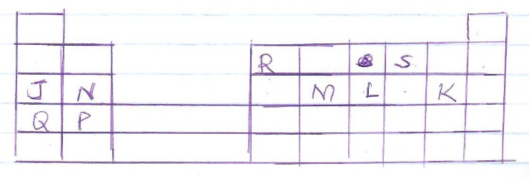
- Write the formula of the compound formed when L and N combines. (1mk)
- Write the electronic configuration of:
- M_______________________________________(1mk)
- P²⁺______________________________________(1mk)
- S²⁻______________________________________(1mk)

- How would reativities of elements N and P with chlorine compare? Explain. (2mks)
______________________________________________________________________________________
______________________________________________________________________________________
______________________________________________________________________________________
- Select the most reactive metal and non-metal. Give a reason. (2mks)
______________________________________________________________________________________
______________________________________________________________________________________
______________________________________________________________________________________
- The diagram below shows a set up used to investigate electrical conductivity of molten Zinc Chloride.
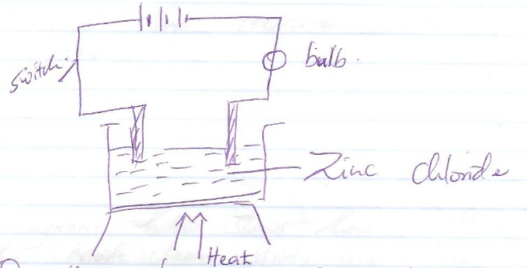

- On the diagram indicate the anode and the cathode. (2mks)
- Give the identity of the products formed at the anode and cathode. (2mks)

- a) Complete the table below
Atom | % abundance | Protons | Electrons | neutrons
⁶⁴₂₉Cu | 69.1 | 29 | 29 | -
⁶⁴₂₉Cu | - | 29 | - | -

(2mks)

- what name is given to the two types of atoms in (a) above (1mk)
______________________________________________________________________________________
______________________________________________________________________________________
- Calculate the relative atomic mass of copper. (3mks)

- The diagram below shows how muddy water can be made clean. Study it and answer the questions that follow.

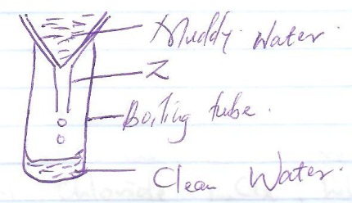
- Name the apparatus labelled Z (1mk) ___________________________________________________

- Name the method of separation shown above. (1mk)________________________________________

- Give a reason why the clean water took long time to drop into the boiling tube. (1mk)
______________________________________________________________________________________
______________________________________________________________________________________
- a) An element has an atomic radius of 0.139nm and ionic radius of 0.064nm. Is this element a metal or a non-metal? Give reasons. (2mks)
______________________________________________________________________________________
______________________________________________________________________________________
______________________________________________________________________________________
b) Describe how you would prepare a dry sample of Lead(II) Sulphate starting with Lead(II) oxide, dilute nitric(V) acid and sodium sulphate. (3mks)
______________________________________________________________________________________
______________________________________________________________________________________
______________________________________________________________________________________
______________________________________________________________________________________
______________________________________________________________________________________
______________________________________________________________________________________
- Element L has an atomic numbeer of 12 while M has 13. L forms chloride LCl_{x}while M forms MCl_{y}
- Find the values of
X_______________________
Y_______________________
- The chloride of M vapourises easily while its oxide has a higher melting point. Account for the diffence. (2mks)
______________________________________________________________________________________
______________________________________________________________________________________
______________________________________________________________________________________
- a) Both methane (CH₄) and diamond have covalent bonds. Explain why methane is a gas whereas diamond is a solid at room temperature. (2mks)
______________________________________________________________________________________
______________________________________________________________________________________
______________________________________________________________________________________
b) Using dots(.) and cross (x) to represent electrons show bonding in the compounds formed by the following elements when they react. (C=6, Cl=17, Ca=20)
i) Calcium and Chlorine. (2mks)

ii) Carbon and Chlorine. (2mks)

- The set up below was used to demonstrate the constituents of air. Use it to answer the questions that follow.
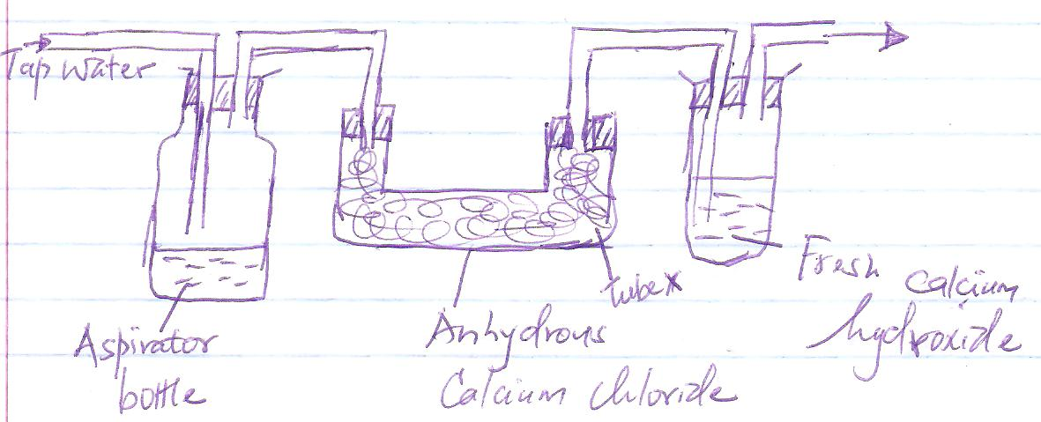

- Why was water drawn into the aspirator bottle? (1mk)
______________________________________________________________________________________
______________________________________________________________________________________
- What happens when air is passed through tube X? (1mk)
______________________________________________________________________________________
______________________________________________________________________________________
- Is air a mixture or a compound? Explain. (2mks)
______________________________________________________________________________________
______________________________________________________________________________________
______________________________________________________________________________________

- Magnesium, Calcium and Barium are elements in group II and their atomic numbers increases in the same order.
- Which of these elements is the most reactive? Explain. (2mks)
______________________________________________________________________________________
______________________________________________________________________________________
- Ionization energy of element P are 590, 1100, 4900 kj per mole. To which group does element P belong? (2mks)
- a) What is drug abuse? (1mk)
______________________________________________________________________________________
______________________________________________________________________________________
b) A patient was given tablets with the prescription 2 x 4 written on the envelope. Clearly outline how the patient should take the tablets. (1mk)
______________________________________________________________________________________
______________________________________________________________________________________

- Study the following diagram on fractional distillation of liquid air and answer the questions that follow.
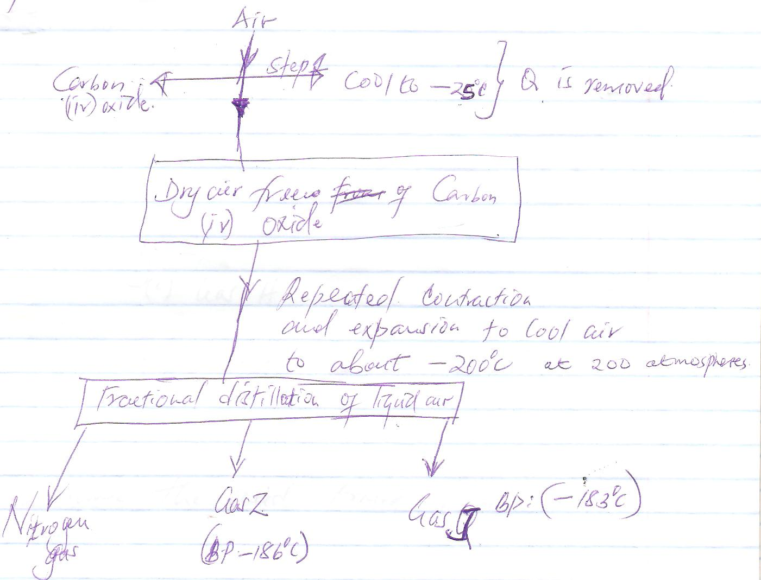

- Name substance Q. (1mk)_____________________________________________

- State one commercial use of oxygen gas(1mk)
______________________________________________________________________________________
______________________________________________________________________________________
- Identify gas

Z ______________________________________(1mk)

J_________________________________________(1mk)

- Use the scheme below to answer the questions that follow
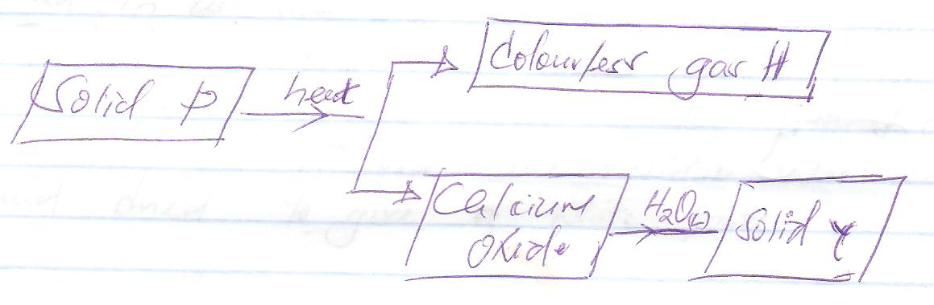
- Identify
- Gas H.______________________________________ (1mk)

- Solid P. _______________________________________________(1mk)

- Name the acid formed when gas H dissolves in water. (1mk)

- a) Describe how Copper(II) Oxide can be obtained from a mixture containing Copper(II) Oxide and Potassium Carbonate. (3mks)
______________________________________________________________________________________
______________________________________________________________________________________
______________________________________________________________________________________
b) When a piece of Magnesium ribbonis burnt completely in oxygen, the mass of the product was greater than the mass of the original pieces. Explain. (2mks)
______________________________________________________________________________________
______________________________________________________________________________________
______________________________________________________________________________________
- Magnesium was burnt in air and the product collected. Dilute Sulphuric(VI)acid was then added to the mixture then the mixture was filtered. Sodium Carbonate was then added to the filtrate and the contents filtered. The residue was washed and dried to give a white powder.
- Give the chemical name of the product. (1mk)
______________________________________________________________________________________
- Identify the filtrate collected after sodium carbonate was added.(1mk)

_____________________________________________________________________________________
- Write an equation to show the formation of the white powder. (2mks)

- Two salts P and Q were tested with universal indicator and the following results were obtained.
Solution pH
P 6.0
Q 13.0
a) What is the nature of
P ____________________________________ (1mk)
Q ____________________________________ (1mk)
- Which solution would react with magnesium metal? (1mk)
____________________________________________________________________________________
- Explain why magnesium hydroxide is given to a person suffering from heart burn. (2mks)
______________________________________________________________________________________
______________________________________________________________________________________
______________________________________________________________________________________
- The following changes occur when pure and impure substances are heated.
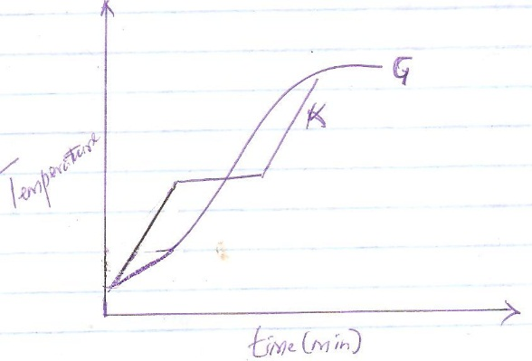

Which curve represents a pure substance? Explain. (2mks)

- When hydrogen is passed over heated lead(II) oxide, a reaction occurs. Study the diagram below and answer the questions that follow.
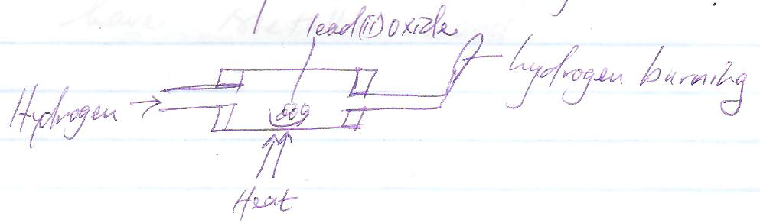
- What observation would be made in the combustion tube? (2mks)
______________________________________________________________________________________
______________________________________________________________________________________
______________________________________________________________________________________
- Write an equation to show how heated lead(II) oxide react with hydrogen.(1mk)

- Study the table below and use the information to answer the questions that follow.

Substance | MP⁰c | BP⁰c | Electrical conductivity
 |  |  | Solid | Liquid
A | 1083 | 2425 | Good | Good
B | 801 | 1413 | Poor | Good
C | 5.5 | 80.1 | Poor | Poor
D | -114.5 | -84.9 | Poor | Poor
E | 3550 | 4827 | Poor | Poor

- Which substance is likely to be a liquid at room temperature? Give reasons. (2mks)
______________________________________________________________________________________
______________________________________________________________________________________
______________________________________________________________________________________
- With reasons state the substances likely to have metallic bonds. (2mks)
______________________________________________________________________________________
______________________________________________________________________________________
- With reasons state the substances with giant atomic structures. (2mks)
______________________________________________________________________________________
______________________________________________________________________________________
______________________________________________________________________________________
- Study the table below and answer the questions that follow

Element | Neutrons | Mass number
P | 12 | 23
Q | 10 | 20
R | 10 | 19
S | 8 | 16

- Suggest two elements that are likely to join together through covalent bonding. (1mk)

- Suggest two elements that are likely to join together through an ionic bond. (1mk)

- State four differences between luminous and non-luminous flame (4mks)
Luminous flame
Luminous flame

- Draw and name two apparatus used to measure specific volumes in the laboratory. (4mks)

- State the effect of impurities on melting and boiling point of a substance. (2mks)
______________________________________________________________________________________
______________________________________________________________________________________
______________________________________________________________________________________
- Apart from labeling the chemicals, state any other two laboratory safety rules. (2mks)
______________________________________________________________________________________
______________________________________________________________________________________
______________________________________________________________________________________

