**MCK LUUMA SECONDARY SCHOOL**

**P.O BOX 28-60605 MUTHARA**

**FORM 2 AGRICULTURE**

**END OF TERM 2 2021 EXAMS.**

**TIME: 2HOURS.**

**NAME……………………………………………….. ADM………**

**Section A (35MKS)ANSWER ALL QUESTIONS.**

1. List four factors that would determine the stage at which a crop is harvested. (2 marks)
2. State two ways in which crop rotation controls weeds. (1 mark)
3. Give two factors which characterize small scale farming. (1 mark)

4. Give two examples for each of the following categories of water pipes.

(a) Metal pipes (I mark)

(b) Hose pipes (1 mark)

5. State four characteristics of a good vegetable seedling. (2 marks)

6. Name three forms of horticulture practiced in Kenya. (1 ½ marks)

7. State two mechanical methods of separate line soil particles according to size, during soil analysis. ( I mark)

8. List four disadvantages of mono cropping in crop production. (2 marks)

9. State four reasons for treating water for use on a farm. (2 marks)

10. Outline two ways of controlling damping off disease on vegetable seedlings in a nursery. (1 mark)

11. State four factors that affect the quality of farm-yard manure. (2 marks)

12.State four factors that determine the depth of planting.(2mks)

13. State four disadvantages of broadcasting seeds during planting.(2mks)

14. State four characteristics of a good site for a nursery bed.(2mks)

15. Define the following terms as used in livestock health. (2mks)

i) health

ii) disease

16.highlight five pre-disposing factors of animals to diseases.(21/2mrks)

17.  Name one breed of livestock under each of the following categories:

(a) dairy cattle (1/2 mark)

(b) dual purpose cattle (1/2 mark)

(c) dual purpose sheep (1/2 mark)

(d) hair goat (1/2 mark)

18. Give four activities that makes agriculture an art.(4mks)

19.state two components of soil.(1mk)

**SECTION B (20MKS)ANSWER ALL QUESTIONS.**

20. The diagrams below represent farm tools and equipment.



[a] Identify the tools labeled A and B [2mark]

[b] State one use of each of the tools labeled C and D [2mark]

[c] Explain one maintenance practice carried out on tool D. [1mark.]

21.The diagram below shows crop establishment using a certain method of planting.Study it carefully and then answer the questions that follow.

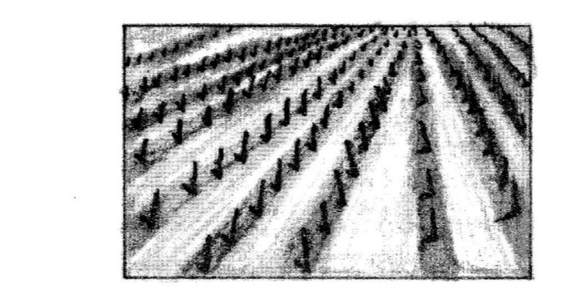

1. Name the method of planting used for the crop. (1 mark)
2. State two advantages of the planting method used for the crop. (2 marks)

(c) State two factors that determine the depth of planting,. (2 marks)

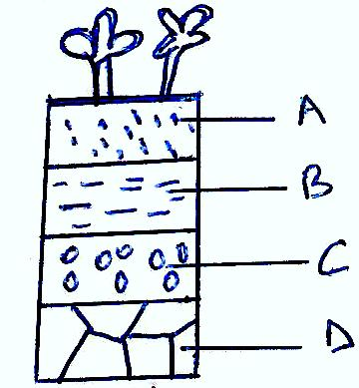22.The diagram below illustrates a feature observed after digging the soil several meters deep. Study the diagram carefully and answer the questions that follow.

(a) Identify the feature that the diagram above represents in the study of soil. (I mark)

(b) Name the parts of the diagram labeled A, B C and D (2 marks)

A

B

C

D

1. State two ways in which the knowledge of the above feature would be of benefit to a farmer. (2 marks)

23.The diagram below illustrate a tomato fruit infested by a field pest

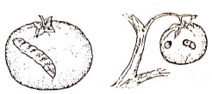

**a)Identify the pest. (1 mark)**

**b) State two ways in which the pest is economically important. (2 marks)**

**c) State two cultural ways of controlling the pest. (2 marks)**

**SECTION C (25MKS)**

24. Describe the production of carrots under the following subheadings;

i)varieties (2mks)

ii) Ecological requirements.(4mks)

iii)Land preparation. (3mks)

iv)Field management practices(6mks)

v)Harvesting and marketing.(5mks)

25. State five problems that are facing agriculture in the 21st century. (5mks)