NAME…………………………………………….ADMISSION NUMBER………………………
443/1
AGRICULTURE
TIME:2 HOURS
2020 FORM 4 TERM 1 END TERM EXAMS
PAPER ONE
TIME 2HOURS
INSTRUCTIONS TO CANDIDATES.
- Write your name and admission number in the spaces provided.
- Answer all questions in the spaces provided.
- This question paper consists of three sections A, B and C.
- Answer all the questions in sections A and B any two questions from section C.
- Answers should be written in the spaces provided.
- The paper consists of 11 printed pages
For Examiner’s use only
Section | Question | Maximum score | Candidate’s score
A | 1-16
B | 17-21
C | 22
C | 23
C | 24
Total

Candidates should check the question paper to ascertain that all the pages are printed as indicate and no questions are missing.

SECTION A(30mks)Attempt all the questions in this section.
- Give two conditions under which shifting cultivation can be practiced. 1mk
………………………………………………………………………………………………………………………………………………………………………………………………
- Differentiate between apiculture and aquaculture. 1mk
………………………………………………………………………………………………………………………………………………………………………………………………

- Give four government policies which influence Agricultural production… 2mks
………………………………………………………………………………………………………………………………………………………………………………………………
………………………………………………………………………………………………………………………………………………………………………………………………
………………………………………………………………………………………………………………………………………………………………………………………………

- State four methods of clearing land. 2mk
………………………………………………………………………………………………………………………………………………………………………………………………
………………………………………………………………………………………………………………………………………………………………………………………………
………………………………………………………………………………………………………………………………………………………………………………………………
- State four importance for treating water for domestic use. 2mks
………………………………………………………………………………………………………………………………………………………………………………………………
………………………………………………………………………………………………………………………………………………………………………………………………
………………………………………………………………………………………………………………………………………………………………………………………………

- Give four qualities of a fertile soil. 2mks
………………………………………………………………………………………………………………………………………………………………………………………………
………………………………………………………………………………………………………………………………………………………………………………………………
………………………………………………………………………………………………………………………………………………………………………………………………

- State four types of farm records… 2mks
………………………………………………………………………………………………………………………………………………………………………………………………
………………………………………………………………………………………………………………………………………………………………………………………………
………………………………………………………………………………………………………………………………………………………………………………………………

- Give four role of nitrogen in a plant. 2mks
………………………………………………………………………………………………………………………………………………………………………………………………
………………………………………………………………………………………………………………………………………………………………………………………………
………………………………………………………………………………………………………………………………………………………………………………………………

- State four factors which influence the rooting of a cutting . 2mks
………………………………………………………………………………………………………………………………………………………………………………………………
………………………………………………………………………………………………………………………………………………………………………………………………
………………………………………………………………………………………………………………………………………………………………………………………………

- Give four reasons for growing seedling in a nursery . 2mks
………………………………………………………………………………………………………………………………………………………………………………………………
………………………………………………………………………………………………………………………………………………………………………………………………
………………………………………………………………………………………………………………………………………………………………………………………………
- Name two methods of pruning . 2mks
………………………………………………………………………………………………………………………………………………………………………………………………
………………………………………………………………………………………………………………………………………………………………………………………………
………………………………………………………………………………………………………………………………………………………………………………………………
- Give two causes of blossom end rot in tomatoes. 2mks
………………………………………………………………………………………………………………………………………………………………………………………………
- Define the following terms as used in Agriculture.
- Land sub-division 1mk
………………………………………………………………………………………………………………………………………………………………………………………………

- Land consolidation. 1mk
………………………………………………………………………………………………………………………………………………………………………………………………

- State four harmful effects of weed. 2mks
………………………………………………………………………………………………………………………………………………………………………………………………
………………………………………………………………………………………………………………………………………………………………………………………………
………………………………………………………………………………………………………………………………………………………………………………………………

- State two categories under which pest can be classified or mode of feeding. 2mks
……………………………………………………………………………………………………………………………………………………………………………………………
………………………………………………………………………………………………………………………………………………………………………………………………

- Name four causes of crop diseases. 2mks
………………………………………………………………………………………………………………………………………………………………………………………………………………………………………………………………………………………………………………………………………………………………………………………………
………………………………………………………………………………………………………………………………………………………………………………………………

SECTION B:20mks:Attempt all questions in this section.
- Below is a diagram of one of the tertially practices that are carried out in land preparation. Study it and answer the questions below
- Identify the tertially practice shown above. 1mk
……………………………………………………………………………………………
- Give four reasons for carrying out the above practice. (2mks)
………………………………………………………………………………………………………………………………………………………………………………………………
………………………………………………………………………………………………………………………………………………………………………………………………
………………………………………………………………………………………………………………………………………………………………………………………………

- Apart from the above practice name any other two tertiary practices that are carried out in a farm (1mk)
………………………………………………………………………………………………

- The table below is one of the record that is kept by livestock farmer in the farm

Dam No |  | Breed colour | Parents: sire |  | Dam
1st Service | 2nd service | 3rd serivice | 4th service | Remarks | No of service
Date of service | Date of service | Date of service | Date of service
Time of service | Time of service | Time of service | Time of service
A  ……. | Bull No Breed | Bull No Breed | Bull no Breed
B…… | Result……………….
Expected date of calving
C…………………………………..
Weight of calf at birth
Sex of the calf
No of calf

- Identify the type of record. 1mk
………………………………………………………………………………………
- Fill in the blank spaces 3mks
A……………………………………………………
B……………………………………………………………
C…………………………………………………………………
- A farmer was advised to apply 150 kg of CAN/ha,while top dressing the maize crop.CAN contains 21% N.Calculate the amount of Nitrogen applied per ha. 4mks
………………………………………………………………………………………………………………………………………………………………………………………………
………………………………………………………………………………………………………………………………………………………………………………………………
……………………………………………………………………………………………………………………………………………………………………………………………

- Below are various pegging methods of tea. Study them and answer the questions that follows.
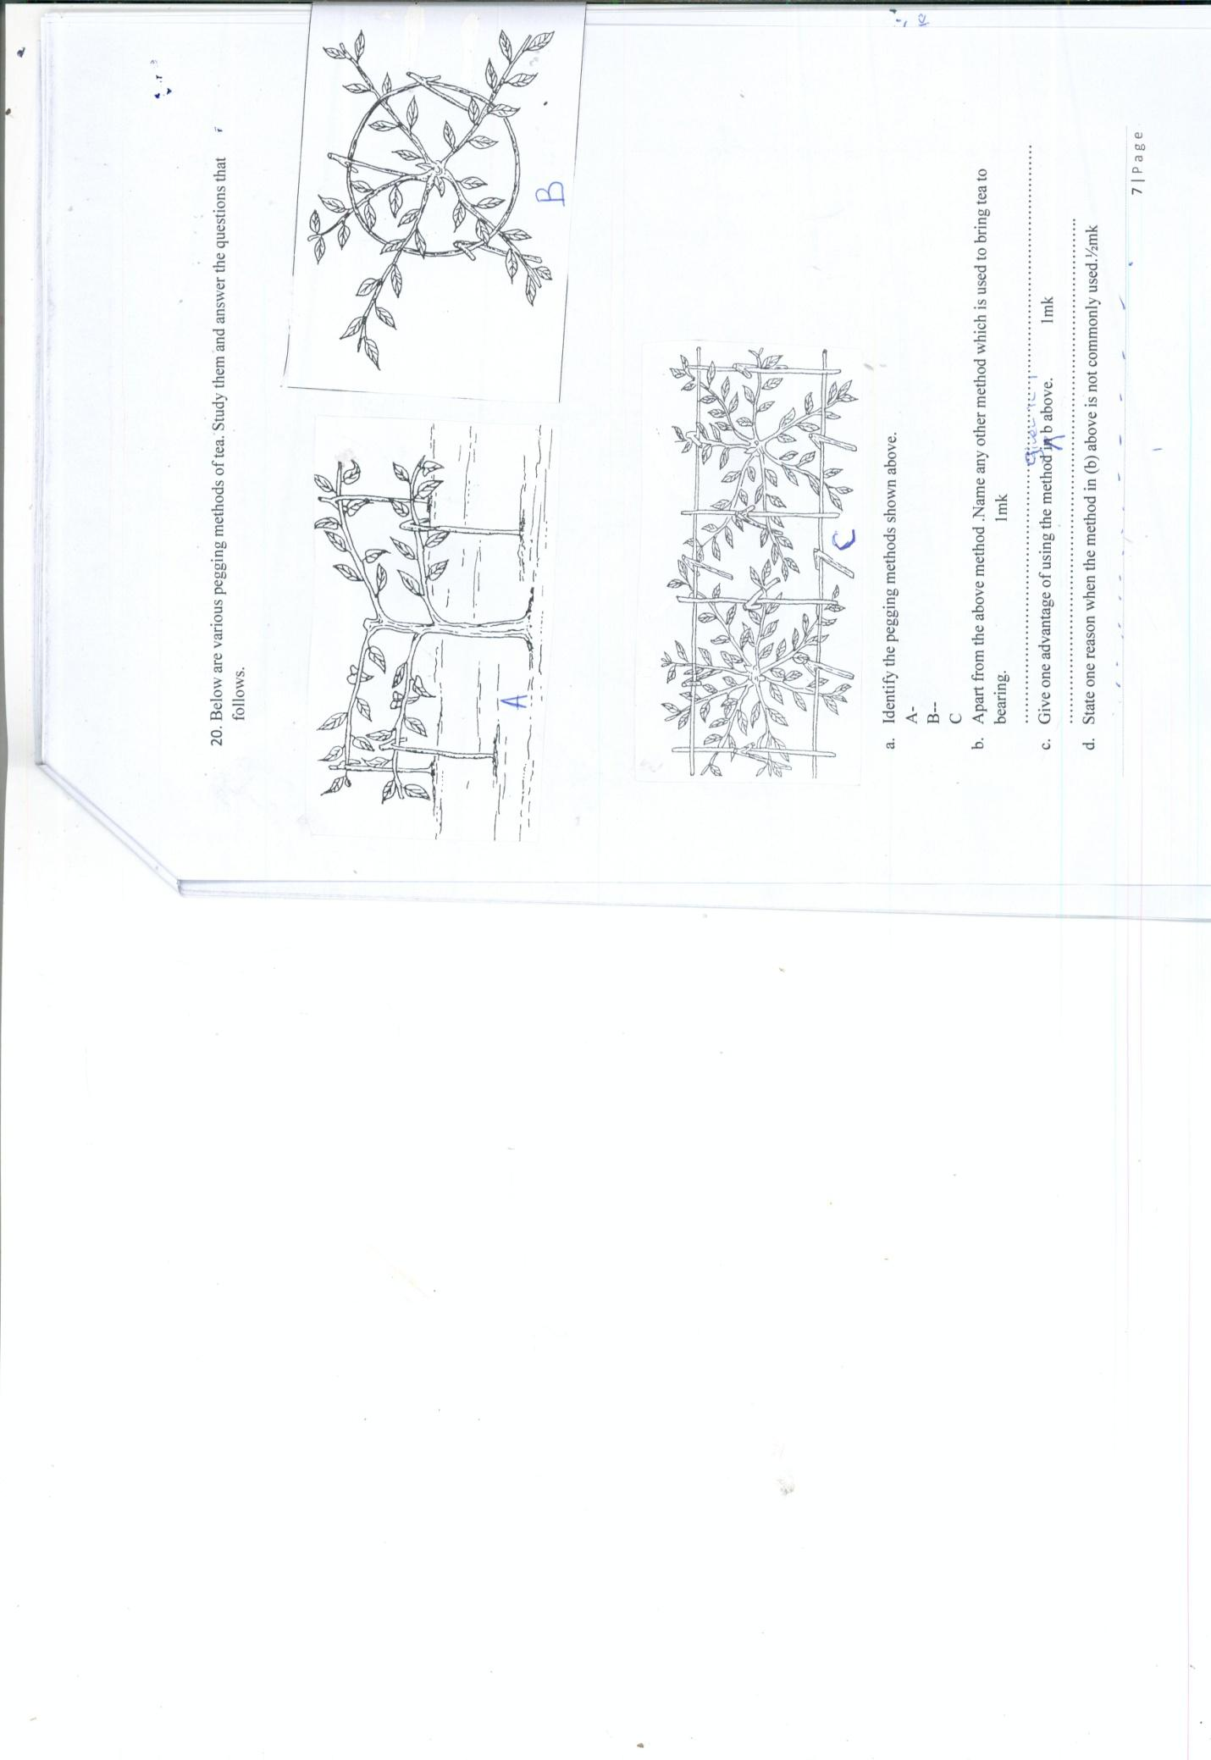
- Identify the pegging methods shown above. 1$\frac{1}{2mks}$
A-
B--
C
- Apart from the above method .Name any other method which is used to bring tea to bearing. 1mk
……………………………………………………………………………………………
- Give one advantage of using the method given in b above. 1mk
………………………………………………………………………………..
- State one reason why the method in (b) above is not commonly used.½mk
……………………………………………………………………………………………..

- Below are some of the common weeds in Kenya. Study them and answer the questions which follow.

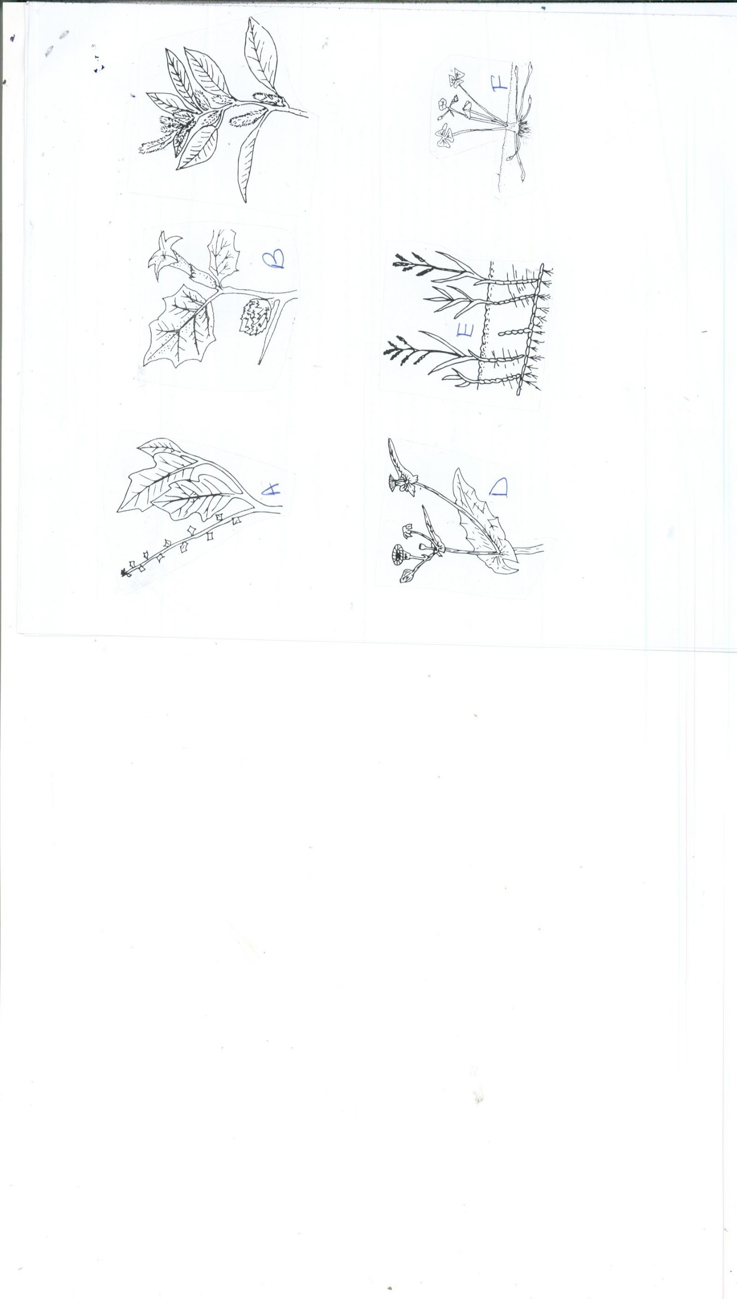
- Identify the weeds A,B,C D. 2MKS
……………………………………………………………………………………………
- What contributes to the competitive ability of weed C 1mk
…………………………………………………………………………………………
- Why is it difficult to control weed E and weed F. 1mk
………………………………………………………………………………………………

SECTION C(Attempt two questions in this section.(40mks)
- (a)Describe the advantages of organic farming in Kenya. 5mks
………………………………………………………………………………………………………………………………………………………………………………………………
………………………………………………………………………………………………………………………………………………………………………………………………
………………………………………………………………………………………………………………………………………………………………………………………………

(b)Explain the overall effects of HIV/AIDS and ill health on Agricultural production.5mks
………………………………………………………………………………………………………………………………………………………………………………………………
………………………………………………………………………………………………………………………………………………………………………………………………
………………………………………………………………………………………………………………………………………………………………………………………………
(c)Describe five reasons of carrying out minimum tillage in agriculture production.5mks
………………………………………………………………………………………………………………………………………………………………………………………………
………………………………………………………………………………………………………………………………………………………………………………………………
………………………………………………………………………………………………………………………………………………………………………………………………
(d)Describe the uses of water in a farm . 5mks
………………………………………………………………………………………………………………………………………………………………………………………………
………………………………………………………………………………………………………………………………………………………………………………………………
……………………………………………………………………………………………………………………………………………………………………………………………

- (a)Explain five ways of maintaining soil fertility. 5mks
………………………………………………………………………………………………………………………………………………………………………………………………
………………………………………………………………………………………………………………………………………………………………………………………………
………………………………………………………………………………………………………………………………………………………………………………………………

(b)Explain the factors which affects the spacing of any crop. 5mks
………………………………………………………………………………………………………………………………………………………………………………………………
………………………………………………………………………………………………………………………………………………………………………………………………
………………………………………………………………………………………………………………………………………………………………………………………………

(c)Describe five management practices carried out in a nursery bed. 5mks
………………………………………………………………………………………………………………………………………………………………………………………………
………………………………………………………………………………………………………………………………………………………………………………………………
………………………………………………………………………………………………………………………………………………………………………………………………………………………………………………………………………………………………
………………………………………………………………………………………………………………………………………………………………………………………………
………………………………………………………………………………………………
(d)Describe the field management practices in tomato production.. 5mks
………………………………………………………………………………………………………………………………………………………………………………………………
………………………………………………………………………………………………………………………………………………………………………………………………………………………………………………………………………………………………
………………………………………………………………………………………………………………………………………………………………………………………………
………………………………………………………………………………………………
………………………………………………………………………………………………………………………………………………………………………………………………
- (a)Describe the effects of land consolidation. 6mks
………………………………………………………………………………………………………………………………………………………………………………………………
………………………………………………………………………………………………………………………………………………………………………………………………………………………………………………………………………………………………
………………………………………………………………………………………………………………………………………………………………………………………………
………………………………………………………………………………………………
………………………………………………………………………………………………………………………………………………………………………………………………
………………………………………………………………………………………………………………………………………………………………………………………………
………………………………………………………………………………………………………………………………………………………………………………………………

(b) Explain cultural methods of controlling pests.14mks
………………………………………………………………………………………………………………………………………………………………………………………………
………………………………………………………………………………………………………………………………………………………………………………………………
………………………………………………………………………………………………………………………………………………………………………………………………
………………………………………………………………………………………………………………………………………………………………………………………………
………………………………………………………………………………………………………………………………………………………………………………………………
………………………………………………………………………………………………………………………………………………………………………………………………
…………………………………………………………………………………………….

