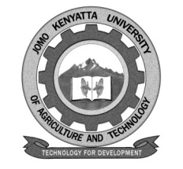
W1-2-60-1-6

JOMO KENYATTA UNIVERSITY OF AGRICULTURE AND TECHNOLOGY

UNIVERSITY EXAMINATIONS 2020/2021

SUPPLEMENTARY/SPECIAL EXAMINATION FOR THE DEGREE OF DOCTOR OF PHILOSOPHY IN FOOD SCIENCE AND NUTRITION

AFS 4122: ADVANCES IN FOOD MICROBIOLOGY AND SAFETY

DATE: MARCH 2021 TIME: 3 HOURS

INSTRUCTIONS: ANSWER ANY FOUR QUESTIONS

1. Using practical examples, discuss food-borne bacterial pathogens. (25 marks)

2. Discuss diversity of microbial metabolism and its significance in Food Science and nutrition. (25 marks)

3. Citing specific microbial species as examples, discuss application of microbes in food processing. (25 marks)

4. a. Discuss general principles of microbiological risk assessment. (12 marks)

b. Using definite examples describe process of conducting microbiological risk assessment in foods. (13 marks)

5. Discuss approaches used in identification and characterization of useful industrial microorganisms. (25 marks)

6. Discuss occurrence of mycotoxins in food value chain and pre and postharvest strategies used to control their occurrence. (25 marks)

